Contact
Address:
Mohalla Balai Koho Dera Bugti
Phone:
03303466907
Email:
mehboobb463@gmail.ccom

Languages
- English
- Urdu
- Balochi

Request note
Kindly consider conducting my interview remotely. Once my job is confirmed, I will be available to visit on-site.
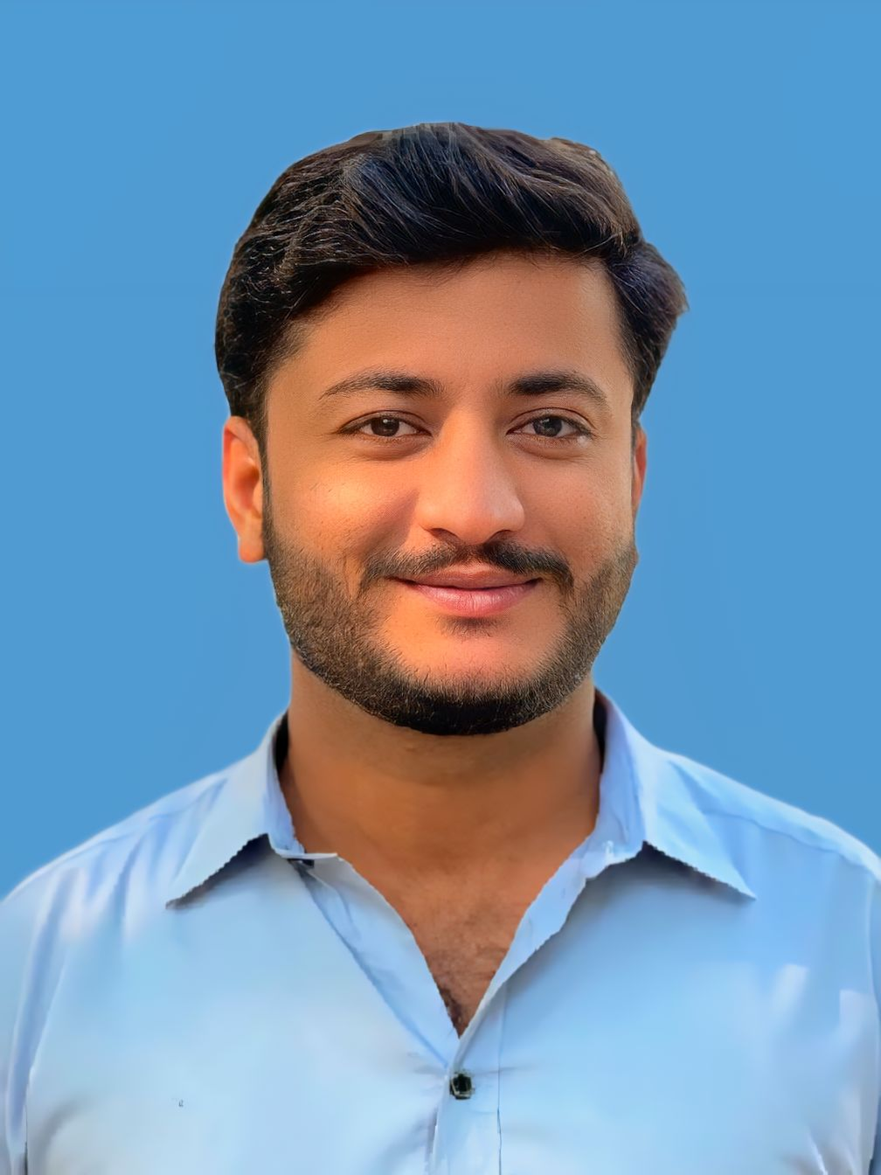
Mehboob Ali

Summary

I am an experienced WordPress and Web Developer with 2 years of expertise in building and customizing dynamic, user-friendly, and responsive websites. I specialize in developing and managing WordPress sites, including theme customization, plugin management, and content updates. I create visually appealing and engaging layouts with a strong eye for design. I focus on delivering clean and efficient websites that provide a smooth user experience across all devices. I collaborate effectively with designers and development teams to deliver functional web solutions, while continuously optimizing performance for fast loading and seamless navigation.

Skill Highlights
- Web developer
- Web designer
- Manage plugins

Experience
Web Developer at Pakistan Web Dev, Islamabad, Pakistan
(2024-2026)

Education
- BS Library & Information Science ( 2020-2024)
University: The Islamia University of Bahawalpur
- FSc ( 2018-2020)
Board: BISE Quttea
- Matric ( 2016-2018)
Board: BISE Multan

