COVID-19 Simulation Report
Generated on: 2025-12-21 22:35:33

Executive Summary
Metric | Value
Total Infections | 245
Total Deaths | 0
Survivors | 1
Peak R-Value | 11.00
Final Vaccination Rate | 0.0%

Epidemic Progression
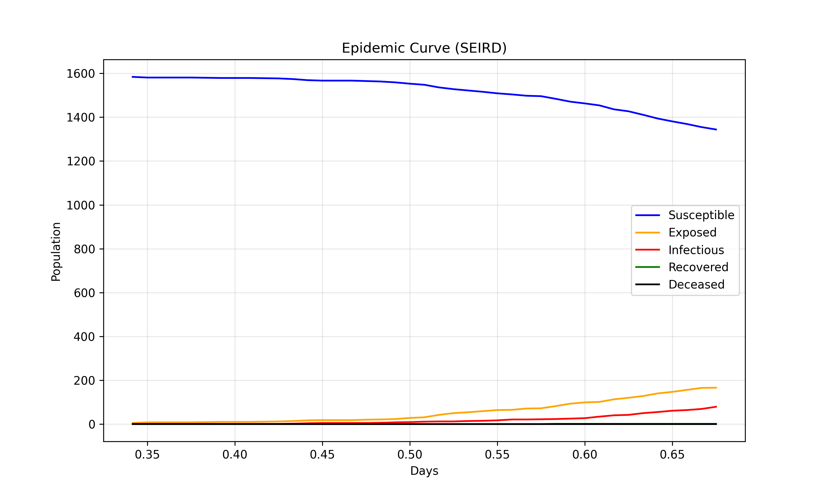

Transmission Dynamics
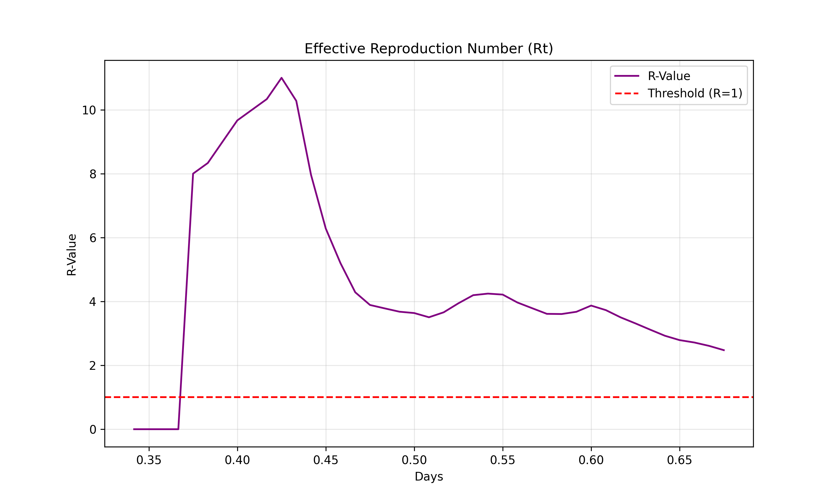

Intervention Impact
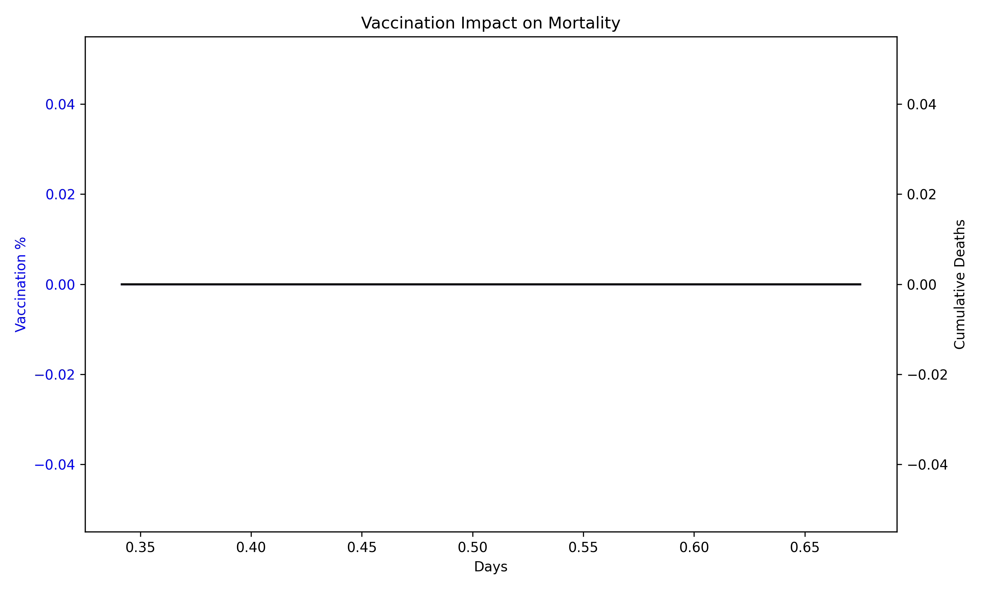

Understanding the Metrics

SEIR Model
The SEIR model tracks the flow of people between four states: Susceptible (S), Exposed (E), Infectious (I), and Recovered (R). Exposed individuals have contracted the virus but are not yet infectious (incubation period).

Effective Reproduction Number (Rt)
Rt represents the average number of people infected by a single infectious person at a specific point in time. An Rt > 1.0 means the epidemic is growing, while Rt < 1.0 means it is shrinking.

Herd Immunity
Vaccinaton reduces the pool of susceptible individuals. When a sufficient proportion of the population is immune, transmission slows down significantly, protecting even those who are not vaccinated.

