-Screen shot showing that I have successfully installed Java 13:

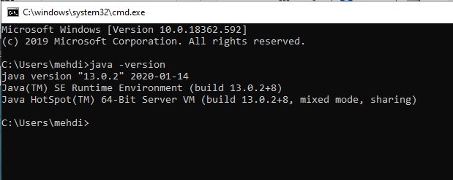

- Screen shot showing that I have successfully created the JAVA_HOME variable:

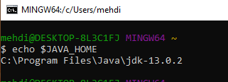

- Screen shot showing that I have successfully created the JAVAFX variable:

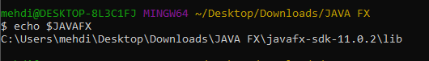

-Screen shot showing that I can successfully execute a JavaFX application:

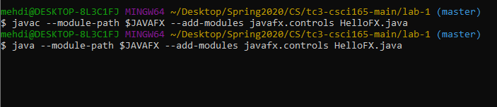

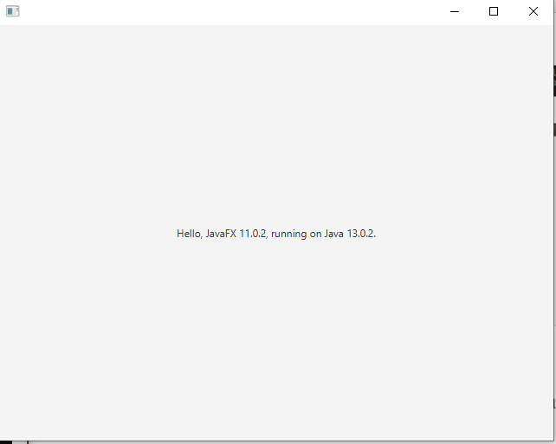

- Screen shot of my program being compiled and executed from the terminal:

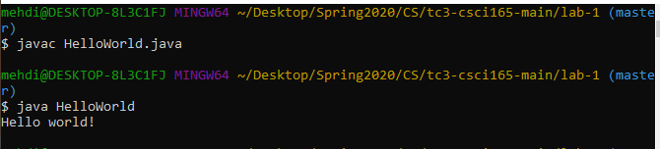

**Additional Problems**

1. Puzzle Problem: to find the average of 10 homework grade she just needs to get the sum of all those homework, ones you have the total of the sum she needs to divide that total by 10 (the number of homework) the result of the division will be the average of the 10 homework.
2. Puzzle Problem: for this Caesar cipher we can create an array list with 26 letters (all the alphabet) and ask the user for a word or text, once we have the word/text our code will get every single element of the users input and one by one find the position of the users chart and sort it in the alphabet list once we find the position or index we will sum 5 to it but we will need to put some exceptions, this exceptions would be the blank spaces (if it is a text) in this case we will leave it as it is and add it into the return and the last 5 letters which will give us a out of bounds error, these 4 letters will be assigned in the code to the first 5 letters of our alphabet list, each chart after the shifting will be added to the return string.
3. Puzzle Problem: to solve this Caesar cipher with out the size of the shift we can loop a Caesar cipher (like the one in “2. Puzzle Problem”) and try the 26 possibilities starting with 1 as the size of the shifting and then check which is the real message, in this case the size is 23 and the message is: “puzzles are fun”.
4. Puzzle Problem: you have 4 digits if his brother has less 10 or less grades between 0-10 we can use 2 digits for the counter (count the number of grades) and the other 2 for the total (the sum of the grades) once he has the total and the counter he will divide the total by the counter, if the little brother has all 10s or 0s the big brother will see 10/00 then the big brother will know if the average was 0 or 10.
5. Puzzle Problem: Round 1 { 0 => 15, 1 => continue (15 is not 1), 2 => continue (15 is not even), 3 => 15*3+1= 46 (15 is odd), 4 => continue (go to step 0)} ; round 2 {0 => 46, 1 => continue (15 is not 1), 2 => 46/2 = 23 (46 is even), 3 => 23*3+1= 70 (23 is odd), 4 => continue (go to step 0)}; round 3 {0 => 70, 1 => continue (70 is not 1), 2 => 70/2 = 35 (70 is even), 3 => 35*3+1= 106 (35 is odd), 4 => continue (go to step 0)}; round 4 {0 => , 106 => continue (106 is not 1), 2 => 106/2 = 53 (106 is even), 3 => 53*3+1= 160 (53 is odd), 4 => continue (go to step 0)}; round 5 {0 => 160, 1 => continue (160 is not 1), 2 => 160/2 = 80 (160 is even), 3 => continue (80 is not odd), 4 => continue (go to step 0)}; round 6 {0 => 80, 1 => continue (80 is not 1), 2 => 80/2 = 40 (80 is even), 3 => continue (40 is not odd), 4 => continue (go to step 0)}; round 7 {0 => 40, 1 => continue (40 is not 1), 2 => 40/2 = 20 (40 is even), 3 => continue (20 is not odd), 4 => continue (go to step 0)}; round 8 {0 => 20, 1 => continue (20 is not 1), 2 => 20/2 = 10 (20 is even), 3 => continue (10 is not odd), 4 => continue (go to step 0)}; round 9 {0 => 10, 1 => continue (10 is not 1), 2 => 10/2 = 5 (10 is even), 3 => 5*3+1=16 (5 is odd), 4 => continue (go to step 0)}; round 10 {0 => 16, 1 => continue (16 is not 1), 2 => 16/2 = 8 (16 is even), 3 => continue (8 is not odd), 4 => continue (go to step 0)}; round 11 {0 => 8, 1 => continue (8 is not 1), 2 => 8/2 = 4 (8 is even), 3 => continue (4 is not odd), 4 => continue (go to step 0)}; round 12 {0 => 4, 1 => continue (4 is not 1), 2 => 4/2 = 2 (8 is even), 3 => continue (2 is not odd), 4 => continue (go to step 0)}; round 13 {0 => 2, 1 => continue (2 is not 1), 2 => 2/2 = 1 (8 is even), 3 => continue (it is odd but it is 1), 4 => continue (go to step 0)}; round 11 {0 => 1, 1 => stop (1 is 1).
6. Puzzle Problem: Round 1 { 0 => 6, 1 => continue (6 is not 1), 2 => 6/2=3 (6 is even), 3 => 3*3+1= 10 (3 is odd), 4 => continue (go to step 0)} ; round 2 {0 => 10, 1 => continue (10 is not 1), 2 => 10/2 = 5 (10 is even), 3 => 5*3+1=16 (5 is odd), 4 => continue (go to step 0)}; round 3 {0 => 16, 1 => continue (16 is not 1), 2 => 16/2 = 8 (16 is even), 3 => continue (8 is not odd), 4 => continue (go to step 0)}; round 4 {0 => 8, 1 => continue (8 is not 1), 2 => 8/2 = 4 (8 is even), 3 => continue (4 is not odd), 4 => continue (go to step 0)}; round 5 {0 => 4, 1 => continue (4 is not 1), 2 => 4/2 = 2 (8 is even), 3 => continue (2 is not odd), 4 => continue (go to step 0)}; round 6 {0 => 2, 1 => continue (2 is not 1), 2 => 2/2 = 1 (8 is even), 3 => continue (it is odd but it is 1), 4 => continue (go to step 0)}; round 7 {0 => 1, 1 => stop (1 is 1).8.

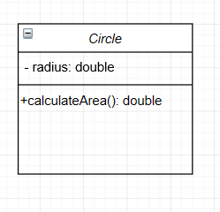

9.

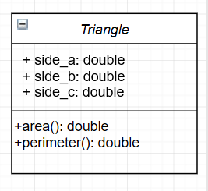

10. 