**Environment variables**

* You can set environment variables for things that can change often: You don’t want to change the code often.
* Use of:
  + *os.environ.get(‘APP_COLOR’)*
  + *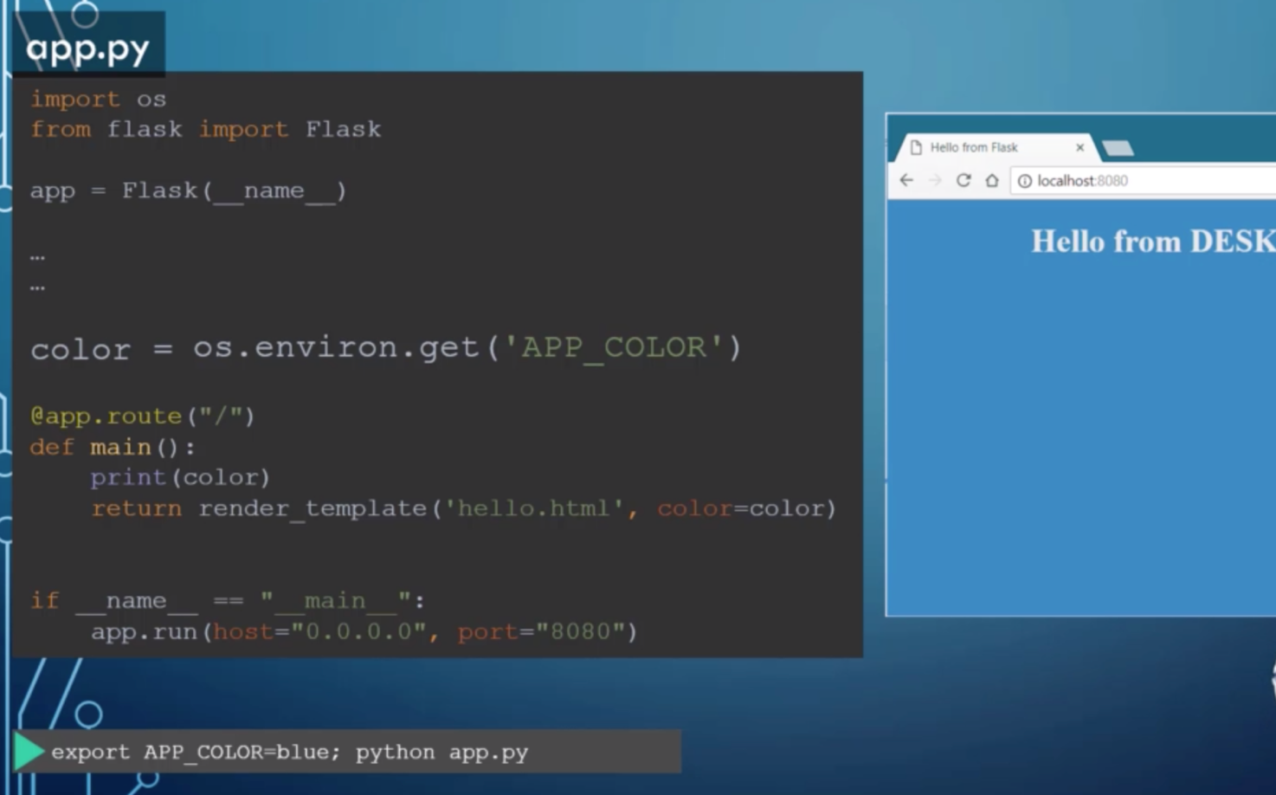export APP_COLOR=blue;*
  + *$ docker run -e APP_COLOR=blue simple-webapp-color*