**Docker Compose**

* In a Prod environment, you have multiple services in containers interacting with each other.
* Instead of running multiple Run commands, we use docker Compose.
* Docker Compose file in Yaml format:

$ docker-compose up

* **Port mapping** in docker compose file:

* **Volume mapping** in docker compose file:

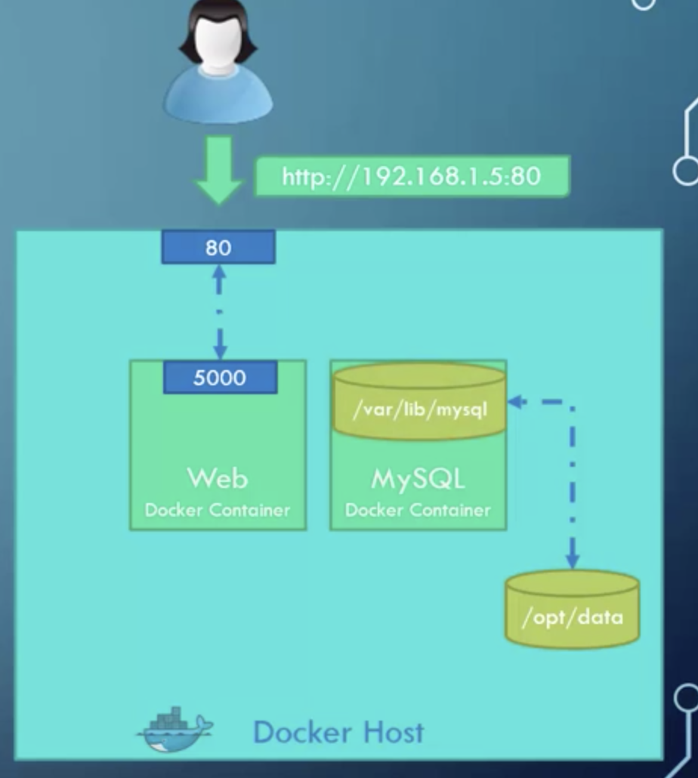

**Docker compose commands**

