**Docker Networking**

* When you install docker, it creates 3 networks:
  + **Bridge** (Default)
  + **None** (You have to specify with - - network= none)
  + **Host**

* **Bridge**:
  + Private internal network created by docker on the host.
  + All containers are attached to it by default and they get an IP address in the range of 172.17
  + To access these containers from the outside world, you must map this container to the Docker host.
  + All containers can communicate with each other.

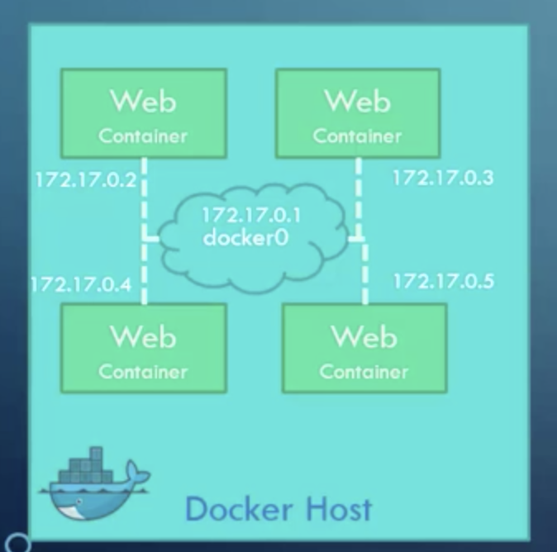

* If you want to isolate 2 containers on another internal network like this:

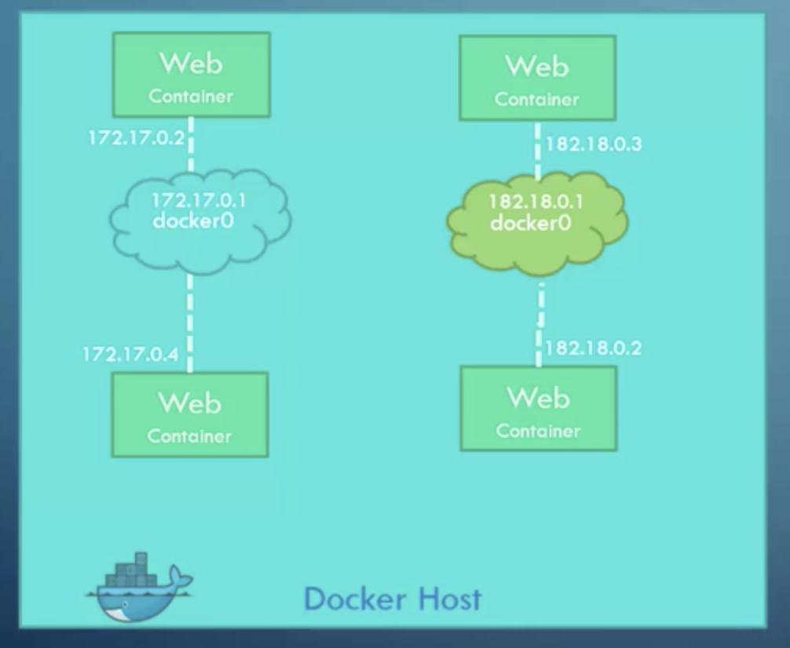

**🡺 By default, docker creates only one Bridge network, you need to create another bridge with command:**

* **List all networks:**

* **Host**
  + Automatically accessible to the host externally on the same @IP. No mapping required!
  + **Disadvantage**: You will not be able to run multiple containers with the same @IP

