**Hands-on Ansible**

<https://www.pluralsight.com/courses/hands-on-ansible>

Ansible is a radically simple IT automation platform that makes your applications and systems easier to deploy. Avoid writing scripts or custom code to deploy and update your applications— automate in a language that approaches plain English, using SSH, with no agents to install on remote systems.

* What is Ansible?

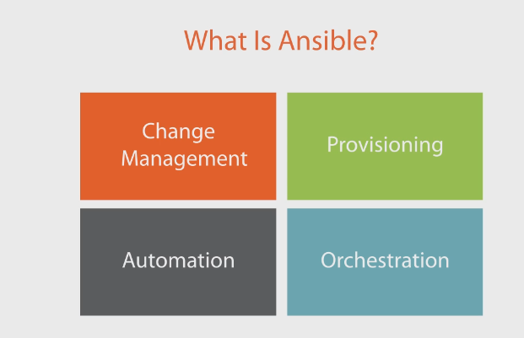

* **Change Management:**
  + You write up what the system would look like under normal circumstances.
  + *Define a* ***“System State”:***
    - Apache Web Installed, version 2.5
    - Apache web Started.
* Anything different or any deviation would be called a ***“Change event”.***
* ***This is very important in production environments.***
* **Provisioning**
  + Transition from one system state to another system state that is expected.
  + Ansible provision is installing and configuring the software on your server.
    - Cleaner than copying images.
  + Example: You want to have a **Web Server** ready. Ansible will take care of all the steps.

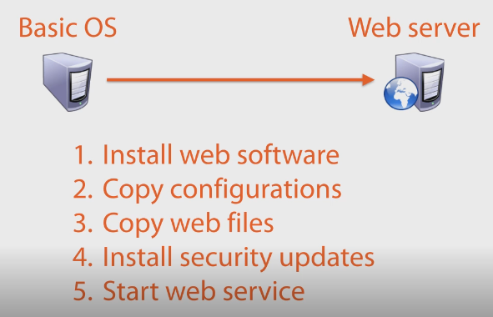

* **Automation**
  + Ansible is an automation tool. You can define tasks to be executed automatically.
  + Ordered tasks
  + Ad-hoc tasks (Done when needed)
  + Make decisions
    - Update files
    - Change network devices
    - Update systems
    - Etc.

**Concreate case**: There is a vulnerability is your current OS version. You need to update 100 servers right away.

* Must be done the next hour.

Ansible: Set it and Forget it

* Run the task
* Get a cup of coffee
* Walk back to desk seeing tasks finished
* Sip your coffee and feel productive.
* **Orchestration**
  + **Orchestration** and **automation** are ***not the same but are related.***
  + Automation is used on a single system
  + Orchestration takes the automation and coordinates the process between multiple systems.
    - Because systems are dependable on each other and some must wait to another to finish.
    - We cannot have orchestration without automation.
  + TASK 1 SYSTEM 1
  + TASK 2 SYSTEM 2
  + TASK 3 SYSTEM 3
  + TASK 4 SYSTEM 1

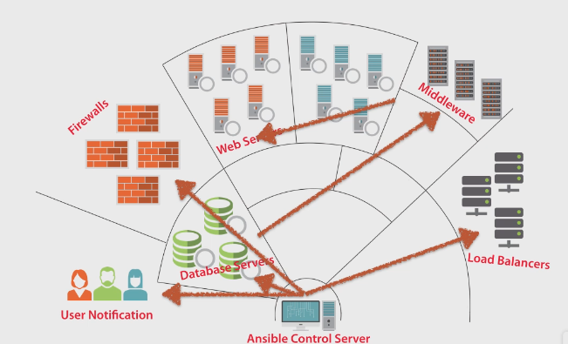

* **Orchestration**: Coordination of automation between different systems.
* **Automation:** Execution of tasks automatically within a single system.

Why Ansible?

* Clean, fast to implement
* No agents
* No database. Movable from System to System.
* No residual Software.
* No complex upgrades.

YAML

* No need to learn a programming language.
* Not a Markup Language.
* Be careful of **white spaces.**

Security

* Uses SSH
* Root/Sudo usage
* Encrypt passwords, etc.
* No Private Key needed (no PKI)

Extendable

* URL RESTful calls
* Shell commands
* Scripts
* JSON
* Ansible Galaxy (Repositories built by other members of the community)

Conclusion

* We define States to implement change Management.
* Using change Management, we can provision new systems to our needs.
* Automations and orchestrations for tasks and dependencies across multiple systems.