**- Ansible inventory**

* Ansible is **agentless**:
  + You don’t need to install a software in the target machine to be able to work with ansible.

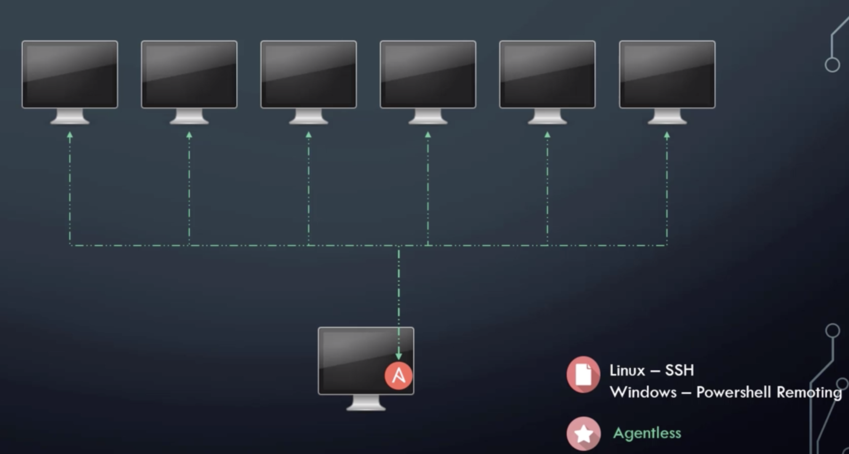

* Information about **target machines** are stored in **inventory file.**

**Example:**

**Use of Aliases, with ansible_host**

**Demo**

* From the **ansiblecontroller** machine, ssh target 1:
  + $ ssh 172.16.0.245
  + Accept fingerprint
* Create new folder ***test-project***
* A large clock mounted to the side

  Description automatically generatedCreate inside an inventor file inside folder and add both target machines
* Use. Ansible command module **ping for target1 machine**
  + $ansible target1 -m ping -i inventory.txt

* ***Try same command for target2***
  + ***A picture containing clock, object, indoor

    Description automatically generatedFails***
* **Solutions:**
  + Try to ssh target 2 in order. To establish a fingerprint
  + Go to ***ansible.cfg***
    - ***Sudo vi /etc/ansible/ansible.cfg***
    - Find option ***host_key_checking*** and activate by removing comment

