I-Coach

Introduction:

As I explained in the previse milestones this app is a Coach athlete application, where can athlete register in a course posted by coaches. And I took ReactJs as my frontend library to work with. While using ReactJs, I have used material Ui https://mui.com as a second party where a can find premade components: such as buttons, appbar, containers…

PWA’s:

I have built this app respecting the perspective behind a progressive web app taking in consideration the advantages of web world (zero installation, cross platform, hyperlinks) and the native world (native app capabilities and live UX) and lastly it must be fast, integrated, reliable and engaging.

Firebase:

Firebase is a mobile and web application development platform developed by Google. It provides a set of tools and services for building, managing, and scaling applications. Some of the features of Firebase include:

1. Real-time database: Firebase provides a cloud-hosted, NoSQL database that can be used to store and sync data across multiple devices.
2. Authentication: Firebase provides tools for user authentication, including support for email/password, phone numbers, and popular social media platforms.
3. Hosting: Firebase provides a hosting service for web applications, with features such as automatic scaling, custom domains, and SSL support.
4. Cloud Functions: Firebase allows developers to run backend code in response to events triggered by Firebase features and HTTPS requests.
5. Storage: Firebase provides a scalable, cloud-based storage service for storing and serving user-generated content, such as photos and videos.
6. Machine learning: Firebase includes tools for building machine learning models that can be used to classify and predict user behavior.

Overall, Firebase is a powerful platform that can help developers quickly build and deploy high-quality applications.

I implemented firebase for hosting my app. After creating a firebase product and make the connecting to my app, I used the following commands for hosting: firebase login (to login with your email) firebase init (to initialize the project) and lastly firebase deploy.

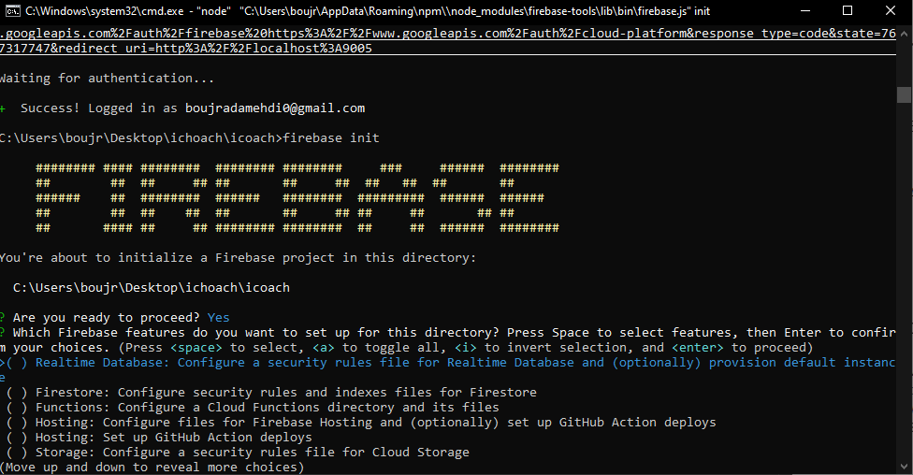After initialize the project you can choose one or multiple functions: hosting, storage …