**Atherosclerotic Cardiovascular Disease**

**Risk Evaluation**

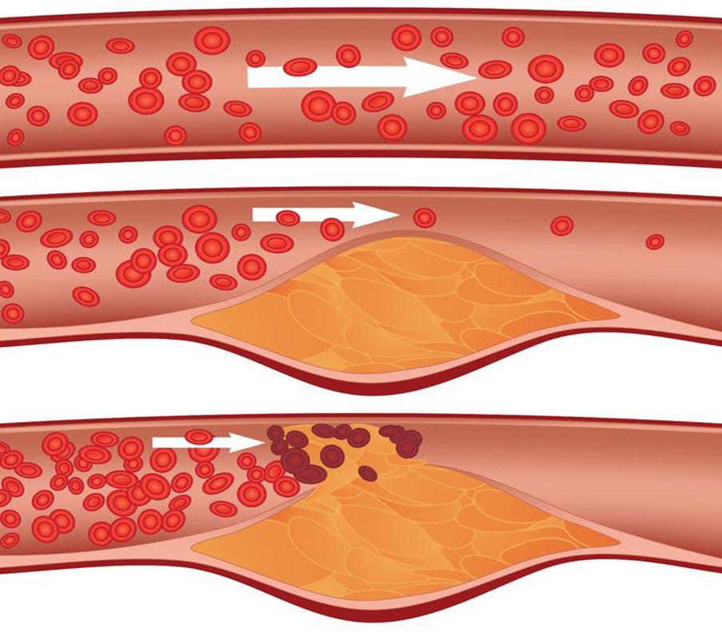

|  |  |  |  |  |
| --- | --- | --- | --- | --- |
| ***Name*** | ${name} |  | ***Gender*** | ${sex} |
| ***Date*** | ${date} |  | ***Age*** | ${age} |

**Atherosclerosis plaque progress:**

|  |  |  |
| --- | --- | --- |
| **${Risk1} %**  **Risk of plaque progress with current risk factors** |  | **${OMen} %**  **Risk of plaque progress with optimal risk factors** |

**MI and CVA risk assessment:**

|  |  |  |
| --- | --- | --- |
| **${Risk2} %**  **Risk of MI and stroke with current risk factors** |  | **${RSK1} %**  **Risk of MI and stroke with optimal risk factors** |

**Arterial Stiffness Index:** (Arterial Stiffness index (ASI < 70) was normal)

**ASI**

**${ASI}**

**Age** (Arterial)

**${ABI}**

**PWV**

**${PWV}**

**Diastolic**

**${DBP}**

**Systolic**

**${SBP}**

**Patient information:**

* **Risk Factors:** ${RISK_FACTORS}
* **History:** ${HISTORY}
* **Chief Complaint:** ${CHIEF_COMPLAINT}

**Body Evaluation:**

* ${msg3}
* ${msg4}
* ${msg5}

**Conclusion:**

The patient is **${msg}** for atherosclerosis plaque progress

The patient is **${msg2}** for MI and stroke event.