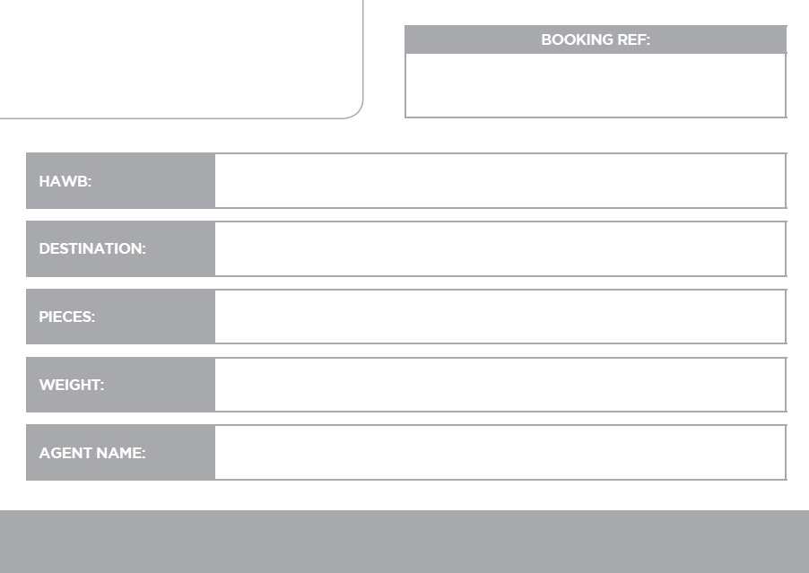

P8590682

AMI - Europost

90KG

Tehran-IKA

4

EPX-TNT-1940