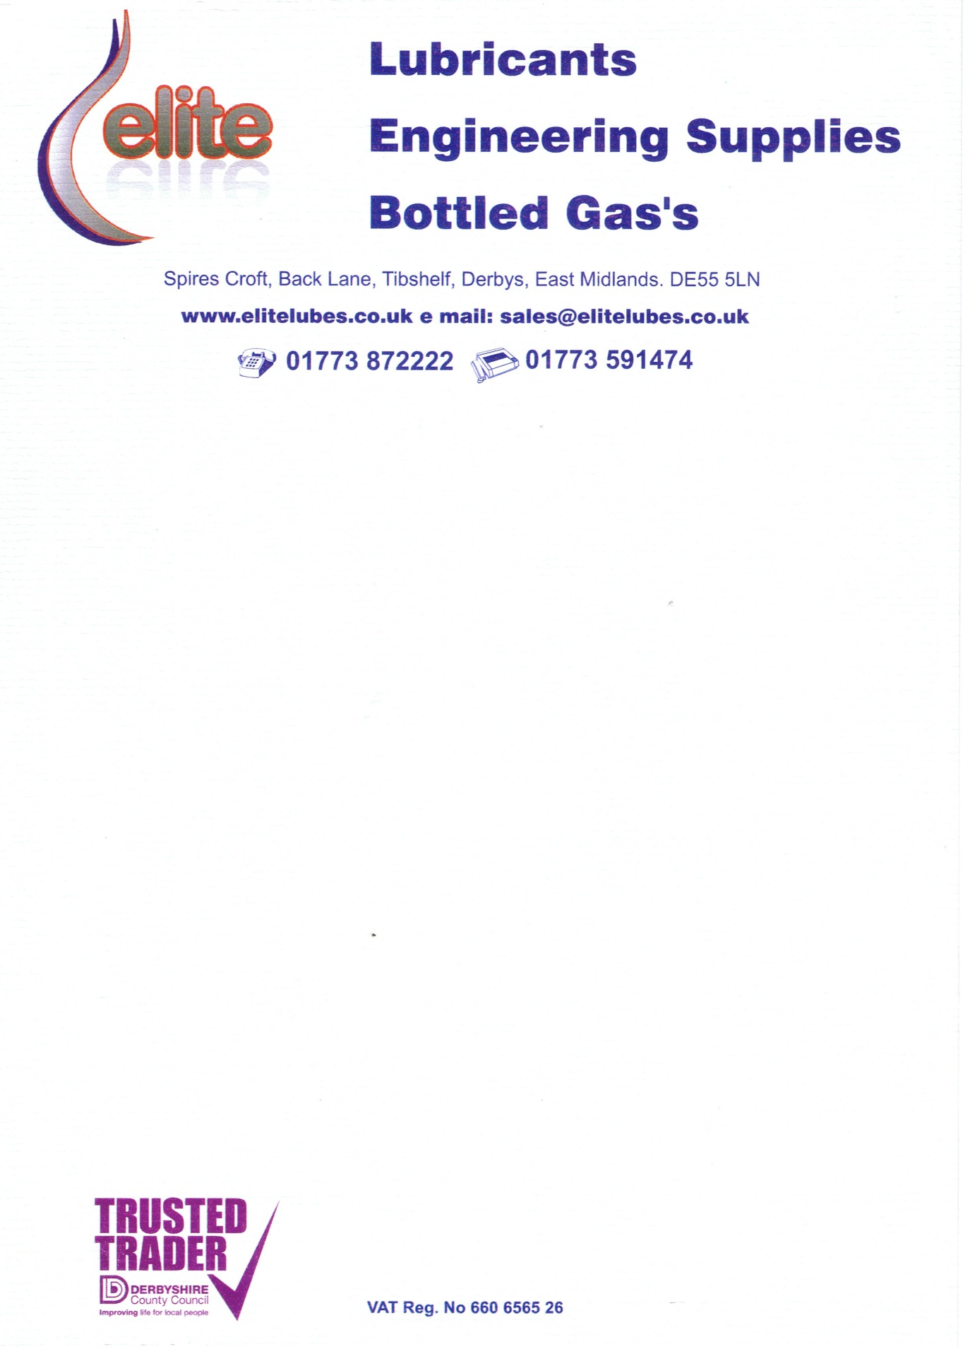

Doraj Rafsanjan Co

No 55, 20th Street,

North Kargar Avenue

Tehran

Iran

**Invoice**

|  |  |  |  |
| --- | --- | --- | --- |
| Description | Quantity | Price ($) | Total ($) |
| Abrasive Discs CD25A60 | 3,000 | 0.18 | 540 |
| Policap Abrasive Cones PC0515LG80 | 2,000 | 0.19 | 380 |
| Policap Abrasive Cones PC0515LG150 | 3,000 | 0.19 | 570 |
| PC Holder PCT 0515L6 | 100 | 1.60 | 160 |
| Policap Abrasive Cones PC1632LG150 | 4,000 | 0.25 | 1000 |
| Combi-Disc Holder SBH25M | 20 | 4.30 | 86 |
| Fan Grinder F3015/6A80 | 1,500 | 0.70 | 1050 |
| PC Holder PCT1626A6 | 100 | 1.60 | 160 |
| Total |  |  | 3946 |