® **Caso: IM0003**

**Versi6n:**

11/21/2020

**CLADEA BALAS**

*Case Consortium*

## IEEM

ESCUELA DE NEGOCIOS

UNIVERSIDAO DE MONTEV IDEO



# •

AUTHORSHIP CREDITS

**Case**

**e-Notificaciones in Uruguay**

The year 2013 was advancing, and Juan Moreno, CEO of Kepler Ltda. (trade name *INTEGRA­ DOC)* had a lot on his mind. He had been awarded a contract to build a nationwide electronic com­ munications and notifications solution under a project of the Uruguayan Electronic Government Agency (AGESIC). After the initial euphoria, he realized how pressed for time and how much was at stake. In the next few days, critical decisions would have to be made. As he went through his swimming routine, he kept turning them over and over in his mind:

We have no margin for error. The goal contractually committed for 2013 is to complete five successful installations in Uruguayan agencies.

This project is significant for us, AGESIC, and the government; there are commitments made with an international organization. For us, in the short term, it represents an im­ portant income. In the long term, it represents the opportunity to continue growing in Uruguay, and to generate a reference case in Latin America.

It is an excellent opportunity for us to consolidate a work platform for several years to come, with unprecedented visibility for our software in public agencies and the general public in Uruguay.

This is much more than just a large-scale project, and we are risking a large part of our future on what we resolve in the next few days.

This case was prepared by Professors **Pablo Sartor and Juan Moreno** from the **IEEM Escueln de Negocios, Universidnd de Montevideo.** Teaching cases are developed solely as the basis for class discussion and are not intended to serve as endorsements, sources of primmy data, or illustrations of effective or ineffective management. To order copies or request permission to reproduce materials, contact coleccion. [cladea@gmail.com.](mailto:cladea@gmail.com)

Copyright © 2020 **IEEM Escueln de Negocios, Universidnd de Montevideo.** No pmt of this publication may be reproduced, stored

in a reb·ieval system, used in a spreadsheet, or transmitted in any form or by any means -elecb·onic, mechanical, photocopying, recording, or otherwise- without the permission of the copyright holder.

**BACKGROUND**



In 2012, AGESIC *(see* **Exhibit** 9, Extract from AGESIC's website ) drafted the tender documents for the acquisition of a complete solution for Notifications and Electronic Communications that could have a national scope. This solution is aligned with the Digital Agenda of Uruguay (2011- 2015) approved by the Executive Power in November 2011 *( see* **Exhibit 8,** Objective 08 of the Digital Agenda Uruguay 2011-2015 ), which had the ruling political force of the parliamentary majority during the period 2010-2015.

This solution would allow entities that use it to notify administrative acts in any of the procedu­ res and services involved in notifying public entities. In other words, potentially, all public bodies could use a single computer system, providing a common and 100% electronic mechanism for notifying and communicating with other public entities, individuals, and legal bodies. The sum- mary of the requested functionality of the solution is in **Figure 1.**

A concrete example: a group of micro-enterprises in the footwear sector that wants to export their shoes to another country and take advantage of a tax exemption available. To do so, each one sub­ mits its application to the Ministry of Industry, which analyses it. Once approved, the ministry drafts a formal "Notification," in which it authorizes the tax exemption for that company. Instead of each representative of the micro-enterprise having to go personally to the ministry to sign the notification (this required travel from different parts of the country), the new system would allow this formal notification, signed electronically, and then be sent to the electronic address of each micro-enterprise. The same mechanism will be repeated for each export, for each micro-enter­ prise, every year. The system will work with other ministries or government entities that must send notifications and communications to individuals, legal entities, and public entities, who will have a single electronic address to receive them, independent of the issuer.

By the end of 2012, the act of receiving and opening the six bids for this tender had taken place, and in February 2013, Kepler Ltda. was awarded the project. A significant aspect of the tender was that, in addition to providing the solution, the project was to be implemented by five organi­ zations *(see* **Exhibit** 2, Extract from the tender documents). The strategy of gradual expansion of the solution would then follow, incorporating additional organizational bodies each year. The first entities were important, as they would gain experience and advance the learning curve and then expand to the others.

Delays in awarding the contract made it difficult to reach the goal of five installations in 2013, but this was non-negotiable because this was AGESIC's commitment to its international funding agencies, which would eliminate future funds if this stage was not fully met. In the project, this commitment was called "the goals," and they were to be met without excuses. For this reason, it was vital to set up a schedule for implementation, which would begin by having the software re­ ady and be completed before the end of 2013. As the system is reasonably operational, adoption by the final recipients (recipients of notifications) is not a problem for Kepler, as the organizatio-

*p.2*

nal bodies will be responsible for promoting it (and once implemented, recipients will have the option of adhering to the new system).

Implementation in each organization was a project in itself. It required intense management of organizational change, to get people to adopt a new way of working, and to empower themselves with an electronic tool that would replace the paper support that they had worked with for many years. To this end, multidisciplinary implementation teams were formed *(see* **Exhibit 6,** Estima­ te of efforts for each implementation ), who performed different tasks necessary for a successful implementation, led by the experts in organizational change who joined the IT team for this pro­ ject (described below). Building these teams was part of the challenge itself, as well as keeping them united and cohesive throughout the project. Furthermore, setting up a schedule for imple­ mentation, which should begin after the software is ready and be completed by the end of 2013, was another challenge. With the team "oiled up," it was estimated that an implementation could be completed in a couple of weeks by putting full focus on this.

The award envisaged that the services associated with the solution (guarantee, support, update) would extend for several more years, in order to accompany the gradual adoption of the solution by the other public bodies.

Notifying entities



Public

**Entities**

Public

**Offi cials**

**External Systems**

**Adminstrators**

**Auditors**

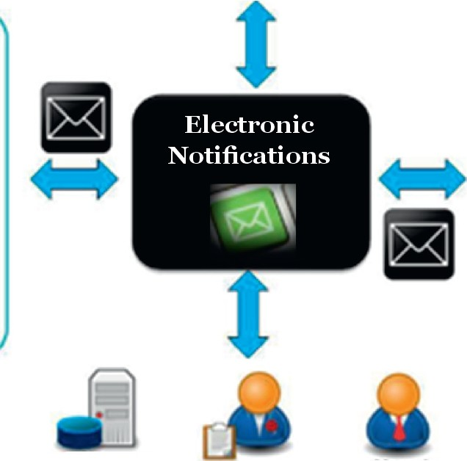

Help Desk

*(* Target Group

Individuals Legal



**Bodies**

J



Public

**Entities**

*p.3*

**Figure 1.** Scheme of operation of the solution

*Source :* Terms and Conditions LP 6/12, AGESIC

###### THE OFFERER

Kepler Ltd. was an Uruguayan software company specialized in business process management (BPM), electronic procedures, and documentation, with medium and large clients in the private and public sectors. The solutions provided by the company typically integrated "package" sof­ tware, consulting services that specialized in business process automation, organizational chan­ ge management for the adoption of the new tools, custom software development when necessary (e.g., to integrate other IT systems), etc. In most cases, these were medium and large projects. In the public sector, the company had a long history in Latin America with government agencies in countries such as Uruguay, Chile, Panama, Peru, and others. Almost 50% of its turnover came from sales to the public sector.

Kepler's latest product, called ***INTEGRADOC,*** was proposed as a core solution for the e-Notifica­ tions project. The company's website defined this product as follows:

*INTEGRADOC* is a document management product, which allows [it] to model busi­ ness processes based on documents, [to] automate and analyze them for improvement. It manages workflows and electronic procedures, integrating documents, people, and processes, to increase the efficiency of your company (BPM: business process manage­ ment). In the public sector, *INTEGRADOC* is a fundamental tool for e-government [and includes] the electronic addresses of citizens.'

The product was nationally recognized and had won several awards. It had been installed in a lar­ ge number of public bodies to improve their operation. However, even though some of them were large, the solutions were limited to the specific operation of each particular entity, a limit that, as already mentioned, was missing in the framework of the e-Notifications project.

With more than ten years of experience working with public bodies, Kepler knew the way these entities worked and how to relate to officials to ensure that projects were successful. In order to have even more assurance in this project, it engaged a consultancy agency with whom had a bac­ kground specializing in organizational change management, thus mitigating the risk related to issues related to possible resistance to change in the agencies. This was also helped by the fact that AGESIC had sought out five organizations whose hierarchies were closely aligned with the government's goals, thus strengthening the "management support" factor.

*p.4*

General Manager (Juan Moreno)

Project Manager (Marcelo Sosa)

I

*(*

DeYelopment Manager (Cristian Mastrantono)

I

Implementation Manager (Mmtin Fros)

'

**SerYice l\tianager**

-

A1t and Design

- Change Management

Consultants

- **Operations and**

Administration

- DeYelopers

- **Trainers**

- 1 st line suppmt

......

QA and testing

......

**Communications**

......

2nd line suppmt

**Figure 2. Organisational chart of Kepler 's team involved in the project**

In the short term, this project had a direct impact on the company's turnover and profitability. Although the project had different stages; the annual amount to be invoiced for the project re­ presented more than 15 % of Kepler's annual turnover. The company was financially healthy. A failure in this project would not make it bankrupt but would be a significant blow and, above all, would close the door to a very promising growth path. Also, the opportunity cost of losing a full year focused on a project that would later not succeed would potentially result in losing ground to its competitors.

Success was also attractive in the long term on this project. Becoming the first nationwide project for the company and the product involved the following:

*p.5*

The need, which was unavoidable, to execute it successfully. Itwould constitute an irre­ placeable "showcase" at the national level, strengthen the relationship with AGESIC and lay the foundations for the work of the coming years by expanding it to the entire country. To be an entry point to other organizations, which after using the electronic Notifications could then apply to other business processes.

To be a reference for other governments in Latin America, many of which had e-govern­ ment initiatives, to which a solution of these characteristics would be of interest.

Failure was the danger to Kepler if the execution of the project was not successful. In such a case, AGESIC would naturally be in an uncomfortable position before international organizations, and that would threaten Kepler's chances of continuing to grow with clients within the Uruguayan government. Additionally, there was a high financial risk since, as with any long term project, Kepler would have to finance a specialized team until it produced income-generating outputs *(see* **Exhibit** 5).

###### TIMELINE

The events, in short, unfolded as follows:

2010: AGESIC defines the e-Notifications as a strategic project and incorporates it in the Uruguayan Digital Agenda for f2011 - 2015.

2011: AGESIC includes e-Notifications as a management objective.

2012, October: AGESIC builds specifications and publishes the bidding process.

2012, December: opening of bids. Kepler Ltda. submits its tool *INTEGRADOC,* and com­ petes with other national and international bidders.

2013, February: Kepler Ltda. is notified of the award.

2013, March: the project begins.

###### THE NOTIFICATION PROCESS AND THE ELECTRONIC ADDRESS

Each electronic notification must be drafted, reviewed, and then sent to the recipient, who can then review it and finally confirm its receipt. At each of these stages, different people work on the notification. Each person performs a specific task, at the end of which the notification is passed to the next person who must work on it.

There were two main components to the solution:

The notification/communication process.

The electronic address where the recipient receives the document.

*p.* 6

The first of these was the public body that generated the notification or communication, and which would do so according to a particular associated business process. It involved officials from the public body primarily, and these were a small and limited number of employees, even in the lar­ gest agencies. **Figure** 3 summarizes this process schematically and in a simplified manner *(see* **Exhibit 4** for the detailed process).

The electronic notification process was ideal for implementation through a business process ma­ nagement (BPM) solution; *see* **Exhibit 11,** Business Process Management (BPM) like INTEGRA­ DOC. One advantage of using a BPM software is the visual modeling of the processes: *"It's like drawing boxes and arrows on the blackboard, we can do that ourselves."*



Notifying Entity

***l***

•

**Creation and**

shipping Admission

Setting DeliYeIT

**proYision**

Recipient

**Figure 3.** Notification process

*Source:* Terms and conditions LP 6/ 12,AGESIC

The second concept was that of the recipient's electronic address. Naturally, hundreds of thou­ sands, potentially millions, of these addresses could exist for each individual, each legal entity, and each public entity in the country. The technological challenge, in this case, was centered on robustness (i.e., that it should always be available), and scalability (i.e., that as more and more users were added, the system should support them without its operation being significantly im­ paired). Acceptable response times were considered to be less than 300 milliseconds (i.e., when faced with any action, the system takes less than 0.3 seconds to return the corresponding result). For the first year, considering that it would only be implemented in five public entities, it was es­ timated that the total number of users with an electronic address would not exceed 500.

In this regard, the engineer was consulted; Cristian Mastrantono, development manager of Ke­ pler Ltda. He was responsible for the team of engineers who would develop the solution, as well as for the technical aspects of the solution; in particular, the architecture of the solution, i.e., how it would be built and the consequences of this in the future. In this respect, he explained:

There are two viable alternatives that the technical team is evaluating concerning the electronic address:

*p. 7*

Use a module already developed and attached to the core product. We estimate at the software factory that making the adjustments and fine-tuning the operation would take a month of work by a senior programmer assigned to it on a full-time basis.

To develop a new module, which exclusively solves the operation of the electronic ad­ dress, uncoupled from the core product. In this case, we estimate that the development and integration with the remaining solution would take 960 hours of senior program - mer profile.

Functionally for the user, both alternatives are similar. However, the solution of uncoupling the electronic address has an additional advantage; the possibility of scaling-up more easily since it allows more servers to be added in a more sophisticated way. It is known as a *"serverfarm, "* as more users need to be served, keeping the system response times under control. On the other hand, it has the risk of involving software development from scratch, having to schedule analy­ sis, design, programming, testing, and integration tasks.

All these tasks must be completed before starting the first implementation of the software since the electronic address is a fundamental part of the solution.

The following dialogue between Mastrantono and Kepler's financial manager, Abel Perezinczy, illustrates the tensions related to the problem of separating the electronic address from the core product:

Mastrantono:

From the point of view of software engineering, the robustness of the system, and the possibilities of scalability in the future, the option of separating is far superior...

Perezinczy:

I understand perfectly, but we are talking about a relevant cost, which in one case would not be present, and in the other would be. We are talking about this amount directly re­ ducing the annual result, given that the billing will be the same in either option.

Mastrantono:

...But precisely the point is that you can't just look at the financial side. How do you ima­ gine[; that] I'm going to tell my engineers to make a substandard solution?

Perezinczy:

... Well, that is no longer my problem, but if it were me, I would not even mention that there is option 2 ... Then there is the issue of the deadline, it is very tight, introducing new developments increases the risk, and we know that after that come requests for more funds.

*p.8*

Mastrantono:

If one of the team leaves, training a new engineer with the experience that the current team has is just as expensive, if not more so, and it will definitely take longer.

###### THE LEGAL FRAMEWORK

Electronic notices require a legal framework that did not exist in the country at the time, and on which a team of legal advisors worked. Naturally, this new wording should circumvent the appro­ val process until it becomes law, including legal and also political reviewers. *As* the final version of this decree was not available, the specific details of how the procedure should be in the system were not known. Beyond the technological aspects, the decree would regulate how the software should work; not taking it into account could render the building of software meaningless becau­ se it does not comply with the regulations.

For example, one of the aspects that the decree would determine was 'when' and 'how' to consi­ der a recipient as being notified. When you make the notification available? When you log on to the system? When you open the notification in the system? All alternatives had advantages and disadvantages. Moreover, the mechanism to be defined had to be consistent with written notifi­ cations, which would remain in place (e.g., telegram queuing) and which would coexist with elec­ tronic ones. Naturally, the behavior of the system had to reflect these definitions, so it should be implemented, tested, and approved before the first deployment.

If the decree were not passed in 2013, Kepler would be protected because it was not a viola­ tion of its own making. This was very unlikely due to the importance of the project. However, it could happen that the decree would be enacted late, which would generate relevant complica­ tions for Kepler and force, under pressure, the implementation of this project. A decision had to be made whether to wait for it to be drafted or to make certain assumptions that would allow the development completion. However, in this scenario, it would be a risk that they would not fully comply with the decree once it was passed, and that some parts of the software would then need redesigning.

###### THE PARTICULARITIES OF THE PROCESS IN EACH ENTITY

The notification process was typical to all agencies, as it was based on the country's administrative procedure. **Exhibit 4** (Details of the process Electronic notifications in BPMN format) presents the breakdown of the process in BPMN1 notation, taken from the tender documents. However,

1. *9*

1BPMN stands for Business Process Management Notation. It is a graphic notation that, by means of diagrams, allows the description of busi­ ness processes. BPMN is an international standard of OMG.

experience showed that each agency would always have details that were different from those of other agencies. For example, a process in the Ministry of Industry for notifying large industrial companies may be quite different from a process in the Directorate-General of Taxation for no­ tifying independent professionals. Without contradicting the "generic" notification process, the­ se details could lead to changes for each organization, to take account of their particularities. A decision had to be made, to provide a generic and uniform notification process for all bodies or whether to allow inclusions of specificities for each body.

The project involved extensive joint activity with the notifying officials to ensure that they adop­ ted the new 100 % electronic operation, which would replace the paper-based notifications and communications to which they were accustomed to. It was envisaged that during these activities, the officials would consider and request minor adjustments to the notification process, to bring it into line with their way of working. Considering that a GMP tool was available, which allowed the processes to be modeled (rather than programmed), it would be technically possible to im- plement these adjustments. Of course, this would imply not having a generic process for all agen­ cies, but a specific one for each organization.

Juan pondered this with his team:

The solution is one, common to all. Moreover, this is fundamental so that it can be re­ plicated in many entities and achieve rapid expansion throughout the country, adding several agencies each year. A direct order from the hierarchy would make it easier to follow this line.

On the other hand, user support is fundamental. Without them, there is no successful project. Furthermore, we know well that users will ask for changes and adjustments for their particular operation. Ignoring them would drastically generate rejection of the new system even more so by having a tool where one can "design" varied processes.

For the initial organizations, approximately 200 hours of process analysts are planned. This time is aimed at appropriately configuring the product, and it must be decided whe­ ther to use these hours in a generic, refined, and highly replicable implementation plan or, if not, to respond to the requests of each entity...

###### A SIXTH IMPLEMENTATION AS COVERAGE?

The team knew that the goal of five installations was binary: it was either met or not met, with no gray areas. In constructing the project's risk matrix, several elements had been identified that could impede implementation in any of the agencies:

*p.10*

Technological risks: for example, the infrastructure available in the entity may not be su­ fficient nor updated to execute the solution, or that not all officials involved have access to an electronic signature, or it may not work on their computers, etc.

That the necessary hierarchical support was not forthcoming. It meant the agency re­ viewing the decision whether to proceed with the implementation, or eventually to halt the implementation, or to abandon it altogether.

That user support will not be enlisted, and that this will result in delays and increased change management efforts, putting at risk the goal of completion by 2013.

That the organization would present particular needs for the software, which had not been anticipated in the specifications, nor in the offer (such as, in the estimation of effort, deadlines, and prices), and that these were unavoidable.

And the most important: "etcetera." There could be countless unforeseen events, some of which are beyond the control of AGESIC, Kepler, and the organization, which would prevent the successful completion of an entity's implementation.

In this context, the option of incorporating a sixth additional implementation as coverage was analyzed. In this respect, Moreno had the following dialogue with the engineer Marcelo Sosa, project manager of INTEGRADOC:

Moreno:

I know it is very difficult what I am going to ask you, but with the team we have, and assuming that the legal framework is defined in time, what is the probability that an or-ganization will finish on time?

Sosa:

Our team is experienced, and the development of the software is challenging but fea­ sible; if you ask me for a number, I would say that in each one we have a 95% chance of finishing on time.

This sixth implementation, of course, was not quoted by Kepler. Furthermore, the project was planned and adjusted for five implementations, with a full-time committed and dedicated pro­ ject team.

Additionally, the profile of the professionals on the team was highly specialized, and working op­ timally with one another was a key factor. This made it very difficult to integrate people who did not previously know each other, nor had proven to be effective in highly demanding projects wi­ thin a tight schedule *(see* **Exhibit** 6, Estimation of efforts for each implementation, and **Exhibit** 7, Outline of the implementation plan included in the tender documents).

*p.11*

###### THE FINAL LAP

Juan took the last lap and lent himself to swimming the last 25 meters at speed. Already in the showers, he recalled the last conversation with Marcelo Sosa, directly involved, and highly commit­ ted to the success of the project. In that context, Sosa added some spice to the thinking that should not be overlooked:

The team is very motivated with the new project and in particular, with the technical cha­ llenge it poses. In a sector without unemployment, retaining talent in the team is a daily challenge, and developing a solution with state-of-the-art technology is a positive point. Nevertheless, with the project deadlines, we cannot afford to lose any team members. Re­ placing them would overload the other team members and delay the development, which would put the success of the project at risk.

*p.12*

***Exhibit 1. Five main reasons why BPM***



•

#### projects fail

**Exhibits Section**

Author Peter Schooff in the book *'Passport to Success in BPM ,,_* identifies five main reasons why BPM projects fail:

* 1. Treat BPM as a project, as something external to the daily operation of the company. BPM should be seen as a *discipline of continuous improvement* that never ends, and that fits into the daily operation.
  2. Poor communication. This affects any activity in the company, and BPM initiatives are no exception. Usually, things get really bad *when there is a lack of supportfrom users,* mana­ gement, or adequate *sponsors,* or a lack of clarity about the roles, responsibilities, and be­ nefits to be gained from the initiative.

1. Treat BPM as an IT project. *BPM is not a technolog y; it is a business discipline,* which can

be supported by technologies, but with which it is not enough. IT must be involved, but abo­ ve all, the owner of each process in each line of business. The latter is ultimately responsible for the success of each initiative.

1. Lack of commitment. BPM initiatives may require additional resources to be successful. Com­

*mitment is needed at the executive level,* and it must be generated by the right framework, as well as transferred to the other levels of the company.

1. Poor business architecture, with units functioning as independent silos. The real gain in

modeling and automating business processes is to *integrate different areas into a single process* from start to finish.

*p.13* 2 *Passport to Success in BPM* (Edited by Layna Fischer• 2014, Future Strategies Inc.)

# •

**Exhibits**

**Section**

*p.14*

***Exhibit 2. Extractfrom***

***the speciji.cation***



National Public Tender No. 6/ 2012 - AGESIC (Agency for the Development of the Government of Electronic Management and the Information and Knowledge Society)

###### PART I - GENERAL SPECIFICATIONS

1. Background

The Agency for the Development of the Government of Electronic Management and the Information and Knowledge Society (hereinafter, AGESIC) intends to acquire a **System of Notifications** and **Electronic Communications** that allows the creation and delivery of reliable notifications and other communications, to those interested in administrative procedures with the State.

The objectives intended with the use of this system are aligned with the objectives proposed by the Uruguayan Digital Agenda 2011-2015, approved by Executive Decree No. 405/011 of 23 November 2011, especially the following ones:

Objective 7. Modernization of public management.

Objective 8. Electronic access to public administration as a citizen's right. Objective 9. An integrated State.

Within this framework, the general objectives of managing and facilitating the use of information technology tools are sought to allow the optimization of both resources and costs in cross-cutting and inter-operational solutions at the level of e-Government. It is also intended to simplify the re­ lationship between individuals and legal entities with the State by receiving notifications and com­ munications through new communication channels, taking advantage of the opportunities offered by new technologies.

1. Object of the proposal

To contribute to the strategic objective of modernizing and extending the availability and use of pro­ cedures and services. AGESIC proposes to incorporate within the Electronic Government Platform (PGE) a solution of Notifications and Electronic Communications. This solution will allow Public Administration bodies to notify, communicate, and exchange information electronically with all in­ dividuals, legal entities, organizations, and public bodies, among others (hereinafter, recipients).

In addition, as part of the tender, this solution will have to be customized and implemented in two

(2) pilots and into at least three (3) other organizations. The solution must also be able to be inte­ grated with other components of the e-government platform and with other systems in the various organizations through their mechanisms ...

# •



Exhibits

|  |  |  |  |
| --- | --- | --- | --- |
| **Users** | **Documents** | **Estimated load** | **Response time (ms)** |
| - | - | - | 100.00 |
| 100.00 | 1,500.00 | 150,000.00 | 109.00 |
| 200.00 | 3,000 .00 | 600,000.00 | 118.00 |
| 300.00 | 4,500.00 | 1,350,000 .00 | 127.00 |
| 400.00 | 6,000 .00 | 2,400,000.00 | 136 .00 |
| 500.00 | 7,500.00 | 3, 750,000.00 | 145.00 |
| 600.00 | 9,000.00 | 5,400,000.00 | 154.00 |
| 700.00 | 10,500.00 | 7,350,000.00 | 163.00 |
| 800.00 | 12,000.00 | 9,600,000.00 | 172.00 |
| 900 .00 | 13,500.00 | 12,150,000.00 | 181.00 |
| 1,000.00 | 15,000.00 | 15,000,000.00 | 190.00 |
| 1,100.00 | 16,500.00 | 18,150,000.00 | 209.00 |
| 1,200.00 | 18,000.00 | 21,600,000.00 | 230.22 |
| 1,300.00 | 19,500.00 | 25,350,000.00 | 254.50 |
| 1,400.00 | 21,000.00 | 29,400,000.00 | 266.00 |
| 1,500.00 | 22,500.00 | 33,750,000 .00 | 306 -43 |
| 1,600.00 | 24,000.00 | 38.400.000.00 | 344.00 |
| 1,700.00 | 25,500.00 | 43,350,000.00 | 393.00 |
| 1,800.00 | 27,000.00 | 48,600,000.00 | 462.00 |
| 1,900.00 | 28,500.00 | 54,150,000.00 | 571.00 |
| 2,000.00 | 30,000 .00 | 60,000,000.00 | 780.00 |

Section

*p.1 5*

***Exhibit 3. Primary analysis carried out by the technical team, according to data estimated from solutions with similar integrated architecture (without separating the electronic address)***

-i

*:::T*

c;;·

a.

g

c

3

".'.".

°'

*r:n*

,...;-

:..:.:..;.". •

(1)

;:l.

c;;·

Ill

s.

*:::T*

0

:::>.

N

*Q*

c

0

(") :!.

c '<

gi_ c:r

0 '<

Electronic Notifications Process

....... o"'

0 .......

::::i Ul"

3 r

(1) Ill

c

jl)

? ::\1

Ction ""'Notifotion Mcy "- mlmiion ""'=king""ili>ble "- Deli'"'l' of Notifi'"tion )

l'Oio

0-

l'Oio

(") Ill

CD !::!':

@ n

*:::T* 9!.

I<ll -=::

a

-

b.()

Create

-l -Sen-d -·I

I •

I

Receive I 1

AcokfnAowvalieldabgielmityent ,.,_ 1 _. +O

eive Stah1

otification

|  |  |  |
| --- | --- | --- |
|  | . |  |
| Rec  N | -s. |

....

D

;=j

##### o

'"""

c:r !"

c -

-

(1) (")

(/) 9!.

CJ) =-=

* @

3

cO

*Q* Ill

OJ ;=-:

0 (")

00

<=I

·.p

s

z0

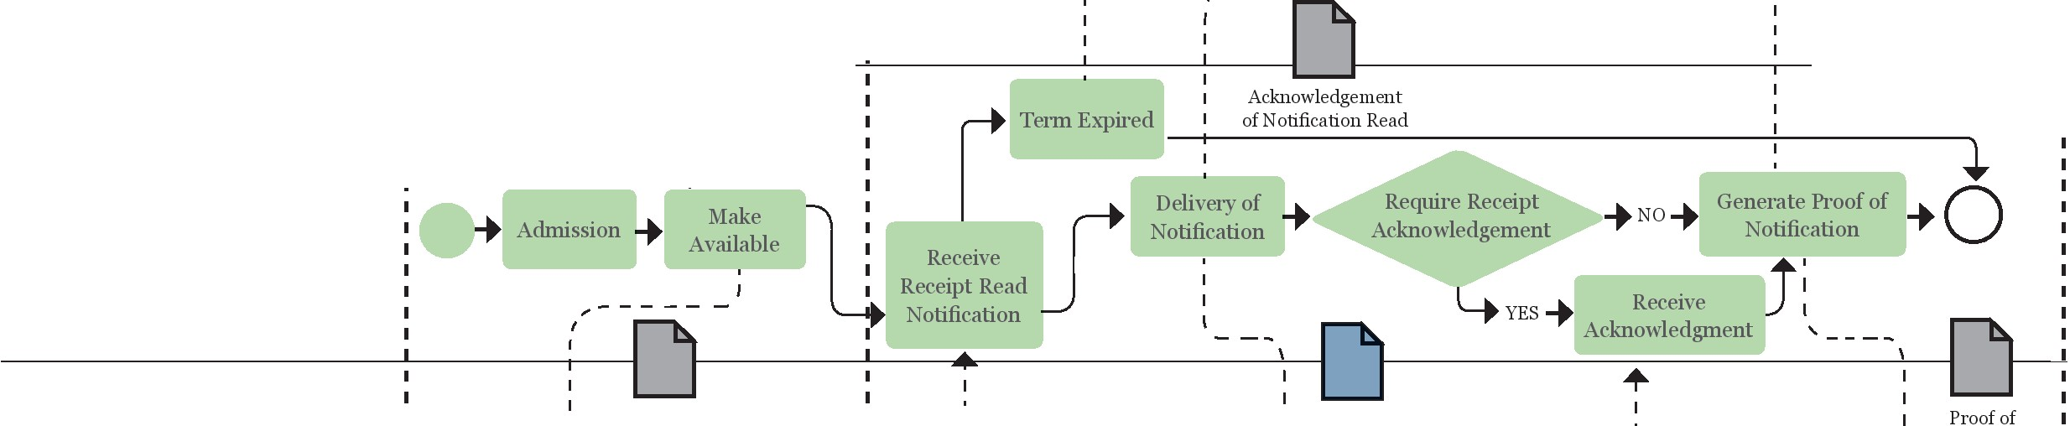

"'

Notification +[Notification

'

'

I

I

..

Notification Acknowledgement

I of the availability

Acknowledge Expiration

Acknowledgement Notified

S;

r.i0

g

i::i

s·

·<:0:-

.;.=..j. ...:.::.:.:!."

9" o

o o

CXl "O OJ .

(J) ::>

-co

*Q* 0

Ill

a. "O

a. 0

a

0 ::;·

::> co

en·

ro· :i

-

(./)

" <=I

0 .....

.;:: B

<l.l·

Q""b"

z

Notice I '- - - - - I Notification

I ' ..

I I Notification

I

I I

I I I I I

......

rq.i-

- E I ;-.: I I o

::>

·"a'

·o

:o-. 1+0 : O+ Access to tbe Inbox +

1. Receive Proof of 1 0

;=j

i::i ......

co

(1)

3

I I

Receive

J

Notice



R f2:vledge

""'1-

r.i

(1)

;:l.

8

ci5"

"1J

m

I I Notification .............. ceipt

Notification

(1)

(")

0

S-

*Q.*

# •

**Exhibits**

**Section**

***Exhibit 5. Remunerations***

**in *the IT sector* in *Uruguay***



Figures in USD: in 2014 the price was around 19 Uruguayan pesos (UYU) per US dollar (USD)

|  |  |  |  |
| --- | --- | --- | --- |
| **Employment Category** | **Media** | | |
| **Minimum** | **Media** | **Maximum** |
| 1st Level Management (functional or business units) | 4,267 | 4,787 | 5,859 |
| Project Leader / Coordinator / Manager | 3,337 | 3,611 | 4,137 |
| Senior Analyst (> 5 years experience) | 1,998 | 2,454 | 2,798 |
| Junior analyst | 1,131 | 1,362 | 1,622 |
| Database Administrator | 1,133 | 1,385 | 1,689 |
| Senior Programmer | 2,743 | 3,222 | 3,744 |
| Junior Progammer | 1,367 | 1,753 | 2,163 |
| Testing | 994 | 1,310 | 1,550 |
| Commercial Executive | 1,745 | 2,140 | 2,768 |
| Support (network and PC mainframe, Unix) | 864 | 1,171 | 1,615 |
| Web Developer / Designer | 716 | 897 | 1.168 |
| Secretaries | 709 | 822 | 962 |
| Administrators (Accounting / Finance | 980 | 1,255 | 1,886 |

***Source:* Uruguayan Chamber of lnfornrntion Technology - (ClJfl)**

*p.1 7*

# •



|  |  |
| --- | --- |
| **Task Hours** | |
| **Application of the customization, installation and configuration** | |
| Basic system configuration for an organization | 120 |
| Setting up a notification type in an organization | 80 |
| **Organizational Change Management** | |
| Diagnosis of the organization | 120 |
| Adjustment Plan for the organization | 120 |
| Implementation in an organization | 300 |
| **Management of communications** | |
| Implementation of the Communications Plan in a profile of 1or 2 organi- zations. | 320 |
| **Training** | |
| Implementation of the Training Plan in a profile 1or 2 organizations. | 320 |

Exhibits

Section

*p.18*

***Exhibit* 6. *Estimation of the effort (in hours)for each implementation***

-i

*:::T*

c;;·

a.

g

c

3

".'.".

*r:n*

'O

,...;-

:..:.:..;.". •

(1)

;:l.

c;;·

Ill

s.

*:::T*

0

:::>.

N

*Q*

c

0

(") :!.

c '<

gi_ c:r

0 '<

3 r

(1) Ill

c

**jl)**

? ::\1

(") Ill

**CD** !::!':

@ n

*:::T* 9!.

I<ll -=::

**a**

c:r !"

c -

-

(1) (")

(/) 9!.

**CJ) =-=**

* @

....... o"'

0 .......

**::::i** Ul"

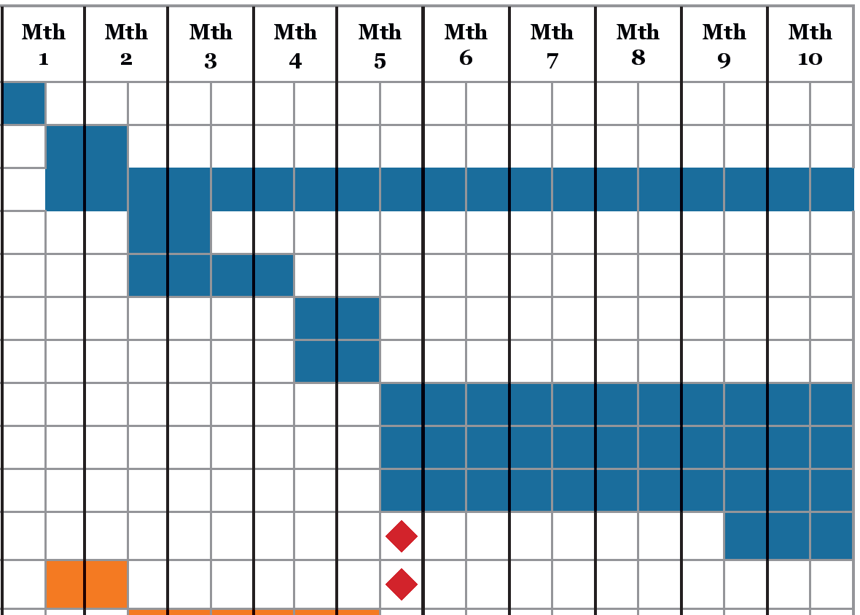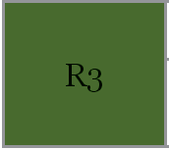

Supplier

Supplier

AGESIC

Supplier

AGESIC

AGESIC

Supplier

Supplier

Supplier

Supplier

Adjustment of Installatation Model

Supplier

Change Management - Pilot 1

Supplier

Training - Pilot 1

Supplier

Communication - Pilot 1

Supplier

Change Management - Pilot 2

Supplier

Training - Pilot 2

Supplier

Communication - Pilot 2

Supplier

Milestone Setting - Pilot 1

AGESIC & Supplier

Milestone Setting - Pilot 1

AGESIC & Supplier

White March (Trial/ Practice) - Pilot 1

Supplier

White March (Trial/ Practice) - Pilot 2

Supplier

Supplier

Supplier

**Item**

**Responsible**

Start

Installation and Configuration Administration, Operation & Support Acceptance Rl

RNI Development Acceptance RNI

Performance and Load testing Help Desk

Functional Management Two-year guarantee

Application, Development and Maintenance

AGESIC & Supplier

**R2**

Three Implimentations

White March (Trial/ Practice) three additional Implementations

......

.§

**(tl**

**;:=j**

**a­**

.

### §

**o.:**

**cO 3**

*Q* Ill

**OJ** ;=-:

0 (")

00

9" o

o o

CXl "O

**OJ .**

(J) ::>

-co

*Q* 0

Ill

a. "O

a. 0

**a**

**0** ::;·

::> co

**en·**

**ro· :i**

-

(./) -

**""'1- ::::::-' l'Oio**

**(tl** ...... """

**;:=j ;:=j** ...

**!:l..** ......."'

**a**

**(tl ;:=j**

**Q.. i::**

**!:l.. i:: """t­**

**o !:l..**

**(J (tl ;:=j**

**i:: !:l.. (tl**

**-·o**

**(tl ;:=j**

**s:. s:.**

::>

co

(1)

3

(1)

;:l.

8

ci5"

"1J

m

(1)

(")

0

S-

*Q.*

*Source:* Sheet LP6/2012 - AGESIC.

**;:=j**

**(tl (tl**

# •

Exhibits

Section

***Exhibit 8. Objective 08 of the Digital Agenda Uruguay 2011-2015***

* 1. Objectives and Goals Set 



**Objective 8: Electronic access to Public Administration as a citizen's right**

•

Inclusion, openness, and participation are three pillars of a public administration that is properly managed for the citizen. In this sense, priority is given to initiatives that promote electronic access to public administration and facilitate interaction between citizens and government.

,../"

**Goals**

* + 1. Promote in 2012 the legal framework that ensures the exercise of the citizen's right to interact electronically with public entities.

•

**b.** Implement a system that allows for electronic communications and notifications

throughout the Central Administration.

**C.** It ensures that all officials, citizens, and businesses have the latest electronic signature, if their task requires it, for the interaction with the state.

**d.** Promote that 80% of the Central Administration agencies have standards and

models of citizen participation and interaction through electronic channels, in the period of the agencies' calendar.

**e.** Develop Open Government Data infrastructures and promote their use through

public - private participation.

,.•.,

**RESPONSIBLE ORGANIZATIONS**

* AGESIC and organizations involved

  

Figure 9. Extracted from Agenda Digital Umgnay 2011-2015 (AGESIC)

*p.20*

# •

**Exhibits**

**Section**

***Exhibit* 9. *Extract.from the AGESIC website***



**Source: www.agesic.gub.uy; visited February, 2014**

**What is AGESIC?**

AGESIC is the "agency for the development of e-government and the information and knowle­ dge society."

Itaims at improving services to the citizen, using the possibilities offered by information and communication technologies (ICT.)

***Among* its *permanent activities are:***

Define and disseminate the information regulations, and monitoring their compliance. Analyze technological trends

Develop projects in information and communication technologies Advise on IT matters to the state's public institutions.

Training and dissemination in the are of e-government, supporting the transformation and transparency of the state.

*p.21*

# •

**Exhibits**

**Section**

***Exhibit 10. Extract from AGESIC Resolution number 009/ 2013.***

***Adjudication***



**Figure 11. Extract from AGESIC's Resolution awarding the tender**

**MANAGING DIRECTOR**

1. that it is appropriate to comply with the recommendation of the Advisory Committee on Procurement and, on its merits, to award this call for tender to the aforementioned firm in the terms referred to;
2. that the Admiistration, Financial Resources and Material Di­ vision of AGESIC has issued the credit affectation certificate, in accordance with the provisions of Article 27 of Law 17.243 of 29 June 2000;
3. that the prior control of compliance with the provisions of Ar­ ticle 3 of Law No 18.244 of 27 December 2007 has been carried out;

**VI)** the pretentive intervention of the Court of Auditors before the Presidency of the Republic, without observations;

**ATTENTION:** to the provision of the Ordered Text of Accounting and Finan­ cial Administration (TOCAF), approved by Decree No 150/012 of 11 May 2012, to the provisions of Resolution of the President of the Republic No 747/009 of 3 August 2009, and other applicable regulations;

THE EXECUTIVE DIRECTOR OF AGESIC

Exercise of delegated powers RESOLVE:

10 Award the public bidding No 06/2012 for the acquisition of Solution of Noti­ fication and Electronic Communications, to the firm Kepla Ltd., for the amount of up to $U 10,165,992 (Uruguayan peso ten million, one hundred and sixty-five thousand, nine hundred and ninety-two with 00/000) VAT included and up to US$ 117,120 (US Dollars one hundred and seventeen thousand, one hundred and twenty with 00/000) VAT included, according to the following details:

*p.22*

* ***Exhibit 11.*** *Business Process*

***Management-BPM [ 1w:1***

*p.23*

**Exhibits Section**

A business process is a sequence of activities carried out in an organization to achieve one of its

ob-jectives. Usually, several people work on a business process, and each one performs a part of the *whole.* They are usually represented by *process models,* such as the one illustrated in **Exhibit 4,** based on the BPML standard, which they facilitate:

"' Its understanding and analysis by different people, who may or may not know the opera- tional details.

Documenting and communicating properly how our process works, allowing us to ques­ tion whether it is the desired logic or a different one would be more effective and efficient. Identify bottlenecks and opportunities for improvement based on objective measurement of how the process is working.

Once the process is modeled, the next step is to *automate* it, with a business process management system (Business Process Management System, simply BPMS, or Workflow Management System). That is to say, to implement that definition of the process in a computer system that allows each stage of the work to arrive to the person it has to be delivered to automatically.

Continuing with the case of notifications, once a notification is drafted, reviewed, and sent, the next step in the process is for the notification to be made available to the recipient for them to read. At this stage, the recipient is considered as notified, without having to send them a notifica­ tion by manual means through written correspondence, or to telephone them to advise them and to go in person to the entity to 'consider themselves notified.'

The business process management system (BPMS) 'knows' that after it approves and sends the no­ tification, it must deliver it to the next user, who can then access it in his or her *Inbox.* In this step, the user retrieves the 'job' that was sent to them from the colleague of the previous stage of the process. Once this person completes their task, the process stage they are working on follows the defined workflow with the job forwarded to the *Inbox* of the next participant in the process.

In addition to handling the *Inboxes,* automating the process allows:

The creation of new process steps by different means. In the notifications: it creates new notifications manually (by an official), and can create new notifications from other sys­ tems (interconnected), etc.

For each of these instances, it facilitates the collaboration between employees at each sta­ ge. It can also allow those who need to be aware of or consulted at what stage a specific notification is in the workflow. In this case, other officials can identify the status of a given notification, e.g., whether it has already been delivered or read, etc.

Control the deadlines so that no process is 'asleep' at any given stage. Example: after a specific time of notification delivery to the recipient, the recipient is considered to have been notified.

# •

**Exhibits**

**Section**

*p.24*

Naturally, all process instances (in this case notifications) are stored in the system; their history is recorded (who wrote them, when they were approved, etc.), in addition to all related documenta­ tion (different versions of them, proof of delivery to the recipient, etc.). Therefore, in a single sys­ tem, we will have all the relevant information of all the notifications issued.

After having automated the process with a business process management system, and using it for some months, the need to measure the processes and identify them arises:

How many instances there are in each stage (that is, how many notifications are in the process of being issued, and how many in each stage)

Define alerts with maximum times in each stage (how long can a notification be delayed at each stage until delivery?)

Know how much work each person has at their respective stage (how many notifications does each staff member process per week?)

The measurement tools in a business process management system allow the issuance of reports and statements, which show the number of instances, the times at each stage. and the productivi­ ty of each person in the process. These measures are called key process performance indicators, or simply KPis. Based on these KPis, the aim is to have an objective diagnosis of how the processes are working, eliminating the subjectivities and perceptions derived from manual work on process instances, based on emails or spreadsheets.

The last stage proposed by the BPM approach is to optimize business processes. This means, intro­ ducing the improvements derived from the previous analysis to improve the process, and re-star­ ting the cycle of continuous improvement, making the changes in the process model in order to improve its efficiency and effectiveness. Itwill depend on the tool (the BPMS) and the working team whether these cycles can be executed efficiently and repeatedly (which is the objective of all continuous improvement).

The principle players involved in establishing a process management in an organization do not have to be IT specialists. In fact, in most BPM initiatives, the people leading are usually from the general, operations, management, organizational, and strategy sectors. Of course, like any techno­ logy implementation, IT approval and support is critical to the success of the initiative.