**Project Overview**

The project aims to develop an **Interactive Stock Market Visualization Tool** to help users analyze historical stock market performance for the S&P 500 through a dynamic dashboard. It will feature historical stock data with interactive visualizations, such as time-series charts, comparative performance analysis, and a sector-based heatmap.

**Objectives**

1. Provide a high-level overview of the performance of the S&P 500 over time.
2. Allow users to analyze specific stock performance trends over time (dashboard).
3. Analyze the current components of the S&P 500 (heatmap).
4. Include user-driven interaction to filter data and customize visualizations.

**Data Sources**

1. [**https://stockanalysis.com/list/sp-500-stocks/**](https://stockanalysis.com/list/sp-500-stocks/)
   * List of all the stocks in the S&P 500 stock index as well current data including market cap, stock price, revenues, trade volume, etc.
2. [**https://www.kaggle.com/datasets/andrewmvd/sp-500-stocks?resource=download**](https://www.kaggle.com/datasets/andrewmvd/sp-500-stocks?resource=download)
   * Provided additional data about the S&P 500 companies including number of employees and business summary.
3. Yahoo Finance
   * Individual stock performance data for various stocks

**Data Ethics Considerations**

1. **Transparency of Data Sources:**
   1. All data sources, including APIs and third-party data providers, have been clearly cited above and documented to provide transparency to users.
   2. The readme file includes documentation on the origin and nature of the data used in the analysis.
   3. The project has tried to use clear and reproducible methods for data cleaning, transformation, and visualization.
2. **Accuracy of Financial Data:**
   1. Financial data has validated against original sources such as Yahoo Finance to the best of our ability to minimize errors and inaccuracies.
   2. Checks have been implemented to ensure that analysis and results align with the most recent and accurate information.
3. **Disclaimer on Financial Advice:**
   1. Note: this tool is for informational purposes only and should not be construed as financial advice.
   2. We are not financial advisors. Users should consult their own Certified Public Accountant (CPA) or financial advisor before making any investment decisions.
4. **Acknowledgment of Bias and Privacy Protections:**
   1. We acknowledge the potential biases inherent in data sources, as well as limitations in scope. Specifically, this project only focuses on the S&P 500 index. For investments, this represents just one option among many others, such as other indexes, individual stocks, ETFs, and various other types of investment products.
   2. The financial data analyzed in this project is entirely publicly available and does not involve private or sensitive information.

**Outline of Site Pages & Visualizations**

**Index**

1. Summary about the S&P 500 (text only)
2. Candlestick Line Graph 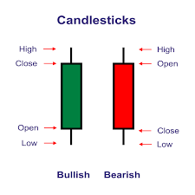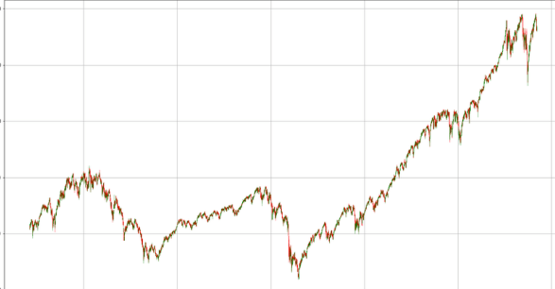charting the overall performance of the S&P 500
3. 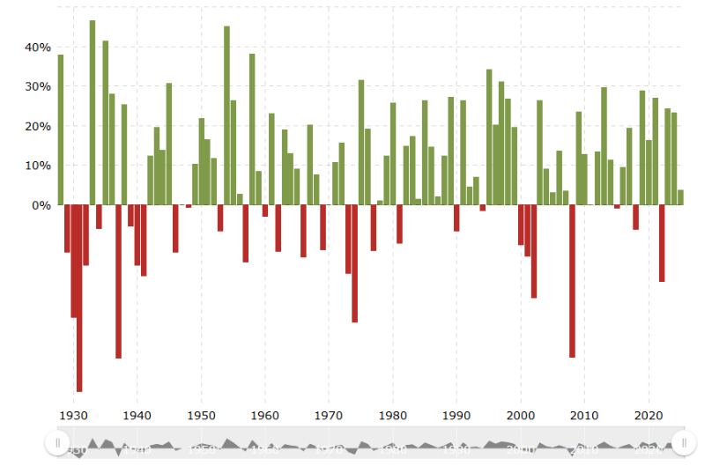Bar graph annual return by year

**Sector Weights**

1. Pie Graph showing the sectors based on company count (ex/ 82 companies in technology)
2. 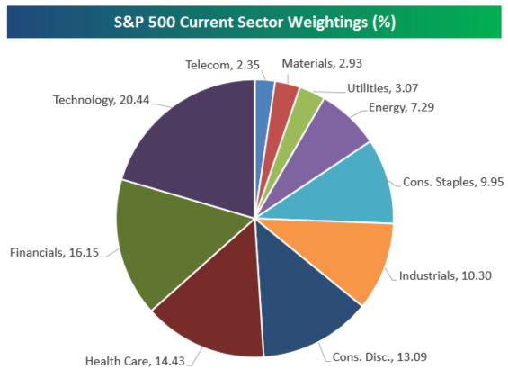Pie Graph showing sectors based on market capitalization (ex/ technology makes up $17.6 trillion)
3. Heat Map by sector and industry

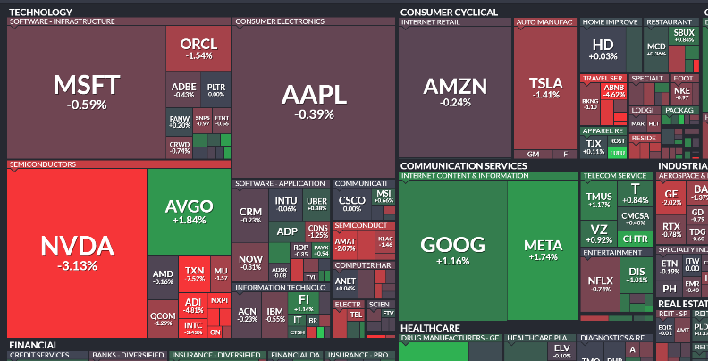

1. Revenue Growth vs Net Income (bubble size is market cap, bubble color is sector)

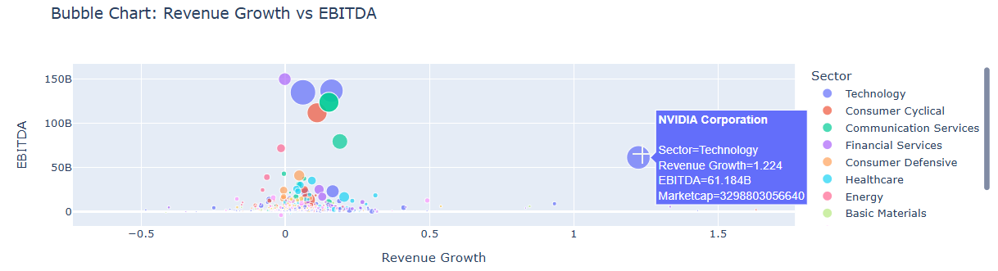

**Component Analysis**

1. Dropdown menu to select each company and show you all the information about the company itself
2. Percent of Total S&P Weight vs. Number of Companies

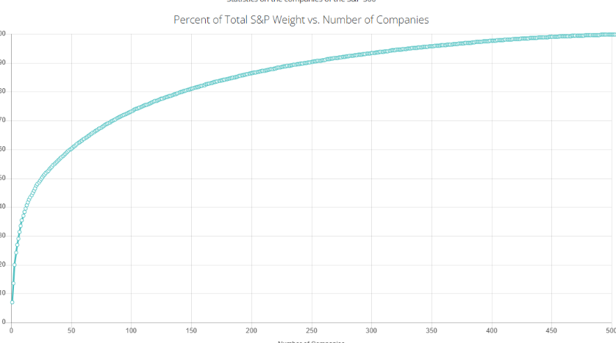

1. Bar graph – top 10 companies by market cap

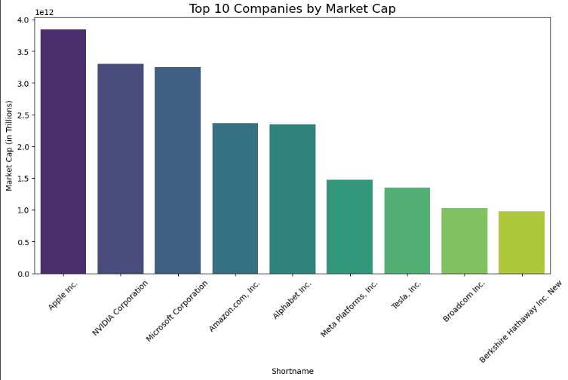

1. Comparative graph – dropdown menu to select multiple companies (up to 5) showing the their performance (don’t have the data yet but easily download from yahoo finance)

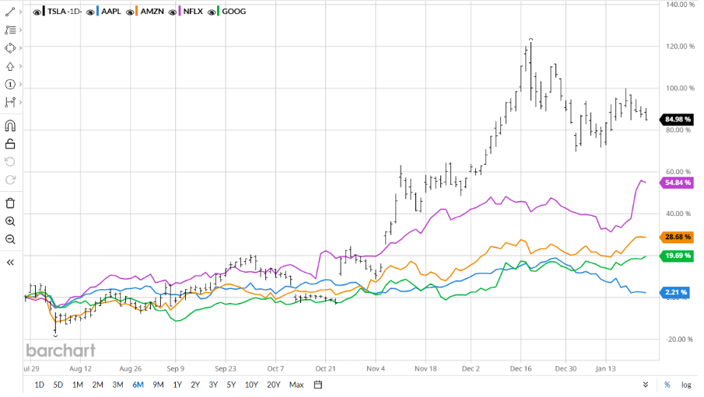

**Location**

1. Map cities of all companies – see if there’s any correlation between sectors and location

**About Us**

1. Names and background on each of us
2. Disclaimers (ex/ this is not finance advice)
3. Ethical considerations

**Project Results: Analysis of S&P 500 Companies**

Our analysis of the S&P 500 companies provided key insights into market structure, sector distribution, and financial performance.

1. **Market Capitalization Influence:** The index is heavily weighted towards a few large-cap companies, with the top 10 firms accounting for a significant portion of the total market value.
2. **Sector Distribution:** While all 11 sectors are represented, Technology and Healthcare dominate, reflecting their substantial market share and growth potential.
3. **Revenue Growth vs. Net Income:** A scatter plot analysis revealed that while high revenue growth correlates with positive net income, certain sectors—particularly Technology and Consumer Discretionary—exhibit high valuations despite lower earnings.
4. **Company-Level Insights:** A dynamic selection tool allowed for deeper exploration of individual companies, providing real-time comparisons of financial metrics.

Overall, this study highlights the concentration of market influence among a few key players and underscores sector-specific trends that drive S&P 500 performance. These insights are valuable for investors assessing risk, diversification, and growth potential within the index.