Across
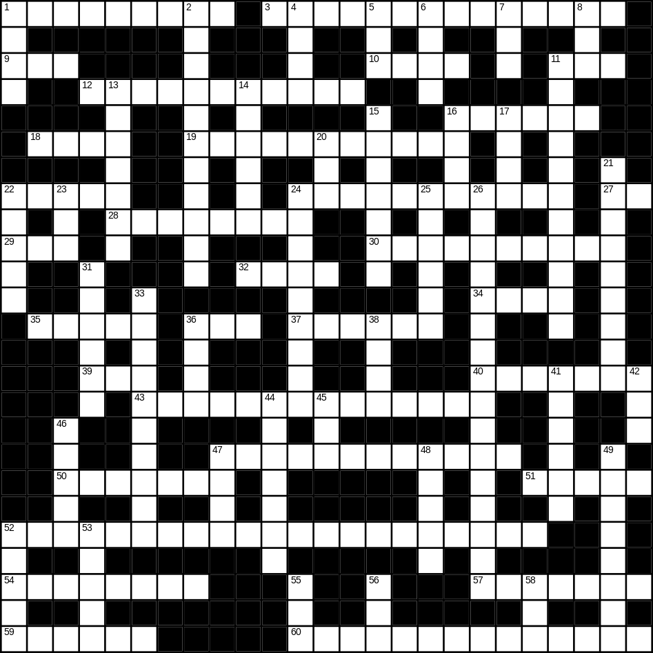

1 loud (9)
3 sunglasses (8,6)
9 egg (3)
10 spade (4)
11 cat (3)
12 bedroom (6,5)
16 kettle (6)
18 comb (4)
19 decorator (11)
22 cupboard (5)
24 television (11)
27 gold (2)
28 cabbage (8)
29 apple (3)
30 spider (6,4)
32 mug (4)
34 hat (4)
35 floor (5)
36 scales (3)
37 strong (6)
39 son (3)
40 river (7)
43 vacuum cleaner (14)
47 pencil (5,7)
50 rubbish (7)
51 chicken (5)
52 microwave (8,13)
54 leaf (8)
57 aeroplane (7)
59 hair (6)
60 caterpillar (5,9)

Down
1 hard (4)
2 ironing board (4,7)
4 pot (4)
5 foot (3)
6 bread (4)
7 rice (3)
8 nephew (3)
11 Christmas tree (5,6)
13 spring (season) (7)
14 lettuce (6)
15 snail (7)
16 heart (4)
17 fire (4)
20 tea (3)
21 cooker (9)
22 quiet (5)
23 hedge (3)
24 family (9)
25 autumn (6)
26 umbrella (5,11)
31 earth (6)
33 breakfast (10)
36 slow (4)
38 brown (4)
41 father (6)
42 new (3)
44 moon (7)
45 lunch (3)
46 doll (5)
47 pram (4)
48 daughter (5)
49 incorrect (8)
52 thumb (5)
53 hall (5)
55 zip (3)
56 bus (3)
58 beach (3)
