Across
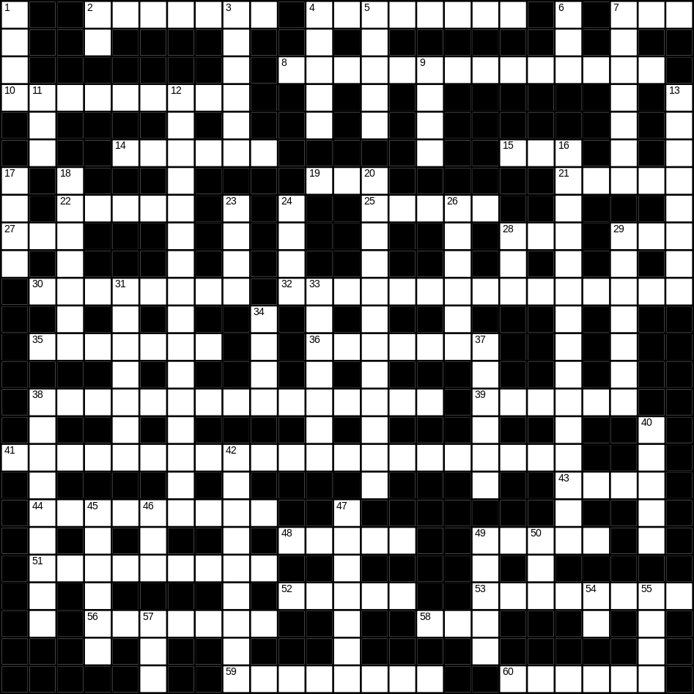

2 biscuit (7)
4 doctor (8)
7 smooth (3)
8 vacuum cleaner (14)
10 orange juice (2,7)
14 ugly (6)
15 bad (3)
19 soft (3)
21 grey (5)
22 stone (5)
25 lamp (5)
27 tea (3)
28 boat (3)
29 zip (3)
30 needle (8)
32 washing machine (7,8)
35 beautiful (7)
36 tie (7)
38 Thanksgiving day (5,2,8)
39 aunt (6)
41 microwave (8,13)
43 bread (4)
44 refrigerator (9)
48 red (5)
49 duck (5)
51 tractor (9)
52 door (5)
53 goldfish (4,4)
56 Christmas (7)
58 bird (3)
59 newspaper (8)
60 light (6)

Down
1 cheese (4)
2 cow (2)
3 basket (6)
4 drink (5)
5 quiet (5)
6 cat (3)
7 surgeon (7)
9 green (4)
11 apple (3)
12 umbrella (5,11)
13 saucer (8)
16 envelope (7,8)
17 coat (4)
18 cutlery (7)
20 motorbike (12)
23 spade (4)
24 pram (4)
26 plant (6)
28 yellow (3)
29 mirror (7)
31 towel (7)
33 key (7)
34 slow (4)
37 train (6)
38 frying pan (9)
40 bench (5)
42 mushroom (9)
45 iron (6)
46 nephew (3)
47 spring (season) (7)
49 shirt (5)
50 foot (3)
54 young (2)
55 blue (4)
57 lunch (3)
