Across
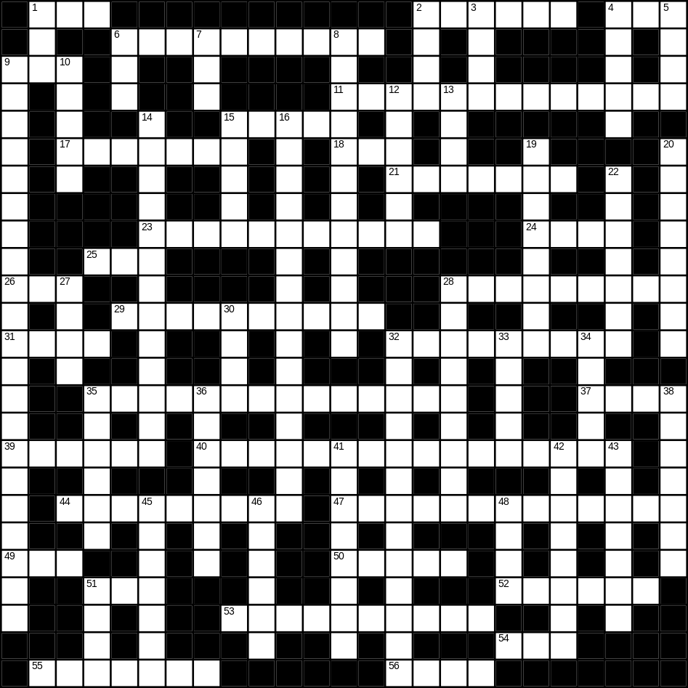

1 video (3)
2 Planet Earth (6)
4 cat (3)
6 email (10)
9 bad (3)
11 ice-cream (7,6)
15 cupboard (5)
17 tooth (7)
18 bus (3)
21 builder (7)
23 jeans (6,5)
24 coat (4)
25 soft (3)
26 pig (3)
28 thunder (9)
29 breakfast (10)
31 bell (4)
32 boy (9)
35 caterpillar (5,9)
37 frost (4)
39 t-shirt (1-5)
40 umbrella (5,11)
44 computer (9)
47 playing card (5,8)
49 nephew (3)
50 water (5)
51 foot (3)
52 kettle (6)
53 spider (6,4)
54 white (3)
55 ant (7)
56 rug (4)

Down
1 hedge (3)
2 black (4)
3 mug (4)
4 quiet (5)
5 fire (4)
6 rose (3)
7 son (3)
8 paintbrush (5,7)
9 microwave (8,13)
10 coffee (5)
12 kitchen (6)
13 sofa (4)
14 hairbrush (5,8)
15 ear (5)
16 Thanksgiving day (5,2,8)
19 goldfish (4,4)
20 snow (8)
22 cloud (7)
27 hill (4)
28 rainbow (3,6)
30 fork (4)
32 bin (5,8)
33 hall (5)
34 match (5)
35 kitten (6)
36 toaster (7)
38 camera (7)
41 saucer (8)
42 newspaper (8)
43 aeroplane (7)
45 dessert (7)
46 bicycle (6)
48 mask (4)
51 hard (4)
