Across
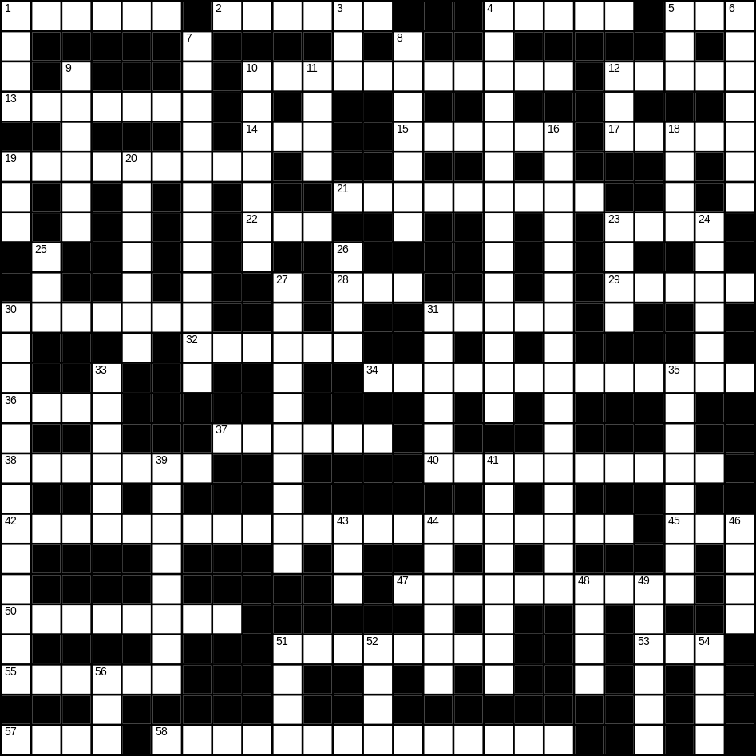

1 helmet (6)
2 earth (6)
4 pen (5)
5 soft (3)
10 office worker (5,6)
12 dog (5)
13 circle (7)
14 nephew (3)
15 lettuce (6)
17 cupboard (5)
19 cooker (9)
21 frying pan (9)
22 apple (3)
23 brown (4)
28 lunch (3)
29 baby (5)
30 cutlery (7)
31 shirt (5)
32 iron (6)
34 ice-cream (7,6)
36 mug (4)
37 phone (6)
38 river (7)
40 mobile phone (6,4)
42 microwave (8,13)
45 rose (3)
47 breakfast (10)
50 triangle (8)
51 bath (8)
53 foot (3)
55 aunt (6)
57 fire (4)
58 sunglasses (8,6)

Down
1 hill (4)
3 big (3)
4 caterpillar (5,9)
5 boat (3)
6 moon (7)
7 cousin (3,9)
8 dictionary (7)
9 monkey (6)
10 onion (7)
11 woman (4)
12 pig (3)
16 umbrella (5,11)
18 wine (4)
19 cat (3)
20 brain (7)
23 black (4)
24 niece (6)
25 son (3)
26 clean (4)
27 grandfather (10)
30 bathroom (6,7)
31 mouse (6)
33 dirty (6)
35 goldfish (4,4)
39 newspaper (8)
41 doughnut (8)
43 rice (3)
44 fruit (6)
46 saw (4)
48 bread (4)
49 taxi (6)
51 fork (4)
52 heart (4)
54 frost (4)
56 tea (3)
