Across
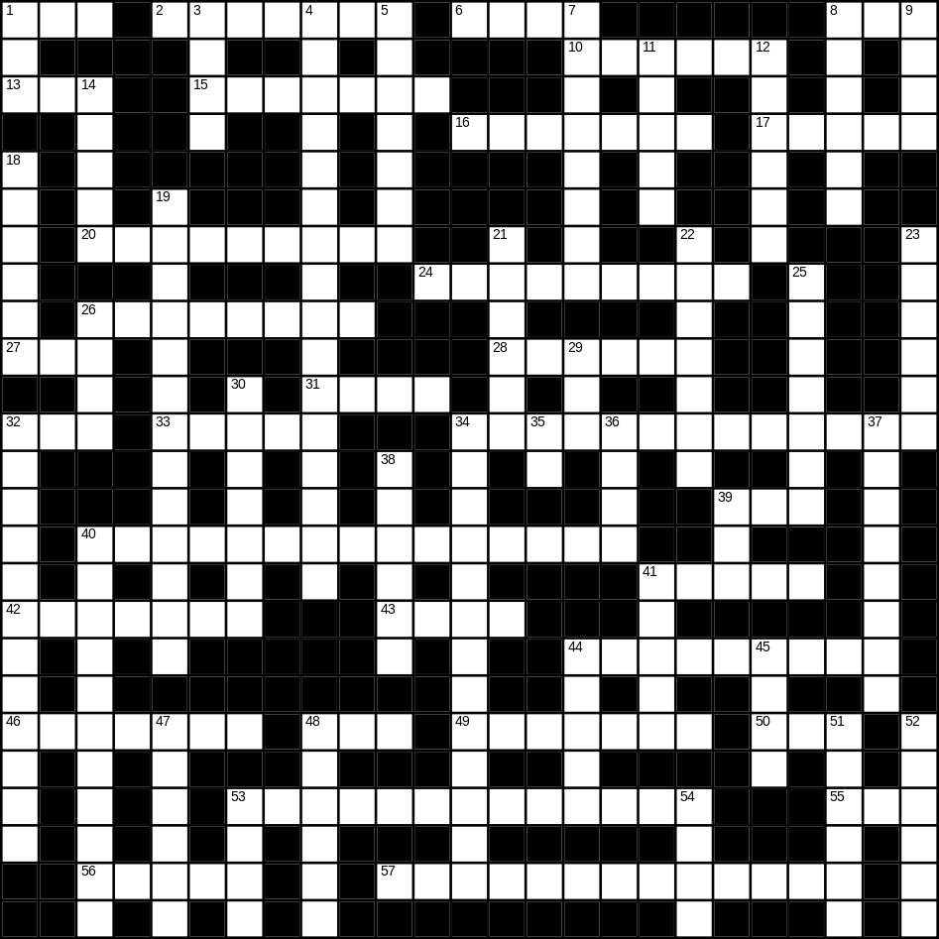

1 hedge (3)
2 orange (7)
6 old (4)
8 son (3)
10 uncle (6)
13 zip (3)
15 beautiful (7)
16 tooth (7)
17 thumb (5)
20 cooker (9)
24 thunder (9)
26 sandwich (8)
27 smooth (3)
28 bowl (6)
31 hat (4)
32 bad (3)
33 hall (5)
34 trainers (5,8)
39 tea (3)
40 washing machine (7,8)
41 bone (5)
42 shell (7)
43 black (4)
44 clown (4,5)
46 mother (7)
48 bus (3)
49 skirt (7)
50 cat (3)
53 Father Christmas (5,2,6)
55 foot (3)
56 daughter (5)
57 playing card (5,8)

Down
1 video (3)
3 rug (4)
4 umbrella (5,11)
5 aeroplane (7)
7 newspaper (8)
8 morning (6)
9 bell (4)
11 Easter (5)
12 lorry (6)
14 field (5)
18 light (6)
19 hairbrush (5,8)
21 pepper (6)
22 cutlery (7)
23 banana (6)
25 sponge (7)
26 hill (4)
29 soft (3)
30 artichoke (7)
32 Halloween (5,7)
34 bin (5,8)
35 gold (2)
36 bread (4)
37 glove (8)
38 ladybird (4,2)
39 beach (3)
40 decorator (11)
41 correct (5)
44 meat (5)
45 rake (4)
47 aunt (6)
48 milk (6)
51 ticket (6)
52 basket (6)
53 brown (4)
54 clean (4)
