Across
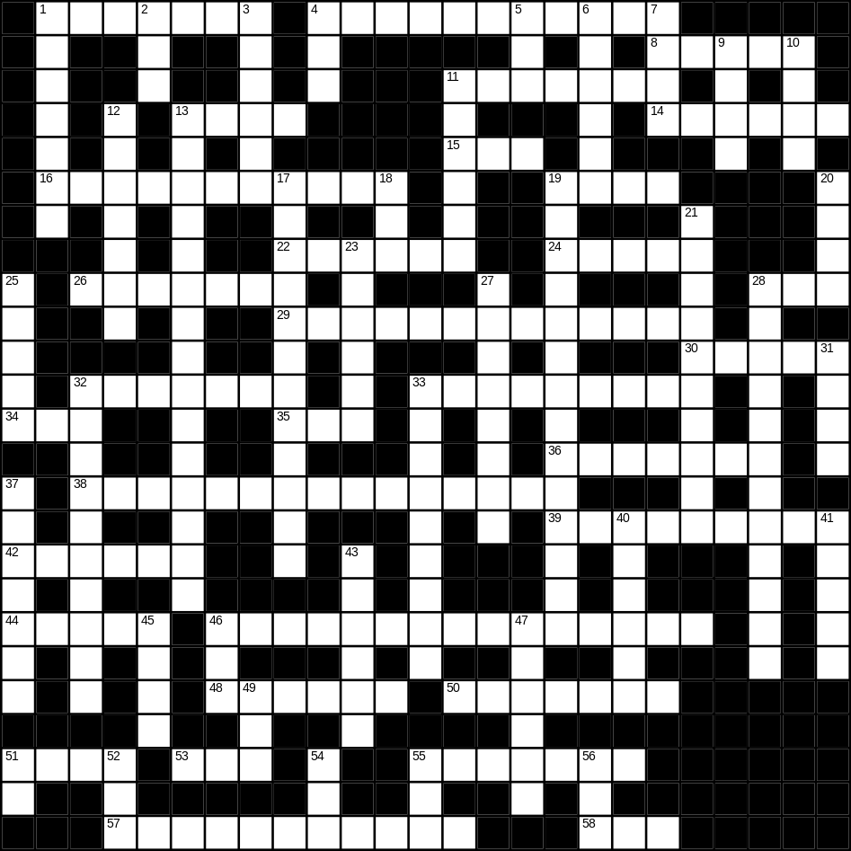

1 cloud (7)
4 Christmas tree (5,6)
8 thumb (5)
11 picture (7)
13 fork (4)
14 monkey (6)
15 bus (3)
16 television (11)
19 frog (4)
22 uncle (6)
24 shirt (5)
26 cutlery (7)
28 hedge (3)
29 bin (5,8)
30 house (5)
32 moon (7)
33 family (9)
34 tea (3)
35 bird (3)
36 river (7)
38 washing machine (7,8)
39 thunder (9)
42 fruit (6)
44 bed (5)
46 envelope (7,8)
48 stamp (6)
50 brain (7)
51 bear (4)
53 scales (3)
55 glasses (7)
57 bedroom (6,5)
58 new (3)

Down
1 skirt (7)
2 son (3)
3 lorry (6)
4 cat (3)
5 bad (3)
6 strong (6)
7 blue (4)
9 brown (4)
10 green (4)
11 tent (6)
12 biscuit (7)
13 Thanksgiving day (5,2,8)
17 paintbrush (5,7)
18 nephew (3)
19 vacuum cleaner (14)
20 mouth (4)
21 rain (10)
23 kitchen (6)
25 correct (5)
27 triangle (8)
28 snowman (4,8)
31 hat (4)
32 winter (10)
33 rainbow (3,6)
37 strawberry (2,5)
40 iron (6)
41 hall (5)
43 button (6)
45 bread (4)
46 foot (3)
47 ticket (6)
49 beach (3)
51 cow (2)
52 rice (3)
54 apple (3)
55 zip (3)
56 lunch (3)

