Across
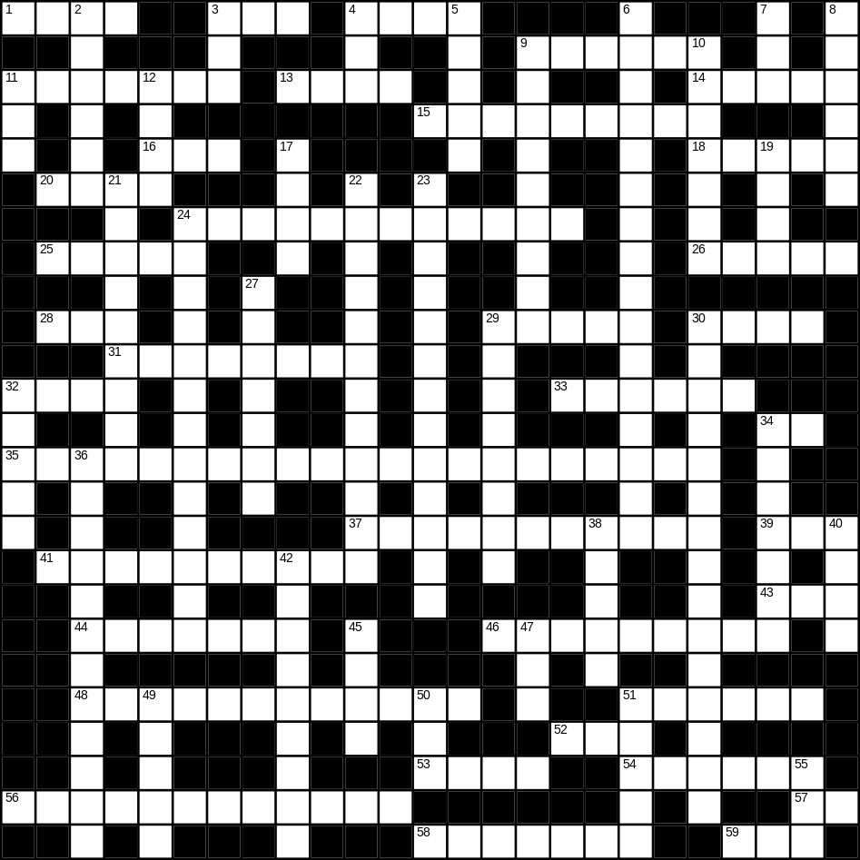

1 mug (4)
3 soft (3)
4 mask (4)
9 sugar (6)
11 mirror (7)
13 fire (4)
14 daughter (5)
15 frying pan (9)
16 beach (3)
18 fast (5)
20 rake (4)
24 shorts (6,6)
25 floor (5)
26 duck (5)
28 scales (3)
29 correct (5)
30 frog (4)
31 newspaper (8)
32 hard (4)
33 train (6)
34 cow (2)
35 microwave (8,13)
37 television (11)
39 bad (3)
41 spider (6,4)
43 cat (3)
44 glasses (7)
46 rainbow (3,6)
48 Halloween (5,7)
51 lettuce (6)
52 tea (3)
53 bread (4)
54 father (6)
56 pencil (5,7)
57 gold (2)
58 cutlery (7)
59 bus (3)

Down
2 ugly (6)
3 white (3)
4 smooth (3)
5 cupboard (5)
6 umbrella (5,11)
7 yellow (3)
8 monkey (6)
9 orange juice (2,7)
10 angel (7)
11 zip (3)
12 hat (4)
17 fish (4)
19 frost (4)
21 loud (9)
22 snowman (4,8)
23 ice-cream (7,6)
24 trainers (5,8)
27 river (7)
29 musician (8)
30 Thanksgiving day (5,2,8)
32 stone (5)
34 biscuit (7)
36 motorbike (12)
38 sock (5)
40 coat (4)
42 ball (9)
45 arm (4)
47 egg (3)
49 tree (5)
50 nephew (3)
51 bed (5)
55 rose (3)
