Across
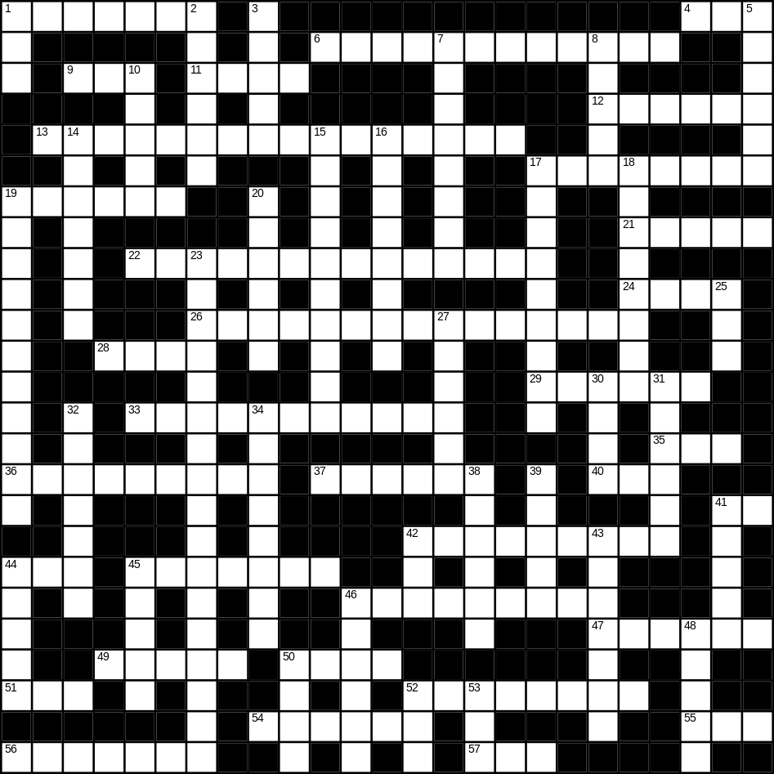

1 lemon (7)
4 son (3)
6 Halloween (5,7)
9 apple (3)
11 mask (4)
12 mouse (6)
13 living room (6,10)
17 chocolate (8)
19 kettle (6)
21 daughter (5)
22 vacuum cleaner (14)
24 lion (4)
26 Thanksgiving day (5,2,8)
28 saw (4)
29 tongue (6)
33 decorator (11)
35 egg (3)
36 toilet (9)
37 lettuce (6)
40 nephew (3)
41 cow (2)
42 red wine (4,5)
44 beach (3)
45 skirt (7)
46 soap (9)
47 aunt (6)
49 tree (5)
50 music (4)
51 scales (3)
52 doughnut (8)
54 ugly (6)
55 foot (3)
56 toy (7)
57 cat (3)

Down
1 lunch (3)
2 Planet Earth (6)
3 cake (5)
5 helmet (6)
7 elephant (8)
8 hall (5)
10 lamp (5)
14 aeroplane (7)
15 winter (10)
16 glove (8)
17 orange juice (2,7)
18 castle (8)
19 ironing board (4,7)
20 kitchen (6)
23 St Valentine’s day (2,6,9)
25 new (3)
27 lorry (6)
30 bread (4)
31 hair (6)
32 artichoke (7)
34 goldfish (4,4)
38 scissors (6)
39 dog (5)
41 baby (5)
42 hedge (3)
43 river (7)
44 dry (5)
45 shark (5)
46 glass (6)
48 house (5)
50 car (4)
52 tea (3)
53 bad (3)
