Across
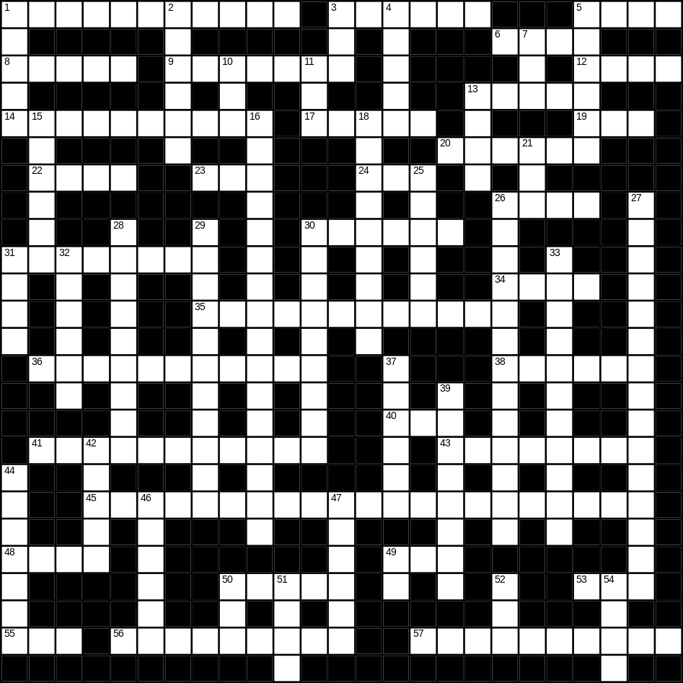

1 bedroom (6,5)
3 light (6)
5 frost (4)
6 hard (4)
8 floor (5)
9 onion (7)
12 lion (4)
13 pasta (5)
14 present (10)
17 duck (5)
19 new (3)
20 nose (6)
22 bread (4)
23 beach (3)
24 foot (3)
26 spade (4)
30 radio (6)
31 chair (8)
34 finger (4)
35 grandmother (12)
36 whiskey (5,6)
38 wet (6)
40 scales (3)
41 office worker (5,6)
43 incorrect (8)
45 microwave (8,13)
48 bear (4)
49 white (3)
50 box (5)
53 egg (3)
55 tea (3)
56 clown (4,5)
57 grandfather (10)

Down
1 brush (5)
2 lorry (6)
3 bird (3)
4 drink (5)
5 salt (6)
7 rose (3)
10 nephew (3)
11 apple (3)
13 pram (4)
15 star (6)
16 umbrella (5,11)
18 cooker (9)
21 zip (3)
25 mountain (6)
26 bathroom (6,7)
27 envelope (7,8)
28 tractor (9)
29 jeans (6,5)
30 computer (9)
31 hill (4)
32 train (6)
33 radiator (11)
37 autumn (6)
39 glove (8)
42 beer (5)
44 tie (7)
46 glass (6)
47 iron (6)
49 cow (2)
50 soft (3)
51 eye (4)
52 lunch (3)
54 small (4)
