Across
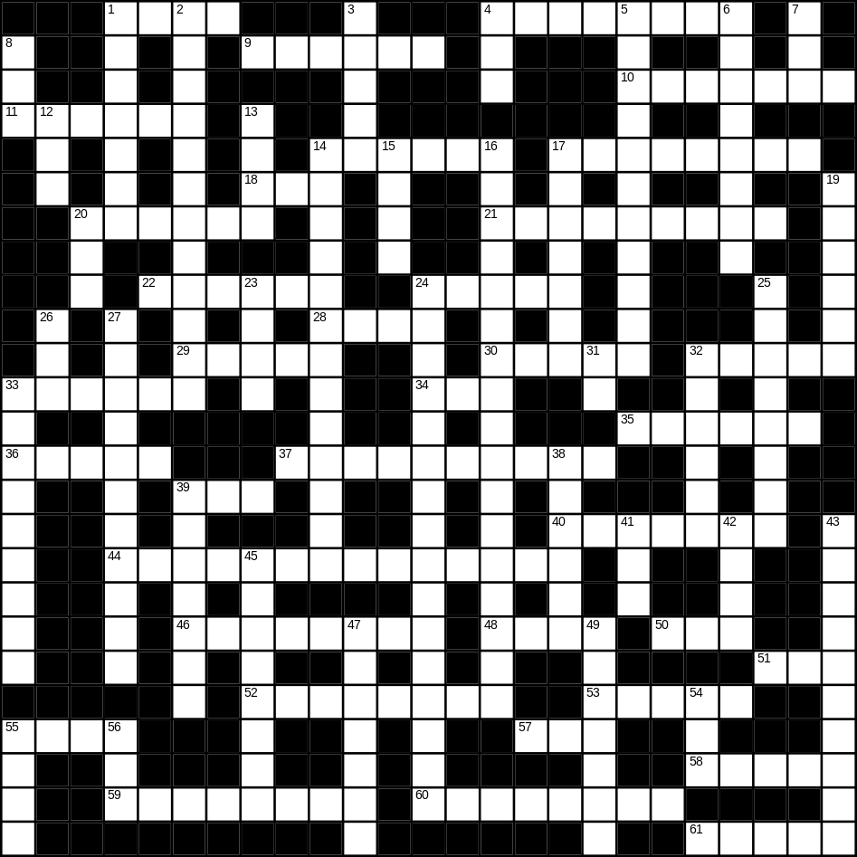

1 mask (4)
4 saucer (8)
9 banana (6)
10 cutlery (7)
11 tap (6)
14 horse (6)
17 snow (8)
18 beach (3)
20 bowl (6)
21 butterfly (9)
22 sugar (6)
24 sky (5)
28 fish (4)
29 dry (5)
30 bed (5)
32 good (5)
33 button (6)
34 tea (3)
35 milk (6)
36 quiet (5)
37 breakfast (10)
39 soft (3)
40 angel (7)
44 sunglasses (8,6)
46 sand (8)
48 fire (4)
50 smooth (3)
51 white (3)
52 glove (8)
53 Easter (5)
55 frost (4)
57 egg (3)
58 pen (5)
59 triangle (8)
60 elephant (8)
61 ear (5)

Down
1 surgeon (7)
2 paintbrush (5,7)
3 sheep (5)
4 hedge (3)
5 whiskey (5,6)
6 newspaper (8)
7 big (3)
8 rice (3)
12 foot (3)
13 pot (4)
14 playing card (5,8)
15 pie (4)
16 St Valentine’s day (2,6,9)
17 skirt (7)
19 bitter (6)
20 yellow (3)
23 car (4)
24 umbrella (5,11)
25 candle (8)
26 lunch (3)
27 television (11)
31 cow (2)
32 necklace (6)
33 cooker (9)
38 train (6)
39 toy (7)
41 nephew (3)
42 bread (4)
43 present (10)
45 castle (8)
47 river (7)
49 key (7)
54 zip (3)
55 spade (4)
56 cat (3)
