Across
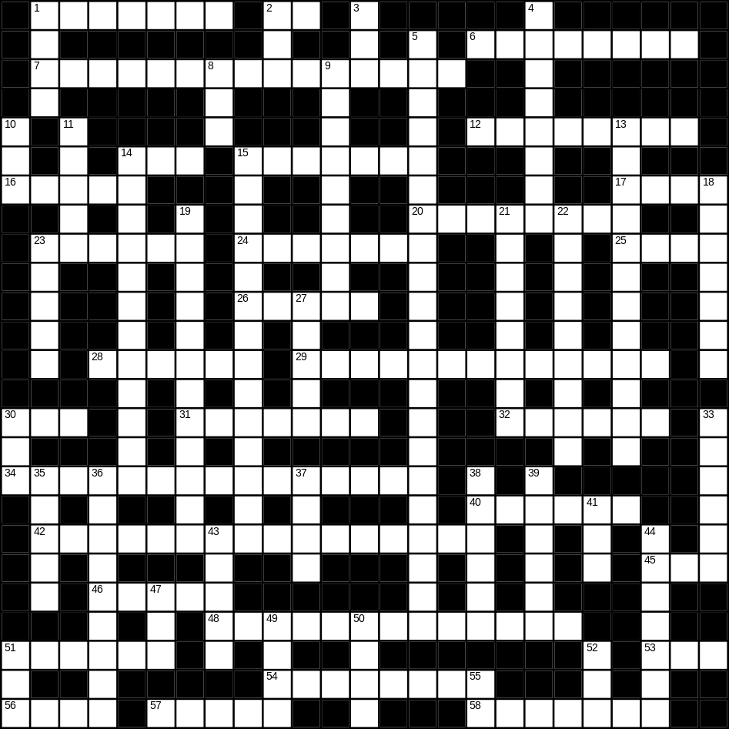

1 book (7)
2 cow (2)
6 chocolate (8)
7 washing machine (7,8)
12 garage (8)
14 video (3)
15 snail (7)
16 shirt (5)
17 bread (4)
20 newspaper (8)
23 lorry (6)
24 river (7)
25 slow (4)
26 duck (5)
28 taxi (6)
29 bathroom (6,7)
30 pig (3)
31 money (7)
32 radio (6)
34 envelope (7,8)
40 earth (6)
42 living room (6,10)
45 rice (3)
46 cupboard (5)
48 playing card (5,8)
51 kettle (6)
53 zip (3)
54 doughnut (8)
56 spade (4)
57 flower (5)
58 beautiful (7)

Down
1 arm (4)
2 yellow (3)
3 egg (3)
4 summer (8)
5 microwave (8,13)
8 nephew (3)
9 loud (9)
10 apple (3)
11 coffee (5)
13 grandmother (12)
14 snowman (4,8)
15 sunglasses (8,6)
18 Christmas (7)
19 Halloween (5,7)
21 chair (8)
22 tractor (9)
23 lamp (5)
27 cake (5)
30 son (3)
33 lettuce (6)
35 match (5)
36 bridge (9)
37 rug (4)
38 father (6)
39 wet (6)
41 scales (3)
43 house (5)
44 biscuit (7)
47 hedge (3)
49 wheel (4)
50 fish (4)
51 foot (3)
52 bird (3)
55 young (2)
