Across
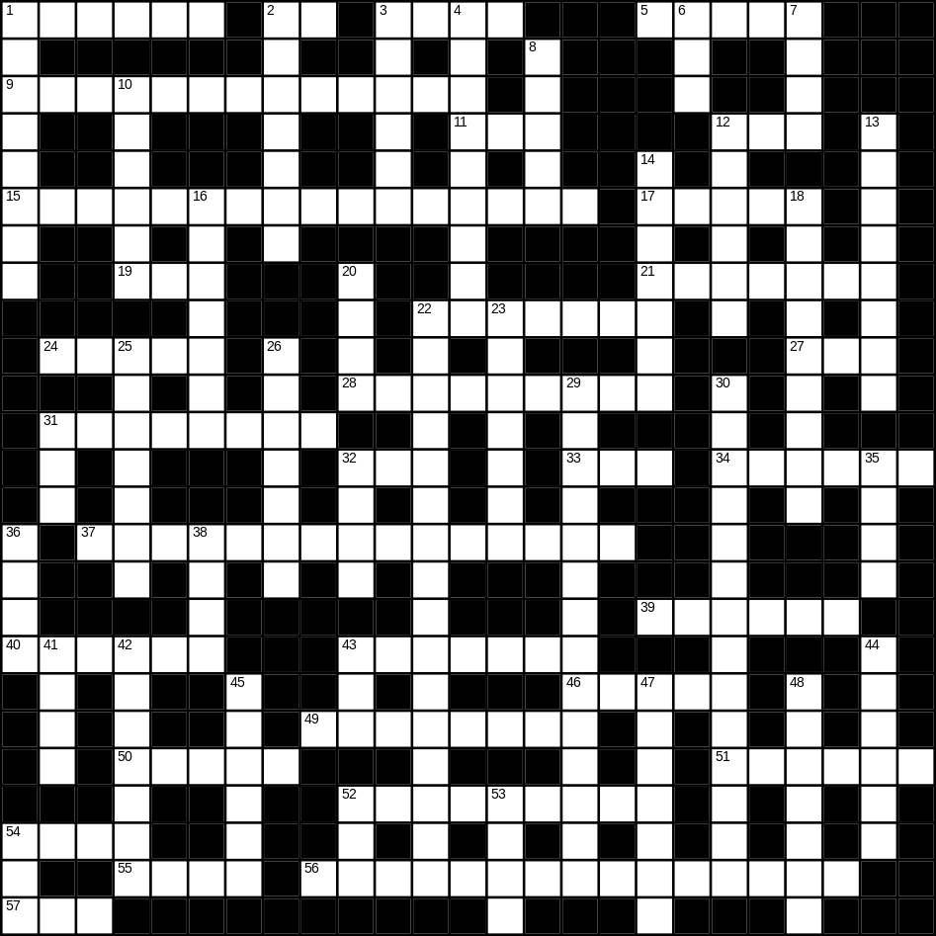

1 button (6)
2 cow (2)
3 jam (4)
5 brush (5)
9 bin (5,8)
11 yellow (3)
12 hedge (3)
15 umbrella (5,11)
17 field (5)
19 nephew (3)
21 brain (7)
22 strawberry (2,5)
24 pasta (5)
27 new (3)
28 orange juice (2,7)
31 chocolate (8)
32 big (3)
33 bird (3)
34 strong (6)
37 envelope (7,8)
39 father (6)
40 nose (6)
43 builder (7)
46 fast (5)
49 musician (8)
50 paint (5)
51 ticket (6)
52 mushroom (9)
54 mug (4)
55 rug (4)
56 St Patrick’s day (2,6,7)
57 foot (3)

Down
1 cabbage (8)
2 rubbish (7)
3 bitter (6)
4 barbecue (9)
6 cat (3)
7 mouth (4)
8 daughter (5)
10 kitchen (6)
12 wet (6)
13 candle (8)
14 sponge (7)
16 tooth (7)
18 refrigerator (9)
20 cheese (4)
22 living room (6,10)
23 towel (7)
25 cloud (7)
26 biscuit (7)
29 sunglasses (8,6)
30 vacuum cleaner (14)
31 zip (3)
32 bag (4)
35 fish (4)
36 frog (4)
38 brown (4)
41 bread (4)
42 supper (7)
43 tea (3)
44 mountain (6)
45 banana (6)
47 film (7)
48 key (7)
52 scales (3)
53 magazine (4)
54 pig (3)
