Across
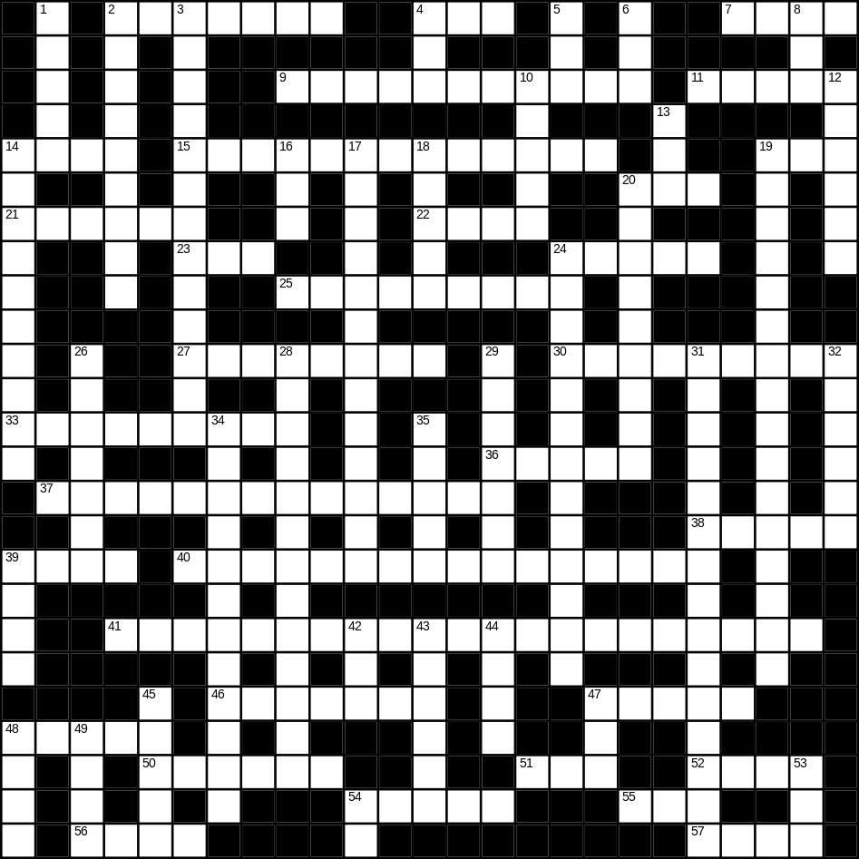

2 toaster (7)
4 scales (3)
7 arm (4)
9 Christmas tree (5,6)
11 field (5)
14 clean (4)
15 bin (5,8)
19 zip (3)
20 boat (3)
21 fruit (6)
22 jam (4)
23 rice (3)
24 door (5)
25 rainbow (3,6)
27 goldfish (4,4)
30 bridge (9)
33 refrigerator (9)
36 bed (5)
37 caterpillar (5,9)
38 head (5)
39 blue (4)
40 living room (6,10)
41 microwave (8,13)
46 mother (7)
47 sheep (5)
48 duck (5)
50 monkey (6)
51 bus (3)
52 bread (4)
54 bench (5)
55 son (3)
56 old (4)
57 hat (4)

Down
1 forest (5)
2 thunder (9)
3 hairbrush (5,8)
4 smooth (3)
5 apple (3)
6 soft (3)
8 big (3)
10 grey (5)
12 horse (6)
13 beach (3)
14 mobile phone (6,4)
16 cat (3)
17 trainers (5,8)
18 water (5)
19 umbrella (5,11)
20 wheelbarrow (4,5)
24 Father Christmas (5,2,6)
26 paper (7)
28 playing card (5,8)
29 fly (7)
31 envelope (7,8)
32 Planet Earth (6)
34 Halloween (5,7)
35 cake (5)
39 green (4)
42 nephew (3)
43 iron (6)
44 rug (4)
45 lamp (5)
47 foot (3)
48 lion (4)
49 cheese (4)
53 new (3)
54 cow (2)
