Across
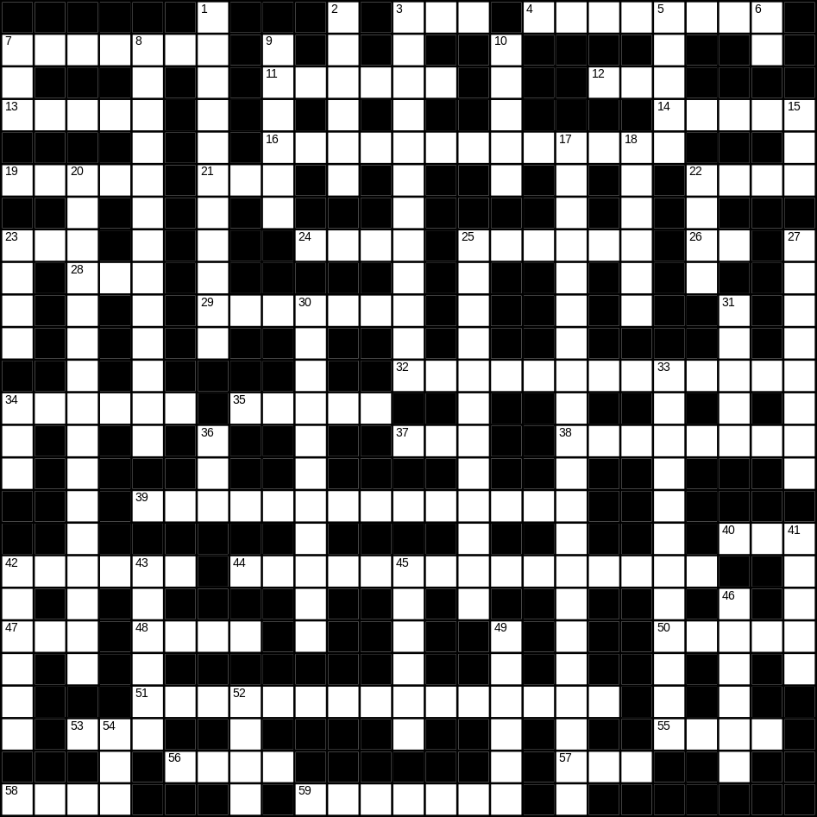

3 soft (3)
4 doughnut (8)
7 circle (7)
11 lettuce (6)
12 rose (3)
13 sky (5)
14 dry (5)
16 ice-cream (7,6)
19 box (5)
21 son (3)
22 frost (4)
23 scales (3)
24 rope (4)
25 phone (6)
26 cow (2)
28 tea (3)
29 book (7)
32 Father Christmas (5,2,6)
34 niece (6)
35 hammer (5)
37 big (3)
38 goldfish (4,4)
39 vacuum cleaner (14)
40 hedge (3)
42 child (6)
44 Thanksgiving day (5,2,8)
47 white (3)
48 lion (4)
50 good (5)
51 washing machine (7,8)
53 egg (3)
55 bread (4)
56 cheese (4)
57 nephew (3)
58 green (4)
59 dinner (7)

Down
1 ironing board (4,7)
2 necklace (6)
3 shorts (6,6)
5 cake (5)
6 young (2)
7 foot (3)
8 playing card (5,8)
9 wet (6)
10 sheep (5)
15 pig (3)
17 microwave (8,13)
18 tongue (6)
20 umbrella (5,11)
22 saw (4)
23 bag (4)
25 motorbike (12)
27 white wine (4,4)
30 jeans (6,5)
31 floor (5)
33 Halloween (5,7)
34 new (3)
36 apple (3)
41 duck (5)
42 tent (6)
43 earth (6)
45 aunt (6)
46 basket (6)
49 father (6)
52 magazine (4)
54 bus (3)
