Across
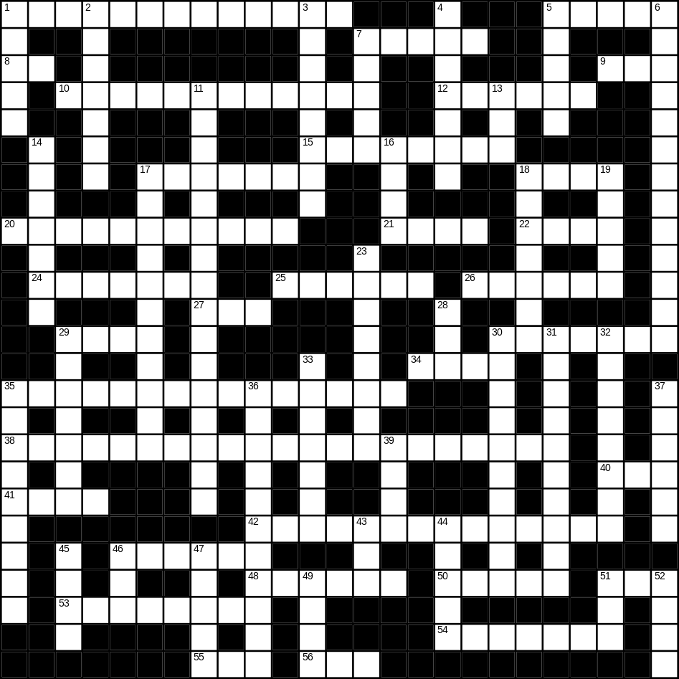

1 trainers (5,8)
5 brush (5)
7 drink (5)
8 cow (2)
9 foot (3)
10 motorbike (12)
12 aunt (6)
15 goldfish (4,4)
17 strawberry (2,5)
18 heavy (4)
20 office worker (5,6)
21 rake (4)
22 spade (4)
24 skirt (7)
25 tap (6)
26 plant (6)
27 rice (3)
29 eye (4)
30 rubbish (7)
34 comb (4)
35 Thanksgiving day (5,2,8)
38 microwave (8,13)
40 bad (3)
41 brown (4)
42 vacuum cleaner (14)
46 monkey (6)
48 stamp (6)
50 hammer (5)
51 soft (3)
53 tray (8)
54 river (7)
55 lunch (3)
56 new (3)

Down
1 baby (5)
2 moon (7)
3 glove (8)
4 cutlery (7)
5 chicken (5)
6 bin (5,8)
7 door (5)
11 umbrella (5,11)
13 nephew (3)
14 sponge (7)
16 car (4)
17 bedroom (6,5)
18 toaster (7)
19 dog (5)
23 snow (8)
28 yellow (3)
29 shell (7)
30 present (10)
31 watch (10)
32 chair (8)
33 circle (7)
35 red wine (4,5)
36 television (11)
37 sugar (6)
39 sofa (4)
43 zip (3)
44 duck (5)
45 coat (4)
46 scales (3)
47 forest (5)
49 bread (4)
51 white (3)
52 green (4)
