Across
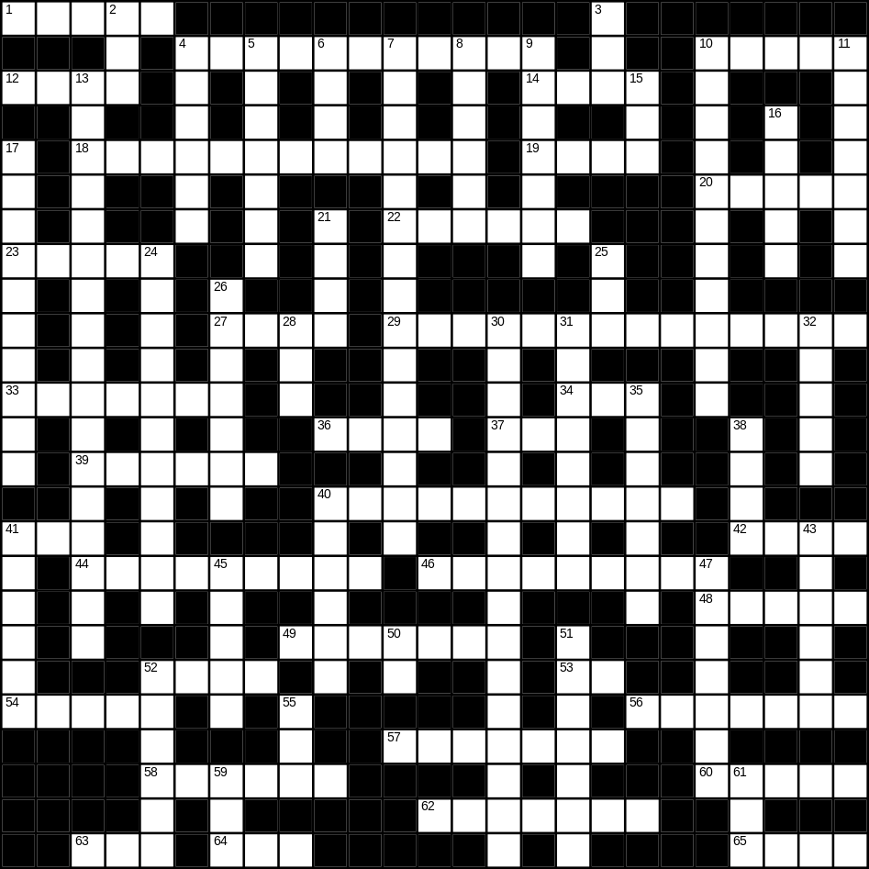

1 hammer (5)
4 bedroom (6,5)
10 cup (5)
12 slow (4)
14 mouth (4)
18 snowman (4,8)
19 bread (4)
20 sock (5)
22 iron (6)
23 Easter (5)
27 fish (4)
29 caterpillar (5,9)
33 film (7)
34 soft (3)
36 car (4)
37 beach (3)
39 lorry (6)
40 television (11)
41 bird (3)
42 mug (4)
44 family (9)
46 rainbow (3,6)
48 daughter (5)
49 tie (7)
52 bag (4)
53 young (2)
54 dog (5)
56 cutlery (7)
57 orange (7)
58 Planet Earth (6)
60 door (5)
62 angel (7)
63 white (3)
64 cat (3)
65 music (4)

Down
2 apple (3)
3 nephew (3)
4 bitter (6)
5 onion (7)
6 rug (4)
7 St Patrick’s day (2,6,7)
8 father (6)
9 river (7)
10 ironing board (4,7)
11 Christmas (7)
13 St Valentine’s day (2,6,9)
15 lunch (3)
16 drink (5)
17 breakfast (10)
21 frost (4)
24 Christmas tree (5,6)
25 egg (3)
26 dinner (7)
28 zip (3)
30 umbrella (5,11)
31 cabbage (8)
32 dry (5)
35 beautiful (7)
38 pram (4)
40 ticket (6)
41 light (6)
43 guitar (6)
45 hall (5)
47 money (7)
50 cow (2)
51 toaster (7)
52 morning (6)
55 new (3)
59 son (3)
61 bad (3)

