



***Software Requirement and Design Specifications***

***E-Commerce Shopping Website***

|  |  |
| --- | --- |
| *Course Code* | *CS 3004* |
| *Instructor* | *Miss Nida Munawar* |
| *Project Team* | *20K-0447 Syed Mehdi Raza*  *20K-0227 Syed Haziq Ahmed*  *20K-0123 Masab Bin Fakhar* |
| *Submission Date* | *December 9, 2022* |



*Table of Contents*

*1.* *INTRODUCTION* **Error! Bookmark not defined.**

1.1. Purpose of Document 3

1.2. Intended Audience 3

*2.* *OVERALL SYSTEM DESCRIPTION* 4

2.1. Project Background 4

2.2. Project Scope 4

2.3. Not In Scope 4

2.4. Project Objectives 4

2.5. Stakeholders 5

2.6. Operating Environment 5

2.7. System Constraints 5

2.8. Assumptions & Dependencies 5

*3.* *EXTERNAL INTERFACE REQUIREMENTS* 5

3.1. Hardware Interfaces 5

3.2. Software Interfaces 5

3.3. Communications Interfaces 5

*4.* *FUNCTIONAL REQUIREMENTS* 6

*4.1.* *FUNCTIONAL HIERARCHY* *5*

4.2. Use Cases 8

4.2.1. Complete Use Case 8

*5.* *NON-FUNCTIONAL REQUIREMENTS* 10

5.1. Performance Requirements 10

5.2. Safety Requirements 9

5.3. Security Requirements 9

5.4. User Documentation *10*

*6****.*** *SYSTEM ARCHITECTURE* ***1*****Error! Bookmark not defined.**

*6.1.* *SYSTEM LEVEL ARCHITECTURE 1*11

*6.2.* *SOFTWARE ARCHITECTURE 1*11

*7****.*** *DESIGN STRATEGY* ***1***12

*8.* *DETAILED SYSTEM DESIGN* ***1***12

*8.1.* *DATABASE DESIGN 1***Error! Bookmark not defined.**

*9.* *APPLICATION DESIGN 1*16

*10.* *REFERENCES* 23

*11.* *APPENDICES* 23

## 1. Introduction

#### 1.1. Purpose of Document

*Describing and defining the specifications and functionalities of our E-Commerce System is the primary goal of this Software Requirements Specification (SRS). This Software Requirements Specification illustrates, in clear terms, the system’s primary uses and required functionality.*

#### 1.2. Intended Audience

##### The Course Instructors or any other person who is connected to this field or finds this project relevant to his needs.

**1.3 Definition of Terms, Acronyms and Abbreviations**

|  |  |
| --- | --- |
| ***Term*** | ***Description*** |
| *SRS* | *Software Requirements Specification* |
| *ECS* | *E-Commerce System* |
| *CRUD* | *Create, Retrieve, Update, Delete* |
| *CS 3004* | Software Design and Analysis |
| SDA | Software Design and Analysis |
| TA | Teaching Assistant |
| Admin | The person who operates the software product. |
| User/Customer | The person who uses/access the software system. |
| Session | The time which a user is actively using the software. |
| Product | An individual entity in the inventory. |
| Shopping Cart | An object that lists customer’s selected products. |
| Button | A user interface element that allows the user to click and then it informs the system to take action. |
| Inventory | An object that holds items available for purchase by the customer. |
| Checkout | A process which happens when a customer goes through to purchase an item. |

***1.4 Document Convention***

* Convention for main title:
  + Font Face: Arial
  + Font Style: Bold and Italic
  + Font Size: 26
* Convention for sub title:
  + Font Face: Arial
  + Font Style: Bold and Italic
  + Font Size: 24
* Convention for table:
  + Font Face: Arial
  + Font Style: Italic
  + Font Size: 10
* Convention for Body:
  + Font Face: Calibri
  + Font Style: Italic
  + Font Size: 11

## 2. Overall System Description

#### 2.1. Project Background

*We have developed this system as a semester project for course CS 3004. We particularly choose this project because e-commerce is a huge part of the economy and is vital to businesses that sell their products or services online and also we can achieve the knowledge of e-commerce website development.*

#### 2.2. Project Scope

*In our system, the web owner, which is an admin, can add, delete and update products, their brands and also their categories, the admin can manage users and their orders, he can also see the customers/users queries and messages. However, a user can view products, search for a particular product, he can order product, manage product and place order by providing required information. A customer can select a payment method as cash on delivery, however he may select another payment method but our system does not provide any other payment method. A user can contact administration, sign up and view his order details and status.*

#### 2.3. Not In Scope

*The system can have other payment methods than cash on delivery.*

#### 2.4. Project Objectives

*Now due to the covid-19 people are stuck at their homes doing quarantine, they cannot go out for shopping however on normal days many people prefer not to go outside for doing shopping, so we have come up with a solution for this problem as an e-commerce shopping website, where a customer can look for their searching item and can purchase them online without any hurdle.*

#### 2.5. Stakeholders

*Not Applicable.*

#### 2.6. Operating Environment

*The product will be operating in a windows environment. Our e-commerce website will operate on Microsoft Edge and Chrome, the only requirement is to use localhost php myadmin and hardware requirement is a computer with internet connection.*

#### 2.7. System Constraints

*The system is designed for adult or mature enough persons who can have an email account so that to place an order or to purchase a product he can provide his email account. The hardware constraint contains that you must have a computer and good internet connection. However, the software requirements include that you must have Xampp installed on your computer and you must have Microsoft Edge.*

#### 2.8. Assumptions & Dependencies

* *We have assumed that our website will be running on a properly working web server and database system with an Internet connection that allows this system to perform all communications with customers*
* *We have assumed that the user’s computer is in proper working condition and that the user is capable of operating these system's basic functions including but not limited to being able to power on the system, login and open Microsoft Edge, and navigate the browser to the address of our website.*
* *The admin account’s email and password may be hard coded.*
* *The admin cannot be a customer..*
* *Any customer cannot edit their account information*

## 3. External Interface Requirements

*[This section is intended to specify any requirements that ensure that the new system will connect properly to external components. Place a context diagram showing the external interfaces at a high level of abstraction.]*

#### 3.1. Hardware Interfaces

* *Operating Systems: Windows*

#### 3.2. Software Interfaces

* *Xampp*
* *Visual Studio Code*
* *MySQL Server*

#### 3.3. Communications Interfaces

*The customer must connect to the internet to interact with the website.*

## 4. Functional Requirements

### *4.1. Functional Hierarchy*

*In our system there are two different panels, one for admin and other for users. In the admin panel admin can manage products, users, and orders. However on the user panel the user can view products, search for products, view product details, add them to cart, user can then manage cart, and checkout by providing order information, then he can view his product details and status. Users can give reviews and ratings for the products they have bought.*

*Following flow chart can give a clear idea about the hierarchy of the system.*

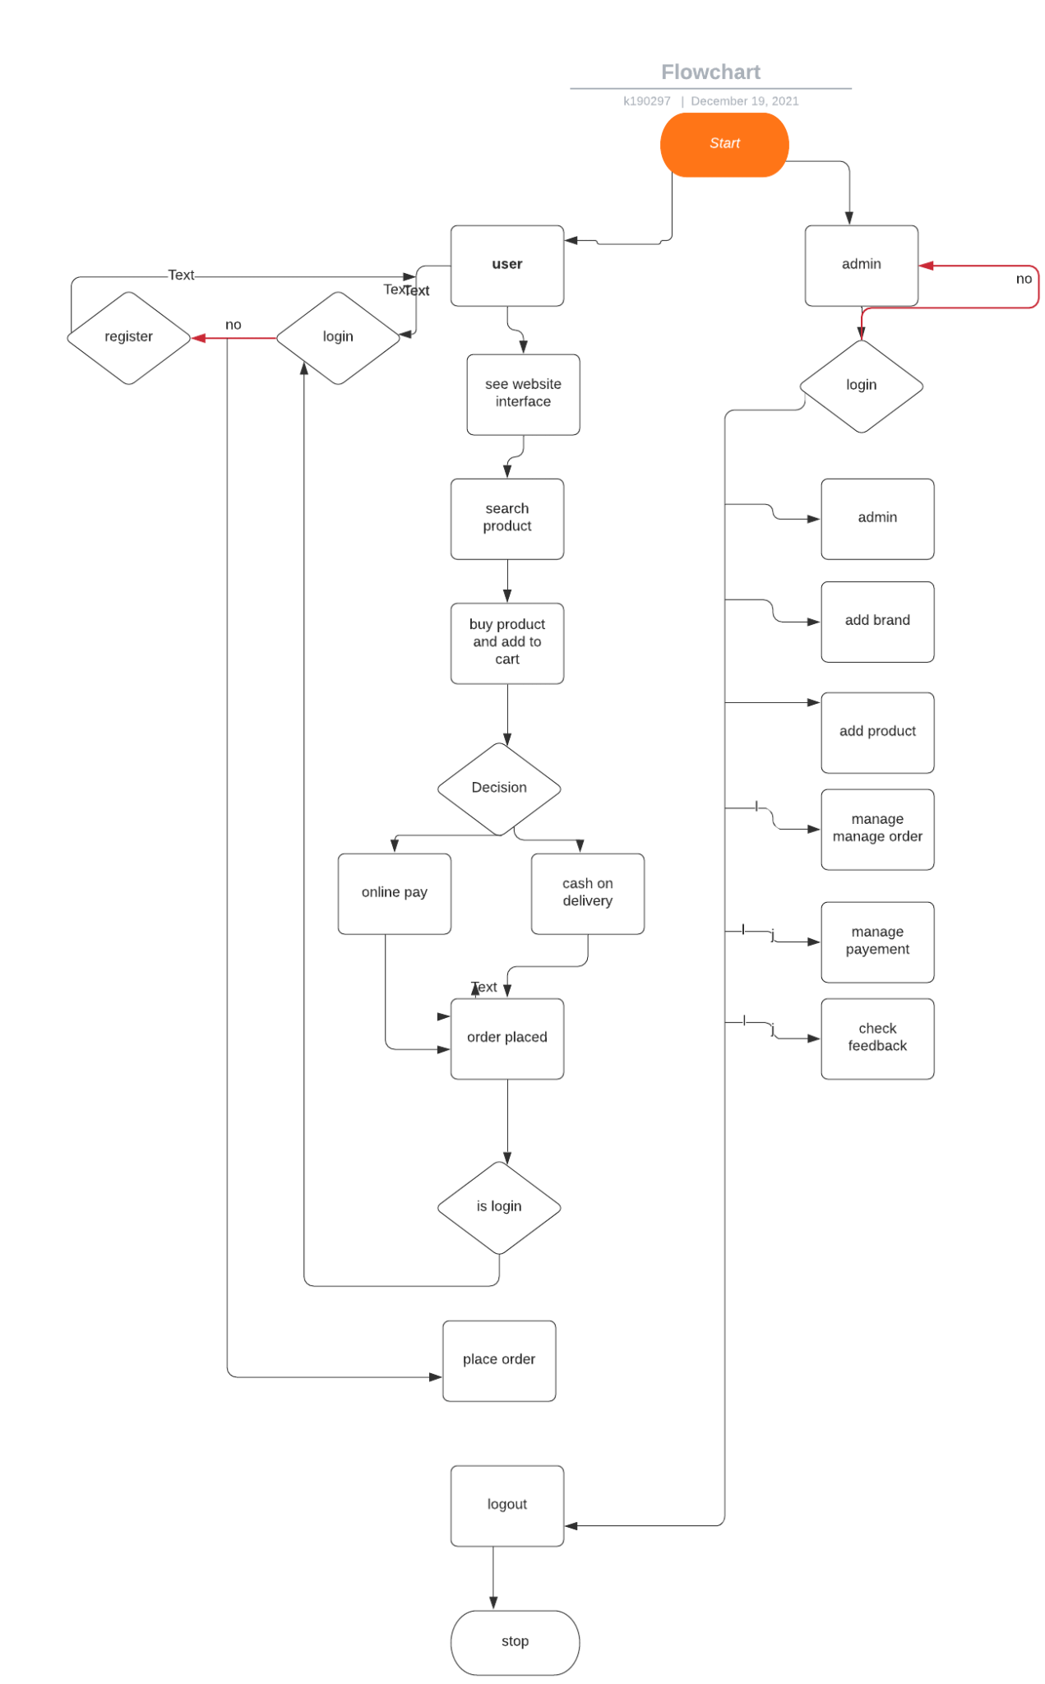

#### 4.2. Complete Use Case of E-Commerce Website

##### 4.2.1. Customer Wants to Buy a Product.

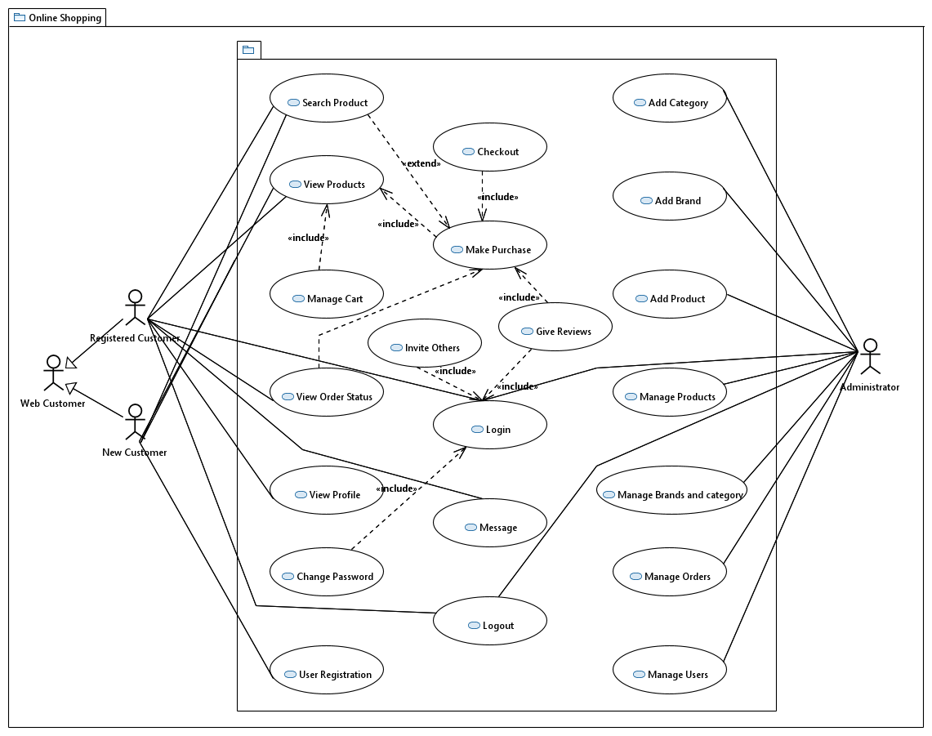

|  |  |
| --- | --- |
| ***Use Case Description*** *: Customer browse the website and looking for his searching product, he view the product details, place order then he sign up or logged in view cart, if he want he can update cart or delete product from cart, then he checkout by providing details. Then customer can see order details and log out.* | |
| ***Use Case name:*** | *Complete E-Commerce Website* |
|  | |
| ***Primary actor:*** *Customer* | ***Other actors:***Admin |
| ***Stakeholders:*** |  |
| ***Relationships:***   * ***Include: user must logged in to give review, purchase product and view order details.*** * ***Exclude:*** | |
| ***Pre-conditions:***  ▪  *To checkout, users must log in first.* | |
| ***Flow of Events:***   1. ***Customers browse website.*** 2. ***Search for products.*** 3. ***View Details and add to cart.*** 4. ***View cart*** 5. ***Login or Sign Up*** 6. ***Checkout by providing address information etc.*** 7. ***View order details and status.*** 8. ***Log out.*** | |
| ***Alternative and exceptional flows:***  1. Login  2. Give Review | |
| ***Post-conditions:***  ▪  *To checkout or give review or purchase product login is required.* | |

##### 4.2.1. Register

|  |  |
| --- | --- |
| ***Use Case Description****: Provides a non-user the functionality to sign up on the website* | |
| ***Use Case name:*** | *Register* |
| ***Use Case Description:*** | |
| ***Primary actor:*** *User* | ***Other actors:*** *None* |
| ***Stakeholders:*** *Admin* |  |
| ***Relationships***▪ ***Includes:*** *Registration Service*  ▪ ***Extends:*** | |
| ***Pre-conditions:***  ▪  *That the user is not logged in / that the email for that account does not already exist* | |
| ***Flow of Events:***  ***1. Actor filling in the forms***  ***2. Submitting via the register button*** | |
| ***Alternative and exceptional flows:***  ***3.1. If the non-user gives an email / user handle already used, they are asked to fill the form again*** | |
| ***Post-conditions:***  ▪  *Login is possible after the register* | |

##### 

##### 4.2.2. Login

|  |  |
| --- | --- |
| ***Use Case Description****: Helps the new user login* | |
| ***Use Case name:*** | *Login* |
| ***Use Case Description:*** | |
| ***Primary actor:*** *User* | ***Other actors:*** *Admin* |
| ***Stakeholders:*** *Admin , Developer* |  |
| ***Relationships***▪ ***Includes:*** *Login Service*  ▪ ***Extends:***  *Checks if all fields are filled and none are left blank.* | |
| ***Pre-conditions:***  ▪  *Must have an email address/ cell phone for sign up. Else logging in needs credentials to be remembered* | |
| ***Flow of Events:***  ***1. User opens the app to signup/ login.***  ***2.Users signs up if not, else logged into the website.*** | |
| ***Alternative and exceptional flows:***  ***3.1.Displays error message if not connected to internet, displays error message if forget the credentials*** | |
| ***Post-conditions:***  ▪  ***Successfully logged in/ signed up now browsing and searching for Products.*** | |

##### 

##### 4.2.3. Homepage View

|  |  |
| --- | --- |
| ***Use Case Description****: View of all the categories, about page, contact page.* | |
| ***Use Case name:*** | *Homepage View* |
| ***Use Case Description:*** | |
| ***Primary actor:*** *User, Admin* | ***Other actors:*** *None* |
| ***Stakeholders:*** *Admin, Developer* |  |
| ***Relationships***▪ ***Includes:*** *Homepage Service*  ▪ ***Extends:*** | |
| ***Pre-conditions:***  ▪  *That the user and admin are logged in.* | |
| ***Flow of Events:***  ***1. None*** | |
| ***Alternative and exceptional flows:***   1. ***None*** | |
| ***Post-conditions:***  ▪  *Since the user is logged in, can be redirected to any page of their choice.* | |

##### 4.2.4. About

|  |  |
| --- | --- |
| ***Use Case Description****: Helps the user to know about Shopify* | |
| ***Use Case name:*** | *About* |
| ***Use Case Description:*** | |
| ***Primary actor:*** *User* | ***Other actors:*** *Admin* |
| ***Stakeholders:*** *User , Developer* |  |
| ***Relationships***▪ ***Includes:*** *About Service*  ▪ ***Extends:***  *Checks if all fields are filled and none are left blank.* | |
| ***Pre-conditions:***  ▪  *none* | |
| ***Flow of Events:***  ***1. User opens the website to signup/ login.***  ***2. Users clicks on the navbar.***  ***3. User views About page*** | |
| ***Alternative and exceptional flows:***  ***3.1.Displays error message if not connected to internet, displays error message if forget the credentials*** | |
| ***Post-conditions:***  ▪  ***Successfully logged in/ signed up now browsing and searching for Products.*** | |

##### 

##### 4.2.5. Search

|  |  |
| --- | --- |
| ***Use Case Description****: Search functionality in the navigation bar.* | |
| ***Use Case name:*** | *Search* |
| ***Use Case Description:*** | |
| ***Primary actor:*** *User* | ***Other actors:*** *Admin* |
| ***Stakeholders:*** *User, Developer* |  |
| ***Relationships***▪ ***Includes:*** *1.Search by Category name*   1. *Search by Product name*   ▪ ***Extends:***  *none* | |
| ***Pre-conditions:***  ▪  *That the user is logged in.* | |
| ***Flow of Events:***  ***1. Input of a product/category is entered***  ***2. Search is made by hitting the Search button*** | |
| ***Alternative and exceptional flows:***  ***3.1. None*** | |
| ***Post-conditions:***  ▪ *None* | |

##### 4.2.6. Logout

|  |  |
| --- | --- |
| ***Use Case Description****: Logs logged in user out* | |
| ***Use Case name:*** | *Log Out* |
| ***Use Case Description:*** | |
| ***Primary actor:*** *User* | ***Other actors:*** *None* |
| ***Stakeholders:*** *Developer ,User* |  |
| ***Relationships***▪ ***Includes:*** *Log Out Service*  ▪ ***Extends:***  *none* | |
| ***Pre-conditions:***  ▪  *That the user is logged in.* | |
| ***Flow of Events:***  ***1. User clicks on ‘Logout’ Button on navigation bar*** | |
| ***Alternative and exceptional flows:***  ***3.1. none*** | |
| ***Post-conditions:***  ▪*none* | |

##### 

##### 4.2.7. Contact Us

|  |  |
| --- | --- |
| ***Use Case Description****: Provides the user the functionality to contact Shopify by filling the form by any concerns arise.* | |
| ***Use Case name:*** | *Contact Us* |
| ***Use Case Description:*** | |
| ***Primary actor:*** *User* | ***Other actors:*** *None* |
| ***Stakeholders:*** *Developer,User* |  |
| ***Relationships***▪ ***Includes:*** *Contact us Service*  ▪ ***Extends:***  *none* | |
| ***Pre-conditions:***  ▪  *That the user is logged in, and has previously been a Shopify user.* | |
| ***Flow of Events:***  ***1. User goes to navigation bar panel.***  ***2. Clicks on Contact button***  ***3. User fills out Contact Us form*** | |
| ***Alternative and exceptional flows:***  ***3.1. none*** | |
| ***Post-conditions:***  ▪  *none* | |

##### 

##### 4.2.8. View Category

|  |  |
| --- | --- |
| ***Use Case Description****: A user views the categories on the Shopify page.* | |
| ***Use Case name:*** | *View Category* |
| ***Use Case Description:*** | |
| ***Primary actor:*** *User* | ***Other actors:*** *Admin* |
| ***Stakeholders:*** *User, Developer* |  |
| ***Relationships***▪ ***Includes:*** *Viewing the category name, category image, category details*  ▪ ***Extends:***  *none* | |
| ***Pre-conditions:***  ▪  *That the user is logged in* | |
| ***Flow of Events:***  ***1. Actor clicks on collections button on the navigation bar.***  ***2. Then the actor can view several categories which are under Shopify*** | |
| ***Alternative and exceptional flows:***  ***3.1 none*** | |
| ***Post-conditions:***  ▪  *Actor can select a specific category that they are interested in, and further choose products they are interest in.* | |

##### 4.2.9. View products

|  |  |
| --- | --- |
| ***Use Case Description****: Provides a user the functionality to view the products up on the website* | |
| ***Use Case name:*** | *View products* |
| ***Use Case Description:*** | |
| ***Primary actor:*** *User* | ***Other actors:*** *Admin* |
| ***Stakeholders:*** *Developer* |  |
| ***Relationships***▪ ***Includes:*** *Viewing the product name, product image, product details and product price.*  ▪ ***Extends:***  *none* | |
| ***Pre-conditions:***  ▪  *That the user is logged in, and coming from the category page.* | |
| ***Flow of Events:***  ***1. User clicks on the category page and selects the desired category.***  ***2. User then can view desired products from the category selected.*** | |
| ***Alternative and exceptional flows:***  ***3.1. none*** | |
| ***Post-conditions:***  ▪  *User can select a product for their liking* | |

##### 4.2.10. Add to Wish-list

|  |  |
| --- | --- |
| ***Use Case Description****: Provides a user the functionality to add their desired product to the wish-list, in hopes of a later purchase.* | |
| ***Use Case name:*** | *Add to wish-list* |
| ***Use Case Description:*** | |
| ***Primary actor:*** *User* | ***Other actors:*** *None* |
| ***Stakeholders:*** *Admin* |  |
| ***Relationships***▪ ***Includes:*** *Wish list Service*  ▪ ***Extends:***  *Remove from wish list and add to cart.* | |
| ***Pre-conditions:***  ▪  *That the user is logged in, and has selected a product for their liking.* | |
| ***Flow of Events:***  ***1. Actor views product***  ***2. Actor likes the product, however doesn't want to purchase it at the moment***  ***3. Actor adds it to their wish list.*** | |
| ***Alternative and exceptional flows:***  ***3.1. If the actor likes the product they can add it to their shopping cart.*** | |
| ***Post-conditions:***  ▪  *Adding to shopping cart is possible after adding to wish list* | |

##### 4.2.11. Add to Cart

|  |  |
| --- | --- |
| ***Use Case Description****: Provides the user the functionality to add their desired product to the shopping cart.* | |
| ***Use Case name:*** | *Add to cart* |
| ***Use Case Description:*** | |
| ***Primary actor:*** *User* | ***Other actors:*** *Admin* |
| ***Stakeholders:*** *Users, Developer* |  |
| ***Relationships***▪ ***Includes:*** *Edit Product Quantity from Cart, View Total Amount*  ▪ ***Extends:***  *View Product by Categories* | |
| ***Pre-conditions:***  ▪  *That the user is logged in & has a product that they have either wishlisted, or intend to purchase.* | |
| ***Flow of Events:***  ***1. Select desired product, view product details.***  ***2. Select product quantity, and click on add to cart button.*** | |
| ***Alternative and exceptional flows:***  ***3.1. If the non-user has a change of heart and decides to add it to their wish list instead.*** | |
| ***Post-conditions:***  ▪  *Checkout is possible after add to cart* | |

##### 4.2.12. View Cart

|  |  |
| --- | --- |
| ***Use Case Description****: Provides the user the ability to view products in their cart before purchasing.* | |
| ***Use Case name:*** | *View Cart* |
| ***Use Case Description:*** | |
| ***Primary actor:*** *User* | ***Other actors:*** *None* |
| ***Stakeholders:*** *Admin* |  |
| ***Relationships***▪ ***Includes:*** *View products in Cart*  ▪ ***Extends:*** | |
| ***Pre-conditions:***  ▪  *That the user is logged in and has added items to their cart.* | |
| ***Flow of Events:***  ***1. none*** | |
| ***Alternative and exceptional flows:***  ***1.none*** | |
| ***Post-conditions:***  ▪ *none* | |

##### 

##### 4.2.13. Update Cart

|  |  |
| --- | --- |
| ***Use Case Description****: Provides the user the functionality to update their cart.* | |
| ***Use Case name:*** | *Update Cart* |
| ***Use Case Description:*** | |
| ***Primary actor:*** *User* | ***Other actors:*** *None* |
| ***Stakeholders:*** *Developer, User* |  |
| ***Relationships***▪ ***Includes:*** *Incrementing and Decrementing the quantity, and Deletion of existing products in Cart*  ▪ ***Extends:***  *none* | |
| ***Pre-conditions:***  ▪  *That the user is logged in and has added products in their cart.* | |
| ***Flow of Events:***  ***1. Actor goes to navigation bar and clicks on shopping cart icon***  ***2. Views the shopping cart, and then clicks on + icon if it wants to increment the quantity of products or vice versa.*** | |
| ***Alternative and exceptional flows:***  ***3.1. If the quantity is not available, an Out of Stock Message is Displayed.*** | |
| ***Post-conditions:***  ▪  *Checkout is possible after updating the cart* | |

##### 4.2.14. Checkout

|  |  |
| --- | --- |
| ***Use Case Description****: Provides a user the functionality to Check out the product from the website.* | |
| ***Use Case name:*** | *checkout* |
| ***Use Case Description:*** | |
| ***Primary actor:*** *User* | ***Other actors:*** *None* |
| ***Stakeholders:*** *User, Developer* |  |
| ***Relationships***▪ ***Includes:*** *Checkout Service*  ▪ ***Extends:***  *none* | |
| ***Pre-conditions:***  ▪  *That the user is logged in / and has added that product to the shopping cart.* | |
| ***Flow of Events:***  ***1. Actor adds their product to the shopping cart***  ***2. Then click on checkout button, to proceed to the Checkout Page.*** | |
| ***Alternative and exceptional flows:***  ***3.1. If the user has no item in cart, they cannot proceed.*** | |
| ***Post-conditions:***  ▪  *Placing an Order is possible after the Checkout Page.* | |

##### 4.2.15. Place Order

|  |  |
| --- | --- |
| ***Use Case Description****: Provides a user the functionality to place an order, and provide address details for where they want their product delivered.* | |
| ***Use Case name:*** | *Place Order* |
| ***Use Case Description:*** | |
| ***Primary actor:*** *User* | ***Other actors:*** *None* |
| ***Stakeholders:*** *User, Developer* |  |
| ***Relationships***▪ ***Includes:*** *Users home address details, zip code, full name etc*  ▪ ***Extends:*** | |
| ***Pre-conditions:***  ▪  *That the user is logged in and has already checked out.* | |
| ***Flow of Events:***  ***1. User fills the checkout form***  ***2. Then places order via the place order button*** | |
| ***Alternative and exceptional flows:***  ***3.1. If the non-user gives an email / user handle already used, they are asked to fill the form again*** | |
| ***Post-conditions:***  ▪  *none* | |

##### 4.2.16. Add Category

|  |  |
| --- | --- |
| ***Use Case Description****: Provides a admin the functionality to add a new category up on the website* | |
| ***Use Case name:*** | *Add Category* |
| ***Use Case Description:*** | |
| ***Primary actor:*** *Admin* | ***Other actors:*** *None* |
| ***Stakeholders:*** *Admin , Developer* |  |
| ***Relationships***▪ ***Includes:*** *This includes insertion of meta-title tags and description of Category.*  ▪ ***Extends:***  *none* | |
| ***Pre-conditions:***  ▪  *That the admin is not logged in* | |
| ***Flow of Events:***  ***1. Admin can view its own dashboard.***  ***2. Then select ‘Add Category’ and then add a new category*** | |
| ***Alternative and exceptional flows:***  ***3.1. none*** | |
| ***Post-conditions:***  ▪ *none* | |

##### 4.2.17. Edit Category

|  |  |
| --- | --- |
| ***Use Case Description****: Provides the admin the functionality to edit categories up on the website* | |
| ***Use Case name:*** | *Edit Category* |
| ***Use Case Description:*** | |
| ***Primary actor:*** *Admin* | ***Other actors:*** *None* |
| ***Stakeholders:*** *Admin* |  |
| ***Relationships***▪ ***Includes:*** *Includes adding categories slug, name, description and SEO tags.*  ▪ ***Extends:***  *none* | |
| ***Pre-conditions:***  ▪  *That the admin is logged in.* | |
| ***Flow of Events:***  ***1. Actor on category list page.***  ***2. Edit the category, by clicking on the Edit button.*** | |
| ***Alternative and exceptional flows:***  ***3.1. none*** | |
| ***Post-conditions:***  ▪  *Viewing Category is possible after Editing the Category.* | |

##### 4.2.18. Delete Category

|  |  |
| --- | --- |
| ***Use Case Description****: Provides a admin the functionality to delete a specific category for the list of categories up on the website* | |
| ***Use Case name:*** | *Delete Category* |
| ***Use Case Description:*** | |
| ***Primary actor:*** *Admin* | ***Other actors:*** *None* |
| ***Stakeholders:*** *Admin* |  |
| ***Relationships***▪ ***Includes:*** *Deleting a Category*  ▪ ***Extends:***  *none* | |
| ***Pre-conditions:***  ▪  *That the admin is logged in.* | |
| ***Flow of Events:***  ***1. Actor visiting the category list page.***  ***2. Deleting a category via the delete button*** | |
| ***Alternative and exceptional flows:***  ***3.1. none*** | |
| ***Post-conditions:***  ▪  *View existing categories.* | |

##### 

##### 4.2.19. Add New Product

|  |  |
| --- | --- |
| ***Use Case Description****: Provides an admin the functionality to add a new product on the website.* | |
| ***Use Case name:*** | *Add new product* |
| ***Use Case Description:*** | |
| ***Primary actor:*** *Admin* | ***Other actors:*** *None* |
| ***Stakeholders:*** *Admin* |  |
| ***Relationships***▪ ***Includes:*** *This includes adding the products category, slug, name and description of the product.*  *SEO and Other Details.*  ▪ ***Extends:***  *none* | |
| ***Pre-conditions:***  ▪  *That the admin is logged in.* | |
| ***Flow of Events:***  ***1. Admin goes to their navigation bar.***  ***2. clicks on add product***  ***3. New product added*** | |
| ***Alternative and exceptional flows:***  ***3.1. If the product already exists it cannot be added again, and an error pops up.*** | |
| ***Post-conditions:***  ▪  *none* | |

##### 4.2.20. Edit Product List

|  |  |
| --- | --- |
| ***Use Case Description****: Provides a admin the functionality to edit the product list up on the website* | |
| ***Use Case name:*** | *Edit Product List* |
| ***Use Case Description:*** | |
| ***Primary actor:*** *Admin* | ***Other actors:*** *None* |
| ***Stakeholders:*** *Admin* |  |
| ***Relationships***▪ ***Includes:*** *Edit Product list Service*  ▪ ***Extends:***  *none* | |
| ***Pre-conditions:***  ▪  *That the admin is logged in and products exist in the list.* | |
| ***Flow of Events:***  ***1. Admin goes to view all products page.***  ***2. Edits product via the edit button*** | |
| ***Alternative and exceptional flows:***  ***3.1. none*** | |
| ***Post-conditions:***  ▪  *View product list is possible* | |

##### 4.2.21. Edit Product List

|  |  |
| --- | --- |
| ***Use Case Description****: Provides a admin the functionality to edit the product list up on the website* | |
| ***Use Case name:*** | *Edit Product List* |
| ***Use Case Description:*** | |
| ***Primary actor:*** *Admin* | ***Other actors:*** *None* |
| ***Stakeholders:*** *Admin* |  |
| ***Relationships***▪ ***Includes:*** *Edit Product list Service*  ▪ ***Extends:***  *none* | |
| ***Pre-conditions:***  ▪  *That the admin is logged in and products exist in the list.* | |
| ***Flow of Events:***  ***1. Admin goes to view all products page.***  ***2. Edits product inventory and thus product status is updated.*** | |
| ***Alternative and exceptional flows:***  ***3.1. none*** | |
| ***Post-conditions:***  ▪  *Viewing product list is possible* | |

##### 4.2.22. View Product Status

|  |  |
| --- | --- |
| ***Use Case Description****: Provides a admin the functionality to view the product status up on the website* | |
| ***Use Case name:*** | *View product status* |
| ***Use Case Description:*** | |
| ***Primary actor:*** *Admin* | ***Other actors:*** *None* |
| ***Stakeholders:*** *Admin* |  |
| ***Relationships***▪ ***Includes:*** *Edit Product status Service*  ▪ ***Extends:***  *none* | |
| ***Pre-conditions:***  ▪  *That the admin is logged in and products exist in the list.* | |
| ***Flow of Events:***  ***1. Admin goes to view all products page.***  ***2. Views product status via the products page.*** | |
| ***Alternative and exceptional flows:***  ***3.1. none*** | |
| ***Post-conditions:***  ▪  *View product list is possible* | |

## 5. Non-functional Requirements

#### 5.1. Performance Requirements

*There is no performance requirement in this system because the server request and response is dependent on the end user internet connection.*

#### 5.2. Safety Requirements

*The database may get crushed at any certain time due to virus or operating system failure. Therefore it is required to have the database backup so that the database would not be lost.*

#### 5.3. Security Requirements

*System will have different types of users and every user has some access restrictions. The system will use a secured database.*

#### 5.4. User Documentation

*Not Applicable.*

### 6. System Architecture

*In our system there are two different panels, one for admin and other for users. In the admin panel admin can manage products, users, and orders. However on the user panel the user can view products, search for products, view product details, add them to cart, user can then manage cart, and checkout by providing order information, then he can view his product details and status. Users can give reviews and ratings for the products they have bought.*

### 6.1. System Level Architecture

Not Applicable.

### 6.2. Software Architecture

*We have used HTML, CSS and JAVASCRIPT for GUI however to connect to GUI with databases we have used PHP. We worked on Xampp localhost phpmyadmin for the database.*

### 6.3. Component Diagram

### 6.3. Deployment Diagram

# 7. Design Strategy

* *In future payment methods can be increased, we will only have to use cash on delivery methods in our system, however users can pay by credit card, jazz cash or paypal and more which can be later added on.*
* *in our system we send emails to users of OTP and about order details, in future sms sending on mobile can also be added.*

# 8. Detailed System Design

***8.1. Database Design***

***8.1.1. ER Diagram***

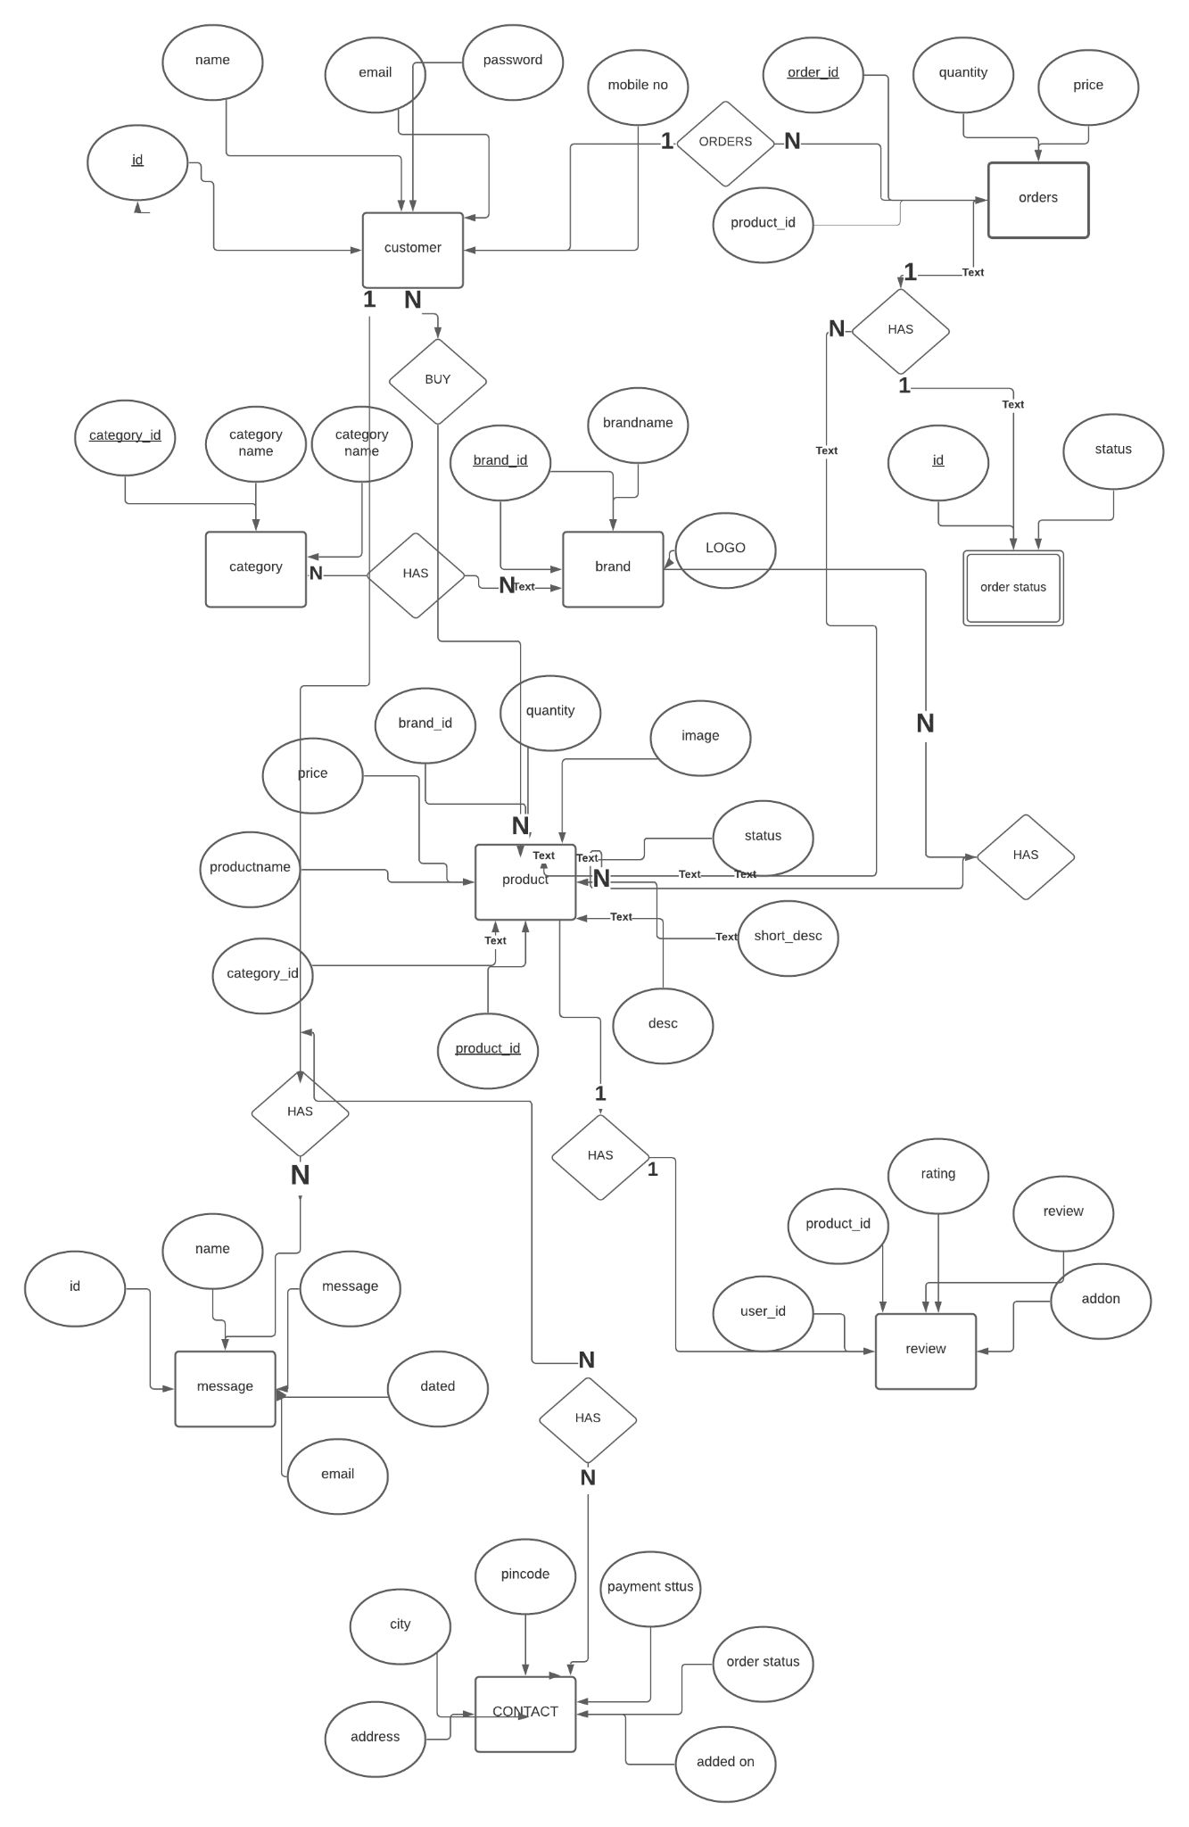

***8.1.2. Class Diagram***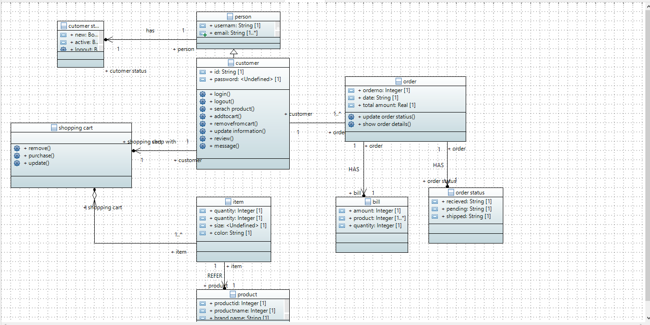

***8.1.3. Data Dictionary***

1. Account(**user_id**, name, **email**, password, email)
2. Categories(**category_id**, category_name)
3. Brands(**brand_id**, brand_name)
4. Products(**product_id**, category_id, brand_id, product_name, price, quantity, image, status, description)
5. Orders(**order_id**, user_id, address, city, pincode, payment_type, payment_status, order_id, total_amount, added_on)
6. Order Details(**id**, order_id, product_id, quantity, price)
7. Order Status(**id**, order_status)
8. Contact(**id**, name, email, message, dated)
9. Review(**id**, user_id, product_id, rating, review, added_on)

Note:

* Underlined & Bold : Primary Key
* Double Underlined : Foreign Key
* Bold : Unique

## 9. Application Design

## 9.1.2. Sequence Diagram

***9.1.2.1 <Sequence Diagram 1>***

*Admin is adding a product.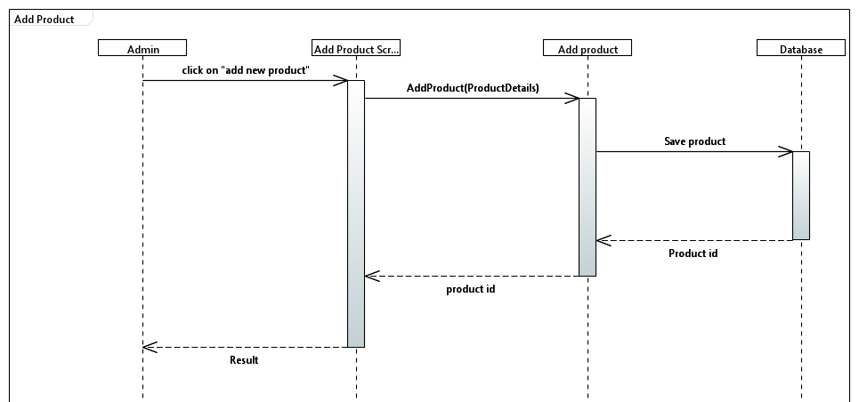*

***9.1.2.2 <Sequence Diagram 2>***

*Admin is Adding Brand.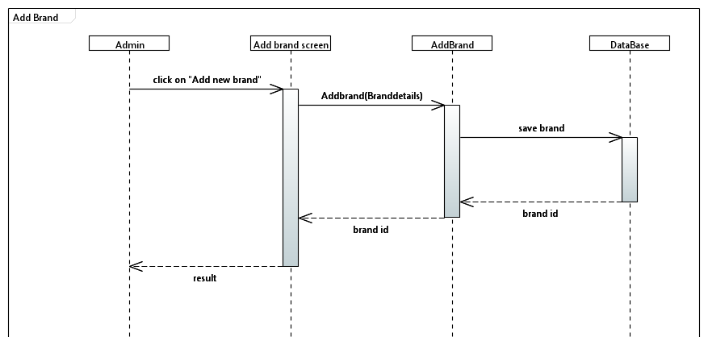*

*.*

*.*

***9.1.2.3 <Sequence Diagram 3>***

*Admin is adding Category.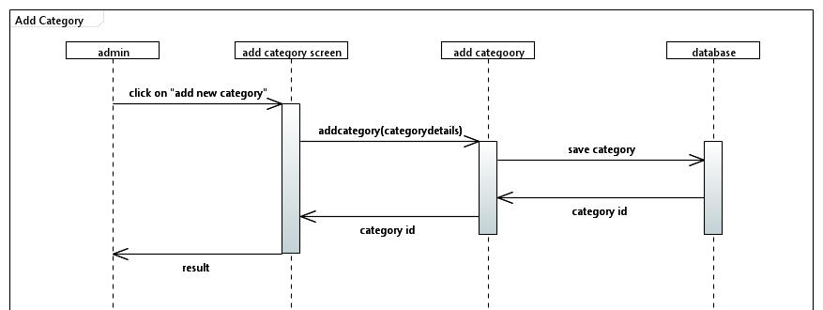*

***9.1.2.4 <Sequence Diagram 4>***

*Customer is Logging In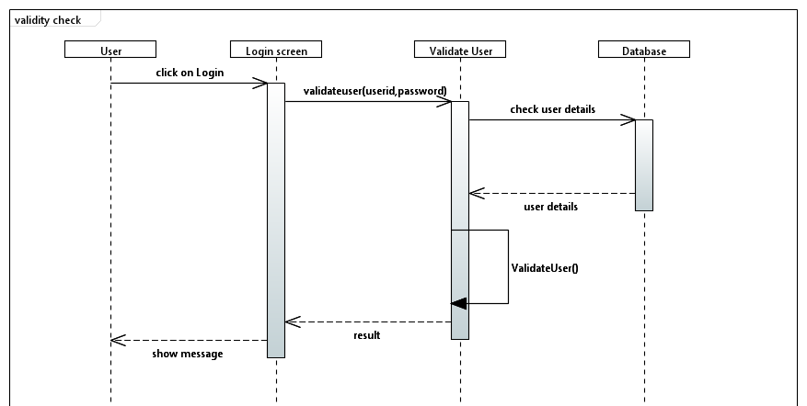*

***9.1.2.5 <Sequence Diagram 5>***

*Customer is registering himself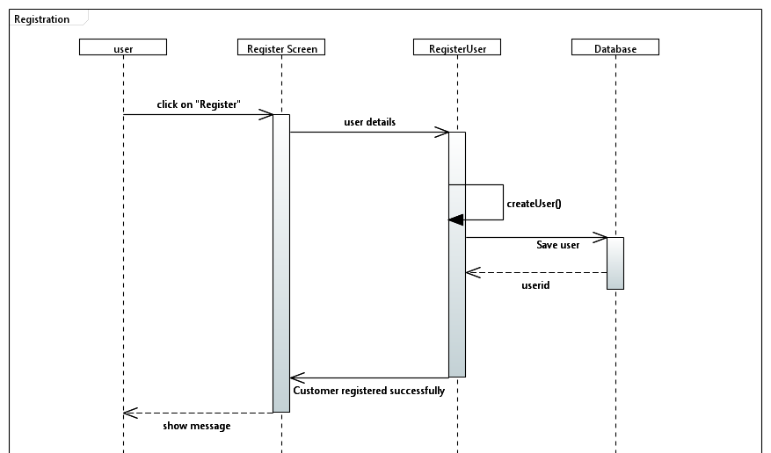*

***9.1.2.6 <Sequence Diagram 6>***

*Customer is purchasing Item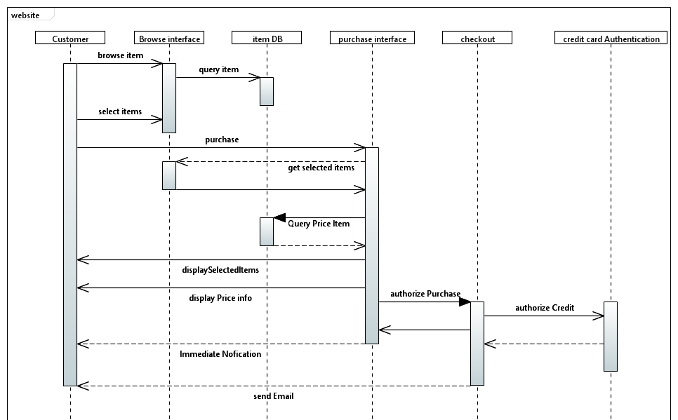*

***9.1.2.7 <Sequence Diagram 7>***

*Customer is managing Cart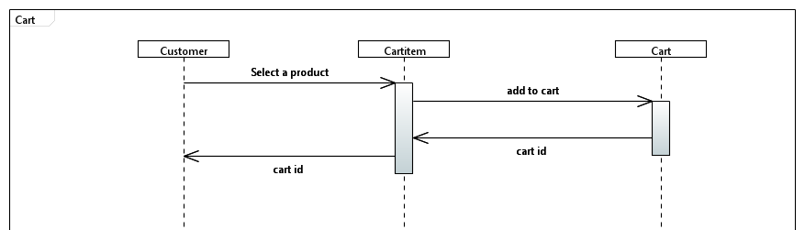*

***9.1.3. State Diagram***

***9.1.3.1 <State Diagram 1>***

*Customer browse the website and looking for his searching product, he view the product details, place order then he sign up or logged in view cart, if he want he can update cart or delete product from cart, then he checkout by providing details. Then customers can see order details and log out.*

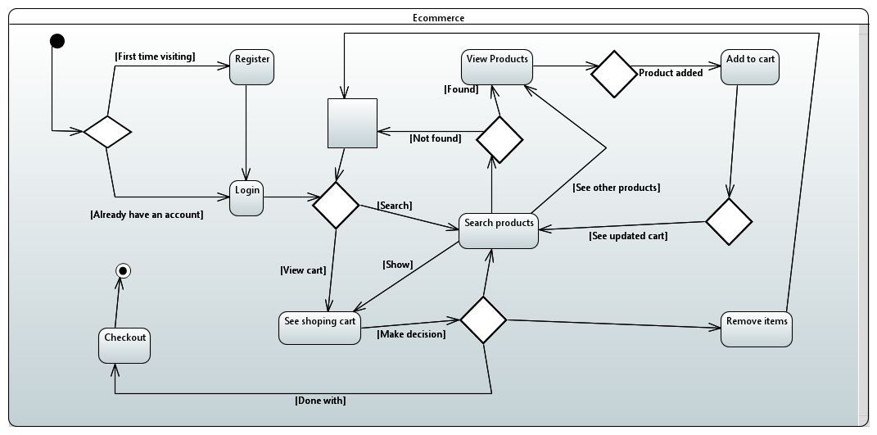

***9.1.4. Activity Diagram***

***9.1.4.1 <Activity Diagram 1>*** *Admin logged in to the website then he can add, edit and delete the product, also he can manage users and orders as well then he can log out of the website.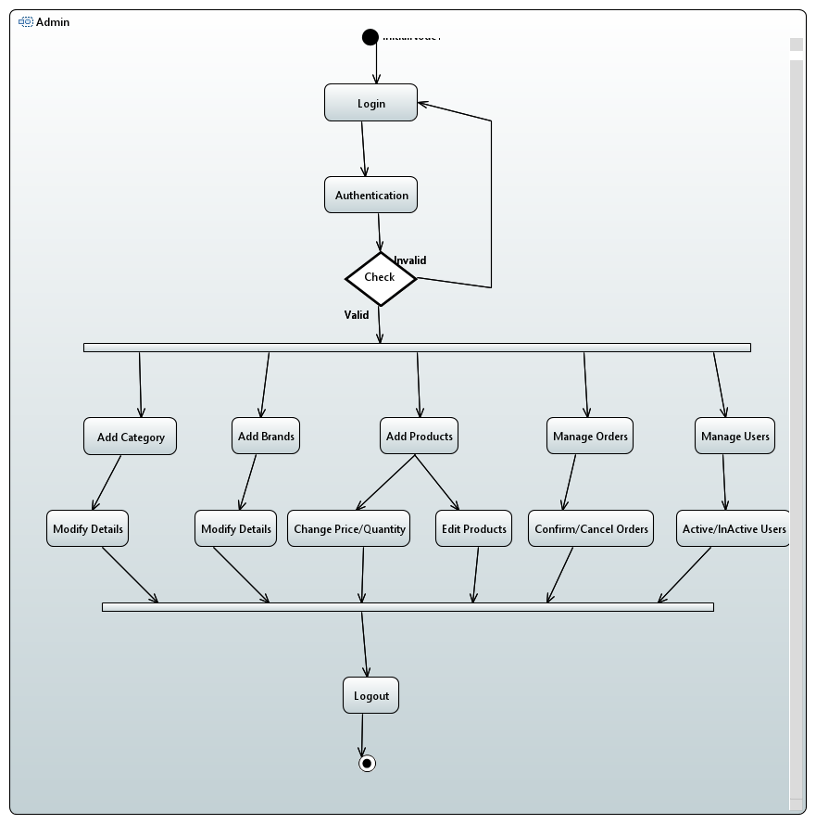*

***9.1.4.2 <Activity Diagram 2>***

*Customer browse the website and looking for his searching product, he view the product details, place order then he sign up or logged in view cart, if he want he can update cart or delete product from cart, then he checkout by providing details. Then customers can see order details and log out.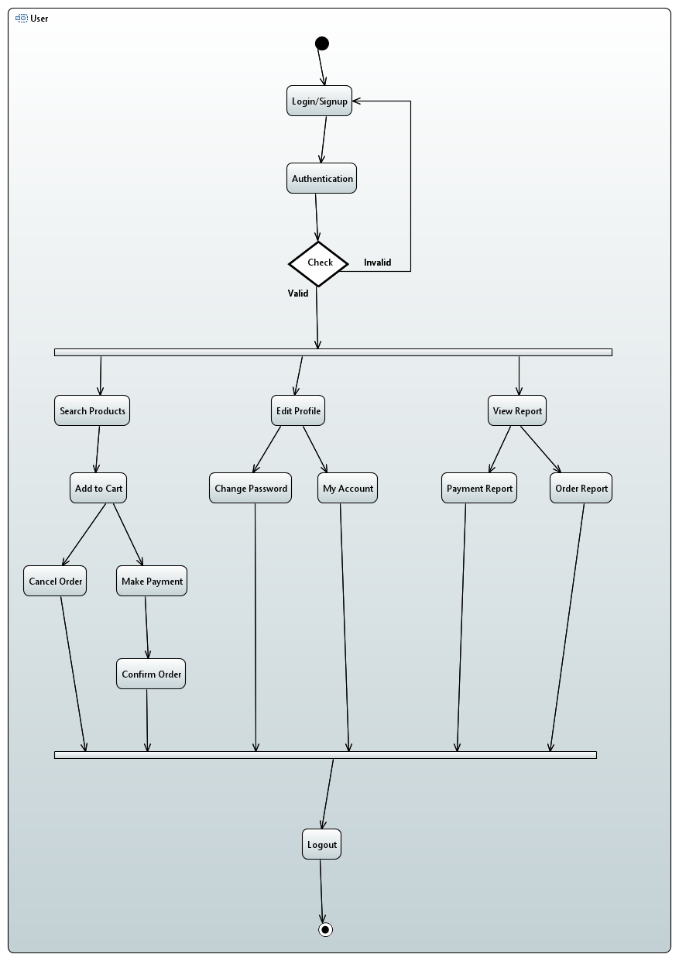*

***9.1.5. Collaboration Diagram***

***9.1.5.1 <Collaboration Diagram 1>***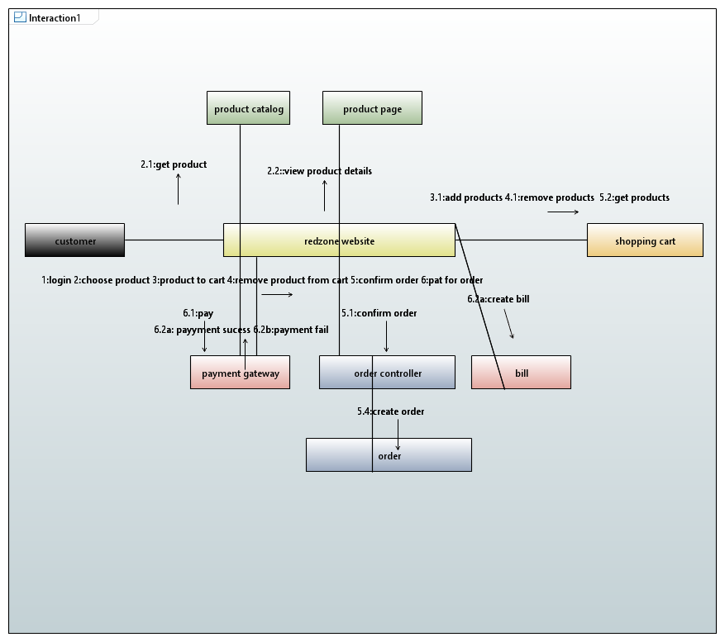

## 10. References

*Not Applicable.*

## 11. Appendices

*Not Applicable.*