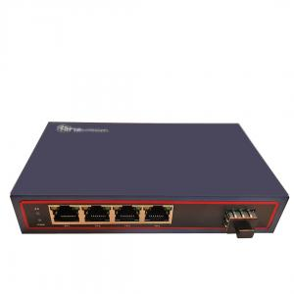

**Features:**

* Support the switch between 10/100Base-TX and 1000Base-SX/LX
* 1*1.25Gbps full-duplex fiber port, 4*100M Ethernet ports with auto-negotiation function
* Support 100M speed rate, MDI/MDIX and half/full-duplex with auto-negotiation function
* Each port has the complete LED Indicator light
* Support 100M speed rate, MDI/MDIX and half/full-duplex with auto-negotiation function
* Each port has the complete LED Indicator light
* Fiber port is SFP slot, choose different SFP modules as real demands
* Support IEEE802.1d Spanning Tree
* Support high performance QoS function on each port
* Support broadcast storm control
* Support 48-56V voltage input
* Support IEEE802.3x flow control and back pressure control
* Require no configuration and will instantly operate as soon as you power it up
* Using MARVEL industrial chips,low power consumption,stable and reliable
* Heat sink built in to ensure longtime efficient operation
* Support POE power up to 30W for each port, support IEEE802.3af, IEEE802.3at

**Description**:

The ITT-SW3914 is an Ethernet Fiber Switch which is specially designed for network monitoring. It has eight 10/100Mbps adaptive Ethernet ports which can support up to 30W power. It adopts imported Marvell chips to ensure low power consumption andhigh stability. It extends the transmission distance of a network from 550m to 100km via coppercables. There are also many other advantages such as isolation protection, good data security, working stability and easy maintenance.

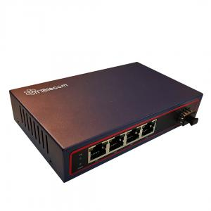

**Technical Parameters**:

|  |  |
| --- | --- |
| * **Standards** | * IEEE802.3 10Base-T * IEEE802.3u 100Base-TX/FX * IEEE802.3x Flow control * IEEE802.3z 1000Base-SX/LX * IEEE802.3af * IEEE802.1p QoS * IEEE802.1d Spanning Tree * IEEE802.3at |
| * **Certifications** | * CCC, CE, FCC, RoHS |
| * **Ethernet Port** | * Connector: RJ45 * Data Rate: 10/100M * Distance: 100m * UTP Type: UTP-5E or higher level |
| * **Fiber Port** | * Connector: SFP slot * Data Rate: 1.25Gbps * Distance: 550m～100km |
| * **Performance** | * Processing Type: Store and Forward * MAC Table Size: 8K * Buffer Space: 1Mbit * Back bandwidth: 2.8G * Time Delay: ＜150μs |
| * **POE** | * Power type: end span * Cell: 1/2+, 3/6- * Port characteristics: 15.4W/30W * Power supply: 65W |
| * **Power** | * Power type: external power supply * Input Voltage: AC100V～240V 50/60Hz * Connector: DC Socket * Working Voltage: 48-56V * Power Consumption: 1.4W～3.0W |
| * **Environment** | * Storage Temperature: -40～70℃ * Operating Temperature: -10～55℃ * Relative Humidity: 5-90% ( no condensation) |
| * **Physical Characteristics** | * Dimension: 160×84×26mm * Weight: 0.30kg * Color: Metal, Black |