

CSE311 Project Report

Project Name: Movie Reviewing website

**Submitted by:**

Name: Sheikh Tahmim Mehdi

ID: 1612139042

Group:3

## Introduction

There are lots of movies around these days and sometimes it’s difficult to choose a good movie to watch. We do have various movie reviewing platforms but these platforms sometimes have too many information and it confuses the users. So, the goal of the project was to present reviews in a more organized way which will help users to select a movie very easily. Some of the existing movie reviewing websites aren’t user friendly because searching for what you want is not easily gettable in those websites. But in this project the users can easily find the necessary information’s of a film.

## About the Movie Reviewing Website

This is a web-based platform which contains numerous films and this will allow different users to present their views on a film and hence it will connect users. The website will require the user to have an account to get access to the main content so there is a sign-up page for the users through which they are required to create an account. After they signup they will be directed to the home page which will show the collection of the films. Now the user must click on the movie that they want to review and this shall get them to the review page. The review page comes with the description of the film and all the reviews the film received till date. If the user wants to put a review, they just have to write the review on the textbox and post it. After posting the review a success message will show. The user will also be able to rate this film by filling the stars. There is one more thing which will allow users to decide if they want to watch the film or not and that is the average rating, by seeing the average rating one can decide about the quality of the film. If the user has rated the film the rating will also appear beside the review which will allow users to understand the reliability of the review. Moreover, there is comment section for all reviews so if a user has any query about a review, they may ask it on the comment section. To prevent spamming the website with reviews each user is only restricted to post one review for a film. The users can also can view their details in the profile page.

## Advantages

There are several advantages of using this website. Firstly, the users will have a platform where they can discuss movies. Additionally, it will save time by allowing the users to choose a good movie within a very short period of time. The user interface of the website is very simple so someone can easily go through the website to select a movie. Some people choose film by seeing the casts so this platform provides a description of the film through which they can see the cast of the movies and simply decide if they want to go for the movie. The rating system is a very well-known measure for judging the quality of a film so this will even make it easier and time efficient for the users to choose a particular movie.

## User Story:

Use case 1: User wants to review a film-

1. User needs to create an account and then choose a movie to give their review.
2. If the user already has an account s/he can just login to give a review.

Use case 2: If user wants to rate a film -

Existing users can login to rate a film and new users would require to signup to give a rating.

Use case 3: If the user wants to comment on a review –

The users need to choose the review where they want to comment and then write the comment on the text box and click the post button. For doing this the user needs to have an account.

## Movie Reviewing Website

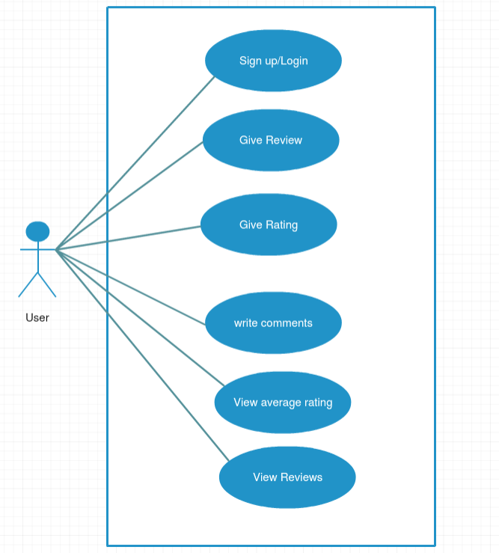

Figure : use case diagram of the website

## Database Schema:

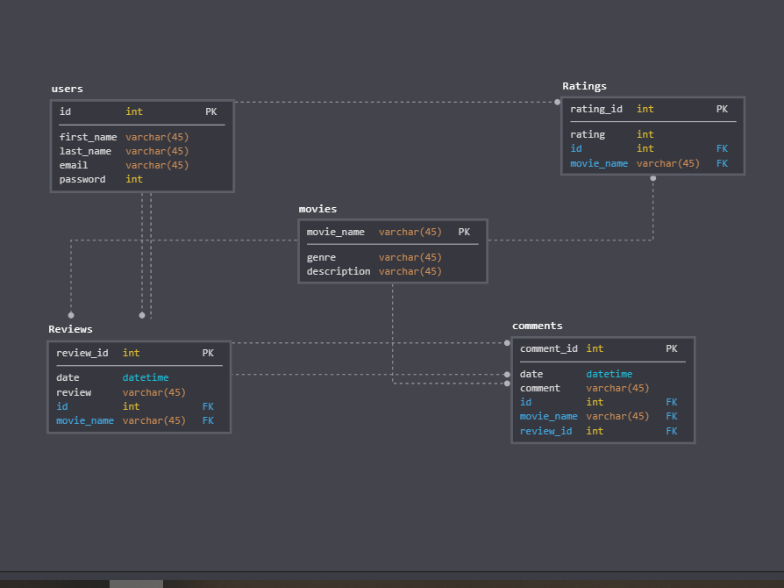

Figure 2: Database schema for the site.

The database comes with 5 tables users, movies, reviews, ratings and comments. The primary keys of each table are indicated by ‘pk’ in the above diagram. The user id and movie name act as a foreign key for the review table. And there are 3 foreign keys in the comments table. User id which comes from the users table, movie name which comes from the movies table and review id which comes from the reviews table. And both user id and movie name act as a foreign key in the ratings table.

## Business prospect

In the context of Bangladesh if this project is commercialized it can earn by selling advertising space on the website. It can also make money by doing publicity for the films.

## Tools and Technologies

* Database: Mysql
* PHP
* Javascript
* Ajax
* HTML, CSS
* Bootstrap

## Some screenshots of the website

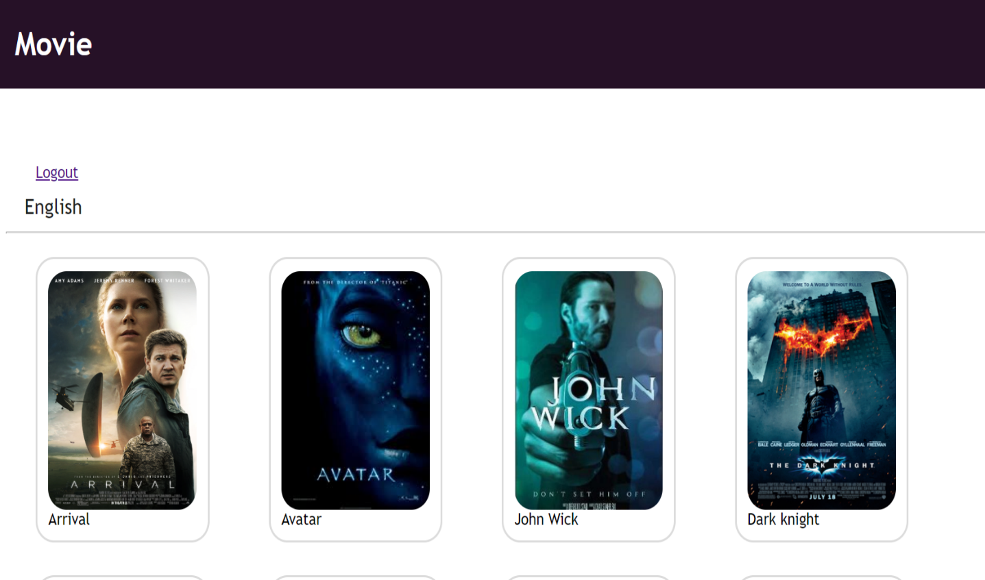

Figure 3: Home page

## Conclusion

This project has it

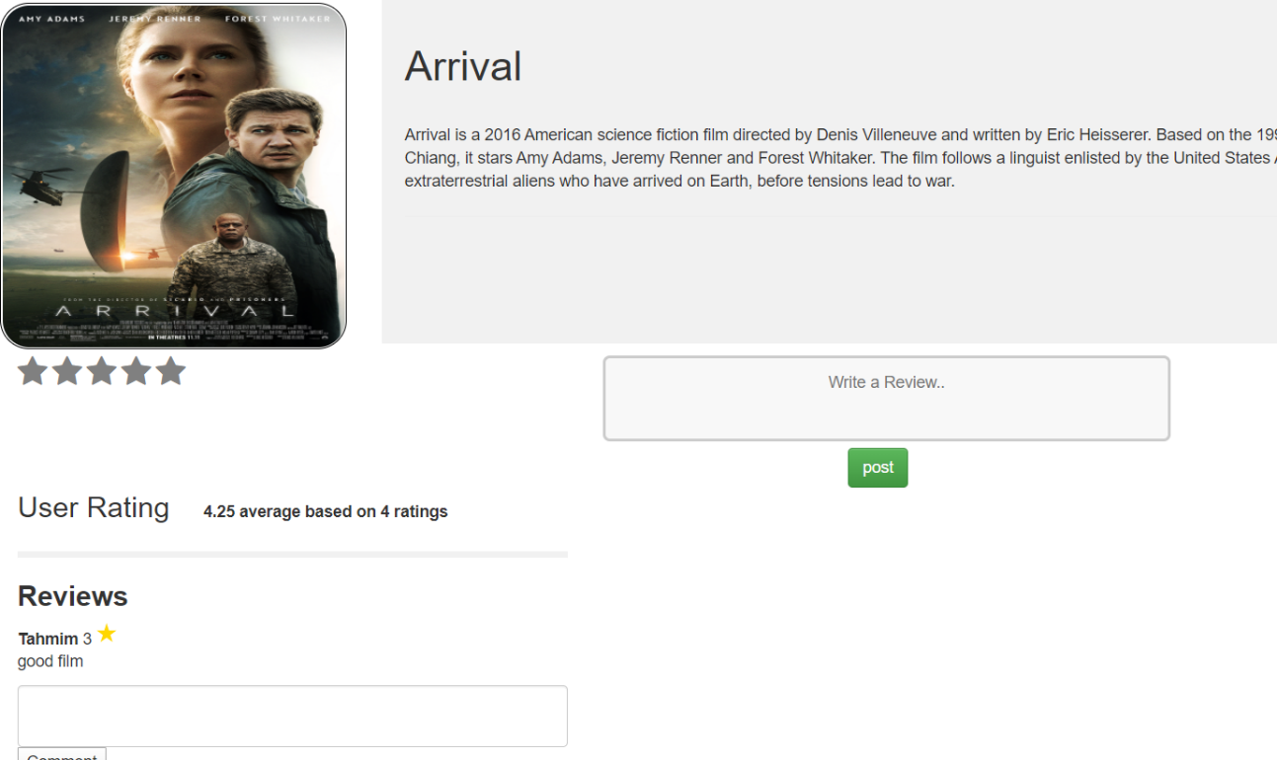Figure 4: Review page

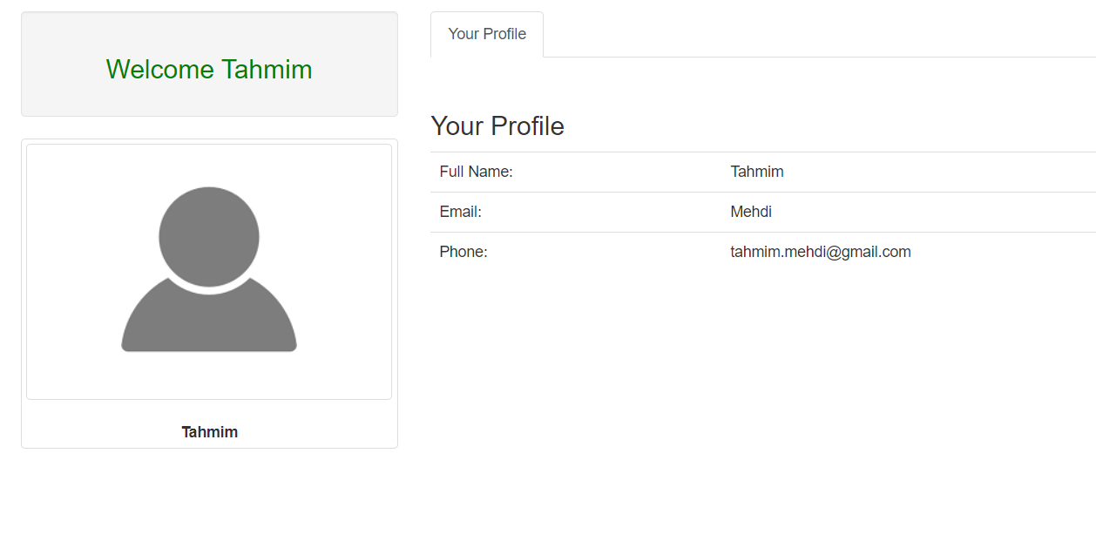

Figure 5: Profile page of the user

## Appendix

#### Contact Information

Name: Sheikh Tahmim Mehdi

ID: 1612139042

Mobile:01777113324

Email: [Tahmim.mehdi@gmail.com](mailto:Tahmim.mehdi@gmail.com)

Github: <https://github.com/mehditahmim/Movie-Review-Website>