RTMLib Mode Comparison Report
Same input video: data/raw/videos/tredmil0.mp4 | Modes: lightweight, balanced, performance
Key finding
- All three runs loaded the same local ONNX detector and pose models: models/detection/yolox_m_humanart.onnx and models/pose/rtmpose_m_body7.onnx.
- Because the configured local model files were identical, the keypoint CSVs and biomechanical feature CSVs are numerically identical across lightweight, balanced, and performance modes.
- The measured timing differences should be treated as runtime observations for this machine and run order, not as proof of different model accuracy.
Main comparison table
Mode | Pose sec | Pose FPS | Total sec | Total FPS | Keypoint rows | Avg conf | Low ratio | Feature rows
lightweight | 57.72 | 15.38 | 66.07 | 13.44 | 15,096 | 0.843688 | 0.0000 | 888
balanced | 51.77 | 17.15 | 55.96 | 15.87 | 15,096 | 0.843688 | 0.0000 | 888
performance | 49.32 | 18.00 | 53.21 | 16.69 | 15,096 | 0.843688 | 0.0000 | 888
Table 1. Pipeline speed and pose-quality outputs for the three RTMLib mode settings.
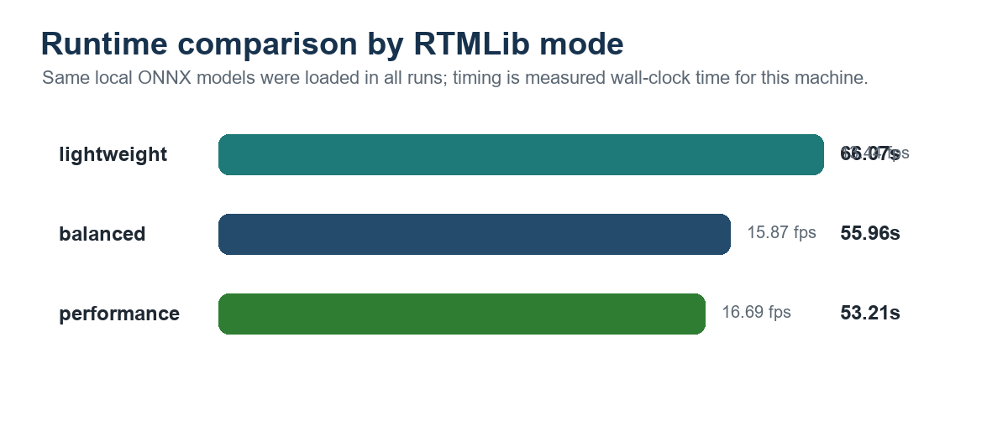
Figure 1. Total measured runtime for pose estimation, smoothing, and feature extraction.
Biomechanical feature comparison
Mode | Left knee mean | Right knee mean | Trunk lean mean | Knee diff mean | Hip diff mean
lightweight | 121.962 | 139.678 | 1.214 | 49.033 | 15.008
balanced | 121.962 | 139.678 | 1.214 | 49.033 | 15.008
performance | 121.962 | 139.678 | 1.214 | 49.033 | 15.008
Table 2. Mean OpenCap-inspired 2D feature values. Identical values confirm that the same local ONNX models produced the same keypoints in all three runs.
Generated outputs
Mode | Keypoints CSV | Quality report | Feature CSV
lightweight | data\processed\keypoints\keypoints_lightweight.csv | data\outputs\reports\mode_comparison\pose_quality_lightweight.csv | data\processed\biomechanics\opencap_style_features_lightweight.csv
balanced | data\processed\keypoints\keypoints_balanced.csv | data\outputs\reports\mode_comparison\pose_quality_balanced.csv | data\processed\biomechanics\opencap_style_features_balanced.csv
performance | data\processed\keypoints\keypoints_performance.csv | data\outputs\reports\mode_comparison\pose_quality_performance.csv | data\processed\biomechanics\opencap_style_features_performance.csv
Interpretation for presentation
- If the goal is to compare true lightweight, balanced, and performance model presets, the next step is to run without forcing the same local model paths or to configure separate ONNX checkpoints per preset.
- For the current reproducible local-model setup, balanced/performance/lightweight are useful CLI labels, but the actual loaded model files are the same in the logs.
- Best conclusion: the pipeline is stable across mode settings under the current local model configuration; measured speed varies, while output quality and features are unchanged.
References
[1] RTMPose: https://arxiv.org/abs/2303.07399 | [2] RTMLib: https://github.com/Tau-J/rtmlib | [3] ONNX Runtime CUDA: https://onnxruntime.ai/docs/execution-providers/CUDA-ExecutionProvider.html | [4] pandas rolling: https://pandas.pydata.org/docs/reference/api/pandas.DataFrame.rolling.html

