Computer Vision Pipeline for Human Posture and Sports Movement Analysis
Presentation scenario for a 15-slide academic project discussion
Key message: This project is a reproducible 2D sports posture analysis prototype, not full OpenCap, not calibrated 3D biomechanics, and not clinical diagnosis.
- Goal: convert ordinary sports video into inspectable 2D pose keypoints, annotated frames, quality metrics, and simple posture features.
- Main experiment: treadmill running video, 888 frames, 30 FPS, 29.60 seconds, 640 x 360 resolution.
- Presentation angle: show the pipeline, explain model/tool choices, present results, and define the scientific limits honestly.
Refs: [1] repository; [3] RTMPose; [5] OpenCap; [6] Pose2Sim.

2. Research Motivation and Problem
Why a modular video-based posture pipeline is useful
Key message: Video-based posture analysis can support rapid sports movement screening, but 2D outputs must be interpreted carefully.
- Manual movement review is slow and subjective; computer vision can make posture evidence easier to save, compare, and discuss.
- Sports and exercise videos are practical inputs because they can be captured with common cameras, but viewpoint and occlusion affect measurements.
- The academic problem is not only estimating keypoints; it is making the pipeline reproducible, inspectable, and scientifically bounded.
Refs: [2] OpenCV; [5] OpenCap; [6] Pose2Sim; [7] video-based 2D/3D limitations.

3. Full Pipeline Architecture
From raw video to visual and tabular posture outputs
Key message: The project is built as a layered pipeline so every stage can be inspected before downstream interpretation.
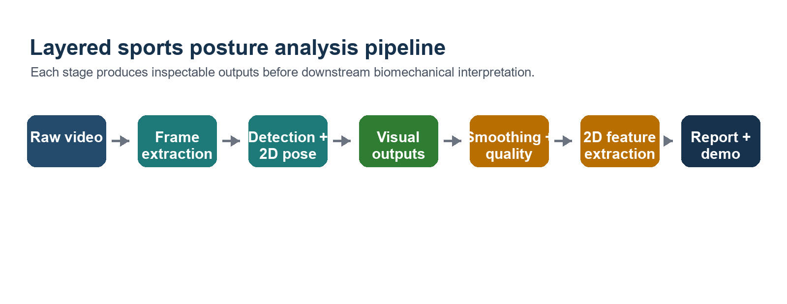
Figure: layered pipeline used in the project.
Refs: [1] repository architecture; [2] OpenCV; [3] RTMPose; [8] pandas rolling.

4. Repository and Software Architecture
Reusable modules are separated from executable scripts
Key message: The repository is organized so future tracking, 3D pose, actions, and risk modules can be added without rewriting the current pipeline.
Layer | Current role | Why it matters
src/hpa/ | Reusable scientific pipeline package | Keeps video, pose, smoothing, and features reusable
src/scripts/ | Command-line entry points | Makes experiments repeatable from terminal commands
configs/ | Default and model configuration | Makes paths and model choices explicit
data/ | Raw, interim, processed, and output folders | Separates input data from derived artifacts
reports/ | Academic reports and presentation outputs | Keeps submission material organized
Refs: [1] repository; [9] Python src-layout packaging guidance.

5. Tools and Model Choices
Why these tools were selected for the prototype
Key message: The stack prioritizes practical installation, local reproducibility, and enough model quality for a working academic prototype.
Tool/model | Project role | Reason for selection
OpenCV | Video I/O, frame extraction, live display | Standard, practical library for reading and displaying video
RTMLib + RTMPose | 2D human pose estimation | Simple API, fast RTMPose models, easier than full MMPose setup
ONNX Runtime CUDA | Local accelerated inference | Deployable runtime with GPU execution provider
pandas | CSV processing and smoothing | Clear tabular operations and rolling-window smoothing
Matplotlib | Feature plots | Simple reproducible plots for report and presentation
Refs: [2] OpenCV; [3] RTMPose; [4] RTMLib; [8] pandas rolling; [10] ONNX Runtime CUDA.

6. Model Management and Reproducibility
Local model paths make experiments explicit
Key message: The project avoids relying only on hidden cache downloads by documenting local detection and pose model paths.
- Detection model path: models/detection/yolox_m_humanart.onnx.
- Pose model path: models/pose/rtmpose_m_body7.onnx.
- If local files are missing, the code warns the user and can fall back to RTMLib defaults instead of silently hiding the behavior.
- This matters academically because model name, model path, backend, device, and parameters affect reproducibility.
Refs: [3] RTMPose; [4] RTMLib; [10] ONNX Runtime CUDA.

7. Experimental Setup
The reported experiment is tied to one explicit video and parameter set
Key message: Every reported result should be connected to video characteristics, model paths, runtime backend, and analysis parameters.
Experimental item | Value
Input video | data/raw/videos/tredmil0.mp4
Resolution | 640 x 360
Duration | 29.60 s
Frame rate | 30 FPS
Total video frames | 888
Frame extraction step | 1
Detector model path | models/detection/yolox_m_humanart.onnx
Pose model path | models/pose/rtmpose_m_body7.onnx
Backend / device | ONNX Runtime / CUDA
Mode | lightweight
Confidence threshold | 0.3
Smoothing window | 5 frames
Refs: [2] OpenCV; [3] RTMPose; [10] ONNX Runtime CUDA; [8] pandas rolling.

8. Execution Commands
Reproducible command sequence used for the project
Key message: The experiment can be repeated because setup, model download, frame extraction, pose estimation, smoothing, features, and live demo commands are explicit.
python -m venv .venv
.venv\Scripts\activate
pip install -r requirements.txt
pip install -e .
python src/scripts/download_models.py
python src/scripts/extract_frames.py --video data/raw/videos/tredmil0.mp4 --output data/interim/frames --step 1
python src/scripts/run_pose_on_frames.py --input data/interim/frames --output-csv data/processed/keypoints/keypoints.csv --output-frames data/outputs/annotated_frames --device cuda --mode lightweight
python src/scripts/smooth_keypoints.py --input data/processed/keypoints/keypoints.csv --output data/processed/smoothed_keypoints/smoothed_keypoints.csv --quality-report data/outputs/reports/pose_quality.csv --window-size 5
python src/scripts/extract_opencap_style_features.py --input data/processed/smoothed_keypoints/smoothed_keypoints.csv --output data/processed/biomechanics/opencap_style_features.csv --plots-dir data/outputs/reports/opencap_style_plots --confidence-threshold 0.3
python src/scripts/live_pose_demo.py --video data/raw/videos/tredmil0.mp4 --device cuda --mode lightweight --max-width 640
Refs: [1] repository scripts; [4] RTMLib; [10] ONNX Runtime CUDA.

9. Offline Frame-Based Pipeline Results
Persistent outputs support reproducible academic reporting
Key message: The offline pipeline produced complete CSV, image, quality, and feature outputs for all 888 frames.
Quality metric | Value
Processed frames | 888
Keypoint rows | 15,096
Unique detected persons | 1
Keypoints per frame/person | 17
Average confidence | 0.843688
Low-confidence count below 0.3 | 0
Low-confidence ratio below 0.3 | 0.0000
Smoothed keypoint rows | 15,096
Biomechanical feature rows | 888
Refs: [3] RTMPose; [11] COCO keypoint format; [8] pandas rolling.

10. Visual Pose Estimation Results
Annotated frames are the first qualitative sanity check
Key message: High confidence is useful, but visual QA is still required to check whether the skeleton is attached to the visible body.
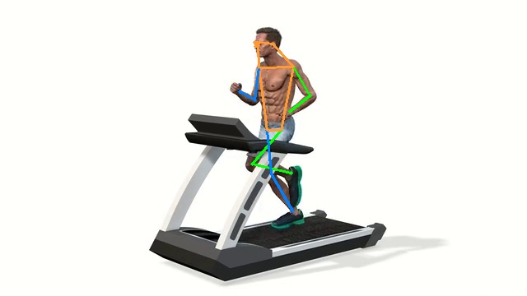 | 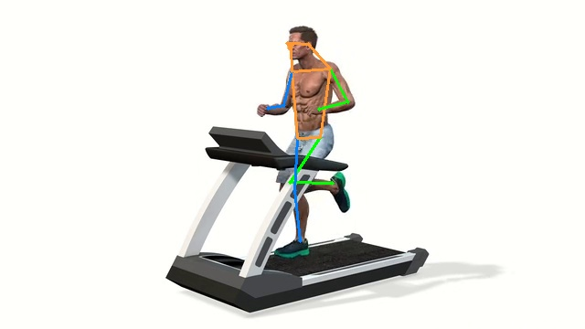
Frame 000014: early gait phase with visible body landmarks. | Frame 000375: different gait phase with one leg more flexed.
Refs: [2] OpenCV visualization; [3] RTMPose; [7] 2D interpretation limits.

11. Temporal Smoothing and Quality Checking
Smoothing prepares keypoints for feature extraction
Key message: The smoother reduces frame-to-frame coordinate jitter while keeping confidence unchanged as a diagnostic signal.
- Input: raw keypoints CSV with frame_name, person_id, keypoint_id, x, y, confidence.
- Method: moving average over x and y per person_id and keypoint_id in frame order.
- Window size: 5 frames, reported as an experimental parameter.
- Quality report: total keypoints, average confidence, low-confidence count, low-confidence ratio, frames processed.
- Confidence is not smoothed because it should remain available for reliability filtering.
Refs: [8] pandas rolling; [3] RTMPose confidence; [7] video-based kinematics limitations.

12. OpenCap-Inspired 2D Feature Extraction
Interpretable posture features from smoothed 2D keypoints
Key message: The feature layer is OpenCap-inspired, but it is not the full OpenCap system and does not produce validated 3D biomechanics.
Feature | Meaning in this prototype
Left/right knee angle | 2D image-plane angle from hip, knee, and ankle landmarks
Left/right hip angle | 2D angle using shoulder, hip, and knee landmarks
Trunk lean angle | 2D trunk orientation estimate from shoulder/hip landmarks
Knee/hip angle difference | Instantaneous left-right difference, not clinical asymmetry
Mean pose confidence | Frame-level reliability indicator for feature interpretation
Low-confidence flag | Quality screen based on configured confidence threshold
Refs: [5] OpenCap; [6] Pose2Sim; [7] 2D/3D kinematics limitations; [11] COCO keypoints.

13. Biomechanical Plots and Result Interpretation
The plots show cyclic 2D movement behavior over time
Key message: Knee and hip curves show repeated running cycles; trunk lean stays close to upright; angle difference is instantaneous, not clinical asymmetry.
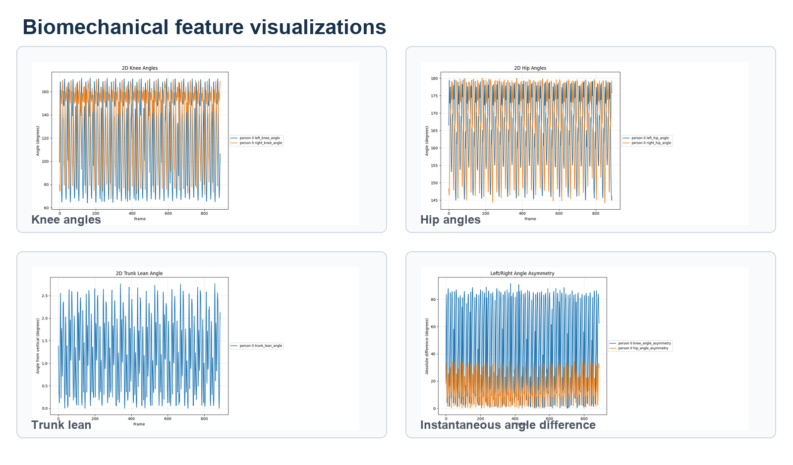
Figure: knee, hip, trunk lean, and instantaneous left-right angle-difference plots.
Refs: [5] OpenCap; [6] Pose2Sim; [7] 2D/3D kinematics limitations.

14. Live Pose Demo vs Offline Analysis
Two workflows for two different presentation needs
Key message: Live pose is best for demonstration; offline frame-based analysis is stronger for reproducibility and debugging.
Criterion | Live pose demo | Offline frame-based pipeline
Main purpose | Real-time demonstration | Reproducible analysis
Speed priority | High | Medium
Debugging | Visual only unless saved | Strong, because intermediate files exist
Reproducibility | Lower unless CSV/video are saved | Higher because outputs are persistent
Best use | Demo and quick inspection | Reported experiment and feature extraction
Accuracy interpretation | Useful for visual plausibility | Better for quantitative summaries and plots
Refs: [2] OpenCV live display; [3] RTMPose; [10] ONNX Runtime CUDA.

15. Limitations, Roadmap, and Closing Message
A strong 2D prototype with a clear path toward validated biomechanics
Key message: The current system is ready for academic demonstration, but stronger claims require validation and calibrated 3D workflows.
Area | Status / next step
Implemented | Video I/O, frame extraction, 2D pose, live demo, smoothing, quality report, OpenCap-inspired 2D features
Main limitation | 2D image-plane measurements are not true 3D anatomical joint angles
Tracking | Future independent detection export and multi-person tracking
3D biomechanics | Future Pose2Sim/OpenCap-style validation with calibrated capture
Higher-level analysis | Future action recognition, fatigue/risk scoring, and dashboard only after validation
Closing line | The project is a reproducible, modular 2D sports posture pipeline with honest scientific boundaries
Refs: [5] OpenCap; [6] Pose2Sim; [7] 2D/3D kinematics limitations; [12] MMPose.

