

|  |  |
| --- | --- |
| Submitted By  Name: Muhammd Mehedi Hasan  Reg: 23201143  Section: C  Subject: CSE 108 | Submitted To  Name: Zaima Sartaj Taheri  Lecturer  Department of Computer Science and Engineering, [University of Asia Pacific](https://uap-bd.edu/) |

Problem : **Growing Sequences**

#include <stdio.h>

int main(){

int n, i;

while(1){

scanf("%d", &n);

if(n == 0)break;

printf("1");

for(i = 2; i <= n;i++)

printf(" %d", i);

printf("\n");

}

return 0;

}

Output:

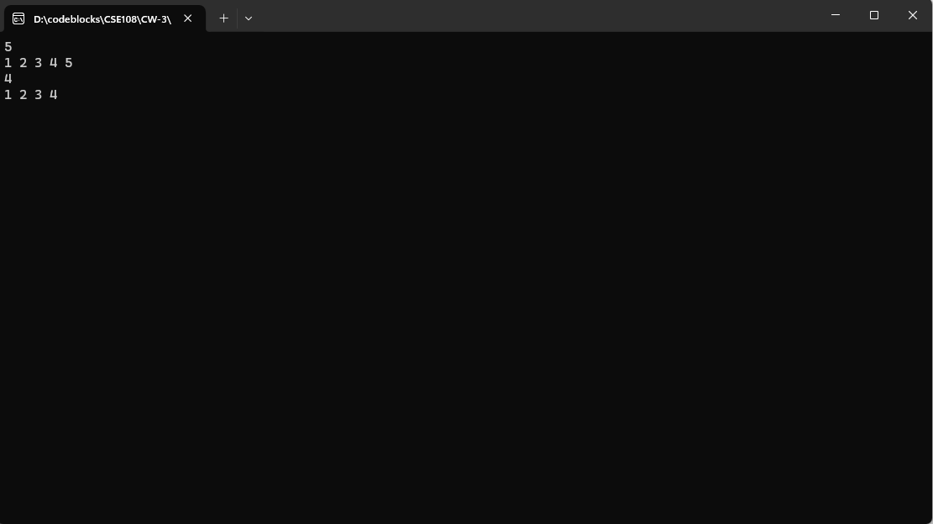

Submission:

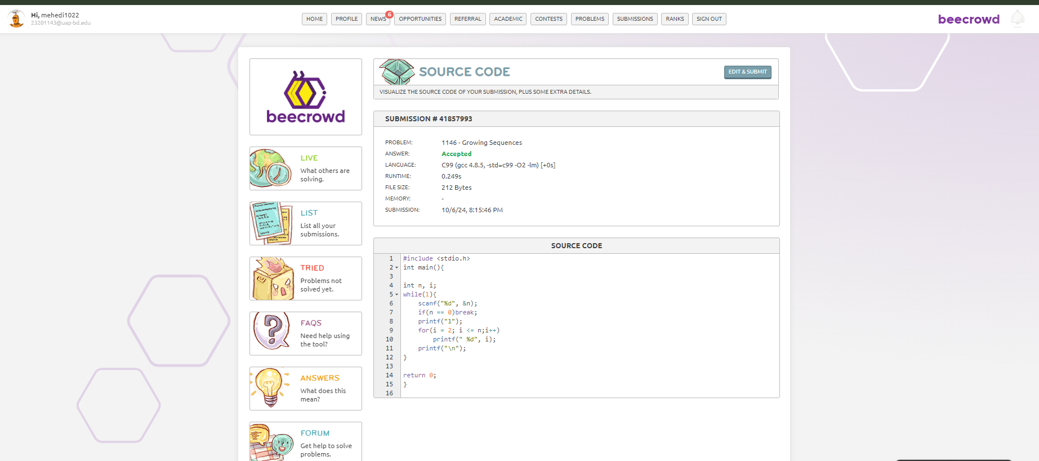

Problem: **Multiples of 13**

#include <stdio.h>

int main(){

int i, a, b, temp, s = 0;

scanf("%d %d", &a, &b);

if(a > b){temp = a; a = b; b = temp;}

for(i = a; i <= b; i++){

if(i % 13 != 0) {

s += i;

}

}

printf("%d\n",s);

return 0;

}

Output:

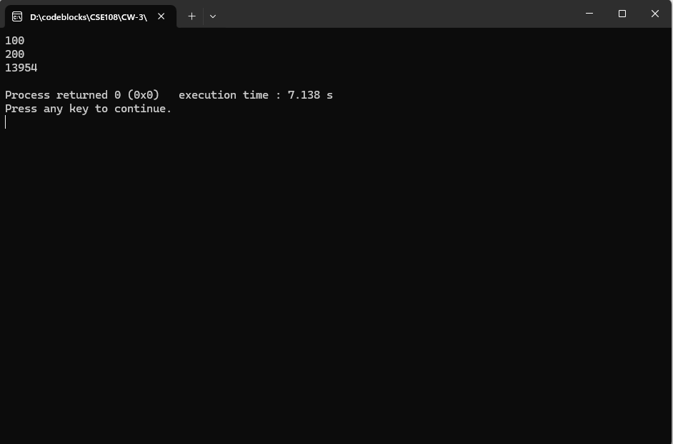

Submission:

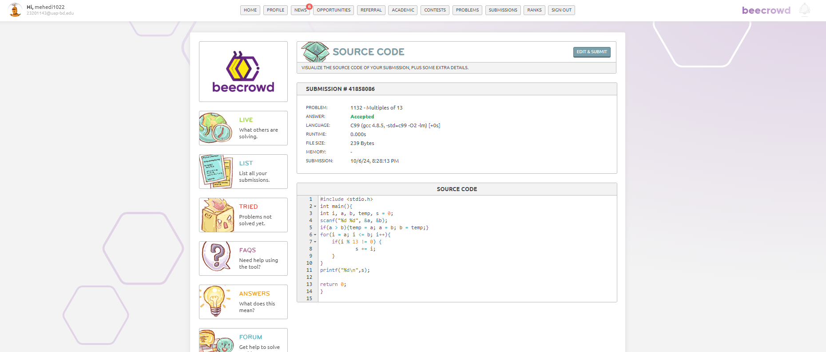

Problem: **Rest of a Division**

#include <stdio.h>

int main(){

int x, y, temp, i;

scanf("%d %d", &x, &y);

if(x > y){

temp = x; x = y; y = temp;

}

x++;

for(i = x; i < y; i++){

if(i % 5 == 2 || i % 5 == 3){

printf("%d\n", i);

}

}

return 0;

}

Output:

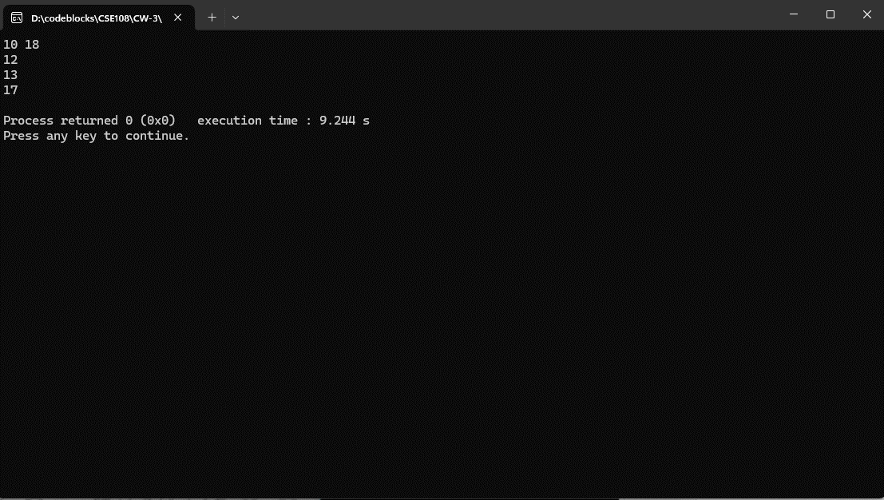

Submission:

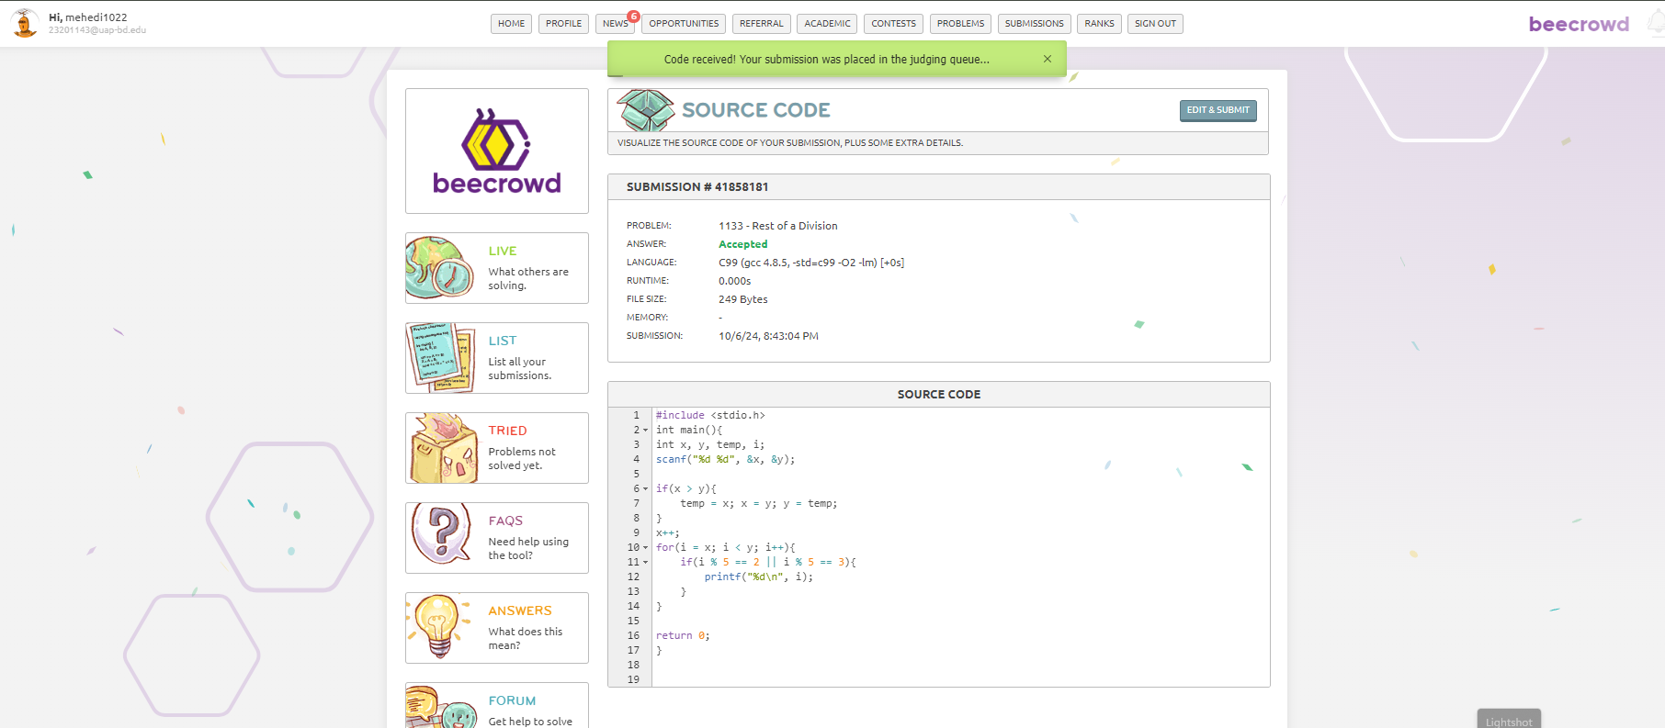

Problem: **Easy Fibonacci**

#include <stdio.h>

int main(){

int n, i, N[100];

scanf("%d", &n);

N[0] = 0;

N[1] = 1;

for(i = 2; i < n; i++){

N[i] = N[i - 1] + N[i - 2];

}

printf("0");

for(i = 1; i < n; i++){

printf(" %d", N[i]);

}

printf("\n");

return 0;

}

Output:

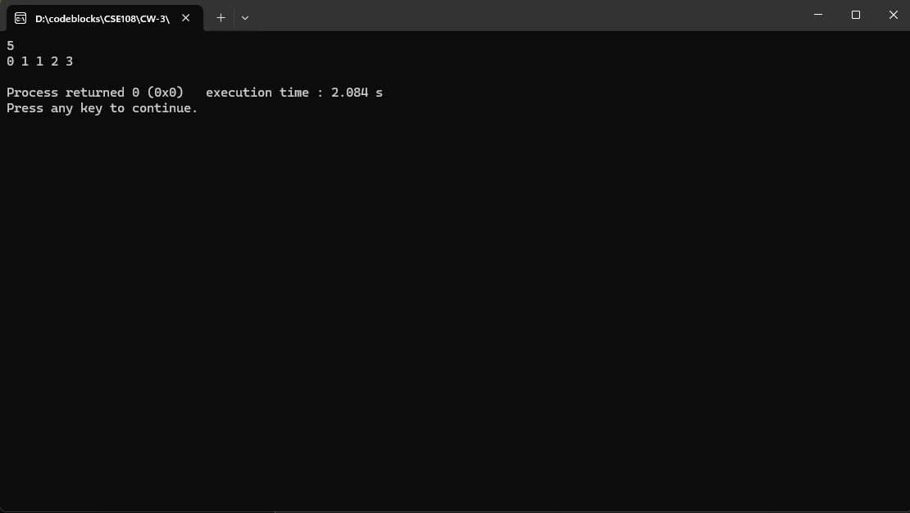

Submission:

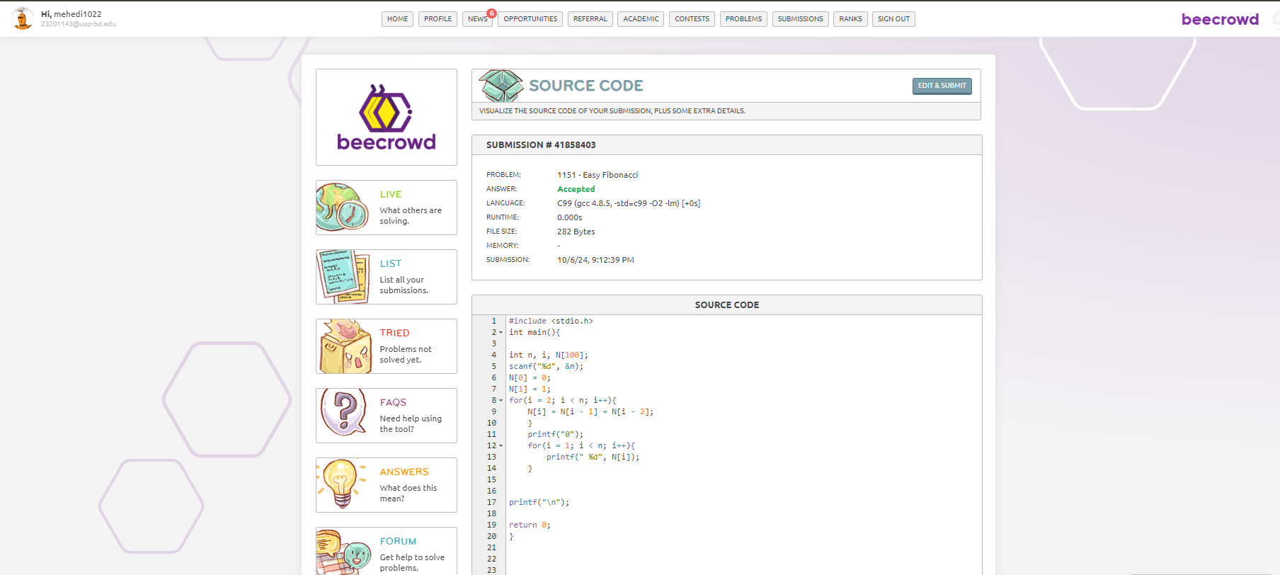

Problem: **Simple Factorial**

#include <stdio.h>

int main(){

int n, s = 1, i;

scanf("%d", &n);

for(i = n; i >= 1; i --){

s = s * i;

}

printf("%d\n", s);

return 0;

}

Output:

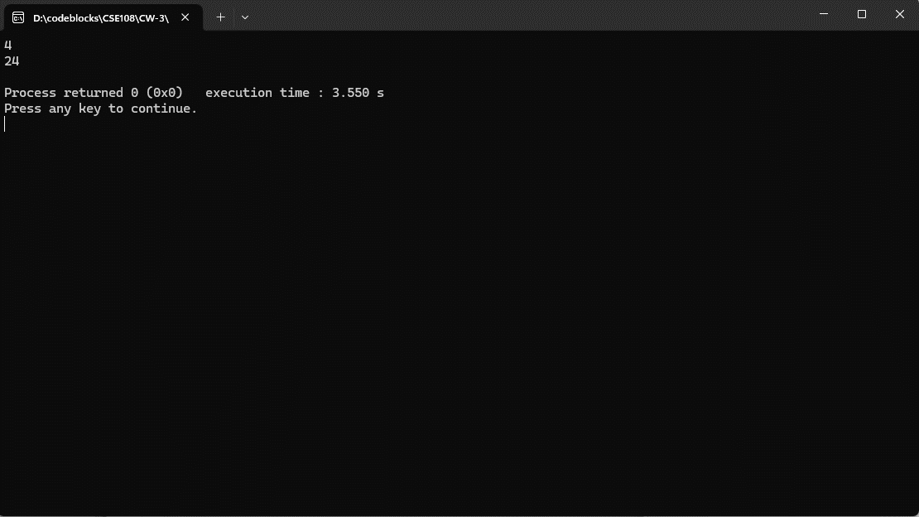

Submission:

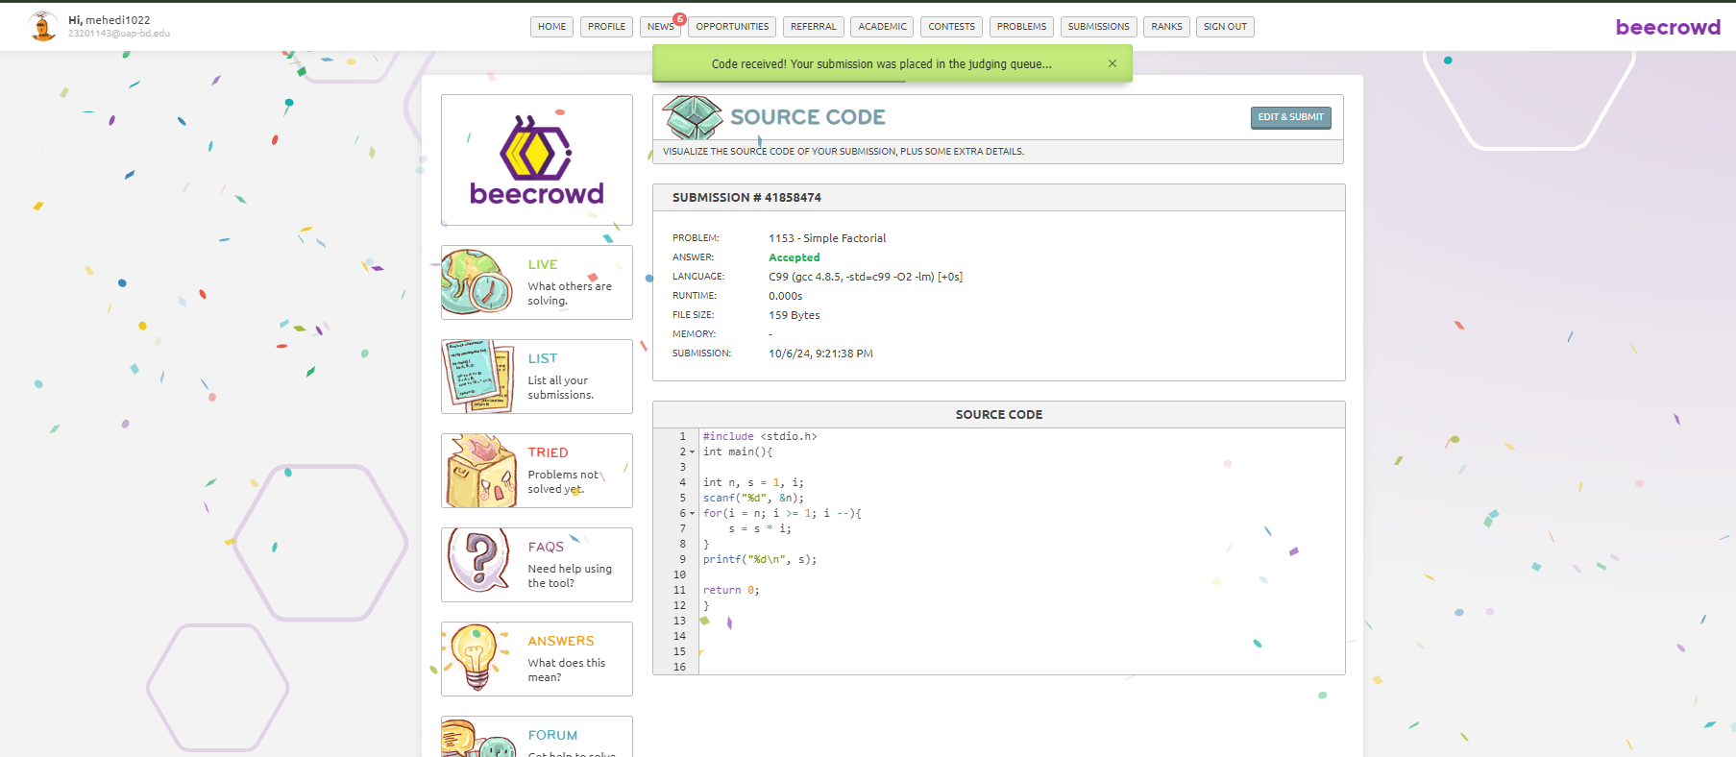

Problem: **Surname is not Easy**

#include <stdio.h>

#include <string.h>

int main()

{

int N;

char vowels[] = "aeiouAEIOU";

scanf("%d", &N);

char surname[43];

for (int i = 0; i < N; i++)

{

scanf("%s", surname);

int len = strlen(surname);

int consonant_count = 0;

int is_hard = 0;

for (int j = 0; j < len; j++)

{

if (strchr(vowels, surname[j]) == NULL)

{

consonant_count++;

if (consonant_count >= 3)

{

is_hard = 1;

break;

}

}

else

{

consonant_count = 0;

}

}

if (is_hard)

{

printf("%s nao eh facil\n", surname);

}

else

{

printf("%s eh facil\n", surname);

}

}

return 0;

}

Output:

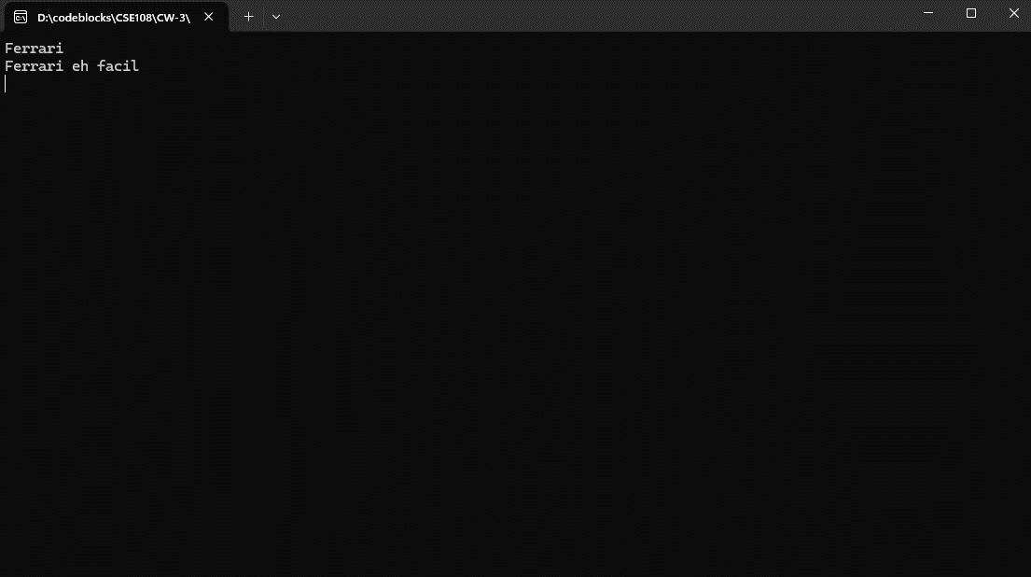

Submission:

