

|  |  |
| --- | --- |
| Submitted By  Name: Muhammd Mehedi Hasan  Reg: 23201143  Section: C  Subject: CSE 108 | Submitted To  Name: Zaima Sartaj Taheri  Lecturer  Department of Computer Science and Engineering, [University of Asia Pacific](https://uap-bd.edu/) |

1. Write a C program to find the greatest common divisor (gcd) of two numbers using Euclid's algorithm.

#include <stdio.h>

int gcd(int a, int b) {

while (b != 0) {

int temp = b;

b = a % b;

a = temp;

}

return a;

}

int main() {

int num1, num2;

printf("Enter two integers: ");

scanf("%d %d", &num1, &num2);

int result = gcd(num1, num2);

printf("GCD of %d and %d is %d\n", num1, num2, result);

return 0;

}

Output:

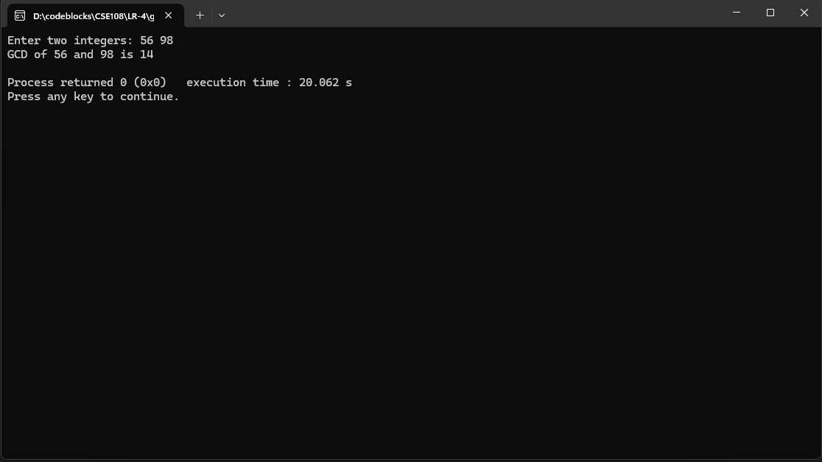

2 .   Develop a C program to calculate the least common multiple (lcm) of two numbers using their gcd.

#include <stdio.h>

int main() {

int num1,num2,i,a,b;

printf("enter two number's : \n");

scanf("%d %d",&num1,&num2);

a=num1;

b=num2;

for(i=1;;i++){

if(num1>num2){

num1=num1-num2;

}

else if(num1<num2){

num2-=num1;

}else{

printf("%d is GCD\n",num1);

break;

}

}

printf("LCM is %d",(a*b)/num1);

return 0;

}

Output:

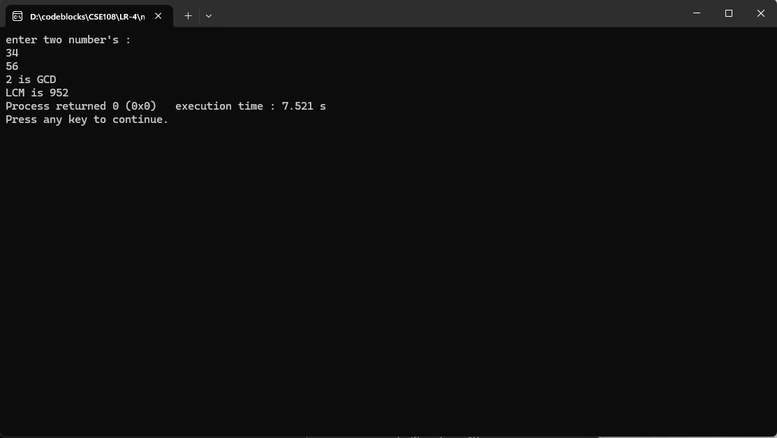

3 . Create a C program to check whether a given number is prime or not.

#include <stdio.h>

int main() {

int i,num,k=1;

printf("Enter a number : ");

scanf("%d",&num);

if (num%2!=0){

for(i=k+2;i<=num/2;i++){

if(num%i==0){

k=1;

break;

}

else{

k=0;

}

}

if(k==1){

printf("The number is not prime");

}else{

printf("The number is prime");

}

} else{

if(num==2){

printf("The number is prime");

}else{

printf("The number is not prime");

}

}

return 0;

}

Output:

