

|  |  |
| --- | --- |
| Submitted By  Name: Muhammd Mehedi Hasan  Reg: 23201143  Section: C  Subject: CSE 108 | Submitted To  Name: Zaima Sartaj Taheri  Lecturer  Department of Computer Science and Engineering, [University of Asia Pacific](https://uap-bd.edu/) |

1132 - Multiples of 13

#include <stdio.h>

int main(){

int i, a, b, temp, s = 0;

scanf("%d %d", &a, &b);

if(a > b){temp = a; a = b; b = temp;}

for(i = a; i <= b; i++){

if(i % 13 != 0) {

s += i;

}

}

printf("%d\n",s);

return 0;

}

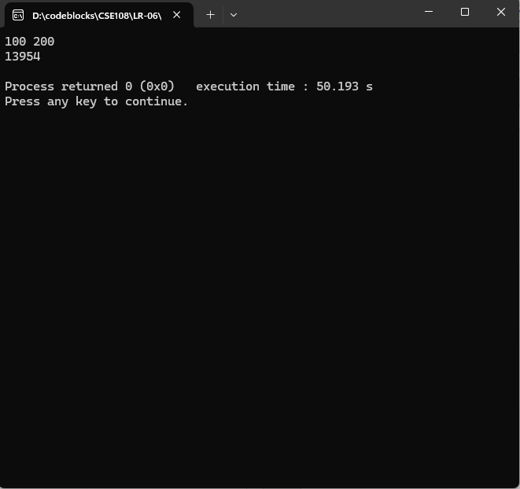

[1133 - Rest of a Division](https://judge.beecrowd.com/en/problems/view/1133)

#include <stdio.h>

int main(){

int x, y, temp, i;

scanf("%d %d", &x, &y);

if(x > y){

temp = x; x = y; y = temp;

}

x++;

for(i = x; i < y; i++){

if(i % 5 == 2 || i % 5 == 3){

printf("%d\n", i);

}

}

return 0;

}

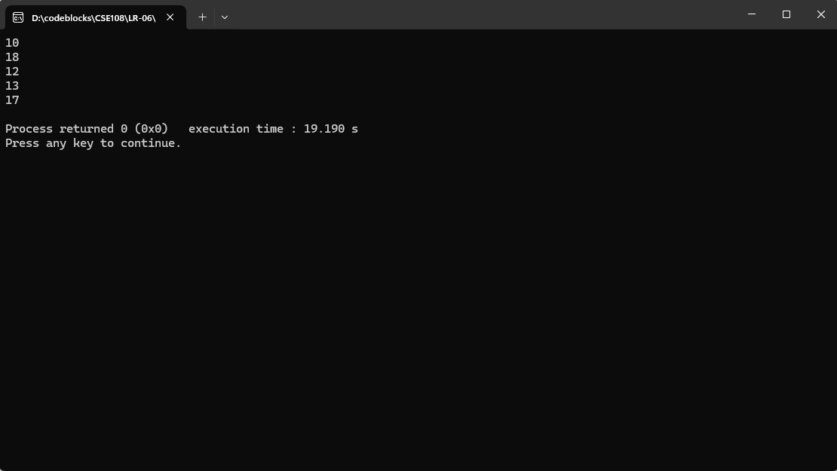

1075 - Remaining 2

#include <stdio.h>

int main(){

int n, i;

scanf("%d", &n);

for(i = 0; i < 10000; i++){

if(i % n == 2){

printf("%d\n", i);

}

}

return 0;

}

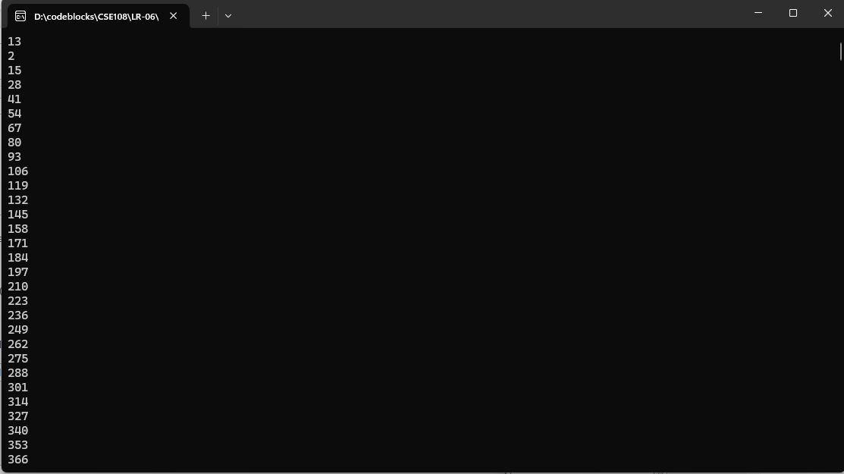

1078 - Multiplication Table

#include <stdio.h>

int main(){

int n, i, mul = 0;

scanf("%d", &n);

for(i = 1; i <= 10; i++){

mul = i * n;

printf("%d x %d = %d\n", i, n, mul);

}

return 0;

}

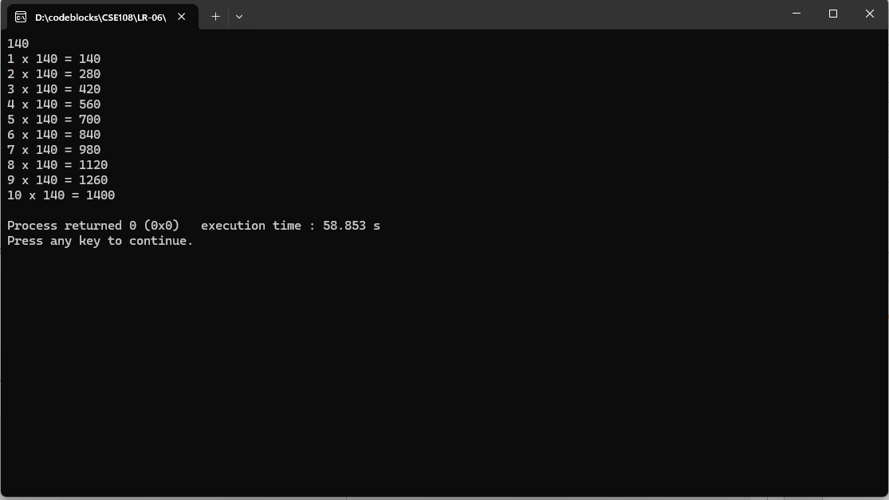

1079 - Weighted Averages

#include <stdio.h>

int main(){

int n, i;

scanf("%d", &n);

float num1, num2,num3, result = 0.0;

for(i = 0; i < n; i++){

scanf("%f %f %f", &num1, &num2, &num3);

result = (((2 * num1) + (3 * num2) + (5 * num3)) / (2 + 3 + 5));

printf("%0.1f\n", result);

}

return 0;

}

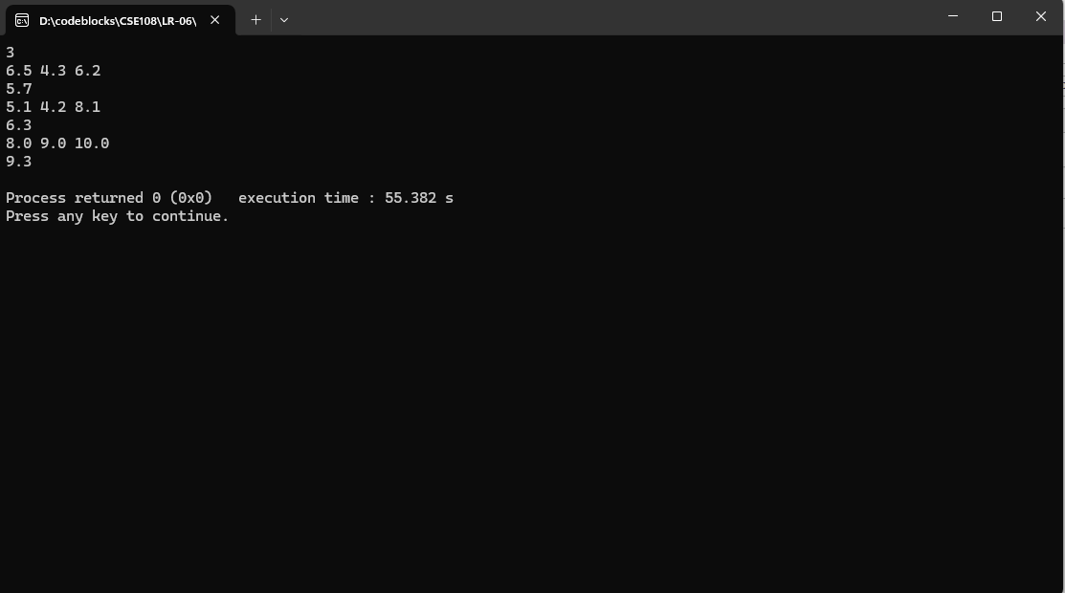

1095 - Sequence IJ 1

#include<stdio.h>

int main()

{

int i,j;

for(i=1,j=60;i<15,j>=0;i+=3,j-=5)

{

printf("I=%d J=%d\n",i,j);

}

return 0;

}

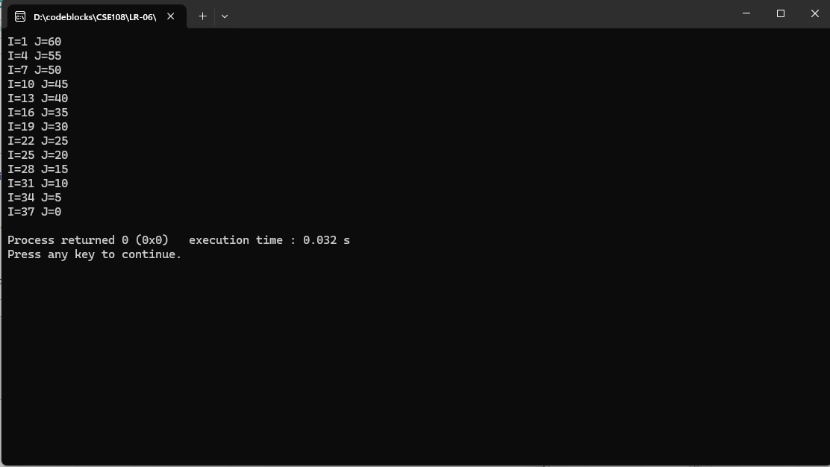

1074 - Even or Odd

#include <stdio.h>

int main() {

int n, x;

scanf("%d", &n);

for (int i = 0; i < n; i++) {

scanf("%d", &x);

if (x < 0) {

if (x % 2 == 0) {

printf("EVEN NEGATIVE\n");

} else {

printf("ODD NEGATIVE\n");

}

} else if (x > 0) {

if (x % 2 == 0) {

printf("EVEN POSITIVE\n");

} else {

printf("ODD POSITIVE\n");

}

} else {

printf("NULL\n");

}

}

return 0;

}

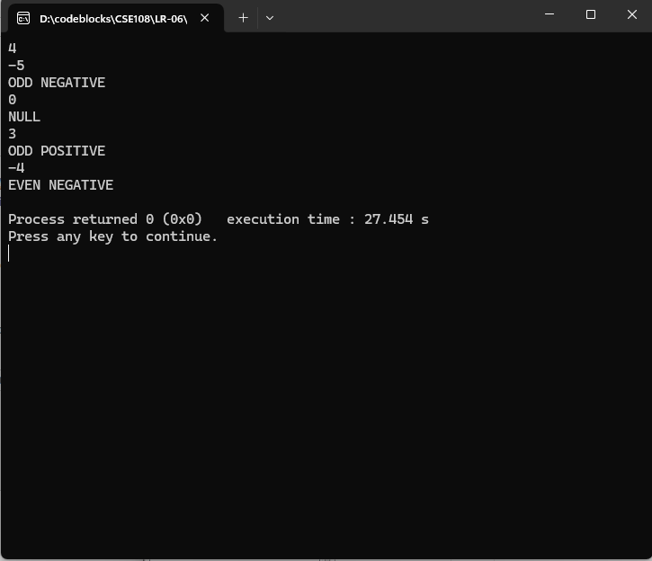

1080 - Highest and Position

#include <stdio.h>

int main(){

int i, n, p, j = 0;

for(i = 1; i <= 100; i++){

scanf("%d", &n);

if(n > j){

j = n;

p = i;

}

}

printf("%d\n%d\n", j, p);

return 0;

}

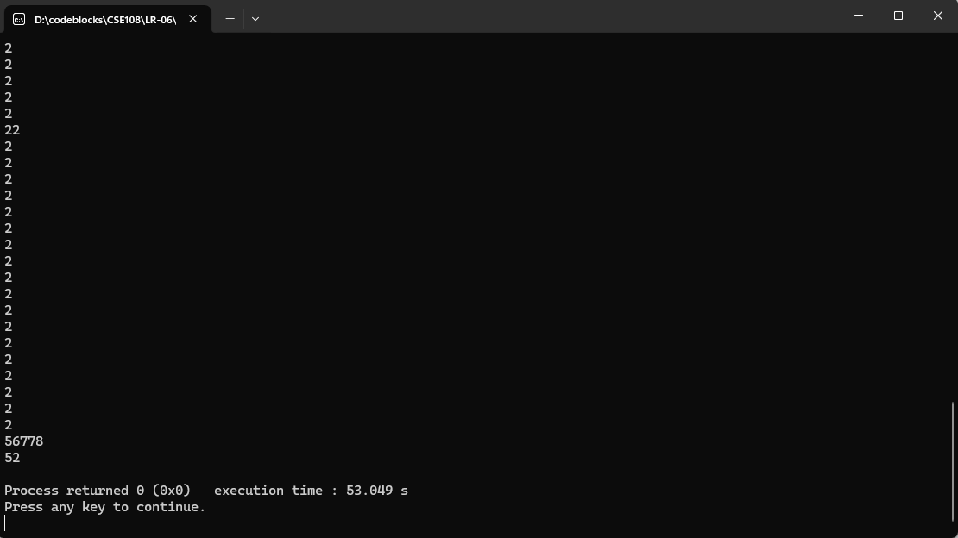

1096 - Sequence IJ 2

#include <stdio.h>

int main() {

for (int i = 1; i <= 9; i += 2) {

for (int k = 0; k < 3; k++) {

int J = 7 - k;

printf("I=%d J=%d\n", i, J);

}

}

return 0;

}

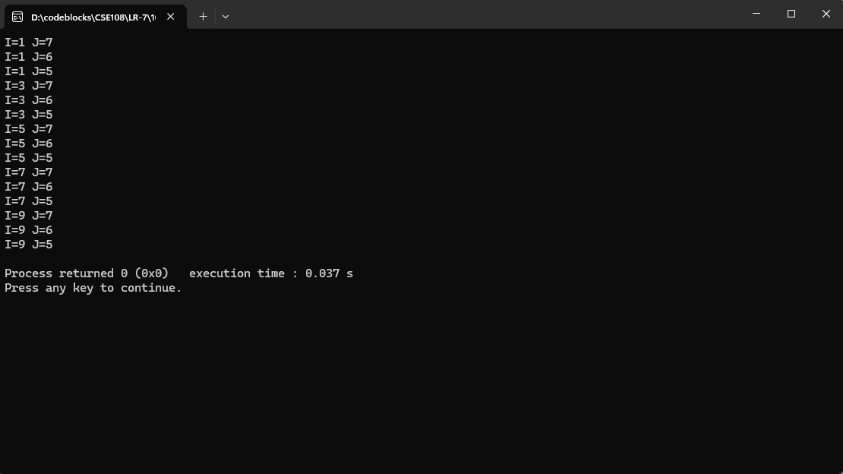

1097 - Sequence IJ 3

#include <stdio.h>

int main() {

int K = 7;

for (int i = 1; i <= 9; i += 2) {

for (int j = 0; j < 3; j++) {

int J = K - j;

printf("I=%d J=%d\n", i, J);

}

K += 2;

}

return 0;

}

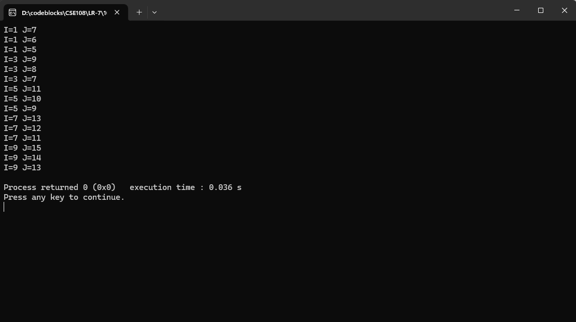

1098 - Sequence IJ 4

#include <stdio.h>

#include <math.h>

int main() {

float i = 0.0, j = 1.0;

while (i <= 2.0) {

for (int a = 0; a < 3; a++) {

if (fabs(i - (int)i) > 1e-6) {

printf("I=%.1f J=%.1f\n", i, j);

} else { // i is an integer

printf("I=%.0f J=%.0f\n", i, j);

}

j += 1.0;

}

i = round((i + 0.2) * 10) / 10;

j = round((j - 2.8) * 10) / 10;

}

return 0;

}

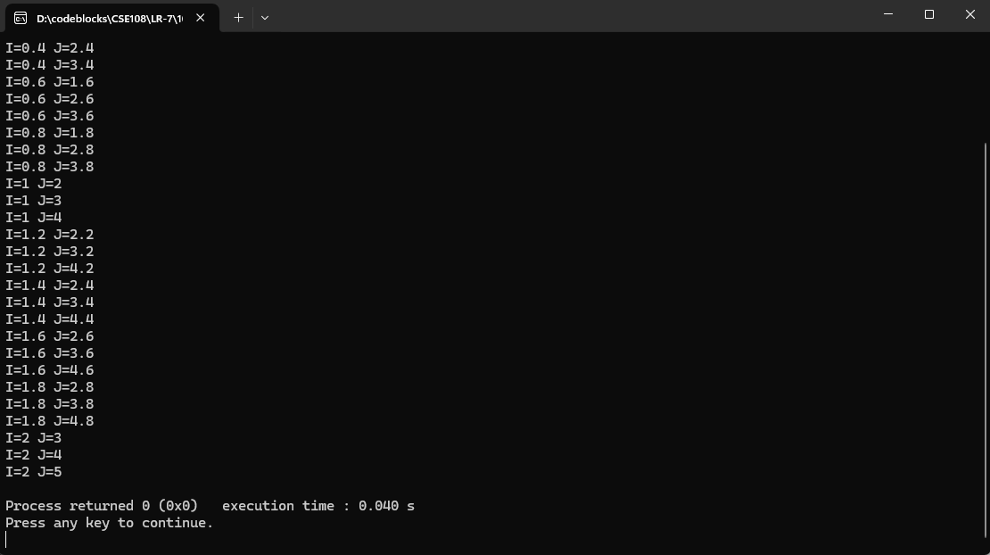

1094 – Experiments

#include <stdio.h>

int main() {

int no_t_c, amount;

char animal;

int t_rabbit = 0, t_rat = 0, t_frog = 0;

scanf("%d", &no_t_c);

for (int i = 0; i < no_t_c; i++) {

scanf("%d %c", &amount, &animal);

if (amount >= 1 && amount <= 15) {

if (animal == 'C') {

t_rabbit += amount;

} else if (animal == 'R') {

t_rat += amount;

} else if (animal == 'S') {

t_frog += amount;

}

}

}

int t_animals = t_rabbit + t_rat + t_frog;

double p_rabbit = (t_rabbit * 100.0) / t_animals;

double p_rat = (t_rat * 100.0) / t_animals;

double p_frog = (t_frog * 100.0) / t_animals;

printf("Total: %d cobaias\n", t_animals);

printf("Total de coelhos: %d\n", t_rabbit);

printf("Total de ratos: %d\n", t_rat);

printf("Total de sapos: %d\n", t_frog);

printf("Percentual de coelhos: %.2f %%\n", p_rabbit);

printf("Percentual de ratos: %.2f %%\n", p_rat);

printf("Percentual de sapos: %.2f %%\n", p_frog);

return 0;

}

