Software Requirements Specification

ADP SYSTEM IN ICT DIVISION

**Annual Development Program System**

**Introduction:**

This document, Software Requirement Specification (SRS), is created to document the software requirements for the ICT Development System. ICT systems have been developed in a discrete way with little or no integration among offices. The real benefits of e -Government occur when related government offices become inter -connected and integrated, allowing them to access each other’s resources and databases instantaneously, share electronic files and documents, communicate more efficiently and make more informative co elaborative decision making and development efforts. To reach the goals of the National ICT Task Force and to attain the UN Millennium Development Goal of an improved, more efficient and transparent governance, there is a definite need to maintain and expand inter - connectivity among key government institutions. This would allow officials from these institutions to share information instantaneously access the national databases and integrate their activities.

The Government of the People’s Republic of Bangladesh has placed important emphasis on the area of e-government to create a more efficient and transparent governance system. ICT systems are being introduced in major government offices throughout the country with direct support from the highest level of government.

**Requirements:**

**Functional Requirements:**

* Problem:

Every year the programming division of planning ministry budget allocation of various sectors and projects are done through a rigorous process which involve interaction of executing agency, Ministry of Finance, Sector division of planning commission, Programming division of planning commission and NEC. The interactions between these stakeholders are done through papers. The existing ADP database system is years old and does not incorporate features like document workflow, dynamic report generation etc.

This has lead to two specific problems.

-The interactions between these stakeholders are very hard to maintain.

-The old system does not incorporate DPP/TPP information related to ADP.

* Purpose:

This document is intended to be used by the members

of the project team that will implement and verify the correct functioning of the system.

Unless otherwise noted, all requirements specified here are high priorities and th e proposed system should include all the features mentioned here.

* Scope:

The Annual Development Program System will record sector wise budget allocation prepared by Planning Commission as well as generate different custom reports based on queries send by various stake holders.

* Output:

User will able to download sector, division or sub sector wise ADP & RADP of different years through the system.

**Non-Functional Requirements:**

Non-Functional requirements are requirements that are not directly concerned with the specific functions delivered by the system. They may relate to emergent system properties such as reliability, response time and store occupancy. They may specify system security, availability and other emergent properties.

1. Safety Requirements

Both data and software should be backed up periodically

1. Security Requirements

ID and Password Protection

Sign-off Button

Failed Log-on Attempts

1. Software Quality Attributes

Reliability

Maintainability

Usability

Portability

Efficiency

Flexibility

1. Hardware Requirements

Standard pc

Internet Connection with good enough speed

At least 500MB hardisk space

Smart Mobile phone

1. Software Requirements

che, php, gtk+, etc. So, we can use any operating systems.

1. Waterfall Model

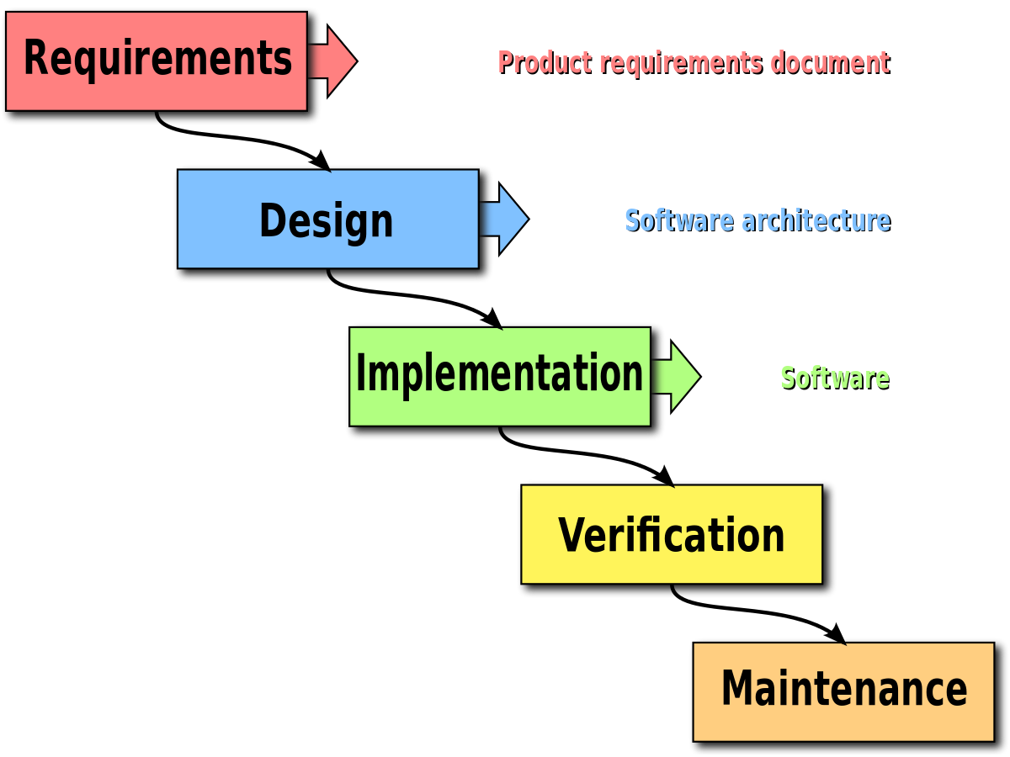

1. Feasibility Study

Economic feasibility

Technical feasibility

**Requirement Analysis**

**Case Diagram:**

* **Registration**

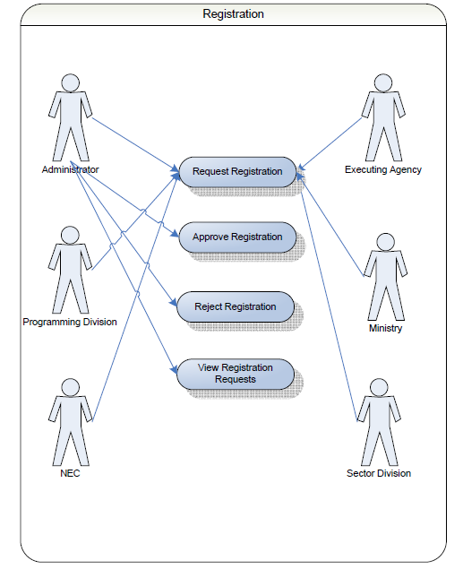

* **Configuration**:

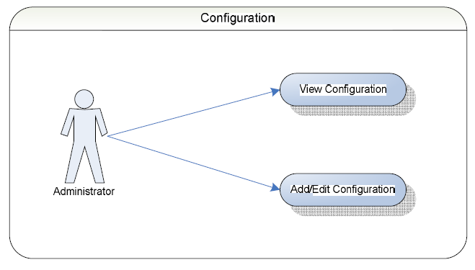

* **ADP Allocation (GOB)**

The whole ADP Allocation process can be summarized into the following steps:

- Ministry of Finance prepare the development budget for ADP Allocation and sends the allocation information in the form of “resource envelope”.

- Programming Division of Planning Commission collect development budget from the Ministry of Finance;

- Programming Division of Planning Commission allocate the budget sector wise

to national priority;

- The Sector Division of the Planning Commission collect ADP allocation from

Programming Division;

* **ADP Allocation (Project Aid)**

The whole ADP Allocation (Project Aid) process can be summarized into the following steps:

- ERD prepare sector wise project aid for ADP allocation;

- Division of Planning Commission collects project aid information from the ERD

- Sector of Planning Commission collect project aid information for the ADP Allocation;

* **User Roles**

The system will have 7 types of user roles. The particulars of different types of users in the system are shown below:

1. Executing Agency

Project Directors of Executing agencies are different agencies that are responsible for implementing various projects.

1. Ministry of Finance

Viewer

1. Sector Division

Determination of development priorities.

1. Programming Division

Determination of the sizes of the Annual Development (ADP) and allocations/ proportions.

1. NEC

reviews the draft copy of the ADP / RADP book and approves or rejects it.

1. Viewer

It includes numerous administrative (DC, TNO ) people who are responsible for implementing various portions of ADP

1. System Admin

Can edit / update any document including configuration documents.

**User Activity Diagram**

* **Executing Agency**

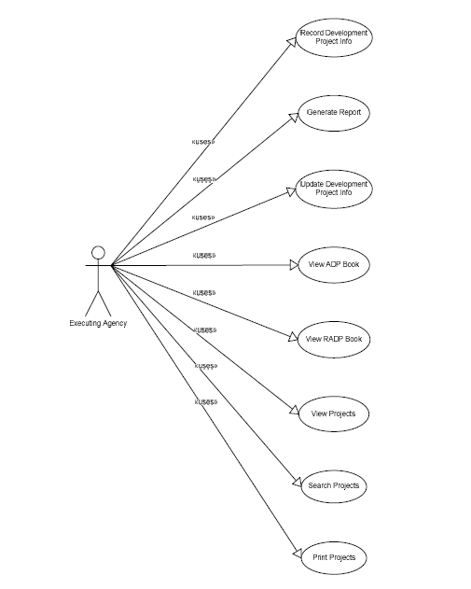

* **Ministry**

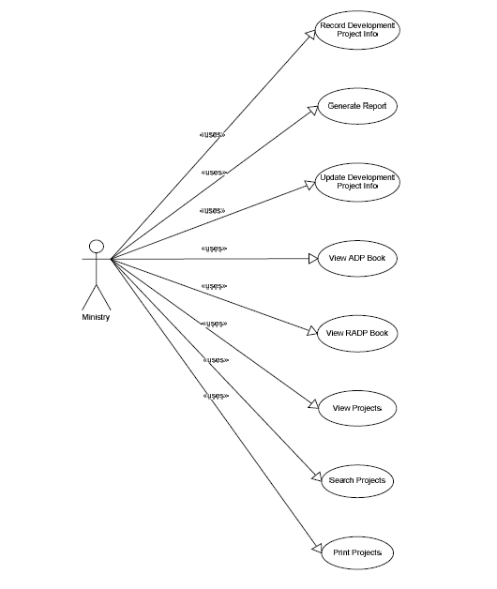

* **Sector Division**

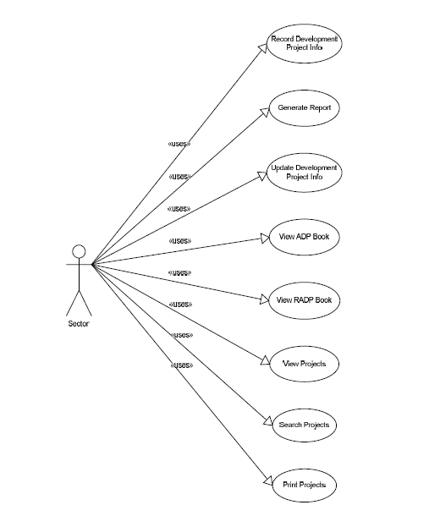

* **Programming Division**

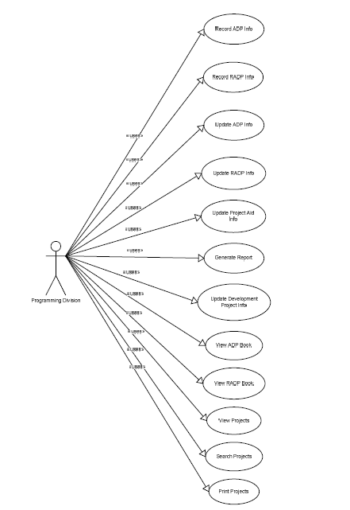

**GIS Reports adoption in ADP Application**

* + Location wise financial expenditure in a given fiscal year
  + Location wise projects in a given sector
  + Location specific amount of money invested on fisheries sub sector
  + Location wise physical progress report in a given fiscal year
  + Donor wise progress report in a given fiscal year
  + Donor wise financial expenditure in a given fiscal year
  + Activities implemented under revenue budget
  + Project wise ADP Allocation, Release and Expenditure
  + Development Sector wise ADP Allocation, Release and Expenditure Donor Monitoring

**Conclusion**

This Software Requirements Specification species the requirements needed for the ADP system, which will be used in ICT Division officers.

This Document will be used by the user to ensure all specification are correct and verified by the software Engineers to design the system.

Designed web forms for specific action required by the users. It will need to be connected to a main database server for storing and retrieving the data of the users.