**Roll No: 2003037**

**Lab Final**

**Lab Task Q1**

**Question:**

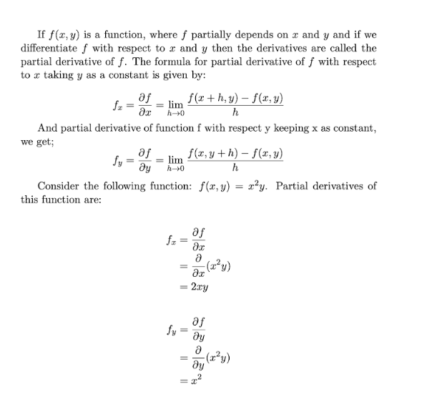

**Solution (Latex Code):**

|  |
| --- |
| *% 2003037*  *% Q3a:*  \documentclass[*a4paper, 10pt*]{book}  \usepackage{ enumerate, tabularx, asymptote, amsmath, amssymb, amsfonts, geometry, color, setspace}  \usepackage{pdflscape, rotating, ulem}  \begin{*document*}  If $f(x,y)$ is a function, where $f$ partially depends on $x$ and $y$  and if  we \\  differentiate $f$ with respect to $x$ and $y$ then the derivatives are called the \\  partial derivative of $f$. The formula for partial derivative of $f$ with respect \\  to $x$ taking $y$ as a constant is given by:\\  \begin{*equation\**}      f_x = \frac{\partial f}{\partial x} = \lim_{h \to 0} \frac{f(x+h,y)-f(x,y)}{h}  \end{*equation\**}\\  And partial derivative of function $f$ with respect to $y$ keeping $x$ as a constant, \\  we get;\\  \begin{*equation\**}      f_y = \frac{\partial f}{\partial y} = \lim_{h \to 0} \frac{f(x,y+h)-f(x,y)}{h}  \end{*equation\**}\\  Consider the following function: $f(x,y) = x^2y$. Partial derivatives of \\  this function are:\\  \begin{*eqnarray\**}      f_x &=& \frac{\partial f}{\partial x}\\          &=& \frac{\partial}{\partial x} (x^2y)\\          &=& 2xy\\[5mm]      f_y &=& \frac{\partial f}{\partial y}\\          &=& \frac{\partial}{\partial y} (x^2y)\\          &=& x^2\\  \end{*eqnarray\**}  \copyright \emph{2003037}  \end{*document*} |

**Output (Screen/SnapShot of Generated PDF):**

Qus: **Q2.**

Solution:

\documentclass[*a4paper, 10pt*]{article}

\usepackage{ enumerate, tabularx, asymptote, amsmath, amssymb, amsfonts, geometry, color, setspace}

\usepackage{pdflscape, rotating, ulem, cite}

\usepackage[*numbers*]{natbib}

\renewcommand{\bibname}{References}

\begin{*document*}

This research work is focused on detecting low-grade glioma tumorous cells \\

in MRI images. Glioma is a common brain tumor, that exhibits properties of \\

benign tumors\cite{wadhwa2019review}. We used the TCGA-LGG Segmentation dataset\cite{buda2019association} for our \\

research. It consists of 3929 brain tumor images and corresponding FLAIR \\

abnormality segmentation masks obtained from 110 patients. \\

\indent Table 1: lists the models used as encoder for U-net architecture.\\

\begin{*table*}[h!]

    \noindent\caption{Models used for U-net encoder and trainable blocks/ stages for fine-\\tuning.}

    \vspace{2mm} *% Adjust the vertical space*

    \begin{*tabularx*}{\linewidth}{>{\centering\arraybackslash}X >{\centering\arraybackslash}X >{\centering\arraybackslash}X}

        \hline

        \textbf{Family} & \textbf{Model} & \textbf{Trainable Blocks}\\

        \hline

        EfficientNet & EfficientNetB0 to B7 & Block 30 to 32\\

        DenseNet & DenseNet169, DenseNet201 & Block 7\\

        ResNet & ResNet18, ResNet50, ResNet101& Stage 4\\

        \hline

    \end{*tabularx*}

\end{*table*}

\bibliographystyle{ieeetr}

\bibliography{LF}

\copyright \emph{2003037}

\end{*document*}

Output:

