# NS Lab Mid – 25 marks

**Router Commands Deadline:1/12/2019**

Name : ID:

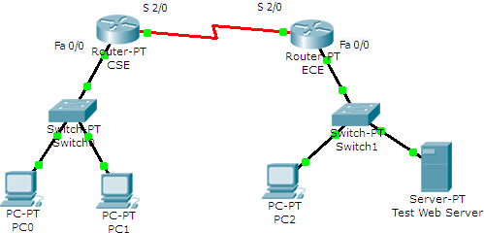

|  |  |  |  |  |
| --- | --- | --- | --- | --- |
| **Router ID** | **Host name** | **Fast Ethernet 0/0 address** | **Interface Serial 2/0** | **Interface Serial 2/0 IP**  **address** |
| Router 0 | CSE | 192.168.25.254/24 | DCE | 192.168.35.1/30 |
| Router 1 | EEE | 192.168.30.254/24 | DTE | 192.168.35.2/30 |

**Configure the router CSE**

Write down the commands necessary to configure the CSE Router.

|  |  |
| --- | --- |
| 1. Enter global configuration mode. | |
|  | Router>enable  Router# configure terminal |
| 2. Configure host name and enable password (password will be class and encrypted ). | |
|  | Router (config) # hostname CSE  CSE (config) # no ip domain-lookup  CSE (config) #enable secret class |
| 3. Configure the line console and line vty (the telnet login) with the password cisco. Then later encrypt all these passwords. | |
|  | CSE (config) line console 0  CSE (config-line) #password cisco  CSE (config-line) #login  CSE (config-line) #exit  CSE (config) #line vty 0 4  CSE (config-line) #password cisco  CSE (config-line) #login  CSE (config-line) #exit |
| 4. Configure the Fast Ethernet 0/0 interface and Serial 2/0 interface with the given IP addresses shown in the table above.    CSE (config) #interface fastethernet 0/0  CSE (config-if) #ip address 192.168.25.254 255.255.255.0  CSE (config-if) #no shutdown  CSE (config-if) #interface serial 2/0  CSE (config-if) #ip address 192.168.35.1 255.255.255.0  CSE (config-if) #clock rate 64000  CSE (config-if) #no shutdown | |

1. interface (at Fast Ethernet interface Fa 0/0) description “THIS IS CSE LAN”

CSE(config)#conf t

CSE(config)#interface fa 0/0

CSE(config-if)#desc THIS IS CSE LAN

1. Configure message of the day in the router “MAINTENANCE ON FRIDAY”
2. Configure a message during login in the router “ RESTRICTED ROUTER ”

CSE(config-if)#banner motd & MANTAINANCE ON FRIDAY &

CSE(config)#banner motd & RESTRICTED ROUTER &

1. Save the running configuration to NVRAM.
2. Configure PC 0 and PC 1 with IP addresses/subnet mask and default gateway.

PC 0:

IP Address : 192.168.25.2

IP subnet mask : 255.255.255.0 Default gateway : 192.168.25.254

PC 1:

IP Address : 192.168.25.3

IP subnet mask : 255.255.255.0 Default gateway : 192.168.25.254

1. Ping from PC 0 to PC 1 at 192.168.25.3

Do you have connectivity? Answer should be yes.

From CSE router ping EEE router’s serial interface.

Do you have connectivity? Answer should be yes.

Ping from PC 0 to PC 2 at 192.168.30.2.

Do you have connectivity? Answer should be no. Why?

1. Configuring a static route in CSE router pointing to the LAN attached at EEE Router. Configuring another static route in EEE router pointing to the LAN attached at CSE Router.
2. Ping from PC 0 to PC 2 at 192.168.30.2.

Do you have connectivity? Answer should be yes. Why?