1. Site slow
2. Homepage Search Location would be Google map like bproperty
3. Homepage popup advertisement system
4. Bengali language add
5. 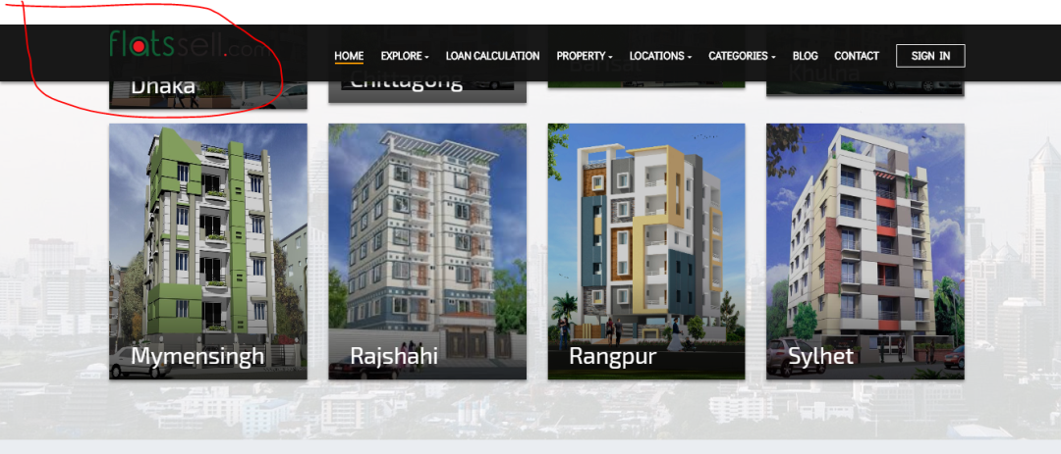top menu logo
6. facebook messenger implement
7. Rent or Sell should be defined on ad images
8. Call and Email Button like bproperty
9. archive system…user chaile kon kon property dekhse ta archive kore rakhte parbe…poroborti te dekhar jonno…abar delt o korte parbe..
10. service???