Server Prepare:

**Java install:**

cd /opt

wget <https://download.oracle.com/otn/java/jdk/8u202-b08/1961070e4c9b4e26a04e7f5a083f551e/jdk-8u202-linux-x64.tar.gz>

tar -zxvf jdk-8u192-linux-x64.tar.gz

cd jdk1.8.0_192/

alternatives --install /usr/bin/java java /opt/jdk1.8.0_192/bin/java 2

alternatives --config java

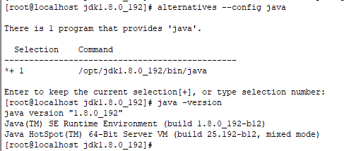

alternatives --install /usr/bin/jar jar /opt/jdk1.8.0_192/bin/jar 2

alternatives --install /usr/bin/javac javac /opt/jdk1.8.0_192/bin/javac 2

alternatives --set jar /opt/jdk1.8.0_192/bin/jar

alternatives --set javac /opt/jdk1.8.0_192/bin/javac

vi ~/.bash_profile

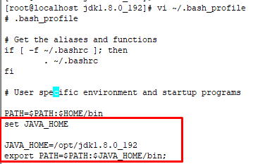

source ~/.bash_profile

echo $JAVA_HOME



**Jenkins Install:**

sudo wget -O /etc/yum.repos.d/jenkins.repo \

https://pkg.jenkins.io/redhat-stable/jenkins.repo

sudo rpm --import https://pkg.jenkins.io/redhat-stable/jenkins.io.key

sudo yum upgrade

sudo yum install epel-release java-11-openjdk-devel

sudo yum install jenkins

sudo systemctl daemon-reload

systemctl start jenkins

systemctl status jenkins

systemctl enable Jenkins

if have firewall then allow port:

**firewall-cmd --permanent --zone=public --add-port=8080/tcp**

**firewall-cmd --reload**

**Setting Up Jenkins**

To set up your new Jenkins installation, open your browser and type your domain or IP address followed by port 8080:

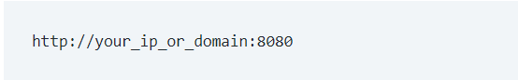

A screen similar to the following will appear, prompting you to enter the Administrator password that is created during the installation:

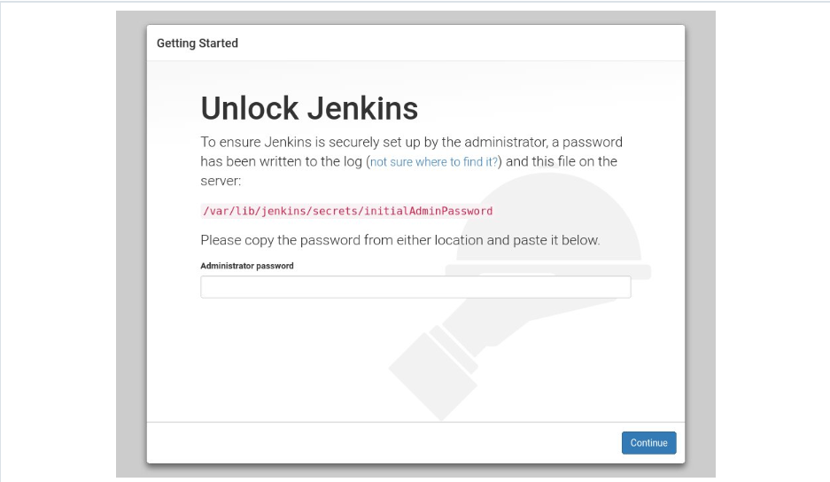

Use the following command to print the password on your terminal:

**# sudo cat /var/lib/jenkins/secrets/initialAdminPassword**

You should see a 32-character long alphanumeric password as shown below:

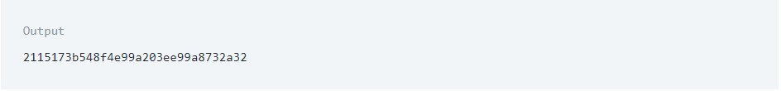

Copy the password from your terminal, paste it into the Administrator password field and click Continue.

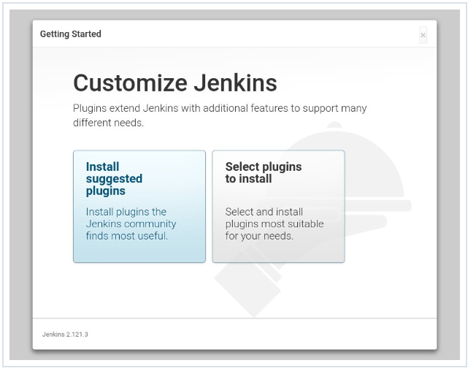

On the next screen, you will be asked whether you want to install the suggested plugins or to select specific plugins.

Click on the Install suggested plugins box, and the installation process will start immediately.

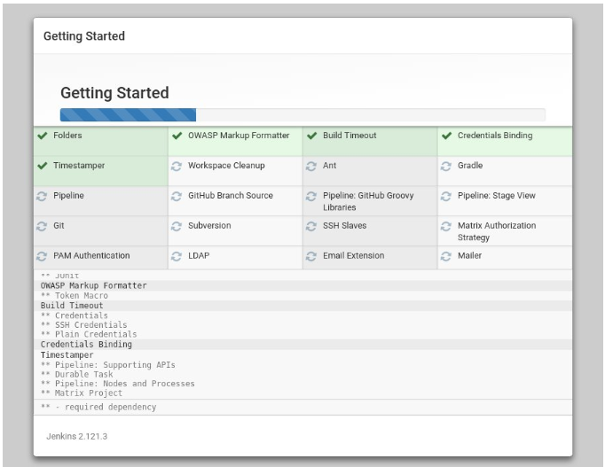

Once the installation is complete, you will be prompted to set up the first administrative user.

Fill out all required information and click Save and Continue.

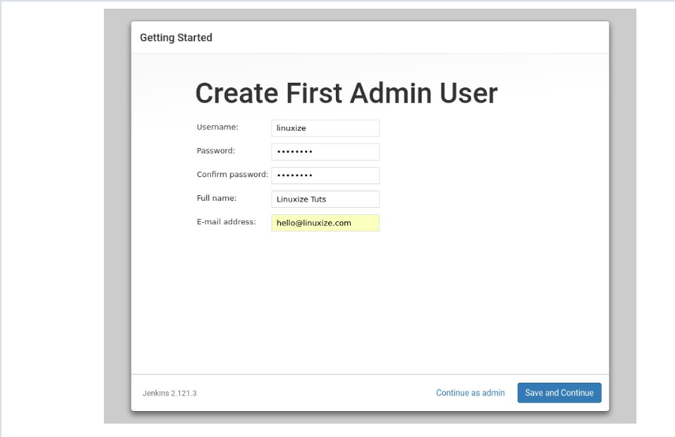

On the next page, you will be asked to set the URL for the Jenkins instance.

The URL field will be populated with an automatically generated URL.

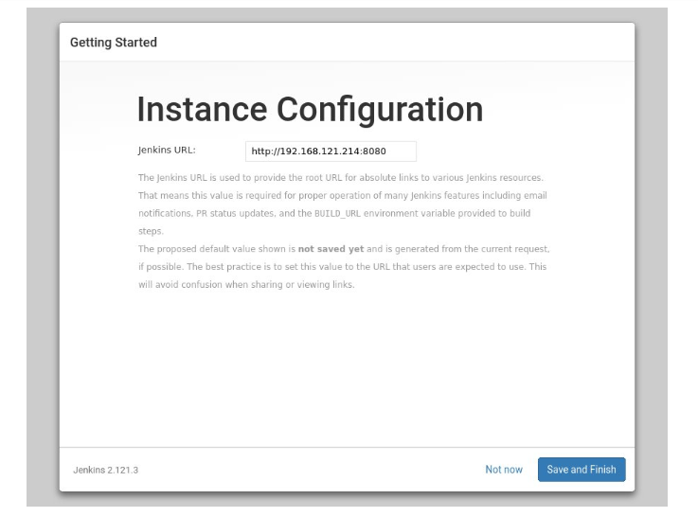

To complete the setup confirm the URL by clicking on the Save and Finish button.

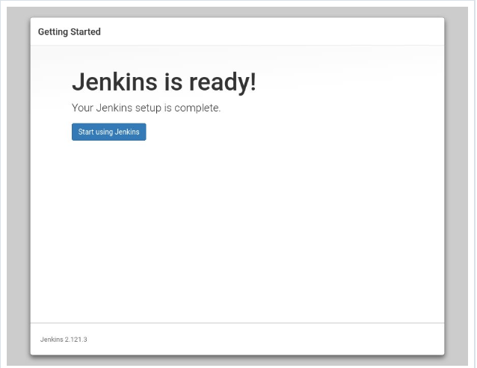

Finally, click on the Start using Jenkins button and you will be redirected to the Jenkins dashboard logged in as the admin user you have created in one of the previous steps.

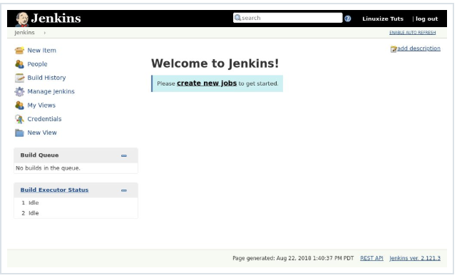

If you’ve reached this point, you’ve successfully installed Jenkins on your CentOS system.

**git Install:**