Customize Script for Discovery Rule in Linux

Introduction:
Discovery Rule discovers all the Info and respond with JSON FORMAT.
{"data":[ {"{#NAME}":"VALUE"},{"{#NAME}":"VALUE"},{"{#NAME}":"VALUE"}] }
after that Item will be created with this VALUE as like as item prototype configuration.

Configuration:
1) Need to set the “UserParameter=” value in “zabbix_agentd.conf” file.
UserParameter=key[*],command
UserParameter=testmz[*], php "/usr/local/testphp/test1.php" "$1" "$2"
Here $1 $2 is used as Parameter Macro which will be passed to key {testmz[*]}

2) To run the command , we need to enable below parameters in “zabbix_agentd.conf” file.
EnableRemoteCommands=1
UnsafeUserParameters=1
After that we need to restart the Zabbix Agent.

Script: (This is my test script)
We have used PHP.This script will read the value from a CSV file and then created JSON format by discovery rule within the value in csv. You could keep the CSV and script in any location of the server just mention the location in UserParameter.
Need to check if the file has execution access to your user.After that Items will be created as we have set the item prototype.
<?php
$item = $argv[1];
$filelocation="/usr/local/testphp/rrr.csv";
$catfile="/usr/local/testphp/";
switch($item)
{
case "jsonformat1":
$r=0;
$coun=0;
echo "{\"data\":[ ";
if(($fileopen=fopen("$filelocation","r"))!=False)
{
while(($data = fgetcsv($fileopen,100,","))!=False){

if($coun<=count($data))
{
$output = "{\"{#NAME}\":\"".$data[$r]."\"},";
echo "$output";
}

if($coun>count($data))
{
$output = "{\"{#NAME}\":\"".$data[$r]."\"}";
echo "$output";
}
$coun++;
}
echo "] }";
fclose($fileopen);
}
break;
case "uptm":
$id = $argv[2];
$value=$id;
$comand=exec("cat $catfile$value");
echo $comand;
break;
default:
$output = "{\"data\":[ {\"{#NAME}\":\"".$filelocation."\"} ] }";
}
exit(); ?>
Then we have to create a discovery rule in templates.
Keyname will be as same as we declared in “UserParameter”.
Then We have to create Item Prototype.
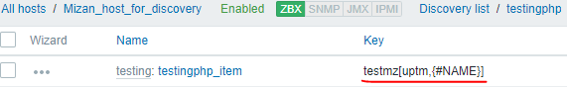
N.B: Macros will declared with Block letter as Zabbix is case sensitive. Here we have set #NAME

Output:
In CSV file:
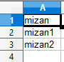
JSON output:
{"data":[ {"{#NAME}":"mizan"},{"{#NAME}":"mizan1"},{"{#NAME}":"mizan2"}] }
Items:
Here #NAME is replaced by the VALUE from JSON.
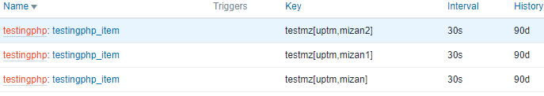
In Zabbix Latest Data:

****Prepared By Mizan****

