Packages need to be installed

| Packages | Version | Install in |
| --- | --- | --- |
| Python | 3.6 | Application server |
| Postgresql | 14 | Database server |
| NGINX |  | Application server |
| Gunicorn |  | Application server |
| Libreoffice |  | Application server |
| Elasticsearch | 5.6 | Application server |
| java-1.8.0-openjdk, java-1.8.0-openjdk-devel |  | Application server |
| redis |  | Application server |

Python Dependencies

| gcc | libicu-devel |
| --- | --- |
| gcc+ | cyrus-sasl-devel |
| make | libmemcached-awesome-1.1.0-9 |
| python3-libs | cmake-filesystem |
| python3-devel | libmemcached-awesome-devel-1.1.0-9 |
| python3-pip |  |
| zlib-devel |  |

Ports to be opened

| 80 |  |
| --- | --- |
| 443 |  |
| 5432 | Postgresql |
| 9200 | Elasticsearch |
| 6379 | Redis |
| 22 | SSH |

Set Cronjob:

*/2 * * * * cd /project_app_folder_path && env_path/bin/python manage.py sendemailtouser

FDMS Architecture diagram:

===========================

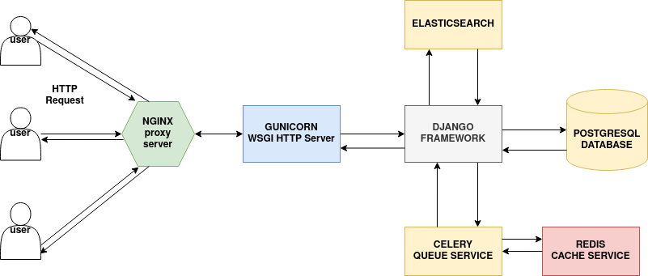

Figure: FDMS Architecture

Module wise resource consumption:

==============================

All calculations are approximately calculated.

If a server has 16 GB memory.

celery.service & redis = 300 Mb

elasticsearch.service = 3 Gb

postgresql.service = 3 Gb

gunicorn.service = 3 Gb

nginx.service = 100 Mb