**Patuakhali Science and Technology University**



**Lab Problem 01**

Course Code: CCE 122

Course Title: Object Oriented Programming Sessional

**Submitted By:**

Mehadi Enam Nerjhor

ID: 2202050

REG: 11241

**Submitted To:**

Professor Dr. Md Samsuzzaman

Dept. of Computer and Communication Engineering

Faculty of Computer Science and Engineering

Date: 6 July 2024

Table of Contents

1. Write the assignment based on how to compile and run java program using command prompt. 2

2. Write step by step for compiling and run java program through IDE like Netbeans, IDEAJ eclipse etc. 3

# Write the assignment based on how to compile and run java program using command prompt.

* First of all, we need to install Java compiler under JRE form the official website of Oracle. Standard name of the Java compiler is “Javac”.
* After installation we need an IDE to write java code.
* Then open IDE and write a java code and then save this java code with “.java” file extension name.
* After that we need to open terminal.
* Then I open the directory where I create the example.java file. I create this file in desktop. That’s why we need to open this directory on terminal.
* I use zsh terminal under macOS that’s why I write “cd” on terminal and then I hit enter. Then terminal will go to main directory.
* Then I write “cd Desktop” and then I pressed enter. Then terminal open the desktop directory.
* And then I write “javac example.java” on terminal and press enter. After press enter a “example.class” named file is create in the same directory. This class file bytecode file which is converted from the high-level java code from .java file. This .class file is the executed file. After that,
* 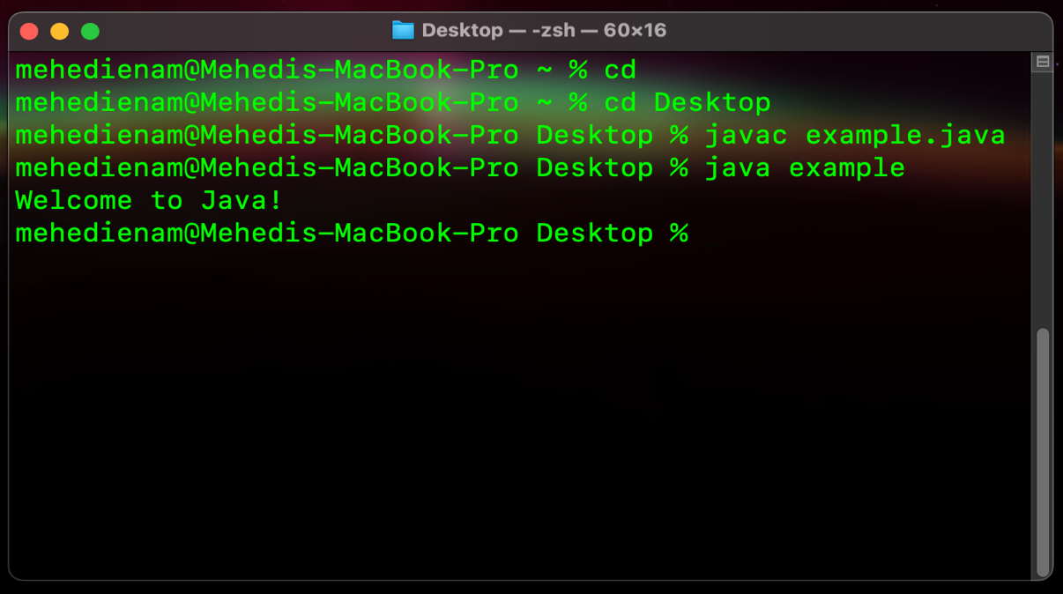Write “java example” and press enter to run the “example.class” file. After pressed it will show the output of that “example.java” file on terminal.
* Then close the terminal to exit.

# Write step by step for compiling and run java program through IDE like Netbeans, IDEAJ eclipse etc.

* At first, we need to install IDE in computer. I installed Netbeans IDE before.
* Open Netbeans software by clicking this icon like above.
* After open, we see a window like this. It is the main window of Netbeans Integrated Development Environment (IDE) application.

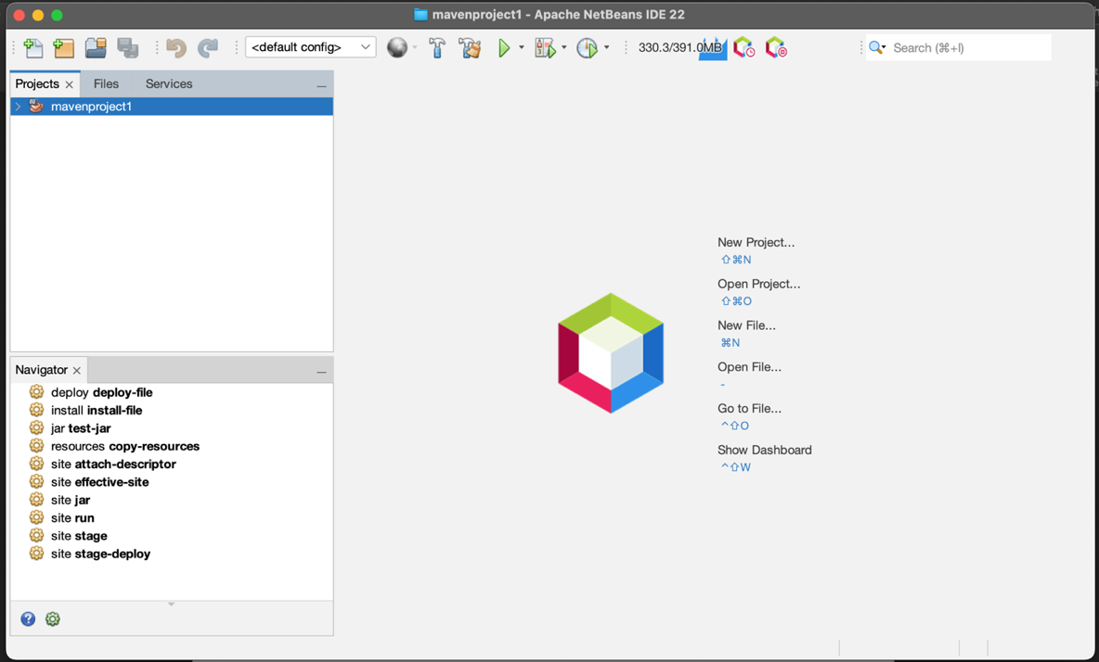

* Then I click on the “New Project” from the file menu. 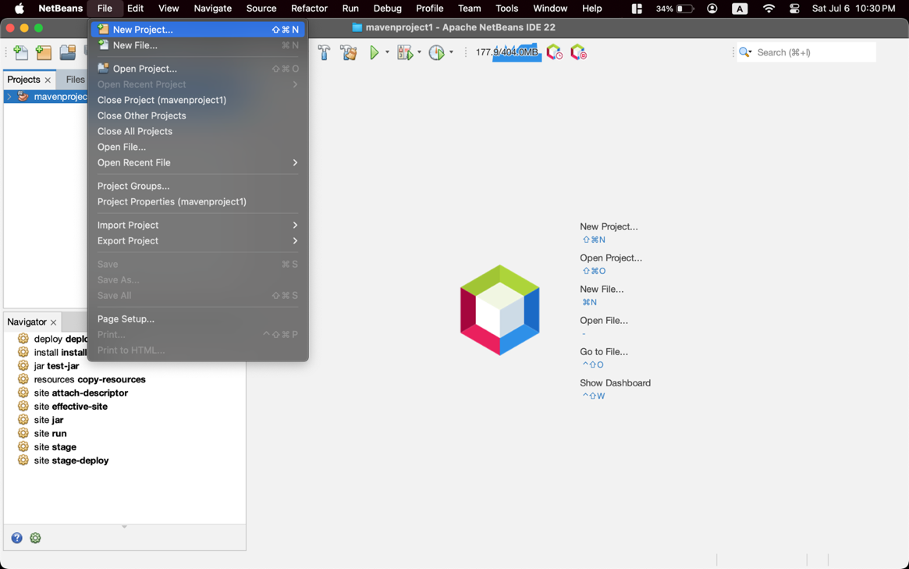
* Then we can see a window like this. Here I select the project type Java Application for run a simple java program. Then I clicked on the next button. 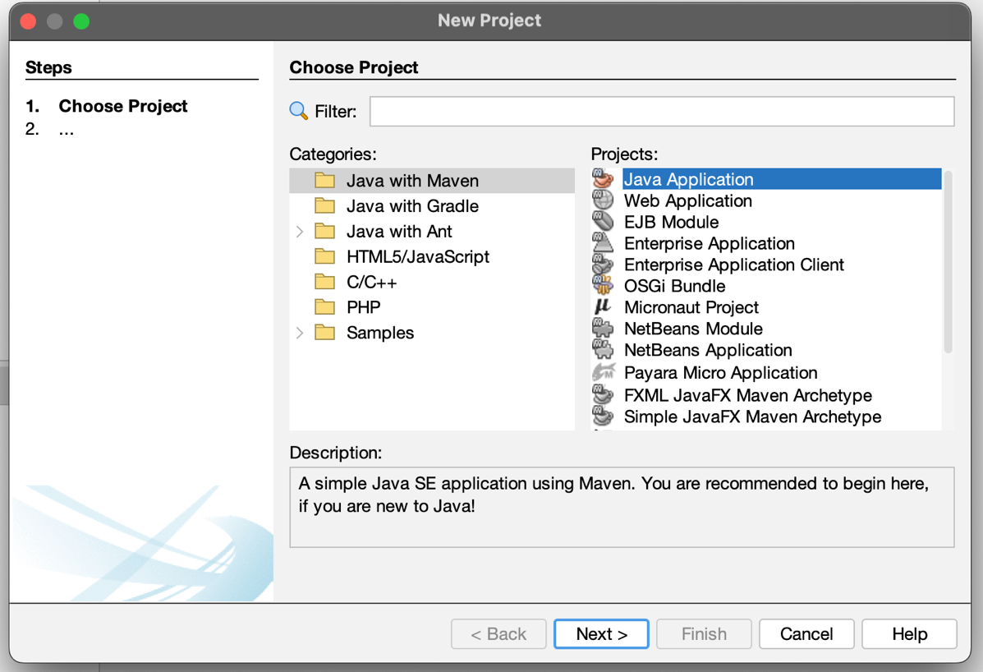
* Then we see this window. Here I give a name of my project to “myproject” and I select the project location where project file will save. After that I click on the “Finish” button.

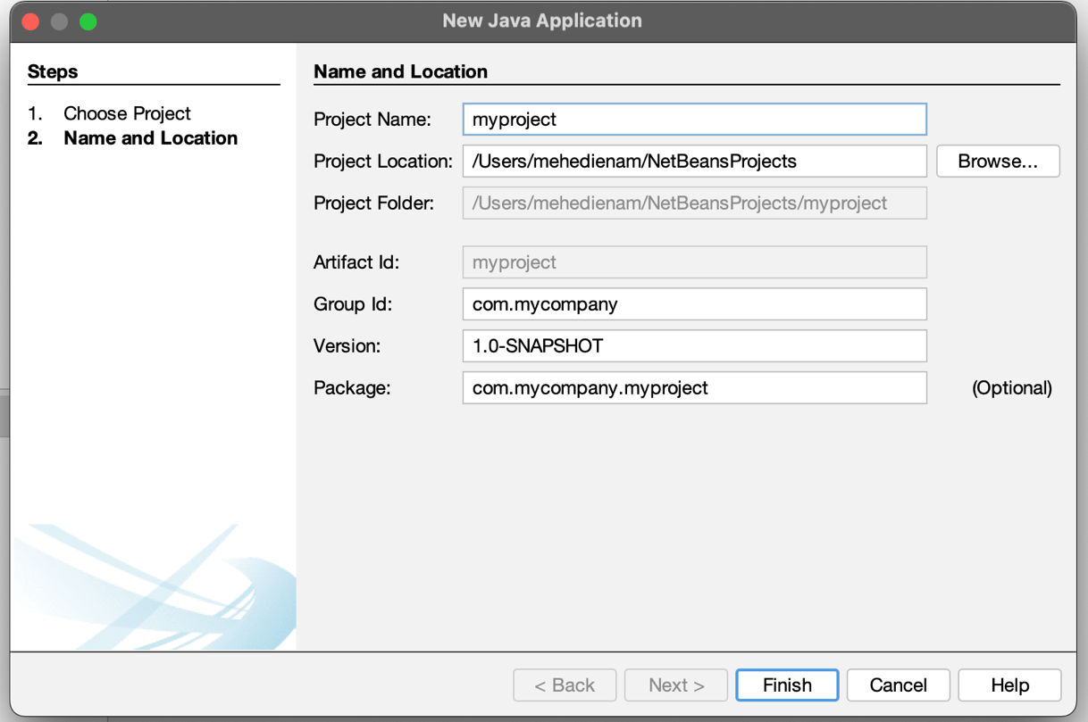

* Then we see that type of window. Here our project is ready to write. We can write code now. 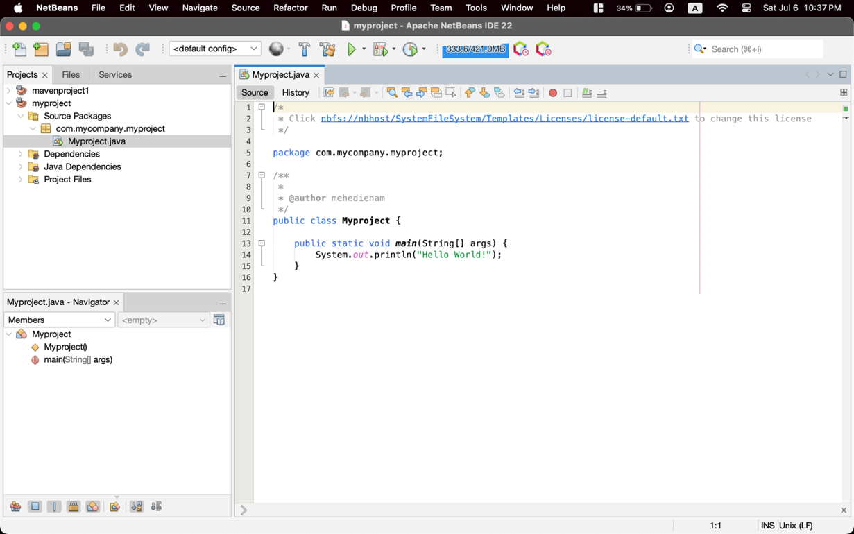
* Then I write a simple java code to show a “Welcome to Java!” message on terminal.

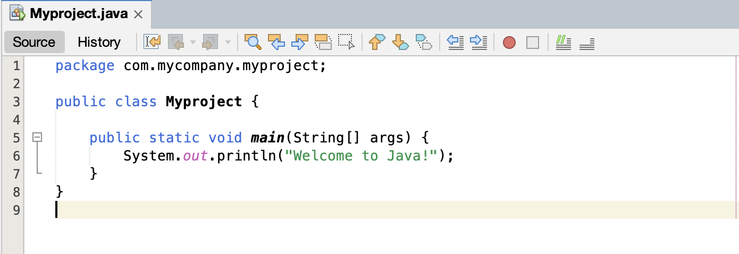

* Then I click on the “Build Project” under “Run” menu.

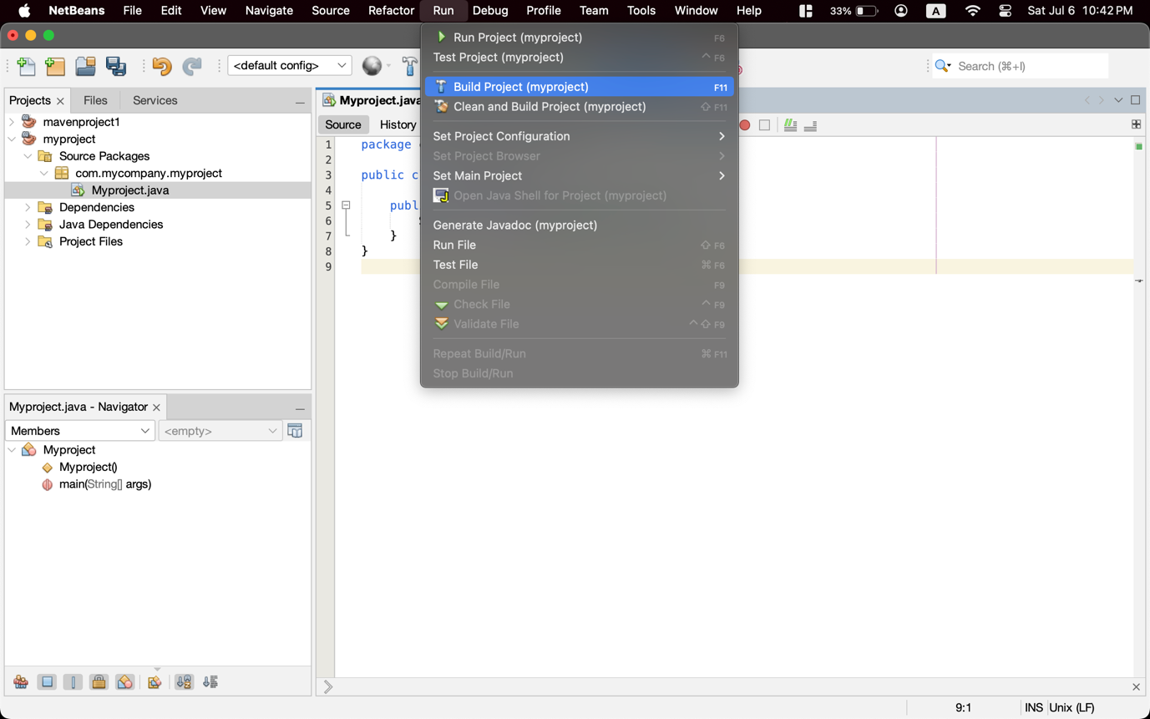

* Then we see a “BUILD SUCCESS” status on terminal like that. 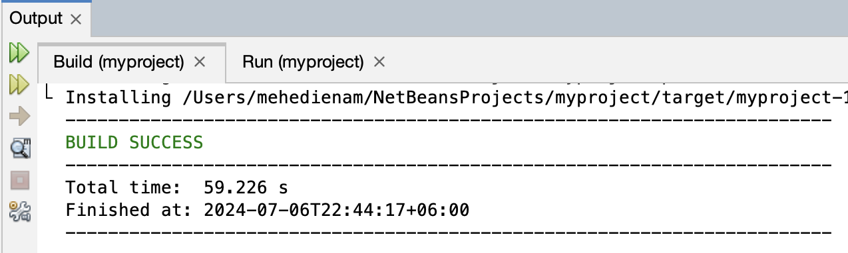
* Then I click “Run project” from “Run” menu after successfully build the project.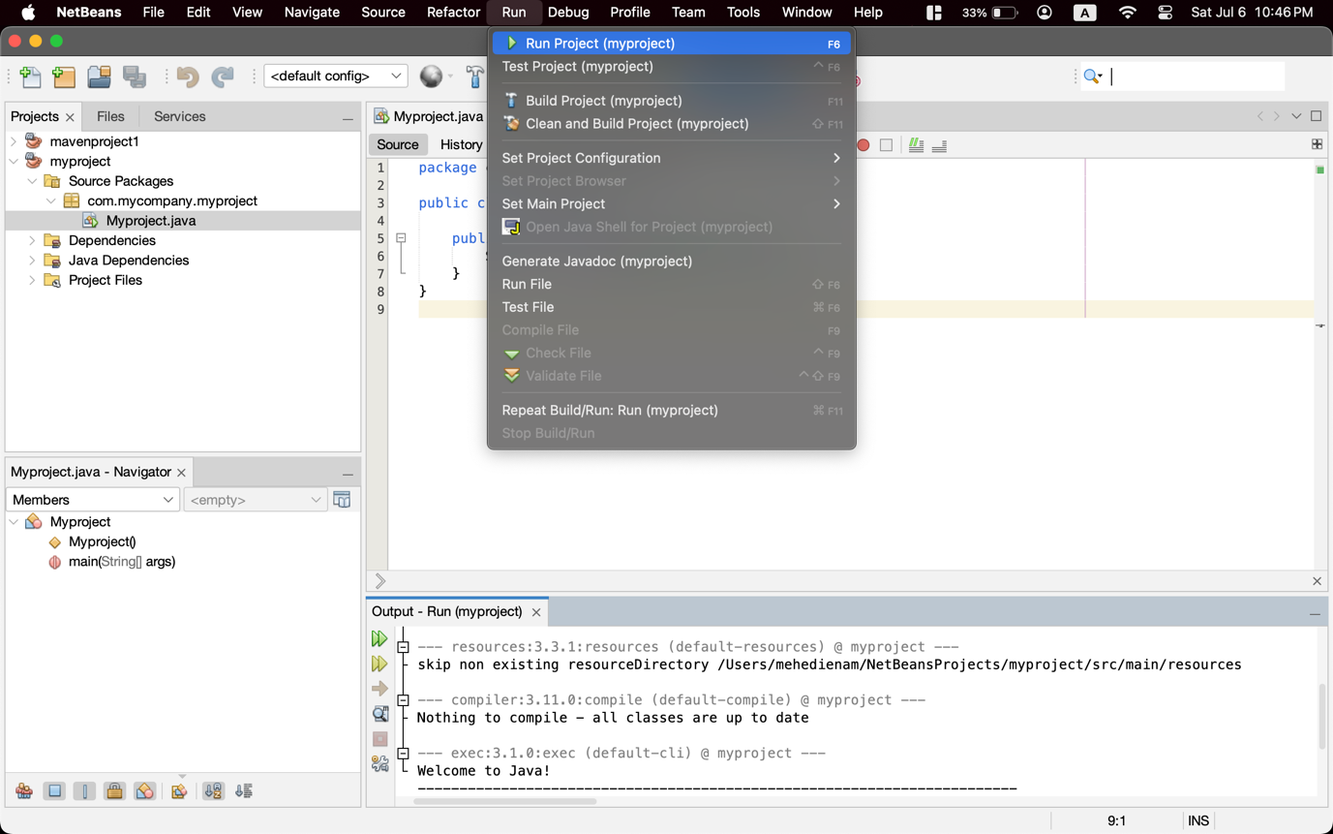
* Then we can the “Welcome to Java!” message on the terminal.