EVALUATING THE RELIABILITY OF
EXPLAINABLE AI IN ENSEMBLE-BASED
INTRUSION DETECTION SYSTEMS
Thesis Submitted in Fulfilment for the Degree of
Bachelor of Science (B.Sc.) in Computer Science and
Engineering (CSE)
by
Mehedi Hasan (C213061)
Sazzadul Islam (C213066R)

DEPARTMENT OF COMPUTER SCIENCE AND ENGINEERING
INTERNATIONAL ISLAMIC UNIVERSITY CHITTAGONG (IIUC)
Chittagong, Bangladesh

DECLARATION
We hereby declare that the work in this thesis is our own except for quotations and summaries which have been duly acknowledged.
We, the undersigned, formally declare that the thesis entitled “Evaluating the Reliability of Explainable AI in Ensemble-Based Intrusion Detection Systems” has been carried out under the supervision of Mr. Md. Mahiuddin, Associate Professor, Department of Computer Science & Engineering, International Islamic University Chittagong.
We affirm that this thesis has not been submitted, either in part or in full, for the award of any other degree or diploma at any university or institution. We further confirm that the contents of this thesis do not violate any copyright laws, and that all sources of information and all software libraries and datasets used have been appropriately acknowledged. We undertake full responsibility for any breach of copyright or ethical standards and agree to indemnify the university against any loss or damage arising from such violations.

Student’s Name and Metric ID:
- Mehedi Hasan (C213061)
- Sazzadul Islam (C213066R)

Supervisor's Declaration
I hereby declare that I have read this thesis and that, in my opinion, this thesis is sufficient in terms of scope and quality for the award of the degree of B.Sc. in Computer Science & Engineering.
I, Mr. Md. Mahiuddin, serving as an Associate Professor in the Department of Computer Science & Engineering at International Islamic University Chittagong, confirm that the thesis entitled “Evaluating the Reliability of Explainable AI in Ensemble-Based Intrusion Detection Systems”, submitted by Mehedi Hasan and Sazzadul Islam, was carried out under my direct supervision and adheres to the ethical standards set forth by the university.
The work makes a considered contribution to the evaluation of explainable machine learning in network security. In particular, the candidates measured properties of explanations that the surrounding literature has largely assumed, and reported outcomes that did not support their own initial hypotheses. After a careful and critical evaluation of the study, I am satisfied with the quality and originality of the work, and I recommend that this thesis be accepted in fulfilment of the requirements for the degree.

Md. Mahiuddin
Associate Professor
Department of CSE, IIUC

Declaration of Thesis and Copyright
THESIS TITLE: Evaluating the Reliability of Explainable AI in Ensemble-Based Intrusion Detection Systems
AUTHORS:
SL NO. | AUTHOR'S NAME | STUDENT ID | SIGNATURE
1 | Mehedi Hasan | C213061
2 | Sazzadul Islam | C213066R

NAME OF SUPERVISOR | SIGNATURE
Md. Mahiuddin, Associate Professor, Dept. of CSE, IIUC

We declare:
- Our thesis may be published as online open access (full text) in the IIUC database or archive.
- The Department of CSE, IIUC reserves the following rights:
  - The thesis is the property of the Department of CSE, IIUC.
  - The Library of IIUC has the right to make copies for the purpose of research only.
  - The Library has the right to make copies of the thesis for academic exchange.
The experimental code supporting this thesis is additionally released under an open-source licence and is archived at https://github.com/mehedihasan722/Thesis-Defense-Project-XAI-ids.

Acknowledgement
First and foremost, praise be to Almighty Allah for all His blessings, for granting us patience and good health throughout the duration of this thesis work.
We are very fortunate to have Mr. Md. Mahiuddin, Associate Professor, Department of Computer Science & Engineering, as our research supervisor. His guidance, his insistence on measuring rather than assuming, and his continuous support have shaped this work at every stage. When our initial hypotheses failed one after another, he encouraged us to report the failures rather than hide them advice that turned out to define the contribution of this thesis.
We are grateful to the faculty members and staff of the Department of Computer Science & Engineering, IIUC, for four years of teaching and for the laboratory access that made the early stages of this project possible.
We acknowledge the University of New South Wales for the original UNSW-NB15 dataset, Sarhan, Layeghy and Portmann for the standardised NetFlow feature set, and the maintainers of scikit-learn, LIME, SHAP and XGBoost, without which none of these experiments could have been run on the modest hardware available to us.
To our dearest families thank you for your unwavering support, patience and encouragement throughout our academic journey.
Last but not least, we gratefully acknowledge one another: this thesis was a genuinely joint effort, and neither of us would have finished it alone.

Abstract
Explainable artificial intelligence is now routinely attached to machine-learning intrusion detection systems, yet the explanations themselves are almost never validated. A published LIME plot is accepted as evidence that a model has been understood, and the reader is left to assume that the same plot would appear if the procedure were repeated, that the features it names are the ones the model actually used, and that a second explainer would broadly agree. This thesis flips that rule: it puts the explanation, not the detector in the center of the explanations evaluation.
Six classifiers Decision Tree, Random Forest, XGBoost, Gaussian Naive Bayes, Logistic Regression and a multilayer perceptron were trained on NF-UNSW-NB15-v2, comprising 1,986,745 flows and, after removal of identifier columns, 39 features across ten classes. The three tree models were combined by soft voting; the remaining three were retained deliberately as controls so that the comparison would not be confined to a single model family. Every model was then frozen, and three properties of its explanations were measured on an identical, seed-fixed test split: stability under repetition (RQ1), faithfulness to the model's actual decision (RQ2), and agreement between independent explainers (RQ4).
Three findings emerge. First, LIME's reproducibility varies 2.6-fold across models with nothing else changed: the mean Jaccard@5 overlap between ten explanations of the same instance ranges from 0.337 on the Decision Tree to 0.868 on the Random Forest. Four candidate mechanisms probability-surface smoothness, detection accuracy, model family and probability granularity were stated as predictions before the experiments were run, and all four were falsified. Second, stability and faithfulness dissociate and move in opposite directions: the Decision Tree, least stable of the six, produced the most faithful explanations, reaching 2.29 times the comprehensiveness of a random-feature control (Wilcoxon p < 10⁻⁶⁴). Third, which explainers agree is a property of the model being explained rather than of the explainers themselves: LIME and TreeSHAP correlate at ρ = 0.676 on the Random Forest, whereas TreeSHAP and permutation importance reach ρ = 0.896 on the Decision Tree, where LIME sits at 0.277.
A fourth result cuts across all three experiments. Set-overlap and rank-correlation measures rank the same models, classes and explainer pairs differently, so the metric chosen determines the conclusion reported. Both must be presented together.
The practical implication is that explanation reliability cannot be inherited from the literature. It is not a feature of LIME or SHAP that can be proven once and then used again; it is a feature of an explainer used on a specific model with a specific dataset and it has to be checked each time it is used. This thesis offers a process done completely from start to finish on regular computers for doing that check along with all the code used in the experiments and the tables, with the results.
Keywords: Explainable AI, Intrusion Detection Systems, LIME, SHAP, Explanation Stability, Faithfulness, Ensemble Learning, NF-UNSW-NB15-v2, Trustworthy Machine Learning, Network Security

Expanded-study update
The original study is retained in this revision, including its numerical tables, figures, references and appendices. The added experiments use a corrected feature-group-disjoint protocol and are reported separately. RQ1 remains stability, RQ2 faithfulness, RQ3 transferability and RQ4 cross-explainer agreement; the LLM comparison is an additional evaluation, not a renaming of RQ4. References to an unexecuted RQ3 describe the original scope; the extension now completes frozen detection and LIME transfer in both directions.
The extension adds NF-CSE-CIC-IDS2018-v2, shallow and deep neural networks, a feature CNN and three local language models. It completes 84 detector configurations and 126 evaluation cells. Best three-seed binary macro-F1 is 0.9750 on UNSW and 0.9852 on IDS2018, but all detector families deteriorate under frozen cross-dataset evaluation. The LLMs predict a constant class under the tested protocol, giving macro-F1 0.3333 on balanced cohorts. These negative results are retained.

Table of Contents
DECLARATION ii
Supervisor's Declaration iii
Declaration of Thesis and Copyright iv
Acknowledgement v
Abstract vi
List of Tables xi
List of Figures xii
List of Abbreviations xiv
CHAPTER I Introduction 1
1.1 Research Background 1
1.2 Problem Statement 2
1.3 Motivation 3
1.4 Objectives of Research 4
1.4.1 Primary Objectives 4
1.4.2 Secondary Objectives 5
1.4.3 Research Questions 5
1.5 Scope and Delimitation 5
1.5.1 Extension of the original scope 6
1.6 Organization of the Thesis 6
CHAPTER II Literature Review 8
2.1 Introduction 8
2.2 Scope of Research 8
2.3 Machine Learning for Network Intrusion Detection 8
2.3.1 From Signatures to Learned Detectors 8
2.3.2 Ensemble Methods and Benchmark Datasets 9
2.4 Explainable AI and Its Application to IDS 10
2.4.1 Post-hoc Explanation Methods 10
2.5 Reliability Properties of Explanations 11
2.5.1 Stability 11
2.5.2 Faithfulness 12
2.5.3 Agreement 12
2.6 Position Against the Closest Prior Art 13
2.7 Identifying the Research Gap 15
2.7.1 Research gap addressed by the extension 16
2.8 Summary of Literature Findings 16
CHAPTER III Methodology 17
3.1 Introduction 17
3.2 Research Approach 17
3.2.1 Philosophy: The Explanation as the Object of Study 17
3.2.2 System Architecture 18
3.3 Dataset Preparation and Analysis 20
3.3.1 NF-UNSW-NB15-v2 Characteristics 20
3.3.2 Preprocessing Pipeline and the Leakage Boundary 21
3.4 Detection Models and the Ensemble 22
3.4.1 Model Selection and Constraints 22
3.4.2 Exclusion of the Support Vector Machine 23
3.4.3 Soft Voting 23
3.5 Explanation Methods 24
3.6 Experimental Protocols 25
3.6.1 RQ1 — Stability Protocol 26
3.6.2 RQ2 — Faithfulness Protocol 27
3.6.3 RQ4 — Agreement Protocol 28
3.7 Evaluation Metrics 28
3.8 Experimental Environment and Reproducibility 29
3.8.1 Expanded study methods 30
3.8.1.1 Study design and evidence separation 30
3.8.1.2 Datasets, representation and splitting 31
3.8.1.3 Classical, ensemble and neural models 32
3.8.1.4 Detection metrics 32
3.8.1.5 LIME repeatability and feature masking 33
3.8.1.6 Masking sensitivity extension 34
3.8.1.7 Local language-model protocol 34
3.8.1.8 Calibration, imbalance and feature shift 35
3.8.1.9 Reproducibility and validation 35
3.9 Summary 36
CHAPTER IV Results and Discussion 37
4.1 Introduction 37
4.2 Results 37
4.2.1 Dataset Composition and the Case for Macro-F1 37
4.2.2 Detection Performance 38
4.2.3 Per-Class Behaviour 40
4.2.4 RQ1 — Stability of LIME Explanations 41
4.2.5 RQ1 — Four Falsified Mechanisms 44
4.2.6 RQ2 — Faithfulness Against a Random Control 46
4.2.7 The Stability–Faithfulness Dissociation 48
4.2.8 RQ4 — Agreement Between Explainers 50
4.2.9 Computational Cost 52
4.2.10 Completed evidence and reading conventions 54
4.2.11 Within-dataset binary and multiclass detection 54
4.2.12 RQ3: detection transfer 59
4.2.13 RQ1 and RQ2: stability versus masking sensitivity 61
4.2.14 RQ3: explanation transfer 64
4.2.15 Sensitivity to the masking definition 68
4.2.16 Matched LLM classification extension 69
4.2.17 LLM explanation validity and conditional masking 70
4.2.18 Calibration and imbalance extensions 72
4.2.19 Threats to validity 72
4.3 Discussion 73
4.3.1 Why Stability Cannot Be Inherited 73
4.3.2 What the Dissociation Means for Practice 74
4.3.3 The Metric Decides the Conclusion 74
4.3.4 An Unresolved Tension 75
4.3.5 Operational Implications for a SOC 75
4.4 Threats to Validity 76
4.5 Summary 77
CHAPTER V Conclusion and Future Works 78
5.1 Conclusion 78
5.1.1 Conclusions from the expanded study 79
5.2 Contribution of this Thesis 80
5.2.1 Empirical Contributions 80
5.2.2 Methodological Contributions 80
5.2.3 Artefact Contributions 81
5.3 Future Works 82
5.3.1 RQ3 — Cross-Network Drift 82
5.3.2 Immediate Extensions 83
5.3.3 Longer-Term Directions 83
5.3.4 Future work after the completed extension 84
5.4 Final Remarks 85
References 86
Appendix A Reproduction Guide 89
A.1 Environment Setup 89
A.2 Data Acquisition and Verification 89
A.3 Stage 2 — Detection Baselines 89
A.4 Explanation Experiments 89
A.5 Diagnostics and Figures 90
Appendix B Supplementary Result Tables 91
B.1 RQ1 Stability by Class on the Decision Tree 91
B.2 Probability Granularity Diagnostic 91
B.3 Smoothness Axis Diagnostic 92
B.4 Repository Structure 92
Appendix C Expanded Study Evidence 94

List of Tables
Table 2.1 Reliability properties and the metrics used to measure them 13
Table 2.2 Comparison of the closest prior art 15
Table 3.1 NF-UNSW-NB15-v2: composition of the test split 20
Table 3.2 Detection models, roles and configurations 22
Table 3.3 Measured RBF-SVM training time against training-set size 23
Table 3.4 Explanation methods and their scope 25
Table 3.5 Experimental environment and pinned software versions 29
Table 3.6: Data and sampling scope. 31
Table 3.7: Fixed detector configurations. 32
Table 4.1 Detection performance on the multiclass task (seed 42) 38
Table 4.2 Detection performance on the binary task (seed 42) 39
Table 4.3 Per-class performance of the soft-voting ensemble 40
Table 4.4 RQ1: LIME stability across six frozen models 42
Table 4.5 RQ1: stability by attack class on the Random Forest 43
Table 4.6 RQ1: four pre-registered mechanisms and their outcomes 45
Table 4.7 RQ2: comprehensiveness and sufficiency AUC by explainer 46
Table 4.8 RQ4: pairwise Spearman ρ over the full 39-feature ranking 50
Table 4.9 RQ4: pairwise Jaccard@5 over the top-five feature sets 50
Table 4.10 RQ4: top-ranked features on the Decision Tree by explainer 51
Table 4.11 Computational cost of detection and explanation 53
Table 4.12: Within-dataset binary macro-F1, mean +/- sample SD across three seeds. 54
Table 4.13: Native multiclass macro-F1, mean +/- sample SD across three seeds. 55
Table 4.14: Frozen binary transfer macro-F1, mean +/- sample SD across three seeds. 59
Table 4.15: Transfer balanced accuracy (BA) and false-alarm rate (FAR), three-seed means. 60
Table 4.16: Explanation transfer, U to I: primary median/absolute protocol. 64
Table 4.17: Explanation transfer, I to U: primary median/absolute protocol. 64
Table 4.18: LLM classification: identical metrics in each of four balanced 100-case direction cells. 69
Table 4.19: Detector macro-F1 on the balanced 100-case LLM cohorts (seed 42). 70
Table 4.20: Valid explanation coverage aggregated over all four direction cells. 70
Table 4.21: Conditional explanation masking: named-minus-random mean advantage on valid outputs... 70
Table B.1: RQ1 — stability by class on the Decision Tree, ordered by Jaccard@5. 91
Table B.2: Probability granularity against LIME stability, ordered by Jaccard@5. 92
Table B.3: Probability-surface character against LIME stability across the six frozen models. 92
Table C.1: Explanation results for U to U. 94
Table C.2: Explanation results for U to I. 94
Table C.3: Explanation results for I to U. 95
Table C.4: Explanation results for I to I. 95

List of Figures
Figure 1.1 The trust gap: what an IDS explanation does not tell an analyst 2
Figure 2.1 Position of this thesis against the closest prior art 14
Figure 3.1 System architecture: from raw flows to the three research questions 19
Figure 3.2 Preprocessing pipeline and the leakage boundary 22
Figure 3.3 Experimental design and the scope of RQ3 26
Figure 3.4 RQ1 protocol: ten LIME runs on one frozen model and one input 27
Figure 3.5 RQ2 protocol: comprehensiveness, sufficiency and the random control 28
Figure 4.1 Test-set class distribution on a logarithmic axis 38
Figure 4.2 Detection performance: macro-F1 and false alarm rate 40
Figure 4.3 Per-class recall and precision for the soft-voting ensemble 41
Figure 4.4 RQ1: LIME stability by model 43
Figure 4.5 RQ1: mean Jaccard@5 by attack class and model 44
Figure 4.6 RQ1: the four falsified mechanisms 46
Figure 4.7 RQ2: comprehensiveness curves against the random control 47
Figure 4.8 RQ2: faithfulness relative to random 47
Figure 4.9 Stability against faithfulness — the central result 49
Figure 4.10 RQ4: explainer agreement heat maps 52
Figure 4.11 Computational cost: training time and inference latency 54
Figure 4.12: UNSW binary macro-f1 across seven detector families 55
Figure 4.13: UNSW binary false-alarm rate across seven detector families 56
Figure 4.14: IDS2018 binary macro-f1 across seven detector families 56
Figure 4.15: IDS2018 binary false-alarm rate across seven detector families 57
Figure 4.16: UNSW multiclass macro-f1 across seven detector families 57
Figure 4.17: UNSW multiclass false-alarm rate across seven detector families 58
Figure 4.18: IDS2018 multiclass macro-f1 across seven detector families 58
Figure 4.19: IDS2018 multiclass false-alarm rate across seven detector families 59
Figure 4.20: Binary detection transfer from UNSW to IDS2018 60
Figure 4.21: Binary detection transfer from IDS2018 to UNSW 61
Figure 4.22: DecisionTree: historical within-model stability versus random-controlled masking... 62
Figure 4.23: RandomForest: historical within-model stability versus random-controlled masking... 63
Figure 4.24: XGBoost: historical within-model stability versus random-controlled masking effect... 63
Figure 4.25: Jaccard@5 for UNSW to UNSW: seed-42 detectors, 20 balanced unique-group cases,... 65
Figure 4.26: LIME minus random probability drop for UNSW to UNSW: seed-42 detectors, 20 balanced... 65
Figure 4.27: Jaccard@5 for UNSW to IDS2018: seed-42 detectors, 20 balanced unique-group cases,... 66
Figure 4.28: LIME minus random probability drop for UNSW to IDS2018: seed-42 detectors, 20... 66
Figure 4.29: Jaccard@5 for IDS2018 to UNSW: seed-42 detectors, 20 balanced unique-group cases,... 67
Figure 4.30: LIME minus random probability drop for IDS2018 to UNSW: seed-42 detectors, 20... 67
Figure 4.31: Jaccard@5 for IDS2018 to IDS2018: seed-42 detectors, 20 balanced unique-group... 68
Figure 4.32: LIME minus random probability drop for IDS2018 to IDS2018: seed-42 detectors, 20... 68
Figure 4.33: Valid own explanations out of all 80 requested outputs per model 71
Figure 4.34: Valid detector explanations out of all 80 requested outputs per model 72

List of Abbreviations
AUC – Area Under the Curve
CTI – Cyber Threat Intelligence
DoS – Denial of Service
DT – Decision Tree
FAR – False Alarm Rate
IDS – Intrusion Detection System
IIUC – International Islamic University Chittagong
LIME – Local Interpretable Model-agnostic Explanations
MLP – Multilayer Perceptron
NF – NetFlow
NIDS – Network Intrusion Detection System
NB – Naive Bayes
PR-AUC – Area Under the Precision–Recall Curve
RF – Random Forest
RQ – Research Question
SHAP – SHapley Additive exPlanations
SOC – Security Operations Centre
SVM – Support Vector Machine
TOPSIS – Technique for Order of Preference by Similarity to Ideal Solution
TTL – Time To Live
XAI – Explainable Artificial Intelligence
XGBoost – Extreme Gradient Boosting

CHAPTER I

Introduction

1.1 Research Background
Network intrusion detection has become a machine-learning problem. Signature matching, which dominated the field for two decades, cannot cover attacks it has never seen, and the volume of traffic in a modern enterprise makes manual triage impossible. Learned detectors decision trees, gradient-boosted ensembles, deep networks now routinely report detection figures above 99% accuracy on public benchmarks, and commercial security products increasingly ship with a model somewhere inside them [1], [2].
That success created a second problem. A security analyst who receives an alert must decide, within seconds, whether to escalate it. A probability score alone does not support that decision. If the system flags a flow as an exploit attempt with probability 0.97, the analyst needs to know what it was about that flow which produced the verdict, and whether the reason is one a human would accept. This is the function that explainable artificial intelligence is expected to serve, and the field has adopted it enthusiastically: post-hoc explainers such as LIME [3] and SHAP [4] are now standard fittings on published intrusion detection systems.
The pattern in that literature is remarkably consistent. A model is trained, its detection metrics are reported, an explainer is applied to a handful of instances, a bar chart of feature contributions is displayed, and the paper concludes that the system is now interpretable. The explanation is presented as an output. It is almost never treated as a measurement, and measurements have properties repeatability, accuracy, agreement with independent instruments that outputs are not asked to demonstrate.
This thesis asks what happens when those properties are checked.

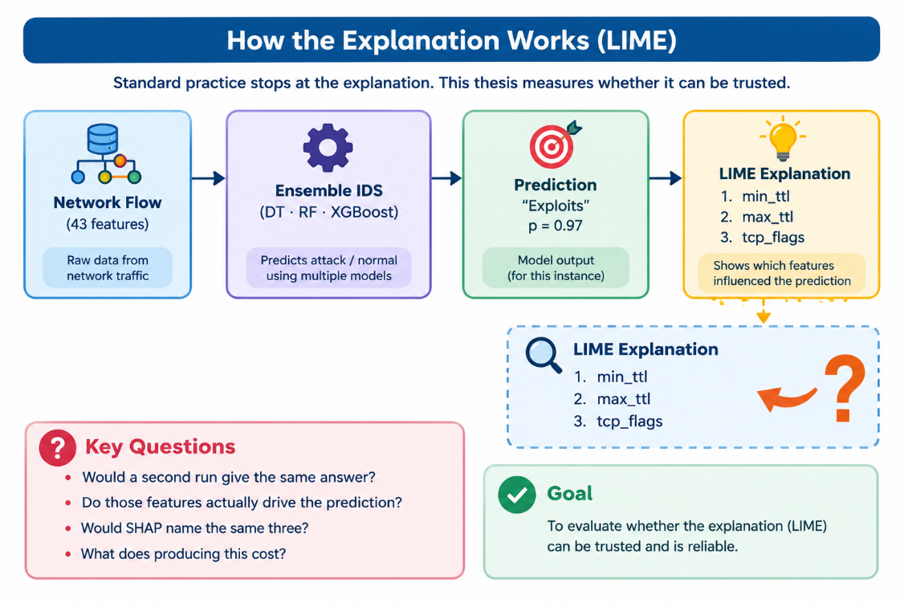
Figure 1.1: The trust gap. A flow is flagged, a probability is produced, an explainer names three features — and the four questions that determine whether an analyst can act on it are left unanswered.

1.2 Problem Statement
An explanation delivered to a security analyst carries an implicit warranty with three clauses. First, that the explanation is repeatable: running the same explainer again on the same flow and the same model would produce substantially the same answer. Second, that it is faithful: the features it names are the ones the model actually relied upon, not an artefact of the explainer's own approximation. Third, that it is corroborated: an independent explanation method applied to the same decision would broadly agree.
None of these clauses is routinely verified in the intrusion detection literature, and there are concrete reasons to doubt each. LIME fits a local surrogate model to a randomly drawn perturbation sample, which makes its output a random variable rather than a function of the input alone [3], [5]. Post-hoc attribution methods try to approximate the model of actually reading it so a ranking that looks reasonable can be created by a substitute model that has learned from noisy data [6] [7]. Also independent explainers use mathematical ideas so there is no promise that they will agree [8].
If any clause fails the result is the same. It is serious. An analyst who relies on an explanation is not making a decision based on real insight. They are making a decision based on a coin flip that looks like insight. A security team that builds its monitoring, around feature rankings that're not reliable is strengthening the wrong parts of its network.. A practitioner who reads one paper saying "LIME and SHAP broadly concur" and then uses that idea in their own work is taking a finding that may not hold up when the model changes and treating it as a general truth.
The issue this thesis tackles is not that intrusion detection models are inaccurate. On benchmarks they are accurate enough. The real problem is that the explanations we layer on top of these models are not measured.. The field has no agreed-upon way to measure them.

1.3 Motivation
Three considerations shaped the direction of this work.
The first is practical. A security operations center operates under time pressure. In that environment explanation isn’t a nice-to-have—it’s essential. Without it an alert remains unclear and unusable. If the explanation is shaky the tool wastes analyst time, which's the most limited resource in any SOC. The cost of an explanation isn’t small. It’s negative. It takes away attention from real threats.
The second consideration is academic. When we read papers on intrusion detection we noticed how many relied on assumptions. Many presented explanations, with three places of precision—yet never checked whether running the same analysis again would give the same results. The qualities we wanted to measure are basic. They’re the kind of things you expect from any instrument before you trust it. Their absence didn’t look like a choice. It looked like something the field had simply overlooked without questioning.
The third consideration is practical, and personal. Both authors intend to work in security engineering, and we wanted a thesis whose result would remain useful even if it turned out to be negative. A protocol that measures whether an explanation can be trusted retains its value whichever way the measurements fall. As it happened, the measurements fell in a direction neither of us predicted, and the four mechanisms we proposed to account for them were all falsified — which is reported in full in Chapter IV rather than quietly dropped.
Related work on cyber threat intelligence makes a parallel argument from a different direction: information shared for defensive purposes carries risk, and its value depends on its quality and provenance being assessable rather than assumed [9]. An explanation produced by an intrusion detection system is intelligence of exactly this kind. It is consumed by a human decision-maker who cannot independently verify it, which is precisely the condition under which measured reliability matters most.

1.4 Objectives of Research

The objectives below were fixed before the experiments were executed. The objectives are listed in the order in which they were pursued.

1.4.1 Primary Objectives
- Quantify explanation stability. Check if running LIME times on the same data point, with the same locked model gives the same list of important features and see if this answer changes when you choose a different model to explain.
- Quantify explanation faithfulness. Is the ability of the feature that the explainer chooses to influence the models decision, checked by comparing it to a random feature instead of looking at it on its own.
- Quantify explainer agreement. Check if independent explanation methods applied to the frozen model produce the same feature rankings. Compare the results to see if the rankings line up.
- Establish a reproducible measurement protocol. Create a working process that can be run with set starting points and specific versions of software that shows all the results, in this thesis using computers.

1.4.2 Secondary Objectives
- Create an ensemble intrusion detector using NF-UNSW-NB15-v2 so that the explanations being studied come from a real functioning system and not from a simple or artificial model.
- Please report the cost for detection and the computational cost, for explanation. An explanation that cannot be produced quickly is of no use.
- Make the codebase and result tables available, to the public so others can try the work again and build on it.

1.4.3 Research Questions
Four research questions were set at the beginning. Three of them were fully carried out; the fourth is. Not done, because the reasons are explained in Section 1.5.
- RQ1 — Stability. Does LIME return the same explanation when applied twice to the same instance under the same frozen model, and does the answer vary across models?
- RQ2 — Faithfulness. Do the features named by an explainer actually drive the model's prediction, relative to a random-feature control?
- RQ3 — Transferability. Do explanations survive a change of network infrastructure? (Specified in Section 5.3.1; not executed.)
- RQ4 — Agreement. Do independent explainers applied to the same model agree with one another, and does the answer depend on the model?

1.5 Scope and Delimitation
This paper presents three boundaries which limit the scope of this research and makes them clear to the reader.
The detector is a means, not an end. This thesis does not aim at providing top-notch detection performance and does not take into account hyperparameter tuning for each model separately. The purpose of models is to make them intelligible explaining how they are constructed to fit the memory resources allocated. If their performance is mentioned, it is only to support the explanation obtained.
RQ3 is specified but not executed. In order to perform research on cross-network transferability another NetFlow database of approximately 3 GB size and the reverse cycle of training is necessary. Unfortunately, there was neither time nor memory required for that in the thesis. The design of the experiment is described in Section 5.3.1 in great detail which allows the following researcher to fulfill this task.
The benchmark is synthetic. NF-UNSW-NB15-v2 is generated traffic, not production capture. This is a limitation shared by essentially all published work in the area, and it is revisited in Section 4.4.

1.5.1 Extension of the original scope
The original study is retained in this revision, including its numerical tables, figures, references and appendices. The added experiments use a corrected feature-group-disjoint protocol and are reported separately. RQ1 remains stability, RQ2 faithfulness, RQ3 transferability and RQ4 cross-explainer agreement; the LLM comparison is an additional evaluation, not a renaming of RQ4. References to an unexecuted RQ3 describe the original scope; the extension now completes frozen detection and LIME transfer in both directions.

1.6 Organization of the Thesis
The thesis comprises five chapters.
Chapter I establishes the trust gap in explainable intrusion detection, states the problem, and fixes the research questions and scope.
Chapter II reviews machine learning for intrusion detection and post-hoc explanation, surveys what is known about the reliability of explanations in other domains, positions this work against the three closest prior studies, and identifies the gap it addresses.
Chapter III describes the methodology: the dataset and its preprocessing, the six detection models and the soft-voting ensemble, the four explanation methods, the three experimental protocols, the evaluation metrics, and the computational environment in which everything was run.
Chapter IV reports the results and discusses them. Detection performance is established first, so that the explanations under study are known to be explanations of a functioning system; the three research questions follow; the central stability–faithfulness dissociation and the threats to validity close the chapter.
Chapter V concludes, states the contributions, specifies the unexecuted RQ3 as future work alongside other extensions, and closes with a reflection on what the field should take from a set of falsified hypotheses.
Two appendices follow the references: Appendix A gives the commands required to reproduce every experiment, and Appendix B contains supplementary result tables referenced from Chapter IV.
CHAPTER II

Literature Review

2.1 Introduction
This chapter traces the path from signature-based intrusion detection to learned detectors, then to the post-hoc explanation methods now layered on top of them, and finally to the small but growing body of work that questions whether those explanations can be trusted. The review is organised around a single thread: at each stage, what was measured, and what was assumed. That distinction is what eventually locates the gap this thesis addresses.

2.2 Scope of Research
The literature reviewed here falls into four groups. The first concerns machine learning for network intrusion detection, and establishes the datasets, models and evaluation conventions in current use. The second covers post-hoc explanation methods — principally LIME, SHAP and permutation importance — and their mathematical foundations. The third, drawn largely from outside the security domain, concerns the reliability of those methods: work on stability, faithfulness and the disagreement problem. The fourth is the small set of studies that apply explainable AI specifically to intrusion detection, which is where this thesis is positioned.
Work on explanation for computer vision and natural language is cited only where the method or the reliability critique carries over to tabular network data. Work on interpretable-by-design models, such as rule lists and generalised additive models, is outside the scope: this thesis is concerned with the post-hoc explanation of models already deployed, which is the situation practitioners actually face.

2.3 Machine Learning for Network Intrusion Detection

2.3.1 From Signatures to Learned Detectors
Signature-based detection matches traffic against a database of known attack patterns. It is precise and its verdicts are trivially explainable — the matched rule is the explanation — but it cannot detect what it has not seen, and maintaining the signature database is a permanent operational cost. Anomaly-based detection promised to close that gap by learning a model of normal behaviour and flagging departures from it.
Sommer and Paxson's assessment of that promise remains the sharpest critique in the field [10]. They argued that intrusion detection is unusually hostile to machine learning: the cost of a false positive is high because analyst time is finite, the class distribution is extreme, and the semantic gap between a statistical anomaly and an actionable security event is wide. Their arguments were presented about the deployment process, which applies equally in explaining it. An explanation that is statistically reliable but semantically meaningless does not bridge the semantic gap; it only embellishes the gap.
Subsequent work has largely confirmed the diagnosis while continuing to report high benchmark figures [11]. The tension between the two is a recurring theme, and it motivates the emphasis in this thesis on macro-averaged metrics and on false alarm rate rather than accuracy.

2.3.2 Ensemble Methods and Benchmark Datasets
Ensemble methods dominate tabular intrusion detection. Random forests [12] reduce the variance of individual decision trees by averaging over bootstrap samples; gradient-boosted trees, of which XGBoost [13] is the standard implementation, fit successive trees to the residuals of their predecessors. Both routinely outperform deep networks on tabular network flow data, and both are fast enough for line-rate inference, which is why they remain the practical default.
Dataset selection is a more contested matter. KDD Cup 1999 and NSL-KDD are still used despite well-documented flaws. UNSW-NB15 [14] was introduced to provide more modern attack behaviour. The more consequential development for this thesis is the NetFlow standardisation of Sarhan, Layeghy and Portmann [15], [16], who re-expressed four widely used corpora — UNSW-NB15, BoT-IoT, ToN-IoT and CSE-CIC-IDS2018 — in a common 43-feature NetFlow schema. The resulting NF-v2 datasets make cross-network comparison possible for the first time without feature-set translation, which is precisely what a transferability study of explanations requires.
A detail of the specific release used here is worth stating early, because it propagates into every number reported in Chapter IV. The deduplicated distribution of NF-UNSW-NB15-v2 contains 1,986,745 flows at a 3.78% attack rate, not the 2.39 million flows and 3.98% rate quoted in much of the literature. Figures reported in this thesis are those produced by the pipeline described in Chapter III, on the release actually used.

2.4 Explainable AI and Its Application to IDS

2.4.1 Post-hoc Explanation Methods
Post-hoc explainers attribute a model's prediction to its input features without modifying the model. Three families are relevant here.
LIME [3] explains an individual prediction by sampling perturbed variants of the instance, querying the model for their predicted probabilities, and fitting a sparse linear surrogate weighted by proximity to the original instance. The surrogate's coefficients form the explanation. The design has one structural consequence that this thesis takes as its starting point: because the perturbation sample is drawn at random, the resulting ranking is a random variable, not a deterministic function of the input.
SHAP [4] grounds attribution in cooperative game theory, assigning each feature its Shapley value — the average marginal contribution over all feature coalitions. The exact computation is exponential, so implementations rely on model-specific approximations. TreeSHAP [17] computes exact Shapley values for tree ensembles in polynomial time, which makes it deterministic and comparatively fast on the models used here; KernelSHAP falls back to a sampling procedure for arbitrary models, and is neither.
Permutation importance [12] is not only different from others methods, but also helps inspect the drop in the value of the metric selected while changing the values of feature over the provided dataset. The method is global, and it is significantly dependent on the selected metric, which is given an explanation in Section 3.5.
TOPSIS [18] is the fourth method which is included in the paper, while it will be used in the paper simply as a reference point without giving any more information regarding TOPSIS. TOPSIS is based on the statistical properties of variables themselves, thus there is no point in asking the data model to get information on the data. If the results of model-based methods yield similar results to those of the TOPSIS method, it indicates that these modelling techniques are based on the similarity of datasets rather than specific features.2.4.2 Explainable AI in Intrusion Detection
Applications of these methods to intrusion detection have multiplied rapidly. Patil et al. [20] combined a detection model with LIME to produce per-alert explanations, and demonstrated that the resulting feature attributions were legible to an analyst. Kalutharage et al. [21] applied explainable AI to distributed denial-of-service identification in IoT networks, using explanation to build confidence in an automated pipeline. Broader surveys [22], [23] catalogue dozens of comparable studies across IoT, industrial control and enterprise settings.
What is striking, reading these papers as a group, is the uniformity of the evaluation. Detection performance is measured carefully — accuracy, precision, recall, F1, sometimes AUC, often with cross-validation. The explanation is then displayed. Where an explanation is evaluated at all, the evaluation is typically qualitative: the highlighted features are described as plausible, or as consistent with domain knowledge. Plausibility is a property of the reader, not of the explanation, and it is not the same as reliability. The gap between the two has been noted repeatedly at the level of principle [31], [32], but not closed at the level of measurement in this domain.

2.5 Reliability Properties of Explanations
Outside the security domain, the reliability of post-hoc explanations has received sustained critical attention. Three properties recur, and they organise the experimental design of this thesis.

2.5.1 Stability
Stability asks whether an explainer returns the same answer twice. Alvarez-Melis and Jaakkola [5] showed that local explanation methods can be badly non-robust: instances that are close in input space, and receive near-identical predictions, can receive materially different explanations. Ghorbani et al. [6] demonstrated that explanations of neural networks can be manipulated by imperceptible input perturbations that leave the prediction unchanged. For LIME specifically, the instability has a clear source in the sampling procedure, and deterministic variants have been proposed to remove it [24].
This literature is almost entirely concerned with image and text models. Whether the same instability appears on tabular network flow data, and whether its magnitude depends on the model being explained, has not been systematically measured — and it is the subject of RQ1.

2.5.2 Faithfulness
Faithfulness asks whether an explanation reflects what the model actually does. The standard operationalisation comes from the ERASER benchmark [25]: comprehensiveness removes the features an explainer nominates and measures how far the prediction falls, while sufficiency retains only those features and measures how much of the prediction survives. Hooker et al. [26] added an essential control by showing that removal-based tests can be confounded by distribution shift, and that any such measurement must be interpreted against a baseline in which randomly chosen features are removed instead.
The random control is not a robustness check appended to the experiment; it is the experiment. Masking ten of thirty-nine features will move a prediction regardless of which ten are chosen, so an absolute comprehensiveness figure means very little on its own. Hence, this research shows faithfulness in terms of its ratio with respect to a random feature control.

2.5.3 Agreement
Agreement asks whether independent explainers converge. Krishna et al. [8] referred to this phenomenon as disagreement and asked practitioners about how they managed the inconsistency in their using different explanation methods - usually by choosing whichever results were more in line with their expectations. Slack et al. [7] showed that LIME and SHAP can be deliberately fooled by an adversarially constructed model, which establishes that agreement between them is not guaranteed even in principle.
Warnecke et al. [27] evaluated explanation methods specifically for security applications and proposed criteria including descriptive accuracy and sparsity. Their work is the closest antecedent to this thesis in spirit, though it addressed malware and vulnerability detection rather than network flow classification, and did not measure run-to-run stability.
Table 2.1: Reliability properties, their operational question, and the metrics used to measure them in this thesis.
Property | Operational question | Metrics used | RQ
Stability | Does the explainer return the same ranking twice? | Jaccard@5, Jaccard@10, Kendall τ | RQ1
Faithfulness | Do the named features drive the prediction? | Comprehensiveness AUC, sufficiency AUC, ratio to random control, Wilcoxon test | RQ2
Transferability | Does the explanation survive a change of network? | Spearman ρ, Kendall τ, Jaccard@10 per class | RQ3 (specified)
Agreement | Do independent explainers converge? | Pairwise Spearman ρ, pairwise Jaccard@5 | RQ4

2.6 Position Against the Closest Prior Art
Three studies sit closest to this work, and the differences are worth stating precisely.
Patil et al. (2022) [20] applied LIME to an intrusion detection model and presented per-instance explanations. The explanations were assessed qualitatively for plausibility. Neither repeatability nor faithfulness was measured, and only one explainer was used, so agreement could not arise as a question.
Kalutharage et al. (2023) [21] used explanation to support DDoS identification in IoT networks, again treating the explanation as an output to be inspected rather than an instrument to be calibrated. Their contribution is a detection pipeline; explanation reliability is outside their stated scope.
Hernandez et al. (2025) [28] is the closest and the most important to distinguish, because a superficial reading might suggest that this thesis reproduces it. They derived feature rankings via SHAP, retrained models on the top-k features, and reported that performance was retained — presenting this as evidence that the rankings were faithful. The inference does not hold. Retraining measures whether a feature subset suffices to build a model; it cannot measure whether the original model used those features, because a retrained model will recover its performance from correlated substitutes for anything removed. Faithfulness to a specific fitted model can only be tested by holding that model fixed and intervening on its inputs, which is what the frozen-model protocol in Section 3.6.2 does. A second difference is that their cross-network comparison of rankings was qualitative and conducted on merged background traffic; the per-class quantitative version is specified here as RQ3 in Section 5.3.1.

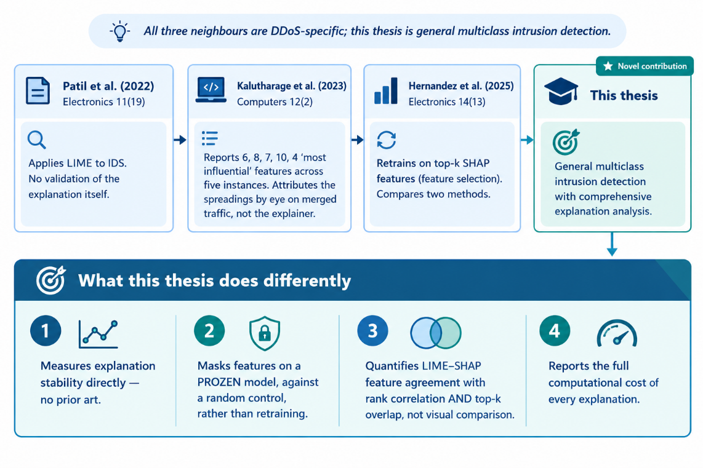
Figure 2.1: Position of this thesis against the three closest prior studies, showing what each measured and the four respects in which the present work differs.
Table 2.2: Comparison of the closest prior art. Only this thesis measures stability, faithfulness against a random control, and cross-explainer agreement on the same frozen model.
Study | Explainer(s) | Explanation evaluated? | Stability | Faithfulness | Agreement
Patil et al. (2022) [20] | LIME | Qualitative | No | No | n/a
Kalutharage et al. (2023) [21] | SHAP | Qualitative | No | No | n/a
Hernandez et al. (2025) [28] | SHAP | Retrain on top-k | No | Retraining proxy | No
Warnecke et al. (2020) [27] | Multiple | Quantitative | Partial | Yes | Partial
This thesis | LIME, SHAP, Permutation, TOPSIS | Quantitative, frozen model | Yes (6 models) | Yes, vs random control | Yes (3 models)

2.7 Identifying the Research Gap
Placing the two bodies of literature side by side makes the gap plain. The reliability critique — instability, unfaithfulness, disagreement — is well developed, but it was formulated for image and text models and has not been carried into network intrusion detection. The intrusion detection literature has adopted the explanation methods enthusiastically but not the critique that accompanies them.
Three specific omissions follow.
- No published intrusion detection study measures run-to-run stability of its explanations. Papers report a single LIME run and do not establish that a second run would agree with it.
- Faithfulness, where it is addressed at all, is measured without a random control or by a retraining proxy. Neither establishes that the fitted model used the features named.
- Agreement between explainers is asserted rather than measured, and where two methods are shown together the comparison is visual.
The gap is therefore not a missing model or a missing dataset. This is the practice of missing measurement. In order to close this, one has to take a model and ensure it’s held constant and explainer applications run repeatedly and concurrently, recording overlaps and correlations with the same rigor that one normally applies to detection metrics..

2.7.1 Research gap addressed by the extension
The extension connects repeatability, random-controlled masking and frozen cross-network transfer under a common input representation. It adds neural and LLM comparisons without claiming the first use of LLMs in intrusion detection. The historical literature and positioning remain above; the following discussion extends that scope.
Houssel et al. evaluate LLM network intrusion detection and discuss a complementary role in explanation and threat response [38]. Their study already establishes that using LLMs for these tasks is not a new idea. The present comparison differs in its small local models, fixed numerical serialization and retained matched-case evidence; it is not a replication of their full setup.
The eX-NIDS framework enriches prompts with flow context and threat-intelligence information to generate explanations of detector decisions [39]. This supports separating a detector's classification from the LLM's interpretive role. Here, detector-grounded prompts instead supply local feature-removal evidence from a frozen XGBoost model. The validity checks are deliberately narrow: JSON structure, exact feature references and named-versus-random masking do not verify every sentence of generated prose.

2.8 Summary of Literature Findings
The findings from this study present the ground for the methodology presented below.
To begin with, the reliability of explanations is an aspect not measured in security literature. The methods are present in literature and are widely used, but not in this case.
Furthermore, faithfulness measures are of no use without a control. As any removal test, some change would occur, and therefore, the main number gives the connection of the model to a random baseline rather than the model’s absolute values.
Finally, the statement about a certain explainer cannot be backed by a single model. If the stability of an explanation varies across models, only in such a particular case it makes sense to conduct research.
CHAPTER III

Methodology

3.1 Introduction
In this chapter, there is a description of converting the research questions of the first chapter into experiments. The chapter provides information about the dataset and its preprocessing, the six detection models and the ensemble, the four feature-ranking methods, the three experimental protocols, the metric used to summarize the experiments, and the environment for running them. Throughout the chapter, the organizing constraint is noted that the model must remain fixed before the explanation is generated such that every following measurement will be made with respect to one fixed object and not to its multiple retrained versions.

3.2 Research Approach

3.2.1 Philosophy: The Explanation as the Object of Study
Traditionally, the model is perceived as the subject of assessment, and explanation is regarded as its outcome. The current thesis, on the other hand, reverses this notion. The detector is being constructed toward the beginning of the study, and its success as a working model is determined through various tests for validity; once the detector is created, it remains unchanged for the rest of the experimentation and is evaluated through the experiments conducted henceforth.
This inversion leads to three concrete conclusions, each of which results in a particular design.
- Freeze before explaining. No model is retrained at any point after the detection stage. A single stratified split at seed 42 is written to disk as split_{task}_seed{seed}.json, and RQ1, RQ2 and RQ4 all load it, so every experiment operates on identical instances and an identical fitted model.
- Control before concluding. Every faithfulness measurement is reported against a random-feature baseline, and three non-tree classifiers are included as stability controls. Numbers without a comparison point are not reported as findings.
- Report what was predicted, including when it fails. Four mechanisms intended to explain the RQ1 result were written down before the corresponding diagnostics were run. All four were falsified, and all four are reported in Section 4.2.5.

3.2.2 System Architecture
Figure 3.1 shows the complete pipeline. Reading top to bottom: raw flows are loaded and identifier columns dropped; six classifiers are trained on the resulting features and combined by soft voting; the fitted models are frozen; four ranking methods are applied to the frozen models; and three research questions are computed from those rankings. The red band marks the freeze point, which is the pivot of the whole design — nothing below it retrains anything above it.
The purple row in the detection layer is labelled RQ1 controls rather than baselines, and the distinction is deliberate. Gaussian Naive Bayes flags nearly half of all benign traffic and is not a working detector; it is present so that the stability comparison in RQ1 is not confined to a single model family. Presented as a baseline it would look like an error; presented as a control it does exactly the job it was included for.

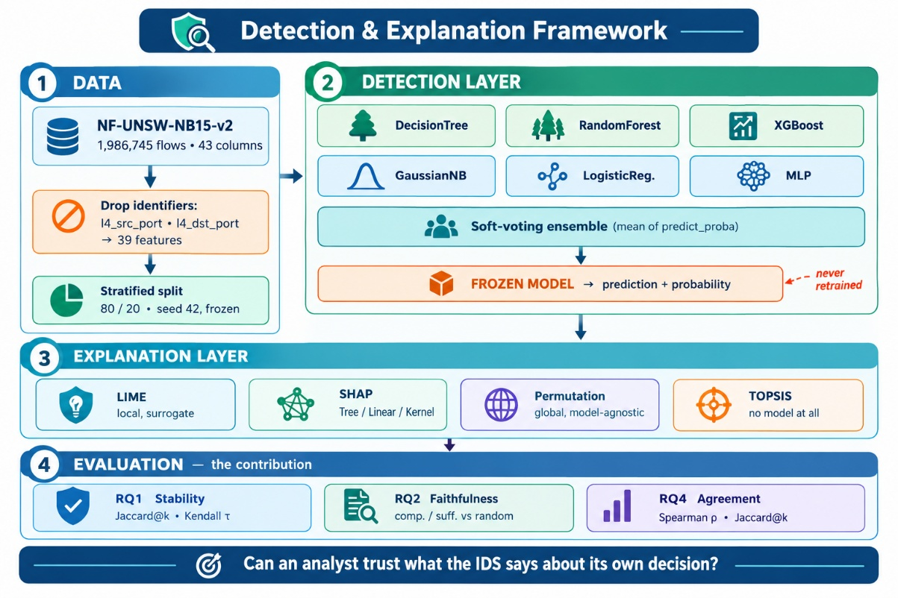
Figure 3.1: System architecture. Data preparation, six detection models combined by soft voting, the freeze point, four ranking methods, and the three executed research questions.

3.3 Dataset Preparation and Analysis

3.3.1 NF-UNSW-NB15-v2 Characteristics
The experiments use NF-UNSW-NB15-v2, the NetFlow re-expression of UNSW-NB15 produced by Sarhan et al. [15], obtained through the deduplicated public distribution released under a CC BY-NC-SA 4.0 licence [36]. The dataset was selected for three reasons: it uses the standardised 43-feature NetFlow schema, which makes the specified cross-network extension in Section 5.3.1 feasible without feature translation; its identifiers are already stripped upstream, reducing the risk of leakage; and its class distribution is severely and realistically imbalanced.
The release used here contains 1,986,745 flows at a 3.78% attack rate. This differs from the 2,390,275 flows and 3.98% rate frequently quoted, because the distribution used is deduplicated. In this thesis, each figure is based upon the release that actually underwent processing by the pipeline, and this must be taken into account when making any comparison with published figure about the non-deduplicated release.
Data was split in a single stratified 80/20 at seeds 42 establishing 1,589,396 training flows and 397,349 test flows. Table 3.1 shows the composition of the test set. The imbalance with 96.22% of normal traffic and Worms class accounting for just 33 flows is out of the ordinary. Any Worms statistic from Chapter IV is based on this data and marked accordingly.
Table 3.1: Composition of the NF-UNSW-NB15-v2 test split (20% stratified, seed 42). Benign traffic dominates; the rarest attack class contains 33 flows.
Class | Test flows | Share of test set | Role
Benign | 382,333 | 96.22% | Negative class
Exploits | 5,981 | 1.51% | Attack
Fuzzers | 4,129 | 1.04% | Attack
Reconnaissance | 2,234 | 0.56% | Attack
Generic | 1,198 | 0.30% | Attack
DoS | 835 | 0.21% | Attack
Shellcode | 285 | 0.07% | Attack
Backdoor | 167 | 0.04% | Attack
Analysis | 154 | 0.04% | Attack
Worms | 33 | 0.01% | Attack (n too small for stable metrics)
Total | 397,349 | 100% | —

3.3.2 Preprocessing Pipeline and the Leakage Boundary
There is little preprocessing and, most importantly, no leakage. In Figure 3.2, the “seven stages” are illustrated; with a dashed boundary marking the step past which the process is only fitted using training data.
The most significant part is the elimination of identifying columns. Source and destination IP addresses, as well as timestamps, are already eliminated in the preprocessed data; however, the loader also removes the l4_src_port and l4_dst_port columns thus reducing the number of columns from 43 to 39 features, which is not a parameter tweaking decision but rather a question of correctness. A model that memorises an attacker's source port reports inflated accuracy, which is the familiar problem. Less familiar, and more damaging here, is the second effect: the explainer would then faithfully report that port as the most important feature. The explanation would be perfectly accurate about the model and completely useless to an analyst. A single leaked identifier would invalidate every explanation chapter of this thesis, which is why the check is enforced by a dedicated gate script, verify.py, that must pass before any model is trained.
Remaining steps are conventional: schema validation, the stratified split, and standardisation fitted on the training partition only. No resampling was applied to the training data; class imbalance is handled inside the models through class_weight="balanced" rather than by altering the data distribution, so that the explanations refer to a model trained on the real distribution.
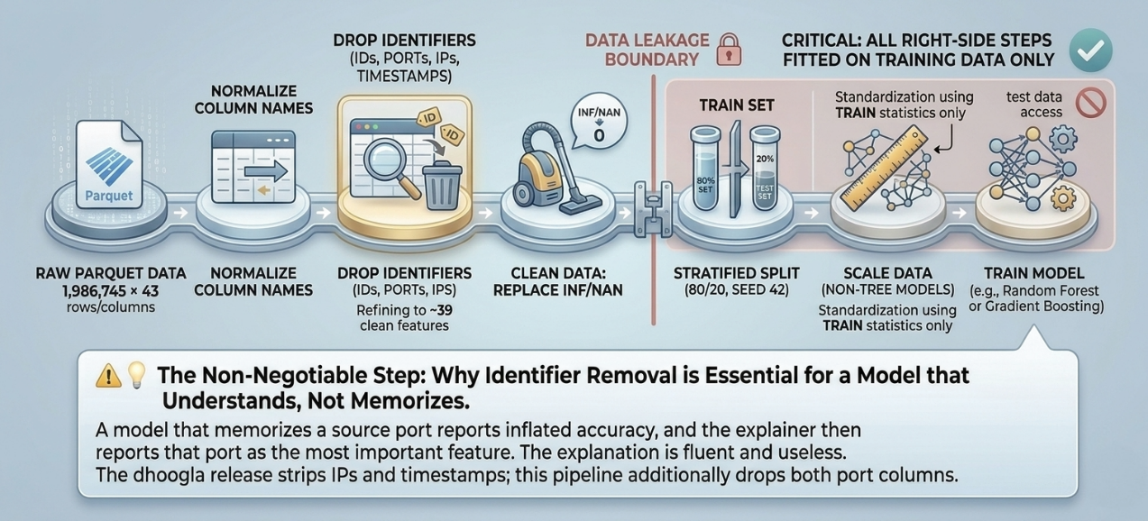
Figure 3.2: Preprocessing pipeline. The dashed boundary marks the leakage limit: every transformation to its right is fitted on training data only. The panel below explains why port removal is non-negotiable.

3.4 Detection Models and the Ensemble

3.4.1 Model Selection and Constraints
Six classifiers were trained. Three — Decision Tree, Random Forest and XGBoost — are the detection models, chosen because tree ensembles are the practical default for tabular flow data and because TreeSHAP provides exact, tractable Shapley values for them. Three — Gaussian Naive Bayes, Logistic Regression and a multilayer perceptron — are RQ1 controls, included so that the stability comparison spans smooth and non-smooth probability surfaces rather than three variants of the same tree family.
Tree depth was capped at 30 with a minimum of five samples per leaf. This was a memory decision, not a tuning decision: on 1.59 million training rows an unconstrained forest exhausts the available 16 GB. The constraint is uniform across all tree models and is carried into Section 4.4 as an untuned-hyperparameter limitation. All tree models use class_weight="balanced", which trades precision for recall on rare classes — a trade that is clearly visible in the per-class results and is discussed there rather than hidden.
Table 3.2: The six classifiers, their role in the study, and the configuration used. Depth constraints were set by the available memory, not by tuning.
Model | Role | Key configuration
Decision Tree | Detection | max_depth=30, min_samples_leaf=5, class_weight=balanced
Random Forest | Detection | 100 trees, max_depth=30, min_samples_leaf=5, class_weight=balanced
XGBoost | Detection | 200 estimators, histogram tree method
Gaussian Naive Bayes | RQ1 control | Default; smooth, simple probability surface
Logistic Regression | RQ1 control | lbfgs, max_iter=1000 (did not converge — reported, not raised)
Multilayer Perceptron | RQ1 control | Single hidden layer; smooth, non-linear surface
Soft-Voting Ensemble | Detection | Mean of predict_proba over member models

3.4.2 Exclusion of the Support Vector Machine
An RBF-kernel support vector machine was considered and excluded. Rather than asserting that it would be too slow, its training time was measured against increasing subsample sizes; the results are in Table 3.3. Growth is roughly quadratic to 80,000 rows and then breaks sharply as the kernel cache overflows, with the empirical exponent exceeding four beyond that point. Extrapolating to 1.59 million training rows places training time far outside any feasible budget on the available hardware.
The measurement is reported rather than the assertion because the scaling curve is itself a small contribution: it documents, with numbers, why kernel methods are impractical at this data scale, and it explains why the ensemble is composed of Decision Tree, Random Forest and XGBoost alone.
Table 3.3: Measured RBF-SVM training time against training-set size. The break beyond 80,000 rows corresponds to kernel cache overflow.
Training rows | 5,000 | 10,000 | 20,000 | 40,000 | 80,000 | 160,000
Training time (s) | 0.1 | 0.2 | 0.7 | 2.6 | 8.5 | 196.0

3.4.3 Soft Voting
The ensemble prediction is the arithmetic mean of the member models' predict_proba outputs, computed directly rather than through scikit-learn's VotingClassifier. The library implementation refits every base estimator when constructed, which would both double the training cost and — more seriously — break the freeze guarantee, since the ensemble members would no longer be the same fitted objects that RQ1, RQ2 and RQ4 explain. The manual computation is mathematically identical and preserves object identity across all experiments.
Two ensemble compositions are reported in Chapter IV: a three-model version over the tree detectors, and a six-model version including the controls. Retaining both is deliberate, because the difference between them turns out to be informative about how soft voting responds to a badly broken member.

3.5 Explanation Methods
Four feature-ranking methods were applied to the frozen models, summarised in Table 3.4.
LIME is the primary object of study, because it is the method most widely applied in the intrusion detection literature and the only one of the four whose output is stochastic by construction. It was configured identically across all six models; the only quantity varied between runs is the random seed.
SHAP is applied with the variant appropriate to the model: TreeSHAP for tree ensembles, LinearSHAP for logistic regression, KernelSHAP otherwise. This choice is reported rather than buried, because tool availability has previously determined which models get explained in published work — Hernandez et al. [28] excluded their recurrent model from SHAP analysis on tooling grounds and then trained that same architecture on SHAP-derived features regardless. Where the variant differs, the comparison changes character, and the reader should know which was used.
Permutation importance was computed under the f1_macro scoring function rather than accuracy. The choice is not cosmetic. A diagnostic run measured maximum importance of 0.085 under f1_macro, with 18 of 39 features falling inside the noise floor established by repeated shuffles; under accuracy maximum importance collapsed to 0.002 with 22 of 39 features inside the noise floor. On a test set that is 96.22% benign, shuffling a feature barely moves accuracy, so an accuracy-scored permutation ranking would have been almost entirely noise. That 18 of 39 features remain within the noise floor even under f1_macro is itself carried forward into the interpretation of RQ4.
TOPSIS ranks features by intrinsic statistical criteria — variance, entropy and inverted mean correlation — without querying the model. It is included as a model-free reference. The criteria are our own selection rather than a canonical set, and this is listed among the threats to validity in Section 4.4.
Table 3.4: The four ranking methods, their scope, and whether their output is deterministic.
Method | Scope | Consults model? | Deterministic? | Role in this study
LIME | Local | Yes (probabilities) | No — random perturbation sample | Primary object of study
SHAP (Tree/Linear/Kernel) | Local | Yes (structure or probabilities) | Yes for TreeSHAP | Independent comparison
Permutation importance | Global | Yes (metric drop) | Approximately | Methodologically independent
TOPSIS | Global | No | Yes | Model-free reference

3.6 Experimental Protocols
Figure 3.3 shows how the three executed research questions hang off the shared frozen model, together with the greyed-out RQ3 that is specified but not run. The double-headed arrow between RQ2 and RQ4 is the interesting relationship in the design: where RQ4 finds two explainers disagreeing, RQ2's faithfulness curves can adjudicate which of them better reflects the model's actual behaviour. That chaining is what makes the design more than three independent measurements.

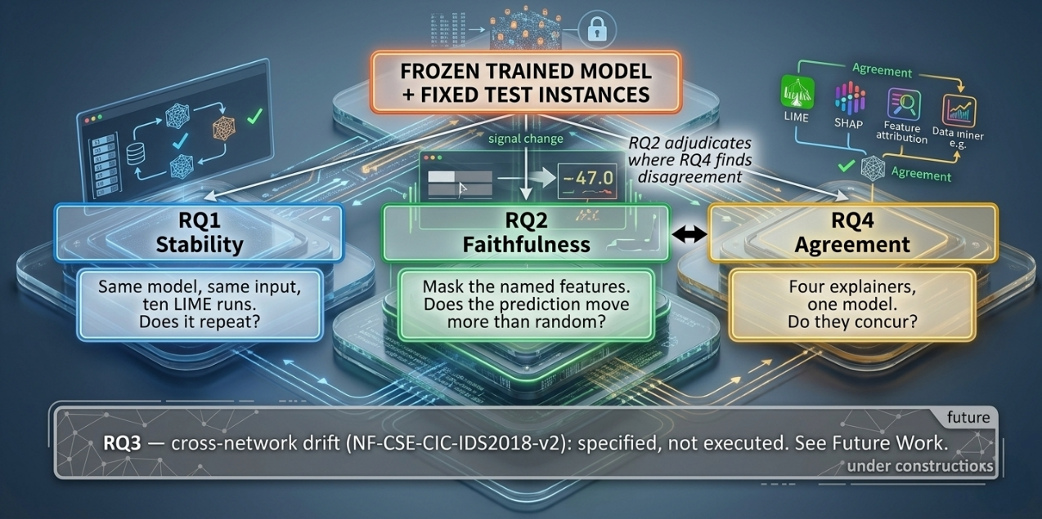
Figure 3.3: Experimental design. Three executed research questions computed from one frozen model, with RQ3 shown greyed out and explicitly declared as specified but not executed.

3.6.1 RQ1 — Stability Protocol
For each of the six frozen models, 933 test instances were sampled with class stratification — approximately 100 per class, with Worms contributing all 33 available flows. LIME was then run ten times on each instance, varying only the random seed (101 to 1010), giving 9,330 explanations per model and 55,980 in total.
Nothing else changes between the ten runs. The model is identical, the input is identical, the explainer configuration is identical. If LIME were deterministic, all ten rankings would coincide exactly. Any divergence is attributable solely to the perturbation sample drawn internally by the explainer. Figure 3.4 makes this structure explicit.
The ten rankings for each instance are compared pairwise, over all 45 pairs, using Jaccard overlap at k = 5 and k = 10 and Kendall's τ over the full 39-feature ordering. The per-instance means are then averaged within class and within model.
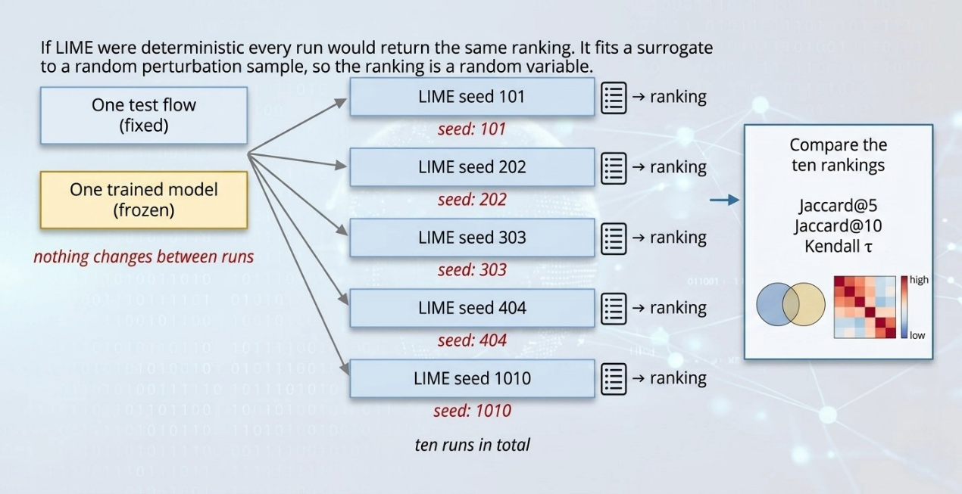
Figure 3.4: RQ1 protocol. One instance, one frozen model, ten LIME runs differing only in random seed, and pairwise comparison of the ten resulting rankings.

3.6.2 RQ2 — Faithfulness Protocol
Faithfulness was measured on 483 test instances for each of the three tree models, using the frozen-model masking protocol shown in Figure 3.5.
For a given instance and a given explainer, the top-k features are masked by mean imputation for k = 1 to 10, and the model's predicted probability for its original class is recorded at each step. Comprehensiveness is the area under the resulting decline curve: a faithful explanation should identify features whose removal collapses the prediction. Sufficiency is the mirror image, retaining only the top-k and discarding the remaining features. Both are computed for LIME, for SHAP, and for a random-feature control that selects k features uniformly at random.
The control is the experiment, not a robustness check. Masking ten of thirty-nine features already reduces the predicted probability by approximately 0.32 on the models studied here. That number alone cannot determine whether the comprehensiveness figure of 0.55 is actually good. Instead, it indicates improvement of 1.74 times from the random chance. All faithfulness results in Chapter IV are therefore reported both absolutely and as a ratio, with significance assessed by the Wilcoxon signed-rank test on paired per-instance values.
The distinction from Hernandez et al. [28] should be stated once more, because it is the methodological heart of this protocol. Retraining on a top-k subset measures whether those features suffice to build a model. Masking on a frozen model measures whether this model used them. Only the second answers the question an analyst is actually asking when they read an explanation.
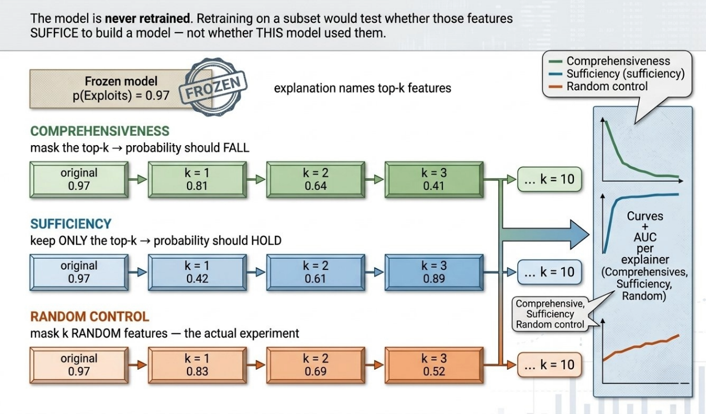
Figure 3.5: RQ2 protocol. Comprehensiveness, sufficiency and the random-feature control, all computed against one frozen model by mean-imputation masking.

3.6.3 RQ4 — Agreement Protocol
For each of the three tree models, global feature rankings were derived from 300 test instances by each of the four methods. LIME and SHAP attributions were aggregated to a global ranking by mean absolute contribution; permutation importance and TOPSIS are global by construction.
The four rankings were then compared pairwise using Spearman's ρ over the complete 39-feature ordering and Jaccard overlap over the top five features. Both are reported for every pair. Reporting both is not redundancy: as Section 4.3.3 shows, they can give materially different pictures of the same pair, and reporting either alone would have supported a different conclusion.

3.7 Evaluation Metrics
Detection metrics. Macro-averaged F1 leads every detection table. Accuracy is reported only in passing, because on a test set that is 96.22% benign a classifier that predicts benign unconditionally attains 96.22% accuracy while detecting nothing at all. False alarm rate — the proportion of benign flows incorrectly flagged — is reported alongside, because it determines analyst workload, and PR-AUC is reported as a threshold-independent summary appropriate to imbalanced data.
Stability metrics. Jaccard@k calculates how two rankings compare in their top-k feature sets; Kendall's τ [33] measures ranking correlation of the complete rankings. The two answer different questions — whether the same features appear at all, and whether they appear in the same order — and both are reported throughout.
Faithfulness metrics. The AUC has been defined in this study along with its standard deviation, while being stated as a ratio against a random control and expressed along with a Wilcoxon signed-rank p-value [35]
Agreement metrics. Pairwise Spearman ρ and pairwise Jaccard@5, reported together for every explainer pair and every model.
Cost metrics. The time taken for training in seconds, the inference latency in milliseconds for each flow, and the average wall-clock time for each explanation in seconds.

3.8 Experimental Environment and Reproducibility
All my experiments were conducted at a standard desktop computer which a normal student would have in his or her lab. That is, though, rather more a limitation than a choice, which works positively as one can repeat conducted experiments on their own machines since it is not a high-end workstation. Overall duration of the whole system is about four hours.
Table 3.5: Experimental environment and pinned software versions. Versions are fixed in requirements.txt; reruns reproduce results to four decimal places.
Component | Specification
Processor | Intel Core i3-10100 (4 cores / 8 threads)
Memory | 16 GB
Operating system | Windows 11
Python | 3.11.9 (virtual environment)
Core libraries | numpy 1.26.4 · pandas 2.2.2 · scikit-learn 1.4.2 [29] · scipy [30] · xgboost 2.0.3
Explainers | lime 0.2.0.1 · shap 0.45.1
Global seed | 42 (split, model initialisation, instance sampling)
LIME seeds | 101–1010 for the ten stability runs
Parallelism | n_jobs = 4
Total runtime | ≈ 4 hours for all six models
Reproducibility is enforced structurally rather than by convention. A single seed constant governs the split, model initialisation and instance sampling. The exact test indices are serialised to split_{task}_seed{seed}.json and reloaded by every downstream experiment, so RQ1, RQ2 and RQ4 provably operate on the same instances and the same fitted models. Dependency versions are pinned. Two independent executions of the binary baseline stage reproduced identical results to four decimal places. The complete codebase, including the result tables from which every figure in Chapter IV is generated, is archived at https://github.com/mehedihasan722/Thesis-Defense-Project-XAI-ids; Appendix A lists the commands required to reproduce each stage.

3.8.1 Expanded study methods
The protocols below govern the new experiments only. They do not retroactively change the original experiments described in Sections 3.1–3.8.

3.8.1.1 Study design and evidence separation
The expanded study starts from the two raw cleaned NetFlow v2 parquet releases and preserves historical results separately. Configuration files fix the three seeds (42, 7 and 1337), sample caps and model families. Completed-run markers control inclusion in summaries. Partial runs do not count as completed experiments. Source hashes, model revisions and saved predictions support later validation.
The primary detector matrix contains seven families, two datasets, two tasks and three seeds: 7 x 2 x 2 x 3 = 84 configurations. Binary models are evaluated both within source and on the other dataset, producing 84 binary cells. Multiclass models produce 42 within-dataset cells. The total is 126 evaluation cells, each using 80,000 sampled test rows. Auxiliary explanation and LLM cohorts are smaller and explicitly separated.

3.8.1.2 Datasets, representation and splitting
Table 3.6: Data and sampling scope.
Item | Specification
NF-UNSW-NB15-v2 | 1,986,745 rows in the downloaded cleaned release.
NF-CSE-CIC-IDS2018-v2 | 17,129,715 rows in the downloaded cleaned release.
Shared input | 39 retained numeric features after port and target removal; inventory in the data manifest.
Partition | Approximately 70/15/15 percent of encoded feature groups for train/validation/test.
Per dataset and seed | Up to 200,000 training, 40,000 validation and 80,000 test rows.
Sampling | Uniform row-priority reservoir after group assignment; original class imbalance is retained.
For each raw numeric value x, the common transformation is sign(x) log(1 + abs(x)), stored at float32 precision. Non-finite inputs use a fixed zero replacement rule, with counts retained. Group assignment hashes the common encoded feature vector, using the same seed-dependent rule across both datasets. Consequently, identical model-input representations cannot be assigned to training in one dataset and test in the other for the same seed. Grouping uses features rather than labels. Repeated rows within a partition may still remain; group separation does not imply independent observations throughout a test set.
Uniform row sampling occurs after partition assignment. It does not balance classes or guarantee that rare categories appear in every training and test sample. All sampled class counts are retained in the data manifest. The signed-log transformation is fixed, while additional neural standardization is fitted only on source training rows. Target-test data are not used for scaling, early stopping, calibration or threshold selection.
The initial tree fit failed because extreme finite raw values exceeded float32 range. Before any successful new model fit, the representation was corrected to apply the common signed-log encoding to every detector and rebuild groups at the model-input precision. IDS2018 contains 213 such extreme values in 211 rows. Encoding avoids overflow, but does not prove that those traffic rates are physically valid. The correction and remaining data-quality limitation are retained rather than hidden.

3.8.1.3 Classical, ensemble and neural models
Table 3.7: Fixed detector configurations.
Model | Configuration
DecisionTree | Maximum depth 30; minimum leaf size 5; balanced class weights.
RandomForest | 100 trees; maximum depth 30; minimum leaf size 5; balanced class weights.
XGBoost | 200 trees; depth 8; learning rate 0.1; row and column sampling 0.8; histogram tree method.
SoftVoting | Equal mean of aligned probabilities from DecisionTree, RandomForest and XGBoost.
ShallowMLP | 39 inputs, hidden layer 64 with ReLU, output layer.
DeepMLP | Hidden widths 256, 128, 64 with ReLU; dropout 0.1 after the first two hidden layers.
FeatureCNN | Feature-axis convolutions 1-to-16 and 16-to-32 channels, kernel 3, padding 1; flattened representation; dense 64; dropout 0.1.
The neural models use source-training standardization, class-weighted cross-entropy, AdamW with learning rate 0.001 and weight decay 0.0001, batch size 1024 and at most 20 epochs. Early stopping uses unweighted source-validation loss with patience four. Best checkpoints and learning histories are retained. The output dimension follows the applicable binary or dataset-specific class inventory. The CNN acts along a fixed feature ordering; it is not a sequence model of chronological traffic.
These are fixed baselines under a bounded compute budget, not exhaustive architecture searches. Binary transfer reuses the same trained model and preprocessing on both datasets. A different training seed also changes the group partition and sample, so the reported standard deviation combines training and split variation. Three seeds do not establish a precise population uncertainty estimate.

3.8.1.4 Detection metrics
For a class treated as positive, precision is TP/(TP+FP), recall is TP/(TP+FN), and F1 is twice precision times recall divided by their sum. Macro-F1 averages class F1 values; balanced accuracy averages class recalls. Binary false-alarm rate is FP/(FP+TN) on benign cases. Accuracy and average precision are retained with confusion matrices and class support in the result artifacts. Per-class undefined precision/F1 values are set to zero. Macro-F1 averages the complete dataset class inventory, including zero scores for absent test classes; balanced accuracy averages recalls for classes present in the test labels. Average precision is averaged only over classes having both positive and negative test examples. Absent classes are recorded.
Results are summarized by mean and sample standard deviation across the three seeds. Macro-F1 is emphasized because accuracy alone can conceal minority-class failures, but it remains dependent on the evaluation cohort. In particular, an 80,000-row prevalence-preserving sample and a balanced 100-case LLM cohort are different evaluation settings. Their scores must not be pooled into a single ranking without that distinction.

3.8.1.5 LIME repeatability and feature masking
For each of the 14 seed-42 binary models, the explanation pilot uses 20 unique feature groups per domain: ten benign and ten attack cases. Each case is explained with three LIME seed offsets (101, 202 and 303) and 5,000 perturbations per explanation. Each offset is added to the row identity modulo 2^32. The discretized tabular explainer uses a fixed 10,000-row source-training background sampled with seed 42. Full feature rankings, weights, local fit information, original probabilities and row/group identities are saved. Absolute coefficient magnitude defines the primary ranking.
Let S(a) and S(b) be the top-five feature sets from two explainer seeds for the same case. Jaccard@5 is the size of their intersection divided by the size of their union. The pilot averages pairwise overlap across the three seed pairs, then across cases. A value near one means repeatable selected sets; it does not directly measure predictive correctness.
Let c be the original predicted class, p(c|x) its original probability, and x(-S) the vector obtained by replacing selected features with their source-training-background medians. The removal drop is p(c|x) - p(c|x(-S)). The class c is held fixed after masking. Matched-size random sets provide control drops. The reported advantage is the selected-feature drop minus the random-control drop, averaged over k = 1, 2, 3, 4 and 5 removed features, then over the three explainer runs and cases. Each run uses one saved random permutation, so selected and random masks have the same size at every k. Positive advantage means the selected features produce a greater reduction than random features under that intervention.
Retention and removal measure different quantities. A sufficiency gap compares original probability with probability after retaining only selected features; smaller gaps indicate better retention under the baseline. The old study's retained-probability ratio is a different measure and can exceed one. This report avoids interpreting either a raw remaining probability or a discrete mean of drops as an unlabeled universal faithfulness score.
For uncertainty, LIME-seed values are averaged within a case before 5,000 stratified bootstrap repetitions resample ten benign and ten attack groups separately. Percentile intervals are conditional on one trained model and the small selected cohort. They are not across-training-seed intervals, are not corrected for multiple comparisons, and do not establish causal validity. Domain arrows connect different cohorts, not paired flows.

3.8.1.6 Masking sensitivity extension
After the primary pilot, a disclosed post-hoc extension compares source-background mean versus median replacement and absolute versus signed-descending rankings. The same cases, saved weights and controls produce four variants per model/domain cell: 112 summary cells and 2,240 case variants. Original median/absolute curves are replayed before interpreting alternatives. Signed-descending ranking may still include nonpositive coefficients when fewer than k positive coefficients exist. All variants are retained; none is selected merely because it produces a preferred correlation.

3.8.1.7 Local language-model protocol
Qwen2.5-0.5B-Instruct, TinyLlama-1.1B-Chat-v1.0 and SmolLM2-1.7B-Instruct are frozen at immutable revisions [40, 41, 42]. Each runs locally on CPU in float32 with two PyTorch threads. No fine-tuning or quantization is used. Each source prompt contains four training examples, two per binary class. The 39 signed-log flow values are serialized to three significant digits, which differs from the full detector input precision.
Each model classifies the same 100 balanced unique feature groups per target, using each of the two source contexts: four source/target combinations and 400 cases per model. Label-completion likelihoods for 0 and 1 are normalized to choose a class. These are not calibrated attack probabilities. TinyLlama's shared whitespace-prefix token is handled before comparing suffix logits; regression checks cover that compatibility correction. Tokenizer correctness alone cannot rule out prompt or label-token bias.
Twenty cases per combination also receive an own-decision explanation and a detector-grounded explanation using supplied evidence from frozen XGBoost. Generation is greedy with a maximum of 192 new tokens. Thus each LLM produces 80 own and 80 detector explanations, with prompts and raw outputs retained. A valid response requires the specified JSON structure, a nonempty explanation and one to three exact feature names. Invalid or truncated responses remain in the coverage denominator.
Only valid explanations enter masking. Their named features are compared with three random sets of the same size using the source-background median. Own explanations are checked against the generating LLM; detector explanations against XGBoost. Original LLM scores must replay within 1e-4. These two types of masking score are not interchangeable because they refer to different models. Feature-name membership and masking do not certify every prose claim.

3.8.1.8 Calibration, imbalance and feature shift
The calibration extension fits a temperature using source-validation negative log likelihood and evaluates Brier score and 15-bin positive-class expected calibration error on test data. Both metrics are lower-is-better. Probabilities are clipped to 1e-7 before scaling. This is a seed-42 extension with no target adaptation.
The imbalance extension compares random forest with balanced class weights, no class weights, and random undersampling of source training rows. Test prevalence is unchanged. Synthetic oversampling is deferred because generating valid mixed protocol/count fields requires an explicit policy. Marginal domain shift is described with empirical KS and Wasserstein distances on 20,000 held-out rows per dataset in the encoded representation. Correlated features and different class mixtures prevent causal attribution from these distances alone.

3.8.1.9 Reproducibility and validation
The repository stores dataset manifests, immutable LLM revisions, configuration files, completion markers, raw outputs, tables and figures. Long runs save recoverable progress. Completed prediction metrics are independently reconstructed, while historical inference replay is reported separately. Concurrent execution and resumed neural fits make the saved timing unsuitable for a controlled efficiency comparison; some neural times cover only the resumed segment. This report therefore makes no runtime winner claim.

3.9 Summary
The methodology described here is organised around a single decision: freeze the model, then measure. Six classifiers are trained on 1,986,745 NetFlow records reduced to 39 leak-free features, combined by soft voting, and frozen. After that, four ranking methods are used with those frozen models. The three distinctly different properties of the produced explanations that are recorded include, in particular, their stability under repetition; their faithfulness to a random control; and the correlation of independent methods. All the measurements are made using metrics known in the surrounding field of explainability literature but not used in this case before.
Two important design decisions should be pointed out, since the results of Chapter IV cannot be understood without them. Three non-tree classifiers are used only as controls but not as baseline classifiers. Besides, random feature baseline used in RQ2 is not a reference point but the foundation of all faithfulness assertions. With those two points understood, the results follow directly.
CHAPTER IV

Results and Discussion

Historical and expanded evidence
Sections 4.2.1–4.2.9 and Figures 4.1–4.11 preserve the original study. Sections 4.2.10 onward add the completed group-disjoint study and audit. Historical random-split performance is not a current leakage-controlled estimate: the audit found 88.97% exact-input overlap in the old random-split evaluation. Cross-model stability ordering must not be interpreted as a general law or evidence of fabricated results.

4.1 Introduction
This chapter reports what the experiments produced and what follows from it. The order is deliberate. Detection performance comes first, because a study of explanations is only interesting if the thing being explained works; the per-class breakdown then establishes where that detector is weak, which conditions the interpretation of everything after it. The three research questions follow in turn, and the relationship between the first two — which is the central finding of this thesis — is treated separately in Section 4.2.7. Discussion, threats to validity and a summary close the chapter.

4.2 Results

4.2.1 Dataset Composition and the Case for Macro-F1
Figure 4.1 shows the test-set class distribution on a logarithmic axis. The choice of scale, and the choice not to draw a pie chart, are both forced by the data: at 96.22% benign a pie chart is one slice and nine slivers, and on a linear axis the nine attack classes are simply invisible.
The figure also justifies the metric convention adopted throughout. A classifier that predicts benign unconditionally scores 96.22% accuracy while detecting nothing whatsoever. Accuracy is therefore reported only in passing; macro-averaged F1, which weights every class equally regardless of frequency, leads every table.
One annotation on the figure carries through the entire chapter. The Worms class contributes 33 test flows. A 95% confidence interval around its recall of 0.939 spans roughly 0.80 to 0.98, and every Worms figure in this chapter should be read with that width in mind.
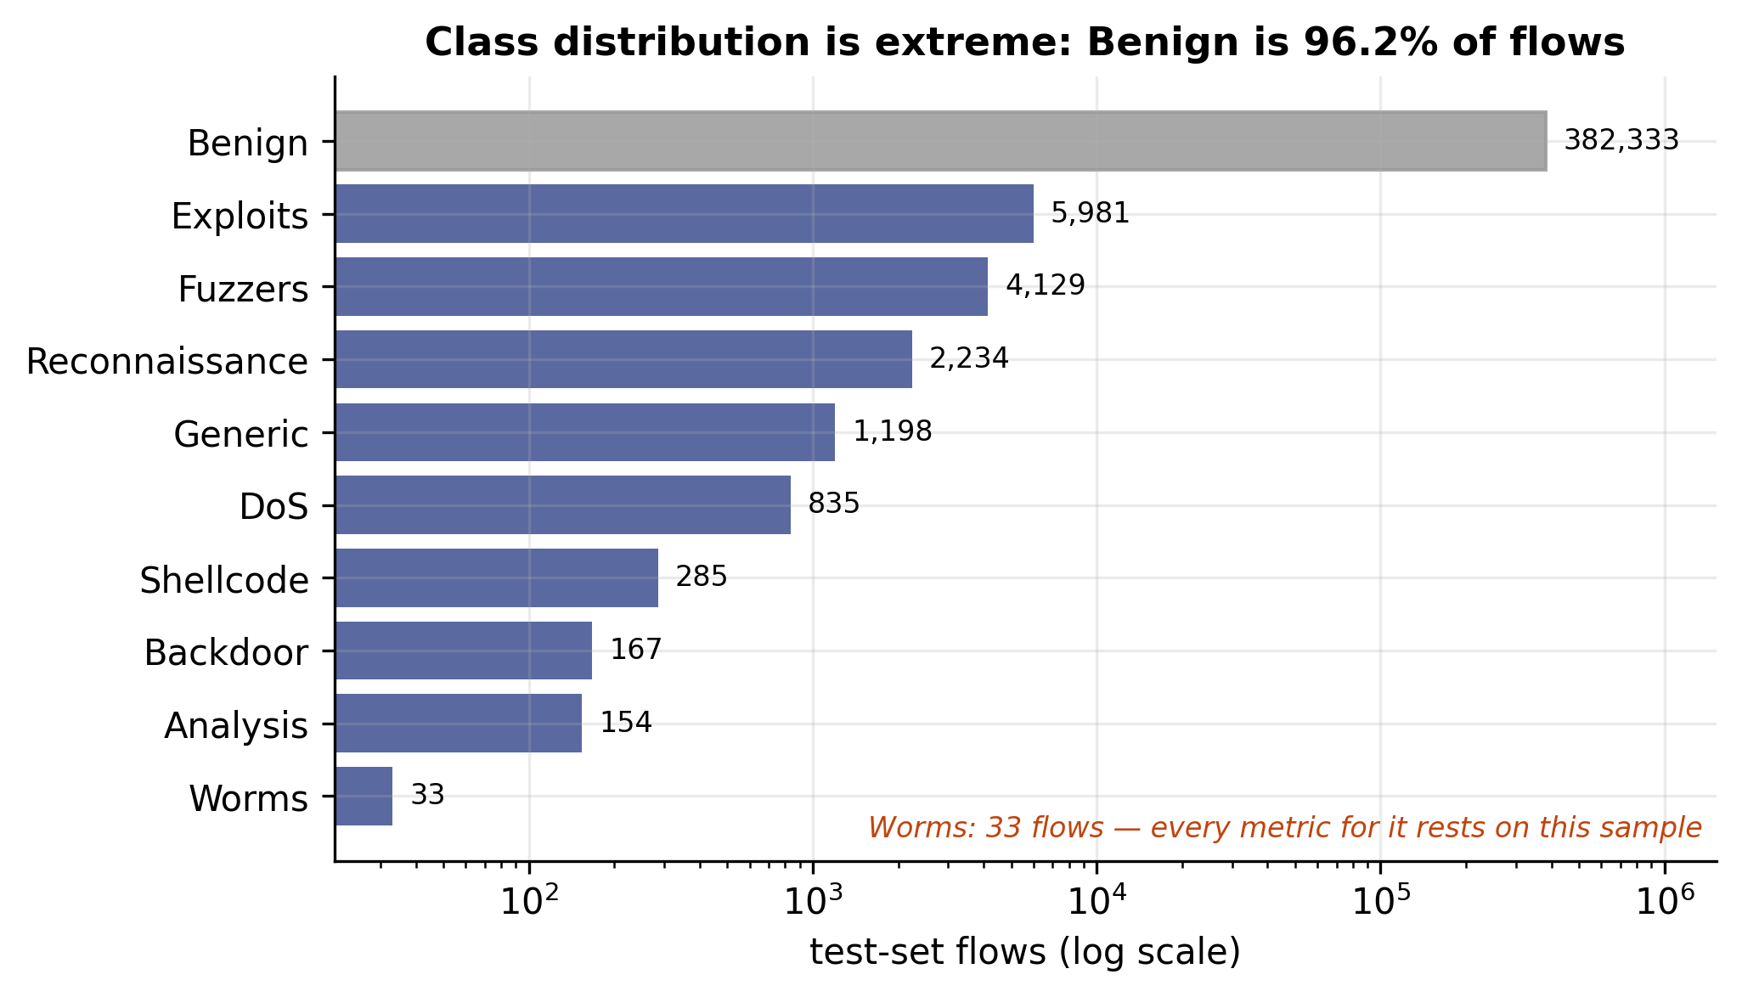
Figure 4.1: Test-set class distribution on a logarithmic axis. Benign accounts for 96.22% of flows; Worms contributes 33. The red annotation marks the class whose metrics rest on the smallest sample.

4.2.2 Detection Performance
Table 4.1 reports multiclass performance for all six models and the soft-voting ensemble, and Figure 4.2 shows macro-F1 alongside false alarm rate.
Table 4.1: Detection performance on the multiclass task (seed 42). GaussianNB, LogisticRegression and MLP are RQ1 controls, not baselines; their weak performance is intentional.
Model | Macro-F1 | PR-AUC | FAR | Accuracy | Train (s) | ms/flow
Decision Tree | 0.6389 | 0.678 | 0.43% | 0.9888 | 11.9 | 0.00023
Random Forest | 0.6629 | 0.731 | 0.46% | 0.9898 | 60.6 | 0.00316
XGBoost | 0.6731 | 0.747 | 0.16% | 0.9924 | 253.5 | 0.01231
Logistic Regression* | 0.3290 | 0.321 | 1.37% | 0.9668 | 539.0 | 0.00060
Gaussian Naive Bayes* | 0.1213 | 0.195 | 44.79% | 0.5362 | 2.0 | 0.00339
Multilayer Perceptron* | 0.4947 | 0.560 | 0.32% | 0.9886 | 65.6 | 0.00127
Soft-Voting Ensemble | 0.6743 | 0.708 | 0.42% | 0.9904 | 932.7 | 0.02096
*RQ1 controls. Included to span model families in the stability comparison, not offered as detectors.
Three observations follow from this table.
Soft voting absorbed a catastrophically broken member. The Gaussian Naive Bayes method flags almost half of the benign traffic (44.79%), however, its macro-F1 rate is at 0.1213 which is actually worse than simply predicting everything as benign. On the other hand, the six-model ensemble that includes the Gaussian Naive Bayes method and has a macro-F1 rate of 0.6743 is slightly better than XGBoost which has a target of 0.6731 and suffers from a 0.42% false alarm rate. The probability averaging method is much more resistant to broken members than was anticipated. The reasoning behind this is simple: a member with wide-ranging probability estimates will not contribute greatly to the argmax after it is averaged with three confident tree models.
The multiclass task is far harder than the binary one. Table 4.2 shows the same tree models on binary classification, where XGBoost reaches macro-F1 0.9799 and the ensemble 0.9751. The roughly thirty-point collapse from binary to multiclass is not a failure of detection but of discrimination between attack families — the models identify that something is wrong far more reliably than they identify what.
Logistic Regression did not converge. It reached the max_iter=1000 limit after 539 seconds with an lbfgs convergence warning. This is reported rather than silently corrected by raising the limit, because the non-converged model is the one that was frozen and subsequently explained, and any reader interpreting its RQ1 stability figure should know that.
Table 4.2: Detection performance on the binary task (seed 42), tree models only. XGBoost alone outperforms the three-model ensemble.
Model | Macro-F1 | PR-AUC | FAR | Accuracy | Train (s)
Decision Tree | 0.9742 | 0.967 | 0.37% | 0.9961 | 18.9
Random Forest | 0.9718 | 0.990 | 0.44% | 0.9957 | 63.1
XGBoost | 0.9799 | 0.990 | 0.20% | 0.9970 | 24.0
Soft-Voting Ensemble | 0.9751 | 0.991 | 0.36% | 0.9962 | 105.9
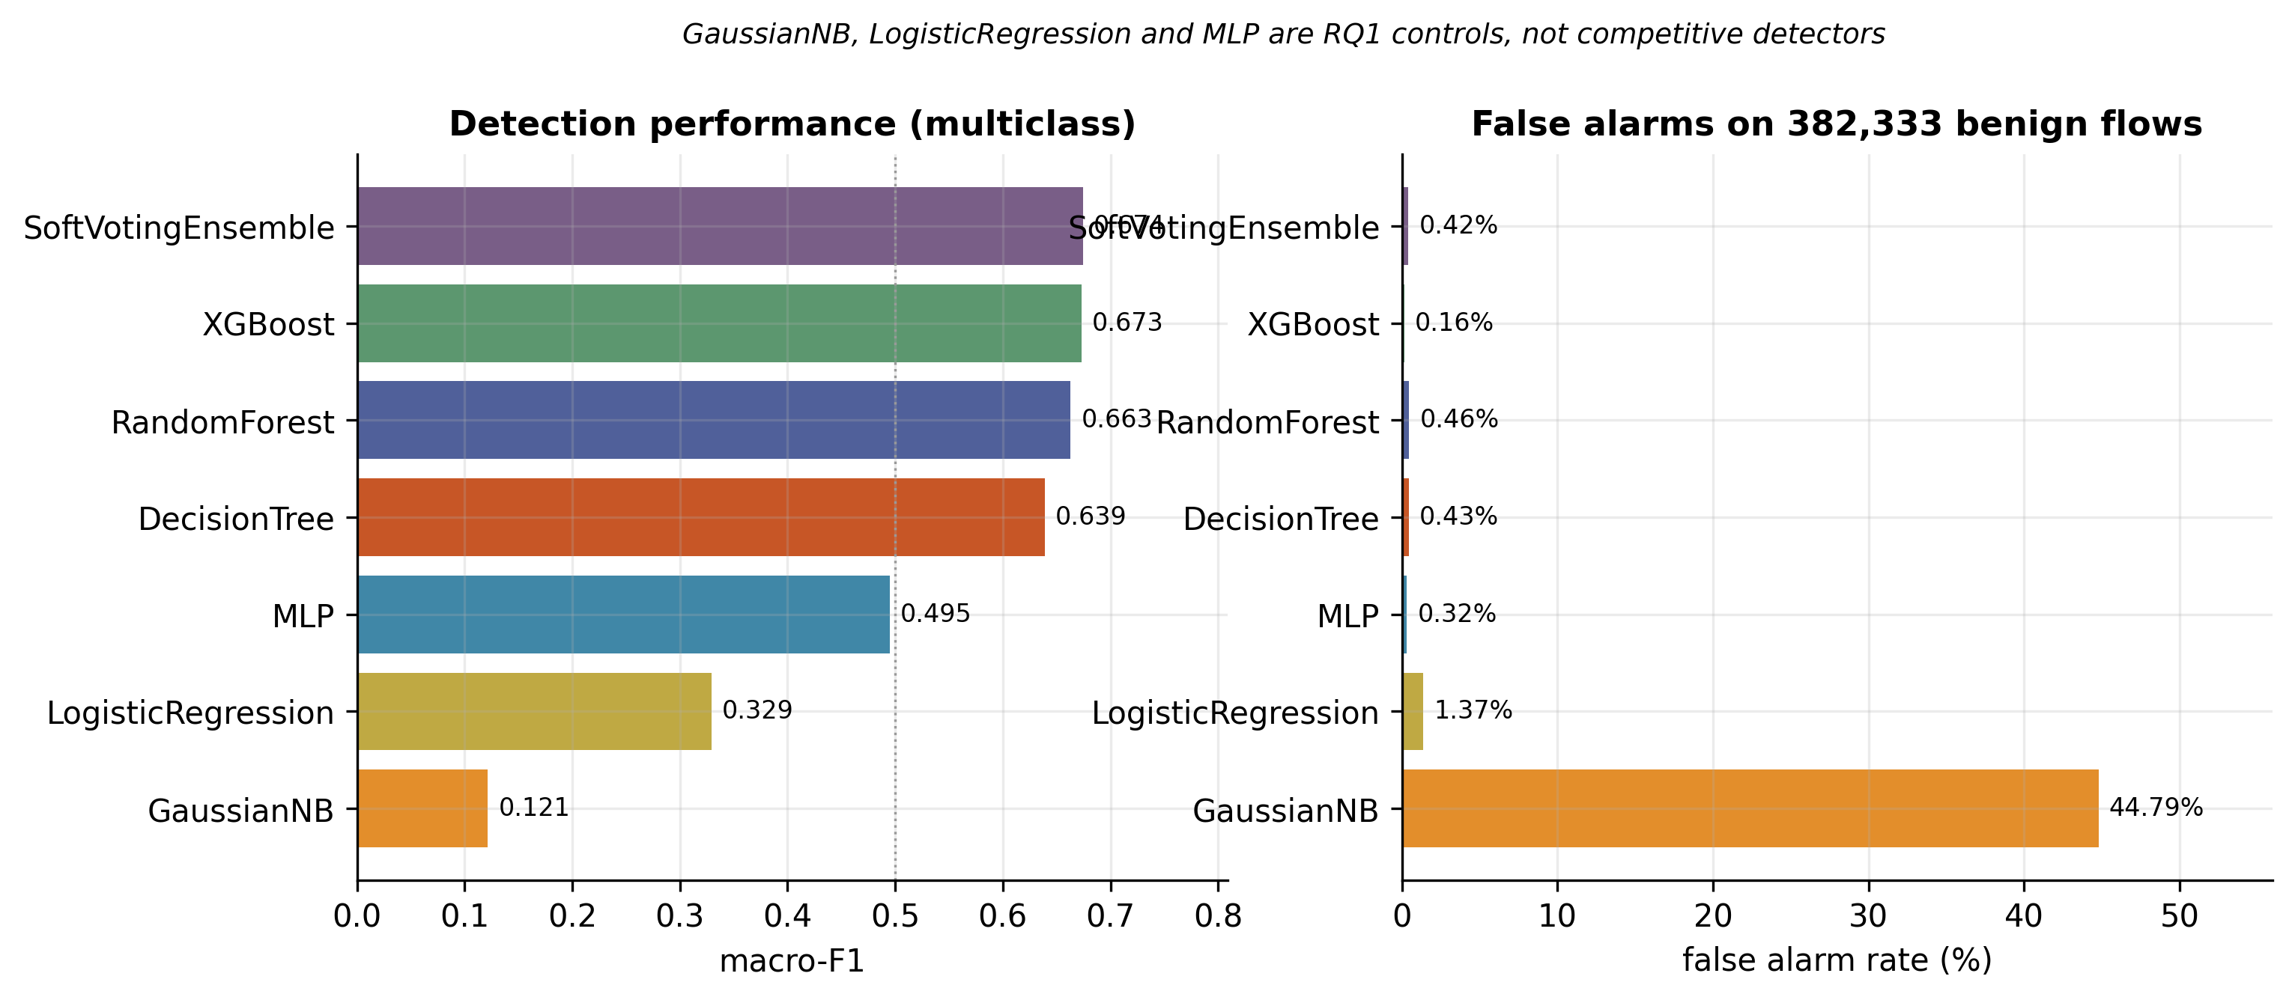
Figure 4.2: Macro-F1 (left) and false alarm rate (right) for the six models and the ensemble. GaussianNB's 44.79% false alarm rate is not a plotting error — it is why that model is designated a control.

4.2.3 Per-Class Behaviour
Table 4.3 and Figure 4.3 report per-class recall and precision for the soft-voting ensemble, ordered by support.
Table 4.3: Per-class performance of the six-model soft-voting ensemble. Rare classes fail on precision, not recall — the signature of class_weight="balanced".
Class | Recall | Precision | F1 | Support
Benign | 0.9958 | 0.9998 | 0.9978 | 382,333
Exploits | 0.8652 | 0.8822 | 0.8736 | 5,981
Fuzzers | 0.9244 | 0.7984 | 0.8568 | 4,129
Reconnaissance | 0.8881 | 0.8885 | 0.8883 | 2,234
Generic | 0.8439 | 0.8947 | 0.8686 | 1,198
DoS | 0.4275 | 0.6550 | 0.5174 | 835
Shellcode | 0.9754 | 0.4323 | 0.5991 | 285
Backdoor | 0.2695 | 0.2406 | 0.2542 | 167
Analysis | 0.6753 | 0.0945 | 0.1659 | 154
Worms | 0.9394 | 0.5849 | 0.7209 | 33
The pattern is consistent and worth naming precisely: the rare classes fail on precision, not on recall. Shellcode is recalled at 0.9754 but with precision 0.4323; Worms at 0.9394 with precision 0.5849; Analysis at 0.6753 with precision 0.0945. The models are finding these attacks — they are simply labelling a great deal of other traffic as those attacks along the way. This is the direct signature of class_weight="balanced", which raises the cost of missing a rare class and therefore encourages over-prediction of it. It is a trade, made deliberately, and it is visible rather than hidden.
Two classes resist the pattern. Backdoor fails on both axes (recall 0.2695, precision 0.2406), and DoS has the lowest recall of any class at 0.4275 despite reasonable support. Both are confused primarily with Exploits, which is unsurprising given that a denial-of-service attempt and an exploit attempt can produce closely similar flow statistics.
The composition of the ensemble also changed the per-class picture materially. Moving from the three-model tree ensemble to the six-model version raised Analysis F1 from 0.087 to 0.166 while lowering Shellcode F1 from 0.708 to 0.599. Both versions are retained in this thesis rather than only the better one, because the difference is itself a finding: adding weak, non-tree members to a soft-voting ensemble does not simply shift overall performance, it redistributes it across classes.
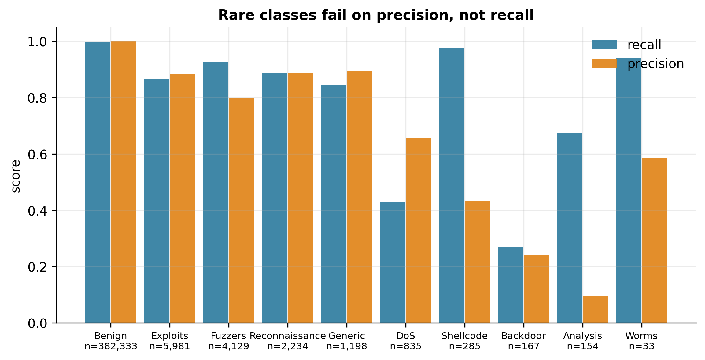
Figure 4.3: Recall and precision by class for the soft-voting ensemble, ordered by support with n printed beneath each class. Rare classes show high recall against low precision.

4.2.4 RQ1 — Stability of LIME Explanations
RQ1 asks whether LIME returns the same explanation twice. Across six frozen models, 933 instances each, ten runs per instance and 55,980 explanations in total, the answer is that it depends almost entirely on which model is being explained.
Table 4.4: RQ1 — LIME stability across six frozen models. Mean pairwise agreement over ten runs on identical instances. The spread between the extremes is 2.6-fold.
Model | Probability surface | Macro-F1 | Jaccard@5 | Jaccard@10 | Kendall τ | s/expl
Decision Tree | single tree, piecewise-constant | 0.639 | 0.337 | 0.285 | 0.158 | 0.090
Gaussian Naive Bayes | smooth, simple | 0.121 | 0.544 | 0.518 | 0.523 | 0.095
Logistic Regression | smooth, linear | 0.329 | 0.551 | 0.559 | 0.432 | 0.076
XGBoost | averaged trees (200) | 0.673 | 0.638 | 0.468 | 0.545 | 0.155
Multilayer Perceptron | smooth, non-linear | 0.495 | 0.808 | 0.648 | 0.498 | 0.077
Random Forest | averaged trees (100) | 0.663 | 0.868 | 0.802 | 0.653 | 0.102
The headline number is the spread. Mean Jaccard@5 ranges from 0.337 on the Decision Tree to 0.868 on the Random Forest — a 2.6-fold difference in reproducibility with no change to the data, the explainer, or its configuration. On the Decision Tree, two runs of LIME on the same input under the same frozen model share barely a third of their top-five features, and their full rankings are close to uncorrelated at Kendall τ = 0.158.
The operational reading is direct. An analyst who runs LIME on a Decision-Tree-based detector, notes the three features it highlights, and runs it again to confirm, will frequently see a different set of three. Nothing about the alert has changed. Nothing about the model has changed. The explanation is simply not a function of the input alone.

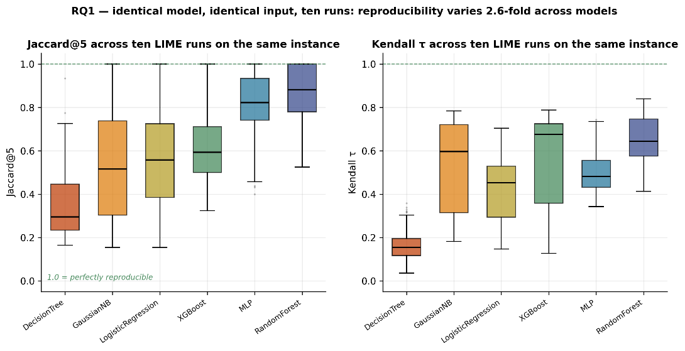
Figure 4.4: RQ1 stability by model. Box plots of Jaccard@5 (left) and Kendall τ (right) across 933 instances per model. The dashed line at 1.0 marks perfect reproducibility.
Figure 4.4 also exposes a secondary result that recurs throughout this thesis: the two panels order the models differently. The multilayer perceptron ranks second on Jaccard@5 but fourth on Kendall τ; Gaussian Naive Bayes ranks fourth on Jaccard but second on τ. Top-k set overlap and full-ranking correlation are not interchangeable summaries of the same quantity, and a study reporting only one of them would have produced a different model ordering.
The identical disconnection is observed within one specific model amongst the various attack categories. Table 4.5 details the Random Forest, categorized according to attack type: Benign category has the maximum Jaccard@5 value of all attack categories at 0.9159 and at the same time the lowest Kendall τ value of 0.5301. The prominent five features are repeated consistently, though the order of these features is not constant. In all three tree models, the Benign category achieved the minimum Kendall τ.
Table 4.5: RQ1 — stability by attack class on the Random Forest, ordered by Jaccard@5. Benign combines the highest set overlap with the lowest rank correlation.
Class | n | Jaccard@5 | Std | Jaccard@10 | Kendall τ
Shellcode | 100 | 0.7262 | 0.1087 | 0.8377 | 0.7710
Reconnaissance | 100 | 0.7869 | 0.0849 | 0.8008 | 0.7730
Worms | 33 | 0.7950 | 0.0624 | 0.7490 | 0.7613
Analysis | 100 | 0.8209 | 0.1058 | 0.7991 | 0.6182
Backdoor | 100 | 0.8364 | 0.0914 | 0.8076 | 0.6224
DoS | 100 | 0.8645 | 0.0875 | 0.7497 | 0.6091
Benign | 100 | 0.9159 | 0.0562 | 0.8094 | 0.5301
Generic | 100 | 0.9445 | 0.0819 | 0.8313 | 0.6850
Exploits | 100 | 0.9719 | 0.0528 | 0.7149 | 0.5430
Fuzzers | 100 | 0.9723 | 0.0625 | 0.8798 | 0.6857
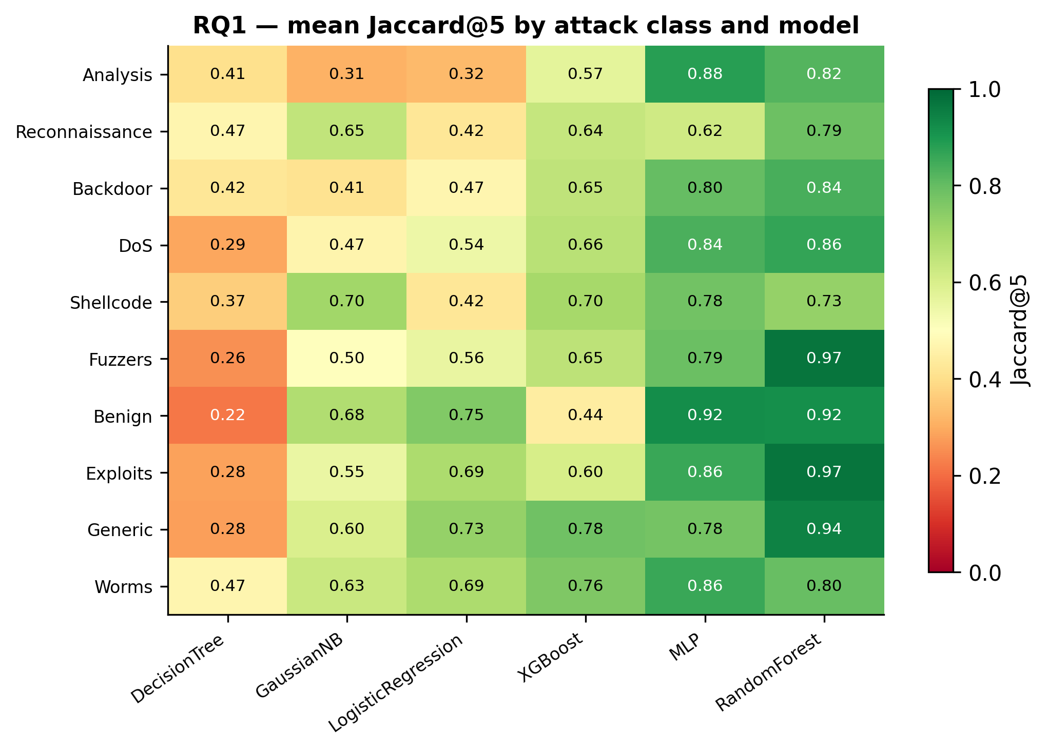
Figure 4.5: Mean Jaccard@5 for every class-by-model combination. Rows read as class effects and columns as model effects; the two do not decompose cleanly, which is itself the point.

4.2.5 RQ1 — Four Falsified Mechanisms
The occurrence of a 2.6-fold increase necessitates an explanation, and four potential mechanisms were identified. Each was formulated as a prediction prior to the verification. All four hypotheses were disproven. It is necessary to include all details in Table 4.6 and Figure 4.6 because a study testing its hypothesis is far more revealing than one giving an impressive explanatory model post factum.
Table 4.6: RQ1 — the four pre-registered mechanisms, the prediction each made, and the observation that falsified it.
Mechanism | Prediction | Observation | Outcome
Surface smoothness | A globally linear model gives LIME's linear surrogate a perfect fit, so Jaccard@5 approaches 1.0 | Logistic Regression ranks fifth of six at 0.551; three inversions along the smoothness axis | Falsified
Detection accuracy | Better detectors yield more stable explanations | GaussianNB (F1 0.121) and Logistic Regression (F1 0.329) sit at 0.544 and 0.551 — near-identical at three times the performance gap | Falsified
Model family | Tree models are less stable than smooth models | Trees occupy both extremes: Decision Tree worst at 0.337, Random Forest best at 0.868 | Falsified
Probability granularity | A model emitting few distinct probabilities gives the surrogate little to fit | ρ = 0.600, p = 0.208. Logistic Regression emits 1,604 distinct top-class probabilities against the Decision Tree's 221, yet is second-worst | Falsified
At this stage, one may be tempted to keep trying different variables until the right one is found. However, this issue has been intentionally avoided. Even six models would not be enough to confirm the significance of a fifth variable that is present only by chance and is unlikely to hold up in a seventh model. One way of seeing the situation soberly is to conclude that the cause of the variance has not yet been discovered.
What the evidence does support is a claim that is weaker as a mechanism but stronger as a warning:
> Across six classifiers on identical data, LIME's mean Jaccard@5 over ten runs on the same instance ranges from 0.337 to 0.868 — a 2.6-fold difference in reproducibility with no change to the data, the explainer, or its configuration. This variation is not predicted by the smoothness of the model's probability surface, by detection performance, by model family, or by the granularity of the model's probability output. Explanation stability is therefore a property that must be measured for each deployed model; it cannot be inferred from a published evaluation of a different one.
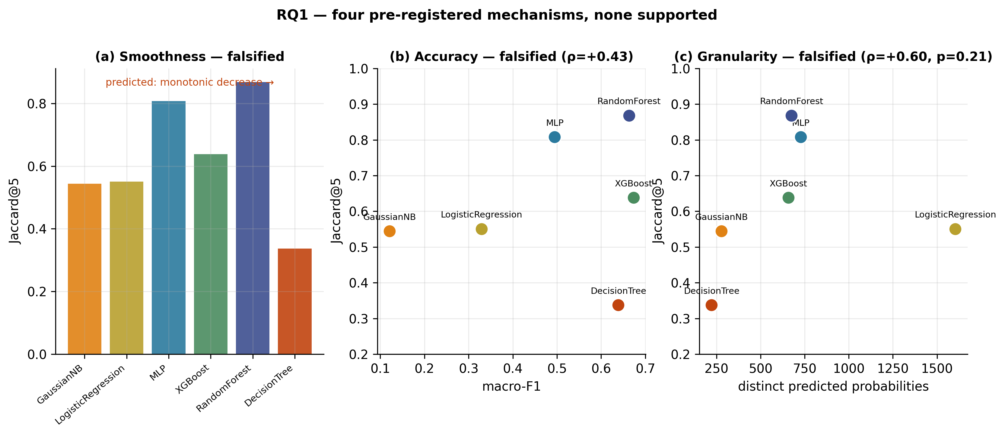
Figure 4.6: The four falsified mechanisms. Each panel plots the predicted relationship against the observed one; in each case the prediction fails.

4.2.6 RQ2 — Faithfulness Against a Random Control
RQ2 asks whether the features an explainer names actually drive the prediction. Table 4.7 reports comprehensiveness and sufficiency AUC over 483 instances per model, for LIME, TreeSHAP and the random-feature control.
Table 4.7: RQ2 — comprehensiveness and sufficiency AUC by explainer, with standard deviations. The LIME ratio is comprehensiveness divided by the random control.
Model | Explainer | Comp. AUC | Std | Suff. AUC | Std | Ratio vs random
Decision Tree | LIME | 0.8015 | 0.323 | 0.3602 | 0.447 | 2.29×
Decision Tree | TreeSHAP | 0.7687 | 0.321 | 0.4172 | 0.399 | 2.20×
Decision Tree | Random | 0.3497 | 0.362 | 0.1384 | 0.333 | 1.00×
Random Forest | LIME | 0.5521 | 0.268 | 0.2427 | 0.305 | 1.74×
Random Forest | TreeSHAP | 0.4738 | 0.260 | 0.1520 | 0.314 | 1.49×
Random Forest | Random | 0.3173 | 0.192 | 0.1350 | 0.298 | 1.00×
XGBoost | LIME | 0.5402 | 0.473 | 0.3146 | 0.723 | 1.73×
XGBoost | TreeSHAP | 0.5474 | 0.478 | 0.3612 | 0.954 | 1.75×
XGBoost | Random | 0.3123 | 0.317 | 0.3644 | 0.970 | 1.00×
The primary result is unambiguous and, unlike RQ1, reassuring: LIME identifies features the model genuinely uses. On all three models it substantially exceeds the random control — 2.29× on the Decision Tree, 1.74× on the Random Forest, 1.73× on XGBoost — and every comparison is significant by Wilcoxon signed-rank test at p < 10⁻⁴⁶ (Decision Tree p = 2.2 × 10⁻⁶⁴, Random Forest p = 3.1 × 10⁻⁷⁶, XGBoost p = 3.5 × 10⁻⁴⁷).
The role of the control deserves emphasis. Masking ten randomly chosen features of thirty-nine already reduces the predicted probability by roughly 0.32. Without that reference, LIME's absolute comprehensiveness of 0.55 on the Random Forest would read as a strong result; against it, the correct statement is that LIME is 1.74 times better than chance. Figure 4.7 makes the point visually — the informative quantity is the vertical gap between the LIME curve and the dashed grey random curve, not the height of the LIME curve itself.
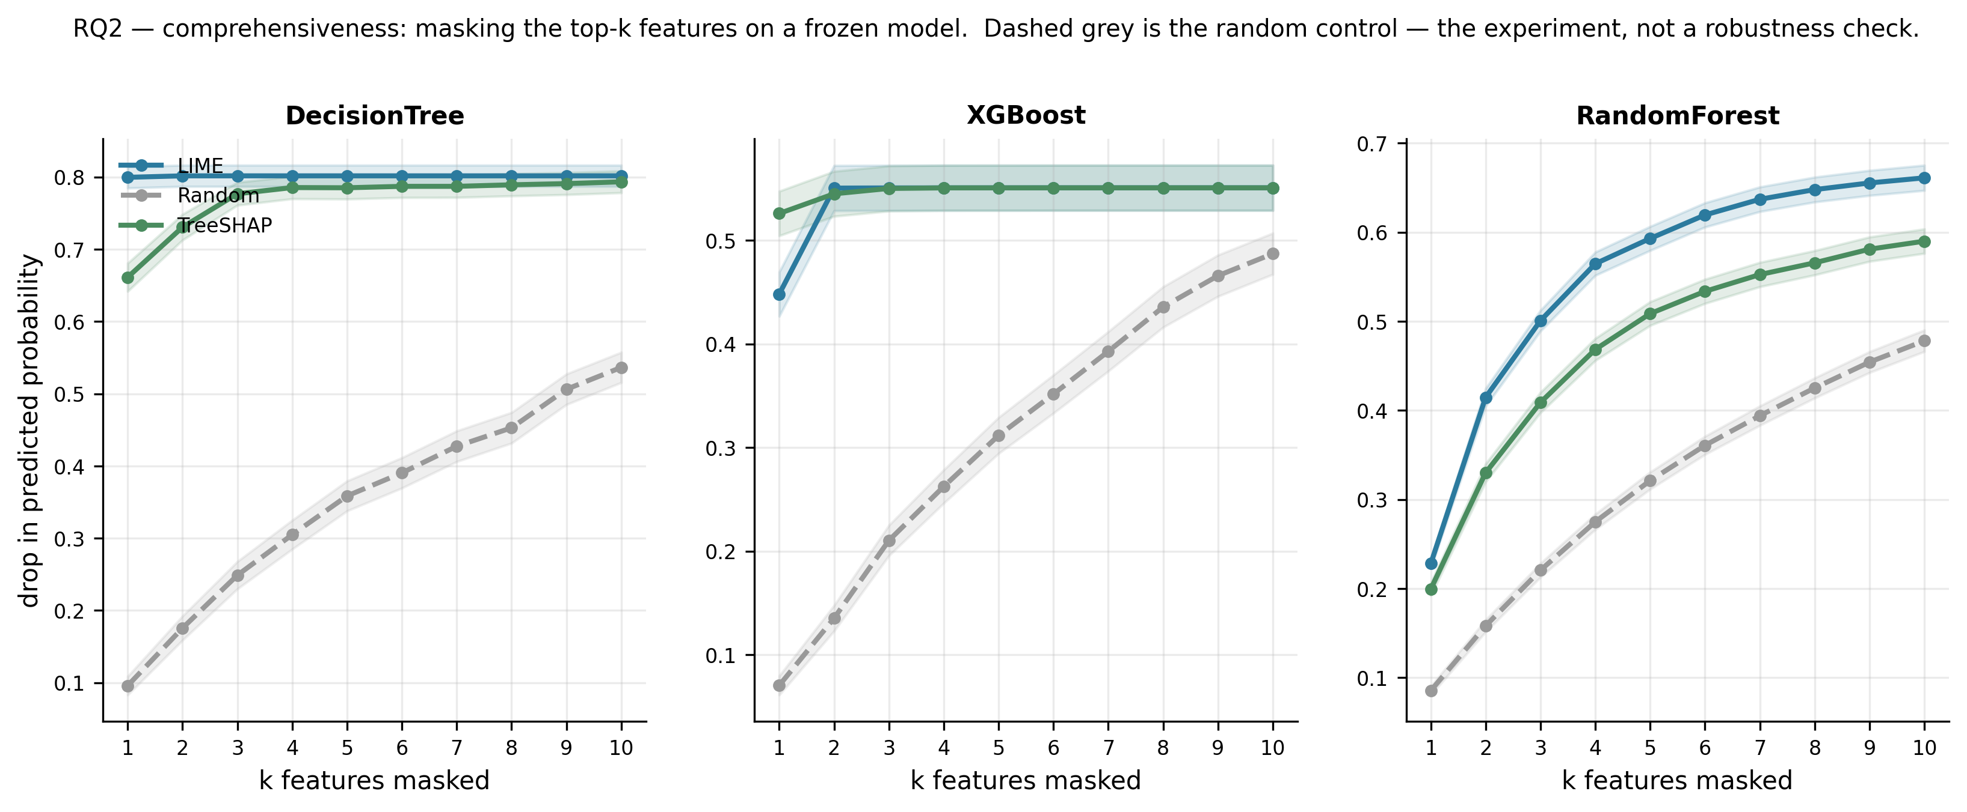
Figure 4.7: Comprehensiveness curves. Drop in predicted probability as k features are masked, k = 1 to 10, one panel per model, with shaded standard-error bands. The gap to the dashed random curve is the result.
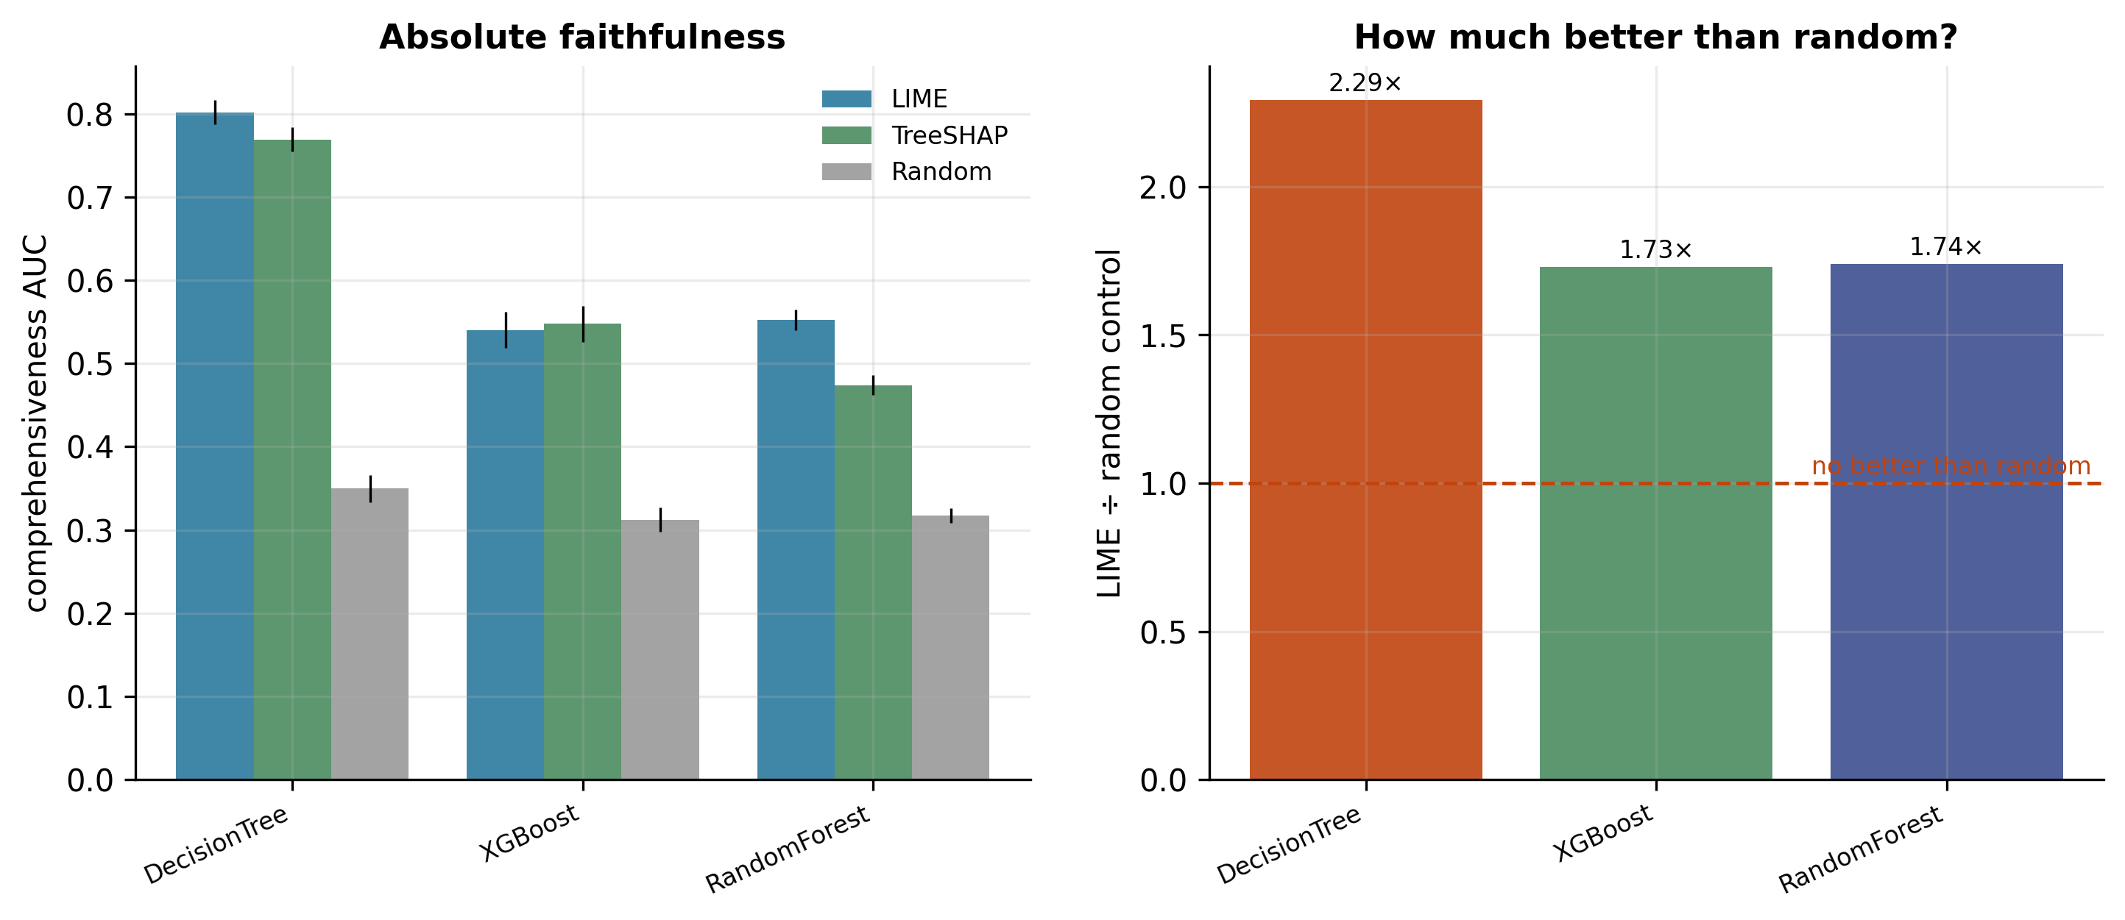
Figure 4.8: Left, absolute comprehensiveness AUC per explainer with error bars. Right, LIME divided by its random control, with a reference line at 1.0 marking “no better than random”.
Two secondary findings qualify this result.
Sufficiency is uninformative here. All explainers retain only 12–36% of the original predicted probability from their top ten of thirty-nine features, and on XGBoost the random control (0.3644) actually exceeds LIME (0.3146), with a standard deviation of 0.97 against a mean of 0.36. A statistic whose spread is nearly three times its mean carries no usable signal. Sufficiency is reported for completeness and no conclusion is drawn from it.
LIME's apparent edge over TreeSHAP should not be over-read. LIME exceeds TreeSHAP on the Random Forest (1.74× against 1.49×) but the two converge on XGBoost (1.73× against 1.75×). A plausible reason for the gap is that LIME's surrogate is fitted in the same perturbation regime that the masking test then applies, which would advantage it on this particular measurement without implying it is a better explainer. The conclusion drawn here is therefore that both methods are substantially better than chance, not that one is superior.
A known gap must also be recorded. RQ2 used a single LIME seed, but RQ1 establishes that the LIME ranking is a random variable. LIME's measured faithfulness is therefore itself stochastic, and its variance is unquantified. The multi-seed version of this experiment is specified in Section 5.3.2.

Audit clarification
The following original discussion is preserved for provenance. The completed matched-case audit later in this chapter qualifies its cross-model interpretation: within each of the three audited tree models, stability correlates positively with LIME-minus-random removal effects. Neither direction alone establishes causation. The old aggregate masking calculations were reproduced to numerical tolerance, but original feature rankings were not saved, so the exact historical masks cannot be replayed.

4.2.7 The Stability–Faithfulness Dissociation
Placing RQ1 and RQ2 side by side produces the central result of this thesis, shown in Figure 4.9. The trend runs downward: the least stable explanations are the most faithful.
The Decision Tree, worst of six models on stability at Jaccard@5 = 0.337, produced the most faithful explanations of any model at 2.29 times its random control. The Random Forest, best on stability at 0.868, achieved 1.74×. The two properties do not merely fail to correlate positively — they move in opposite directions.

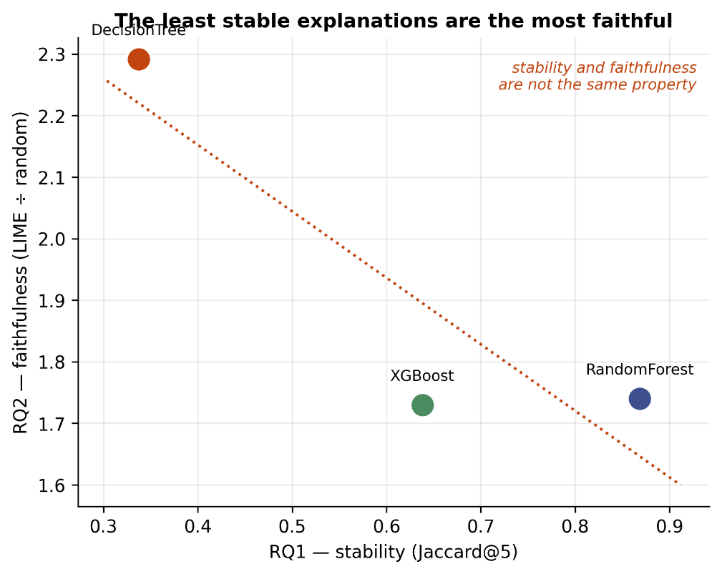
Figure 4.9: Stability (RQ1) against faithfulness (RQ2), one point per model. The downward trend is the central result: the least stable explanations were the most faithful.
A candidate reading, offered as a question rather than a conclusion, is this. A constrained tree routes each instance through a small handful of decision features. Masking any one of them can push the instance to a different leaf, so comprehensiveness is high for almost any explanation that happens to name a feature the tree actually uses. That same flat-with-cliffs probability surface, however, gives LIME's local linear surrogate no gradient to fit, so which of the redundant sufficient features it names varies from run to run. Different runs find different members of a redundant set, each individually sufficient to break the prediction. The result would be local faithfulness without global validity.
This account is consistent with the data but was not itself tested, and it is offered in that spirit. What does not depend on the account is the practical conclusion: stability and faithfulness measure different things and can move in opposite directions, so an explainer validated on either one alone has not been validated.

4.2.8 RQ4 — Agreement Between Explainers
RQ4 asks whether independent explainers converge. Tables 4.8 and 4.9 give pairwise Spearman ρ over the full 39-feature ranking and pairwise Jaccard@5 over the top-five sets, for each of the three tree models.
Table 4.8: RQ4 — pairwise Spearman ρ over the full 39-feature ranking. The closest pair differs in every model.
Explainer pair | Random Forest | Decision Tree | XGBoost
LIME ↔ TreeSHAP | 0.676 | 0.277 | 0.481
TreeSHAP ↔ Permutation | 0.017 | 0.896 | 0.578
LIME ↔ Permutation | −0.057 | 0.163 | 0.563
LIME ↔ TOPSIS | 0.261 | −0.045 | 0.160
TreeSHAP ↔ TOPSIS | 0.267 | 0.145 | 0.109
Permutation ↔ TOPSIS | 0.015 | 0.048 | 0.074
Table 4.9: RQ4 — pairwise Jaccard@5 over the top-five feature sets. Compare with Table 4.8: the two measures do not agree about which pairs are close.
Explainer pair | Random Forest | Decision Tree | XGBoost
LIME ↔ TreeSHAP | 0.250 | 0.250 | 0.250
TreeSHAP ↔ Permutation | 0.250 | 0.667 | 0.429
LIME ↔ Permutation | 0.000 | 0.111 | 0.667
LIME ↔ TOPSIS | 0.000 | 0.000 | 0.111
TreeSHAP ↔ TOPSIS | 0.000 | 0.111 | 0.000
Permutation ↔ TOPSIS | 0.111 | 0.111 | 0.111
The headline is that which explainers agree is a property of the model being explained, not of the explainers. A different pair is closest in each of the three models: LIME and TreeSHAP on the Random Forest (ρ = 0.676), TreeSHAP and permutation importance on the Decision Tree (ρ = 0.896), and LIME and permutation importance on XGBoost (ρ = 0.563). The ordering reshuffles completely between models. A practitioner who reads in one paper that LIME and SHAP broadly concur, and carries that conclusion to their own system, has generalised a model-specific observation.
LIME is the outlier on the Decision Tree. TreeSHAP and permutation importance — two methodologically independent methods, one reading the tree structure and one intervening on the data — converge at ρ = 0.896 and Jaccard@5 = 0.667, while LIME sits at 0.277 and 0.111 against them. This is precisely the model on which RQ1 found LIME least stable, at Kendall τ = 0.158. Table 4.10 shows what LIME nominates there that the other methods do not: dns_query_id, dns_query_type and dns_ttl_answer all appear in its top ten. A DNS query identifier is a transaction nonce with no intrinsic security meaning. Its appearance in a top-ten ranking is what a surrogate fitting noise looks like.
Table 4.10: RQ4 — top-ranked features on the Decision Tree by explainer. Three methods place min_ttl first; LIME additionally nominates DNS nonce fields that the others do not.
Rank | LIME | TreeSHAP | Permutation | TOPSIS
1 | min_ttl | min_ttl | min_ttl | src_to_dst_second_bytes
2 | max_ttl | l7_proto | max_ip_pkt_len | tcp_win_max_in
3 | protocol | max_ip_pkt_len | l7_proto | icmp_type
4 | duration_in | protocol | dst_to_src_second_bytes | icmp_ipv4_type
5 | shortest_flow_pkt | src_to_dst_second_bytes | src_to_dst_second_bytes | tcp_win_max_out
6 | dns_query_id | dst_to_src_second_bytes | retransmitted_in_bytes | max_ip_pkt_len
7 | duration_out | icmp_type | src_to_dst_avg_throughput | longest_flow_pkt
8 | dns_ttl_answer | longest_flow_pkt | in_bytes | server_tcp_flags
9 | max_ip_pkt_len | retransmitted_in_bytes | longest_flow_pkt | client_tcp_flags
10 | dns_query_type | shortest_flow_pkt | icmp_type | tcp_flags
Where the methods do converge, they converge on TTL. min_ttl is ranked first by LIME, TreeSHAP and permutation importance on both the Decision Tree and XGBoost. Three methods resting on different mathematics agreeing on a single feature across two models is the strongest positive signal in the RQ4 data, and it is domain-plausible: time-to-live values carry information about path length and about crafted packets, and prior SHAP-based analyses of intrusion data have also reported TTL fields as dominant [28].
TOPSIS correlates weakly with everything, reaching at most 0.267 and occasionally turning negative. This is the reassuring result in the table. A model-free ranking based on the statistical properties of the features alone does not reproduce what the model-based explainers report, which indicates that those explainers are tracking model behaviour rather than merely re-describing the dataset.
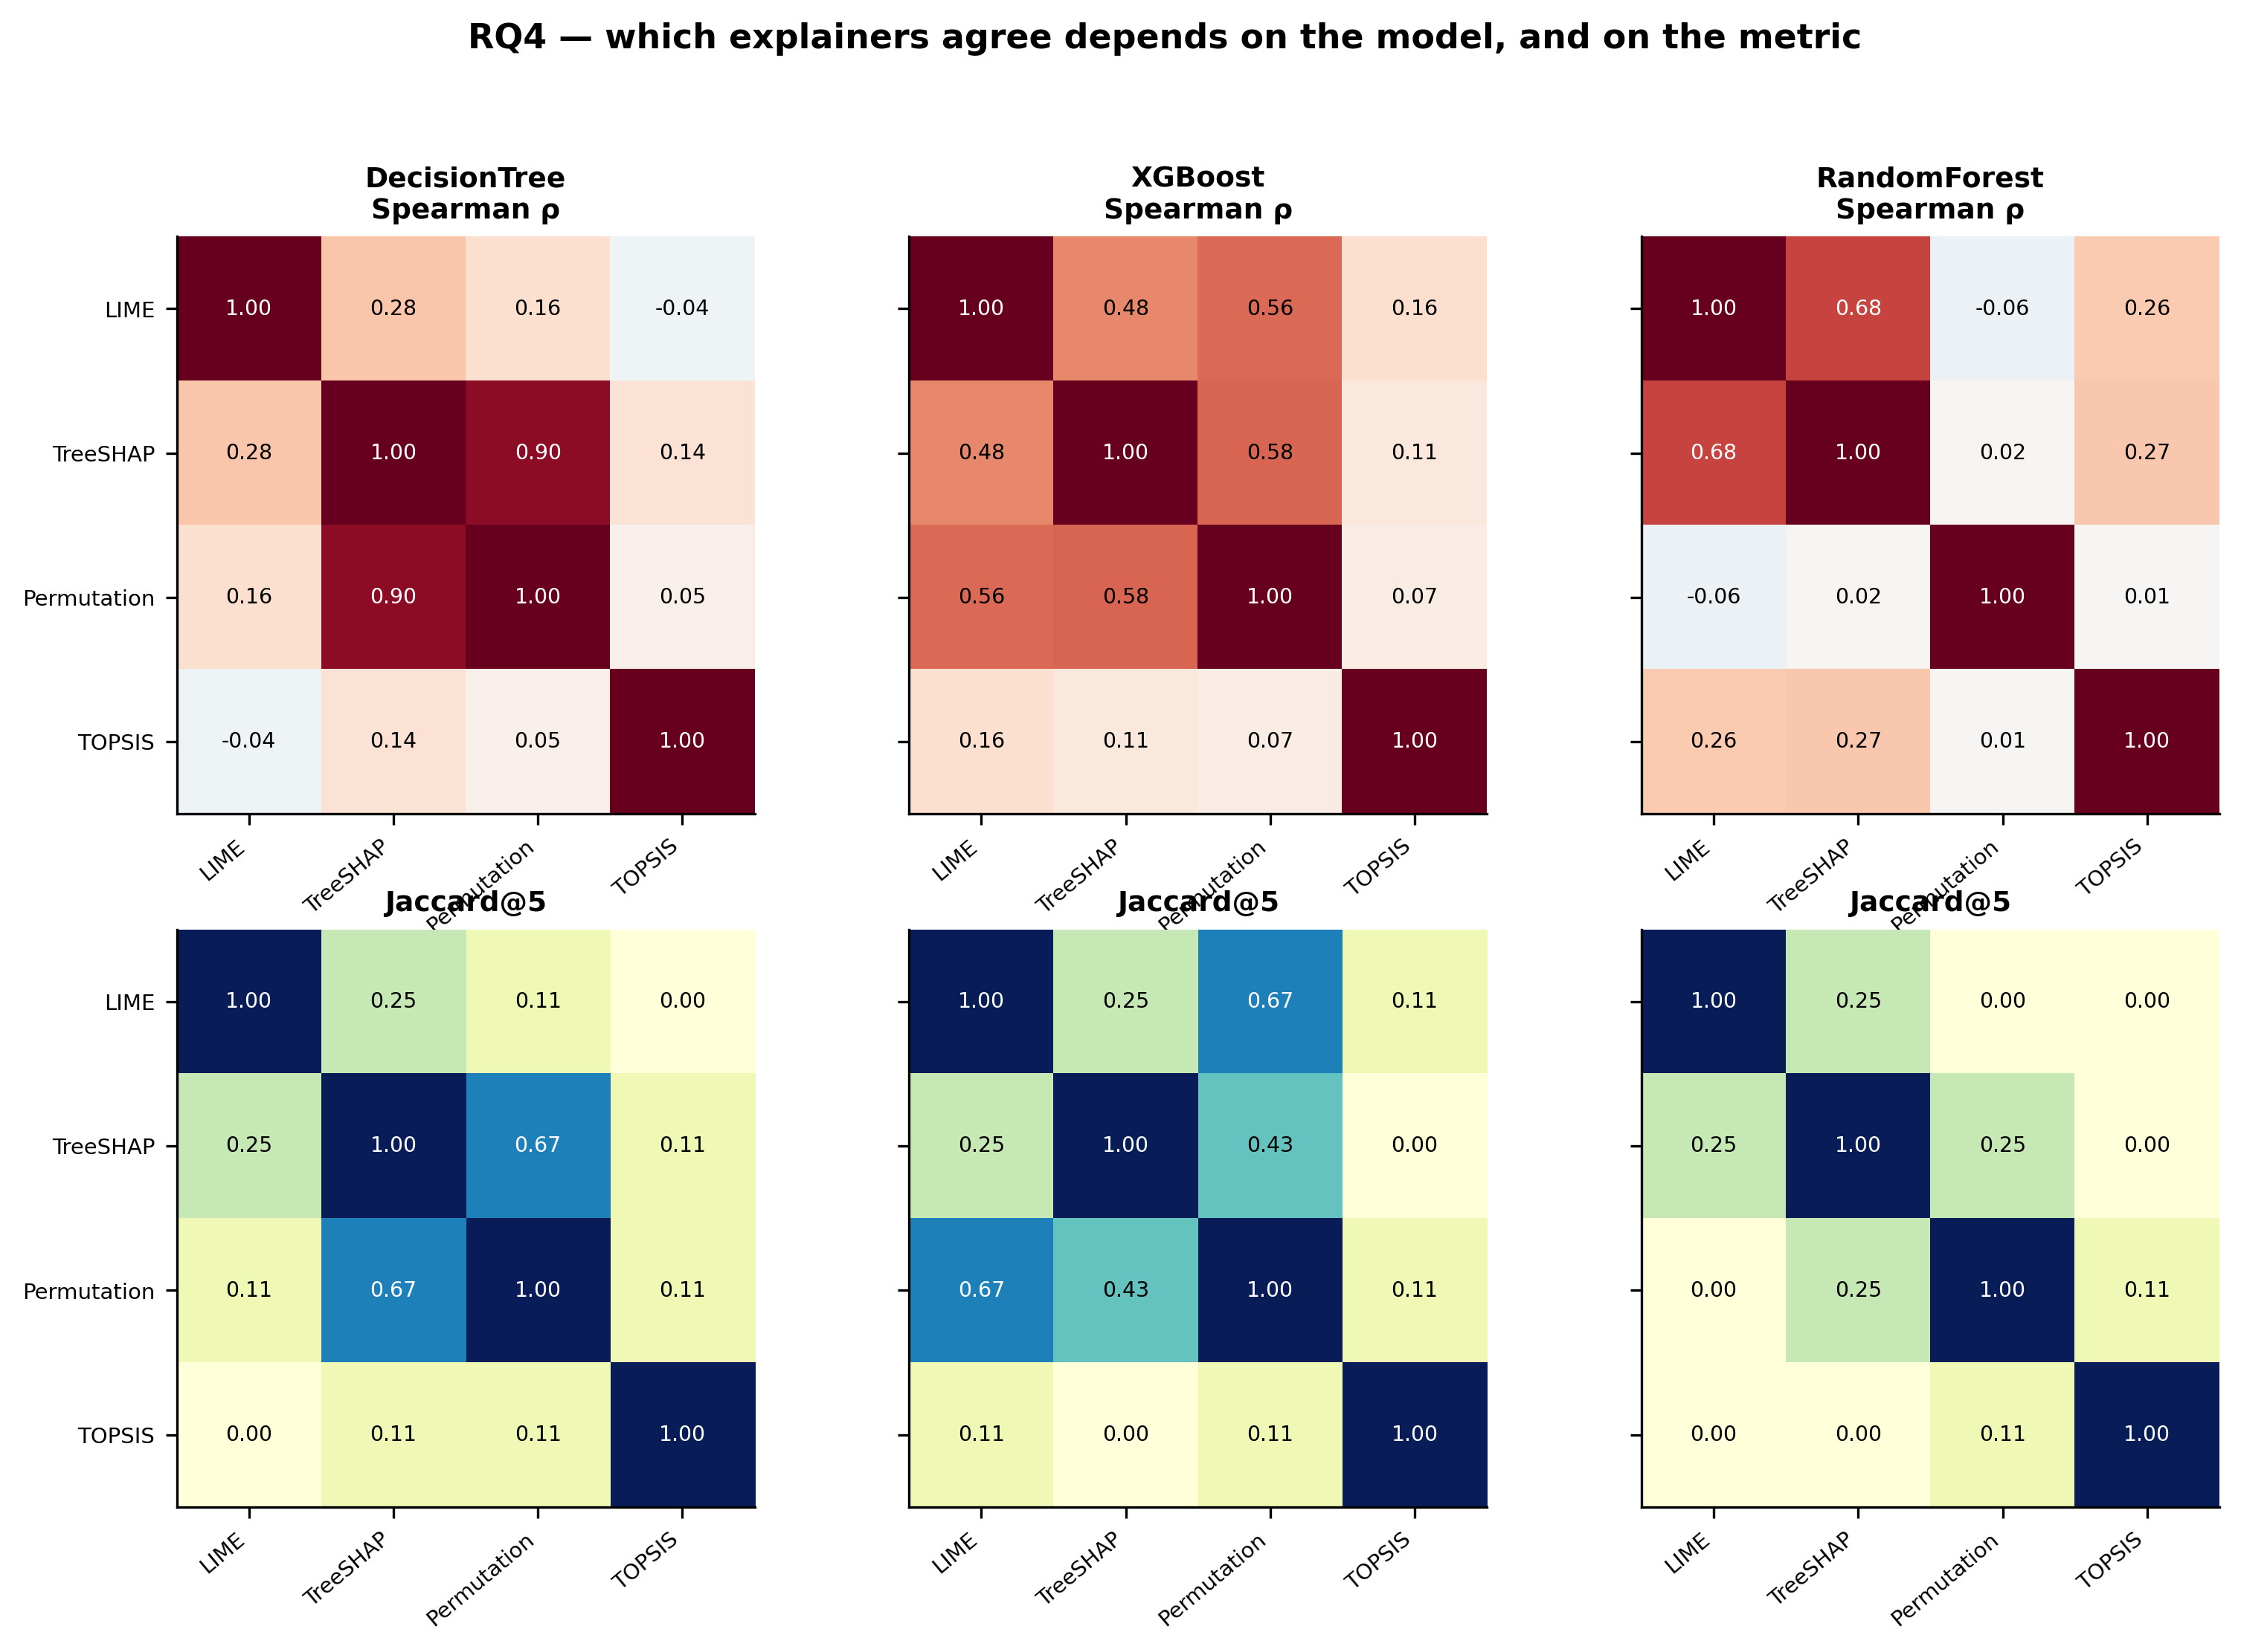
Figure 4.10: RQ4 agreement. Two rows per model — Spearman ρ over the full ranking, and Jaccard@5 over the top-five sets. The two rows disagree, which is why both are reported.

4.2.9 Computational Cost
Every claim in this chapter has a price, and Table 4.11 records it.
Table 4.11: Computational cost of detection and explanation. LIME timings are means per explanation; the Random Forest figure was measured on an idle machine, the others under varying load.
Model | Train (s) | Inference (ms/flow) | LIME (s/explanation)
Decision Tree | 11.9 | 0.00023 | 0.090
Random Forest | 60.6 | 0.00316 | 0.102
XGBoost | 253.5 | 0.01231 | 0.155
Gaussian Naive Bayes | 2.0 | 0.00339 | 0.095
Logistic Regression | 539.0 | 0.00060 | 0.076
Multilayer Perceptron | 65.6 | 0.00127 | 0.077
Soft-Voting Ensemble | 932.7 | 0.02096 | —
Two gaps stand out. XGBoost costs 0.01231 ms per flow against the Decision Tree's 0.00023 ms — a fifty-fold difference for 3.4 points of macro-F1. Whether that is worth paying depends on the deployment, but the trade should be stated rather than assumed.
The second gap is the operationally consequential one. Detection costs microseconds per flow; explanation costs roughly a tenth of a second. That is a difference of four to five orders of magnitude. A security operations centre handling thousands of alerts an hour cannot explain them all in real time. Explanation must be triggered selectively — on escalation, on analyst request, or on a sampled subset — and any architecture that assumes an explanation accompanies every alert has not been costed. This is a finding about deployment, not an implementation footnote.

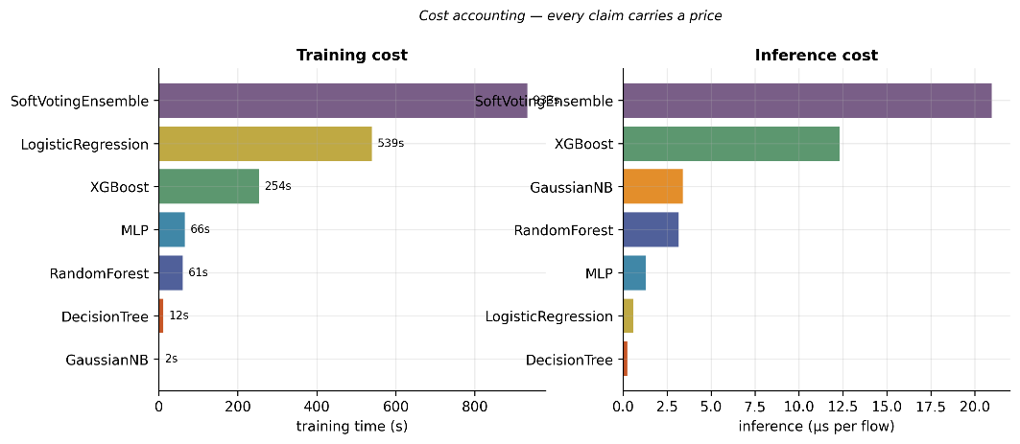
Figure 4.11: Training time and per-flow inference latency by model. Note the logarithmic axis on inference latency.

4.2.10 Completed evidence and reading conventions
All 84 detector configurations and 126 evaluation cells are complete. The 42 model/task/direction groups each contain three seeds. All 14 explanation pilots and all three 400-case LLM runs are complete. Tables below are generated from the saved CSVs rather than manually transcribed. U denotes NF-UNSW-NB15-v2 and I denotes NF-CSE-CIC-IDS2018-v2. Direction is always training source to evaluation target. Scores are proportions, not percentages.

4.2.11 Within-dataset binary and multiclass detection
Table 4.12: Within-dataset binary macro-F1, mean +/- sample SD across three seeds.
Model | U to U | I to I
DecisionTree | 0.9662 +/- 0.0091 | 0.9487 +/- 0.0144
RandomForest | 0.9701 +/- 0.0061 | 0.9852 +/- 0.0029
XGBoost | 0.9750 +/- 0.0050 | 0.9850 +/- 0.0021
SoftVoting | 0.9679 +/- 0.0089 | 0.9785 +/- 0.0103
ShallowMLP | 0.8643 +/- 0.1722 | 0.9732 +/- 0.0038
DeepMLP | 0.9627 +/- 0.0093 | 0.9842 +/- 0.0013
FeatureCNN | 0.9621 +/- 0.0100 | 0.9755 +/- 0.0146
XGBoost has the largest mean binary macro-F1 on U (0.9750), while random forest has the largest on I (0.9852). The latter is close to XGBoost and DeepMLP; these descriptive means do not establish a statistically significant ranking. DeepMLP reaches 0.9627 on U and 0.9842 on I, showing that neural baselines are competitive in familiar domains. ShallowMLP's U result has substantial seed variation (SD 0.1722), so a single favorable run would be misleading.
Table 4.13: Native multiclass macro-F1, mean +/- sample SD across three seeds.
Model | U to U | I to I
DecisionTree | 0.5230 +/- 0.0477 | 0.6775 +/- 0.0337
RandomForest | 0.5467 +/- 0.0354 | 0.7179 +/- 0.0358
XGBoost | 0.4952 +/- 0.0467 | 0.7060 +/- 0.0355
SoftVoting | 0.5379 +/- 0.0247 | 0.7111 +/- 0.0245
ShallowMLP | 0.3865 +/- 0.0437 | 0.5384 +/- 0.1041
DeepMLP | 0.4006 +/- 0.0487 | 0.5739 +/- 0.1122
FeatureCNN | 0.4074 +/- 0.0020 | 0.5438 +/- 0.0461
Native multiclass macro-F1 is substantially lower than binary macro-F1. Random forest has the largest mean in both datasets: 0.5467 on U and 0.7179 on I. These outcomes concern different native label sets and are not directly comparable as equally difficult tasks. Rare classes may be absent from bounded samples, and macro averages must be read together with per-class support. The neural architectures do not provide a uniform improvement over trees under the fixed protocol.
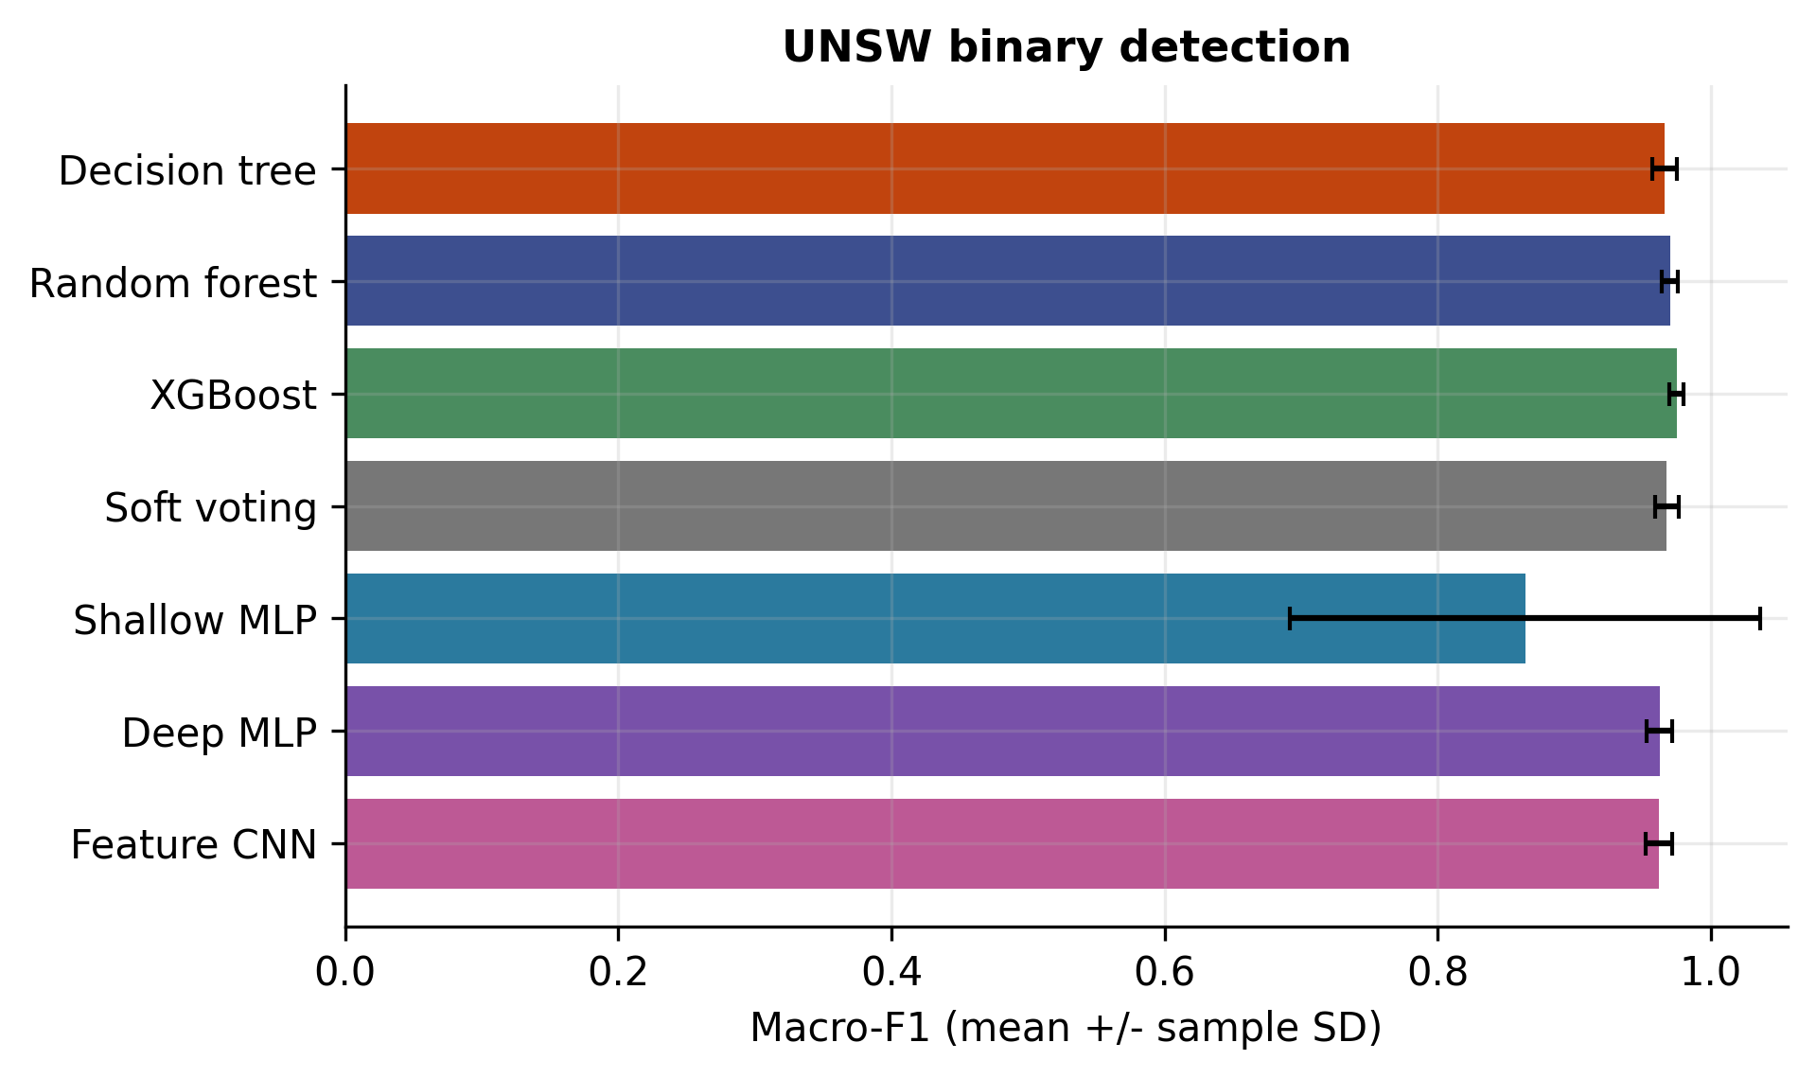
Figure 4.12: UNSW binary macro-f1 across seven detector families. Error bars show sample SD across seeds 7, 42 and 1337; 80,000 test flows per evaluation. These group-disjoint results are separate from the historical protocol in Figure 4.2.
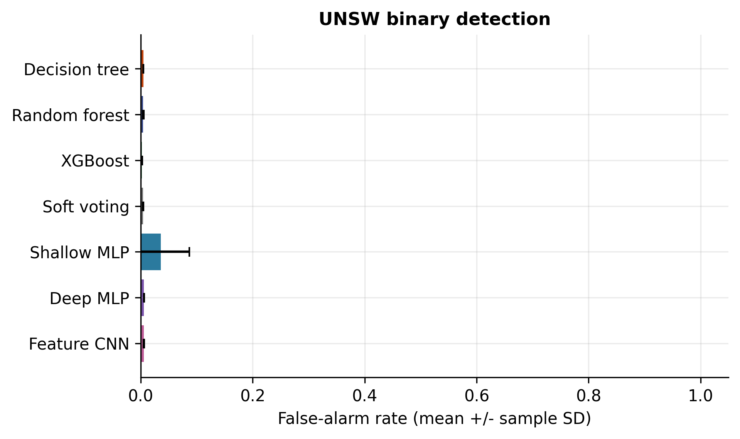
Figure 4.13: UNSW binary false-alarm rate across seven detector families. Error bars show sample SD across seeds 7, 42 and 1337; 80,000 test flows per evaluation. These group-disjoint results are separate from the historical protocol in Figure 4.2.
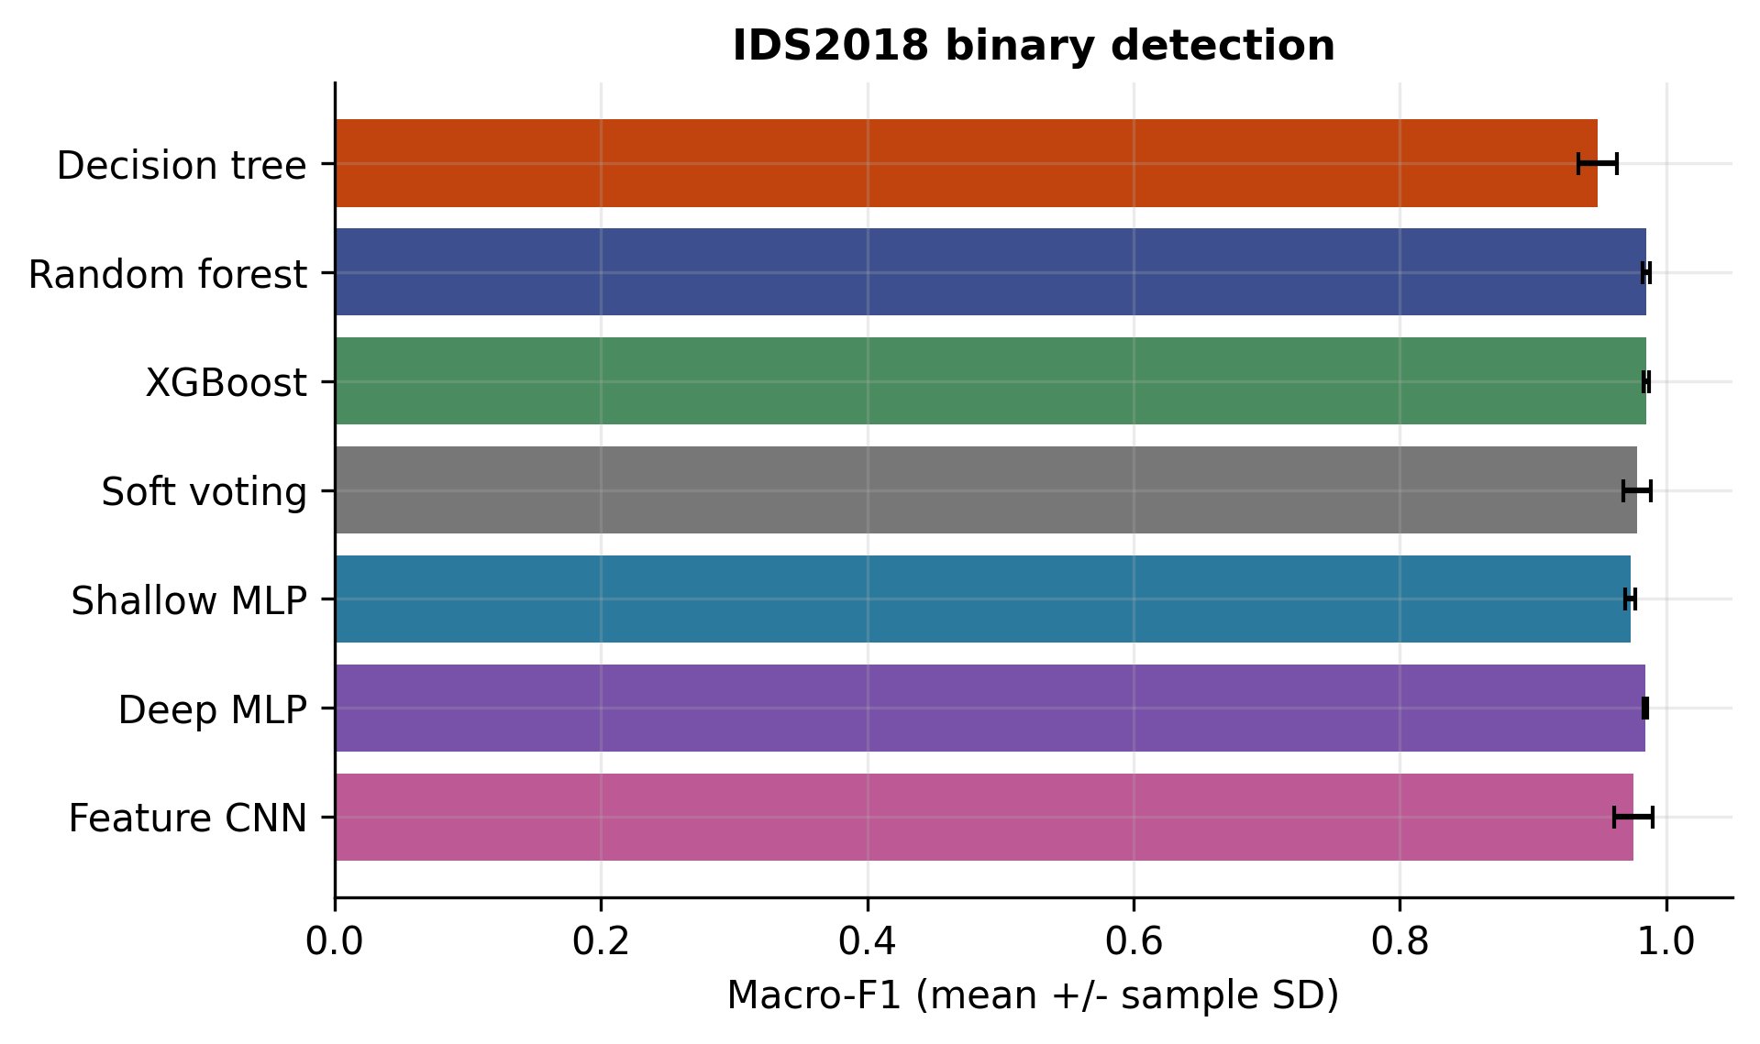
Figure 4.14: IDS2018 binary macro-f1 across seven detector families. Error bars show sample SD across seeds 7, 42 and 1337; 80,000 test flows per evaluation. These group-disjoint results are separate from the historical protocol in Figure 4.2.
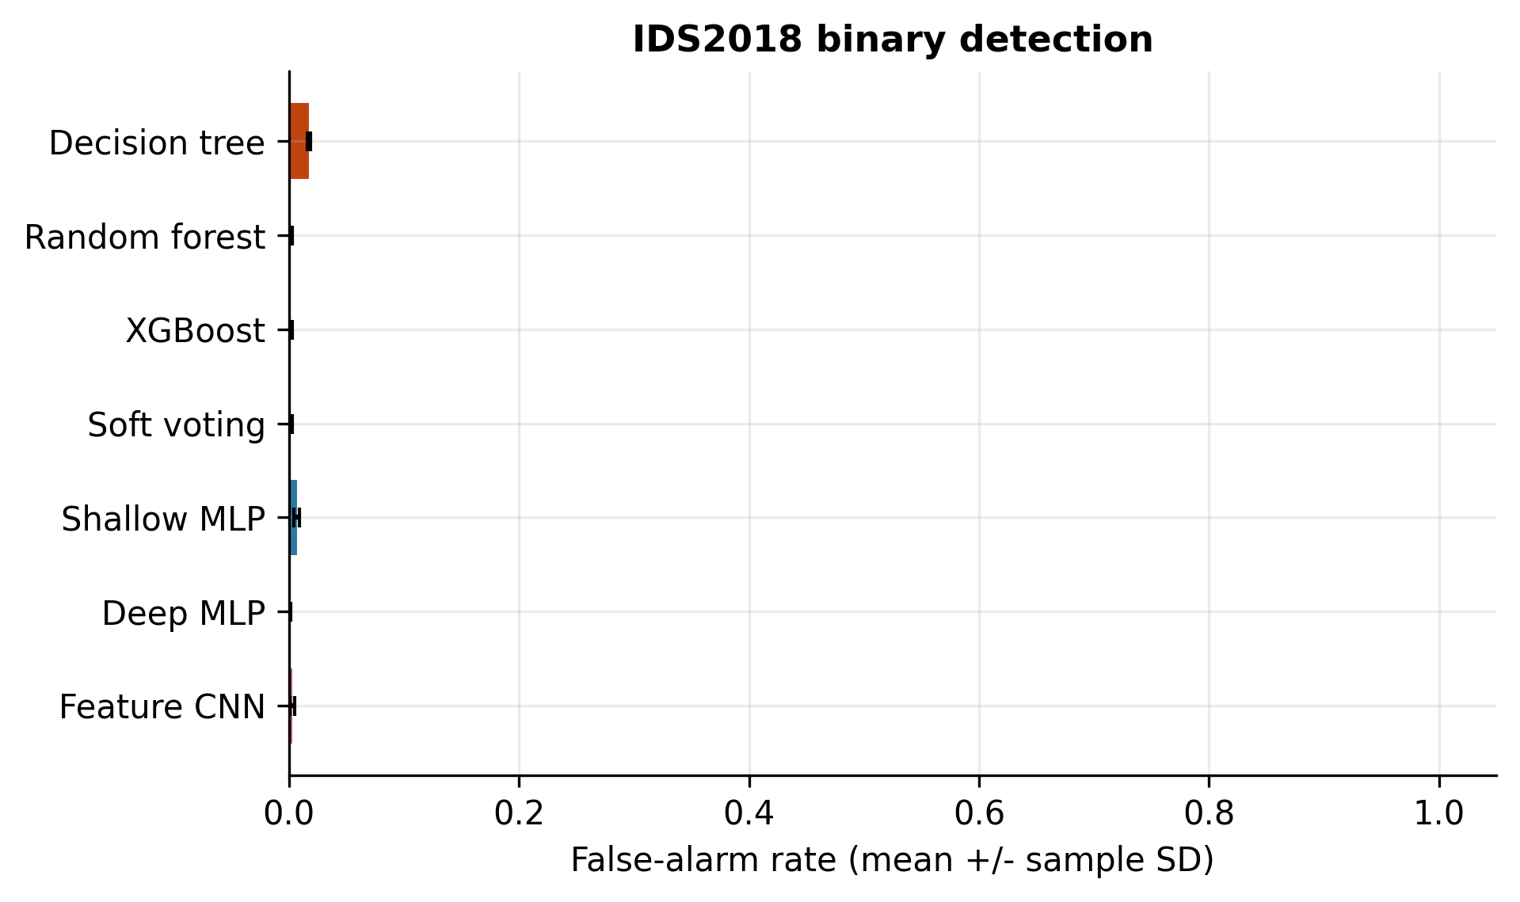
Figure 4.15: IDS2018 binary false-alarm rate across seven detector families. Error bars show sample SD across seeds 7, 42 and 1337; 80,000 test flows per evaluation. These group-disjoint results are separate from the historical protocol in Figure 4.2.
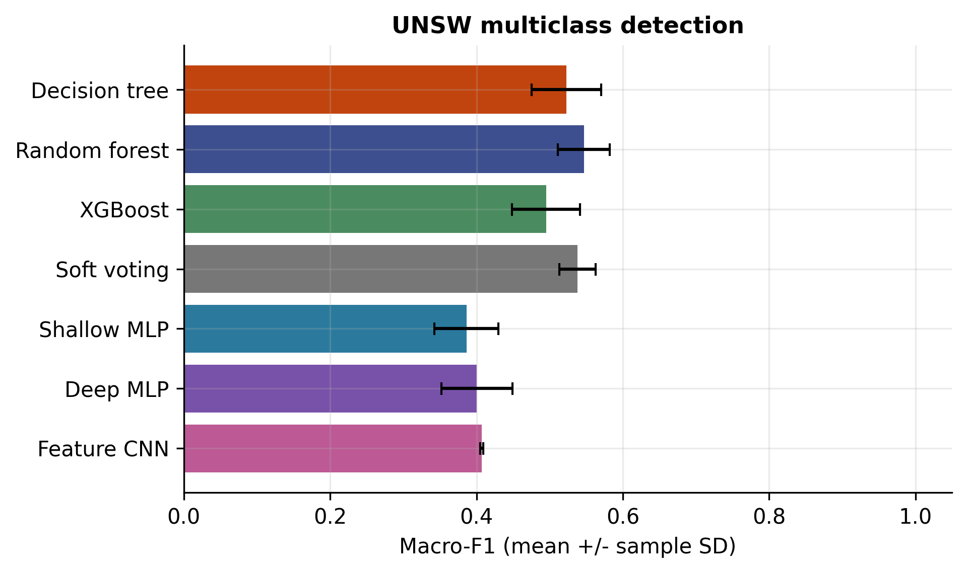
Figure 4.16: UNSW multiclass macro-f1 across seven detector families. Error bars show sample SD across seeds 7, 42 and 1337; 80,000 test flows per evaluation. These group-disjoint results are separate from the historical protocol in Figure 4.2.
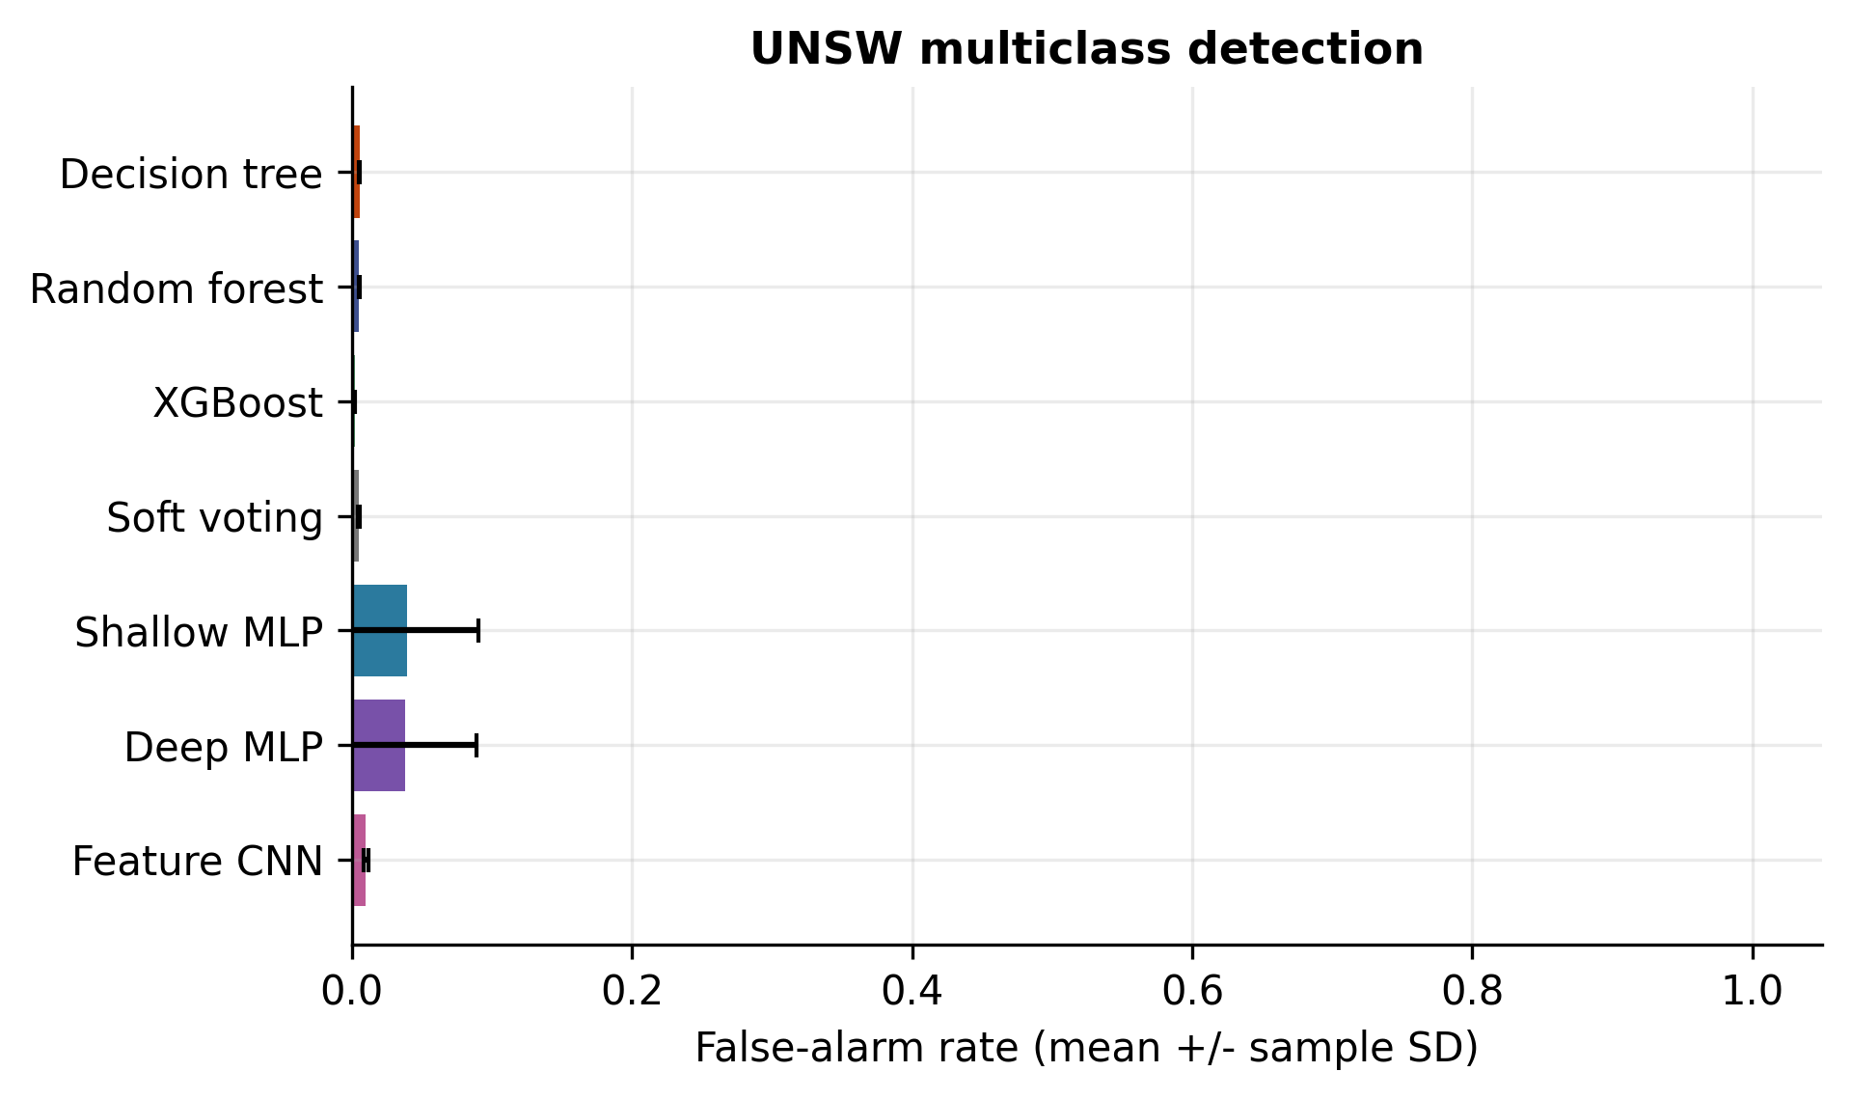
Figure 4.17: UNSW multiclass false-alarm rate across seven detector families. Error bars show sample SD across seeds 7, 42 and 1337; 80,000 test flows per evaluation. These group-disjoint results are separate from the historical protocol in Figure 4.2.
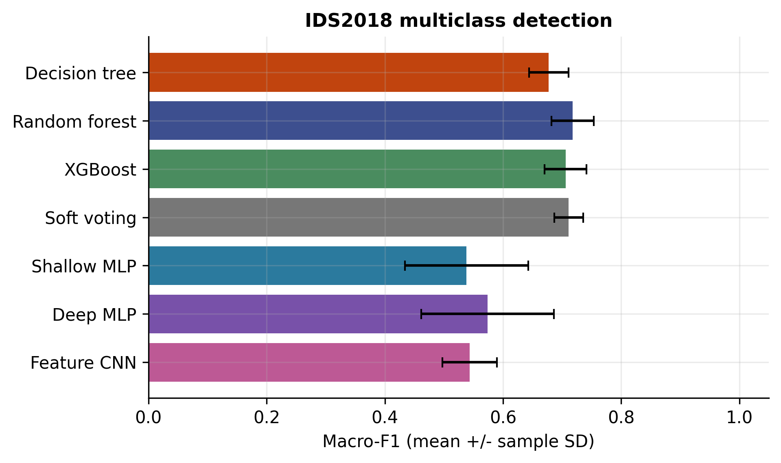
Figure 4.18: IDS2018 multiclass macro-f1 across seven detector families. Error bars show sample SD across seeds 7, 42 and 1337; 80,000 test flows per evaluation. These group-disjoint results are separate from the historical protocol in Figure 4.2.
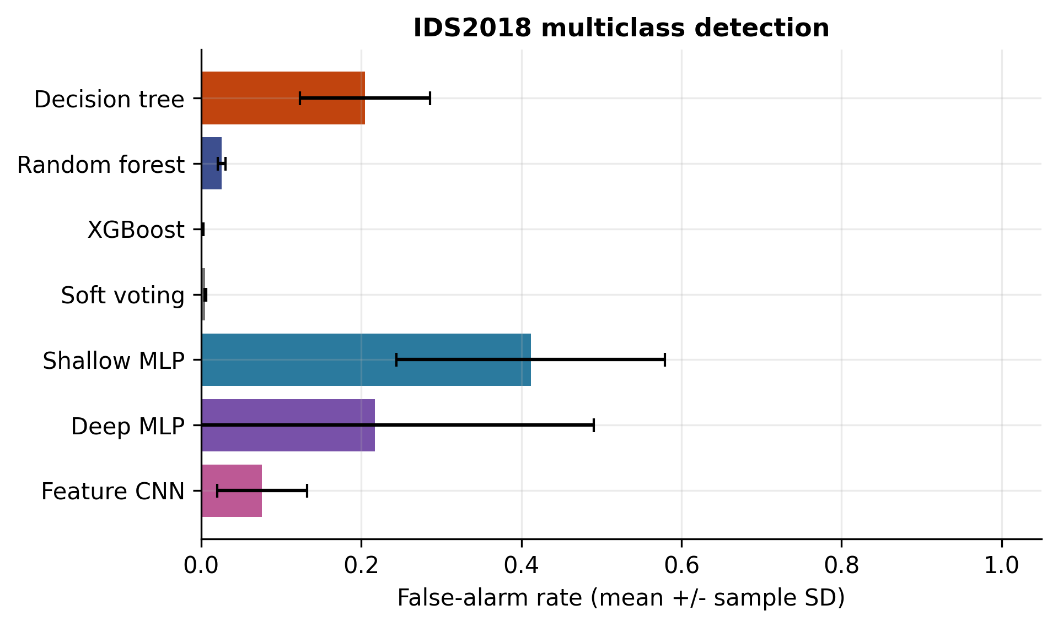
Figure 4.19: IDS2018 multiclass false-alarm rate across seven detector families. Error bars show sample SD across seeds 7, 42 and 1337; 80,000 test flows per evaluation. These group-disjoint results are separate from the historical protocol in Figure 4.2.

4.2.12 RQ3: detection transfer
Table 4.14: Frozen binary transfer macro-F1, mean +/- sample SD across three seeds.
Model | U to I | I to U
DecisionTree | 0.5118 +/- 0.1153 | 0.4624 +/- 0.0316
RandomForest | 0.4366 +/- 0.0048 | 0.4876 +/- 0.0006
XGBoost | 0.4629 +/- 0.0050 | 0.5157 +/- 0.0233
SoftVoting | 0.4445 +/- 0.0058 | 0.5095 +/- 0.0112
ShallowMLP | 0.4575 +/- 0.0283 | 0.4434 +/- 0.0917
DeepMLP | 0.4364 +/- 0.0256 | 0.5164 +/- 0.0256
FeatureCNN | 0.4274 +/- 0.0359 | 0.4853 +/- 0.0031
Every detector's cross-dataset mean macro-F1 is below its corresponding within-source mean. U-trained XGBoost falls from 0.9750 to 0.4629 on I; U-trained random forest falls from 0.9701 to 0.4366. In the reverse direction, DeepMLP changes from 0.9842 within I to 0.5164 on U. The U-to-I decision tree has the highest mean transfer macro-F1 in that direction (0.5118), but its SD is 0.1153. The result does not justify selecting that detector for deployment without further validation.
Table 4.15: Transfer balanced accuracy (BA) and false-alarm rate (FAR), three-seed means.
Model | U to I BA | U to I FAR | I to U BA | I to U FAR
DecisionTree | 0.5475 | 0.2687 | 0.4814 | 0.1897
RandomForest | 0.4342 | 0.1508 | 0.4937 | 0.0135
XGBoost | 0.4815 | 0.0472 | 0.5130 | 0.0003
SoftVoting | 0.4483 | 0.1185 | 0.5096 | 0.0017
ShallowMLP | 0.5928 | 0.4913 | 0.4240 | 0.1987
DeepMLP | 0.6513 | 0.5855 | 0.5130 | 0.0054
FeatureCNN | 0.6209 | 0.5826 | 0.4840 | 0.0460
Balanced accuracy and false-alarm rate reveal why a single macro-F1 value is insufficient. A model can recover some attack recall while creating many false alarms, or produce few alarms while missing attacks. The domain shift is a combined empirical effect; the experiment does not isolate a single causal feature or collection artifact responsible for it.
The largest marginal KS distance in the 20,000-row descriptive comparison is 0.6690 for retransmitted_out_bytes. Several retransmission and ICMP fields also differ strongly. These observations show distribution differences in the shared representation, not evidence that changing those fields would repair transfer. IDS2018's extreme finite rates are separately documented; numerical overflow prevention does not resolve their physical interpretation.
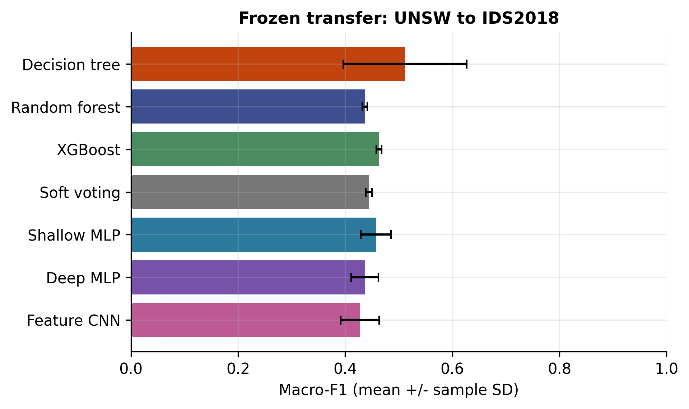
Figure 4.20: Binary detection transfer from UNSW to IDS2018. All seven models are fitted on the source only; error bars represent three training seeds.
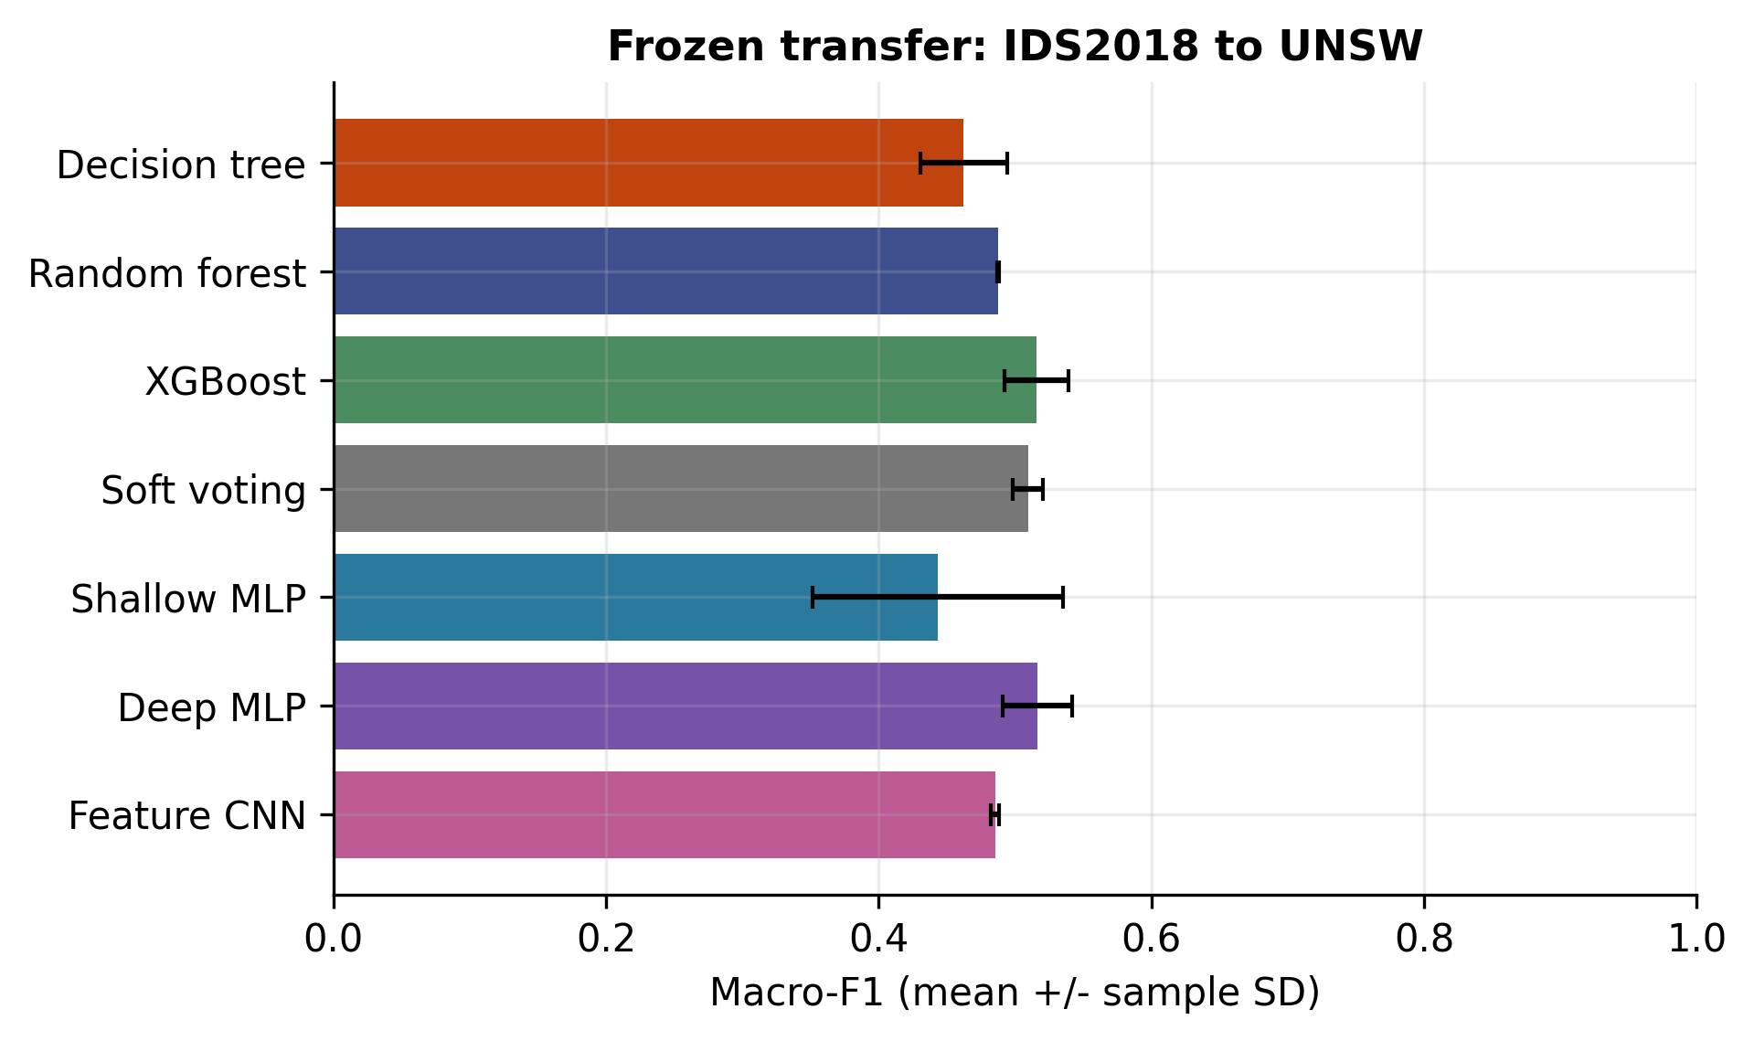
Figure 4.21: Binary detection transfer from IDS2018 to UNSW. All seven models are fitted on the source only; error bars represent three training seeds.

4.2.13 RQ1 and RQ2: stability versus masking sensitivity
The historical audit addresses the concern that less stable explanations appeared more faithful. For 483 matched cases per original tree model, reconstructing stored aggregate formulas produces only numerically small discrepancies: at most 5.17e-7 for the XGBoost retained-probability ratio and below 7e-16 for the other two models. Replaying original unmasked maximum probabilities yields no errors above 1e-6. These checks support arithmetic consistency; they do not validate unavailable historical masks.
The main interpretation risks were opposite metric directions and different levels of comparison. Historical comp_k values are probabilities remaining after removal, where lower means a larger effect. Historical comprehensiveness_auc is a discrete mean of probability drops, where higher means a larger effect; it is not an integrated area. Historical sufficiency_auc is a retained/original probability ratio, where higher means more retention and values can exceed one. Mixing these under one faithfulness axis can reverse an interpretation without any falsified numbers.
Within each model, historical Spearman correlations between Jaccard@5 and the LIME-minus-random removal effect are positive: 0.2037 for decision tree, 0.2082 for random forest and 0.2584 for XGBoost. This differs from ordering three model averages. Neither comparison establishes a universal law. Duplicate feature groups further limit independent-observation assumptions. Exact original masked predictions cannot be replayed because the historical feature rankings were not retained.
The historical random split also had substantial exact retained-feature overlap: 88.97% of test flows shared a representation with training. That finding motivates the new group-disjoint protocol and prevents treating old headline detection scores as directly comparable to the revised results. The evidence does not support declaring all previous outcomes falsified. It supports narrower corrections to metric interpretation, leakage control and provenance.
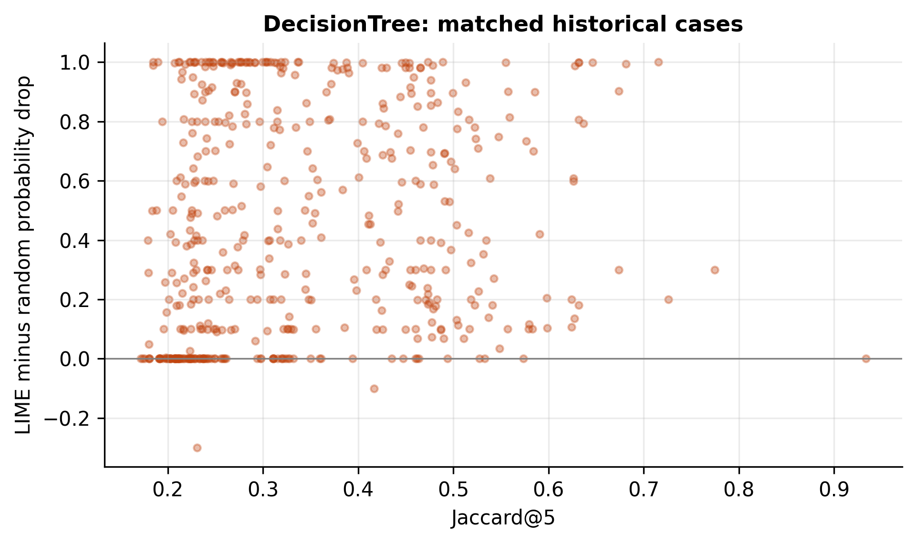
Figure 4.22: DecisionTree: historical within-model stability versus random-controlled masking effect on 483 matched cases. Descriptive Spearman rho = 0.2037; this addresses a different question from the cross-model means in Figure 4.9.
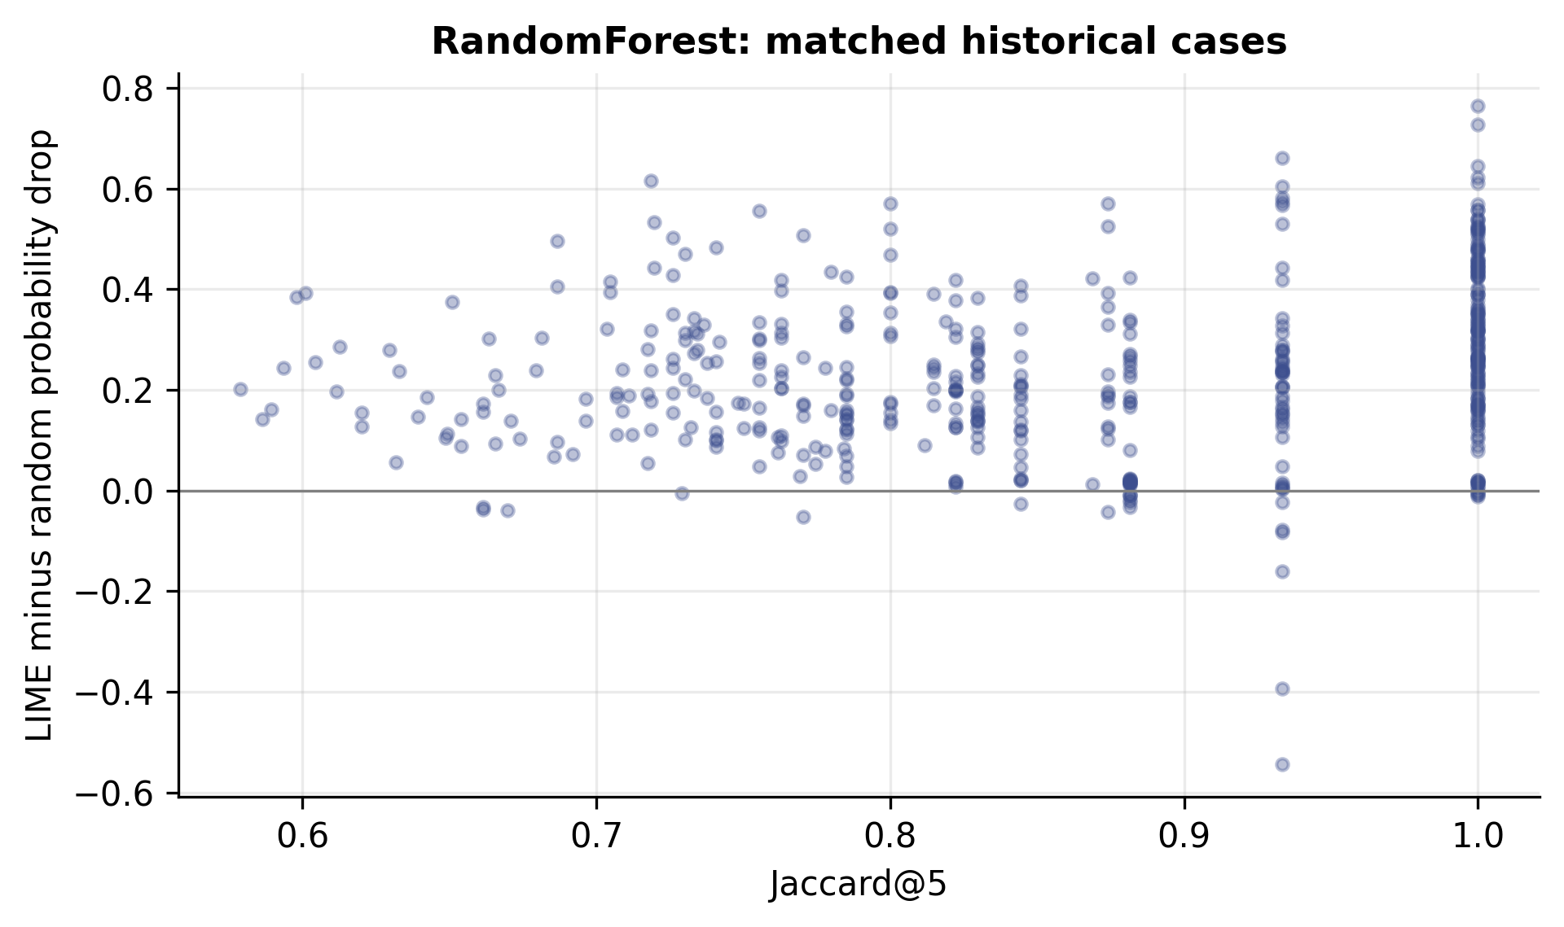
Figure 4.23: RandomForest: historical within-model stability versus random-controlled masking effect on 483 matched cases. Descriptive Spearman rho = 0.2082; this addresses a different question from the cross-model means in Figure 4.9.
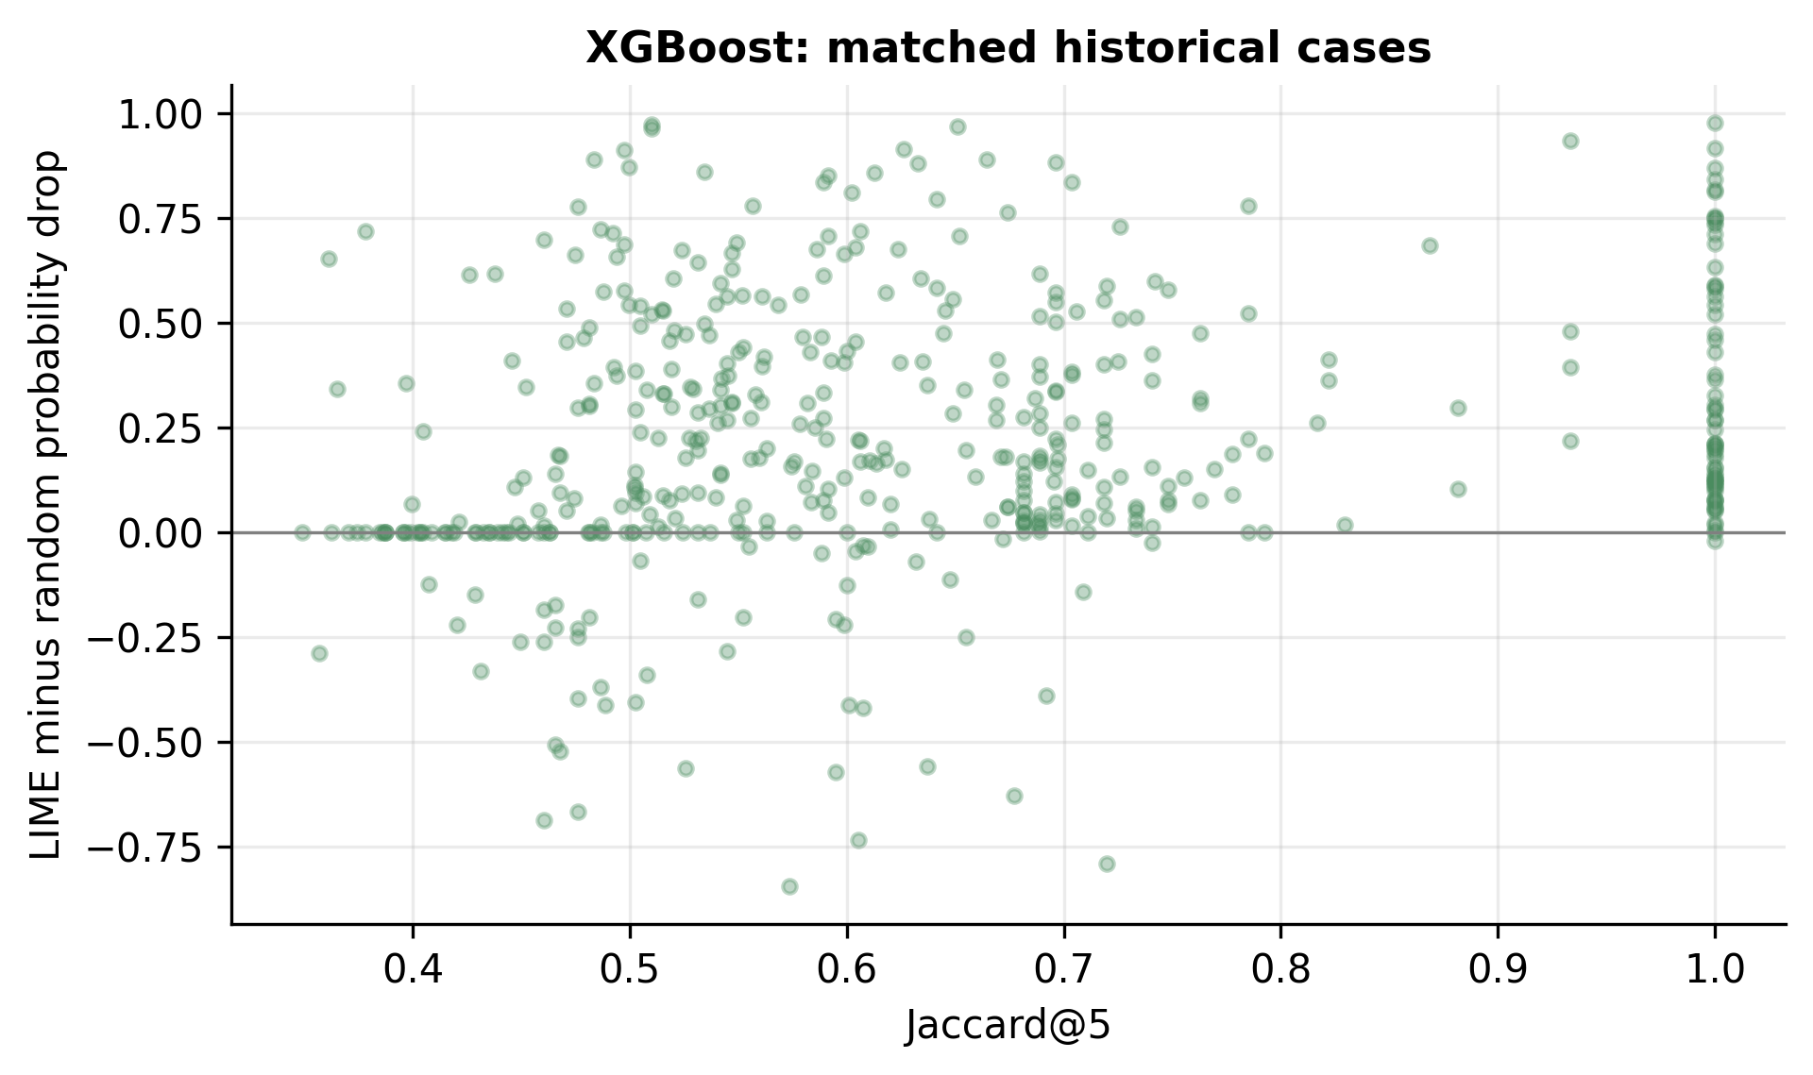
Figure 4.24: XGBoost: historical within-model stability versus random-controlled masking effect on 483 matched cases. Descriptive Spearman rho = 0.2584; this addresses a different question from the cross-model means in Figure 4.9.

4.2.14 RQ3: explanation transfer
Table 4.16: Explanation transfer, U to I: primary median/absolute protocol.
Model | Jaccard@5 | Advantage | 95% interval
DecisionTree | 0.5960 | 0.0394 | [-0.0525, 0.1545]
RandomForest | 0.9222 | -0.1338 | [-0.2034, -0.0476]
XGBoost | 0.5706 | 0.0268 | [-0.0032, 0.0848]
SoftVoting | 0.8056 | -0.0395 | [-0.0898, 0.0370]
ShallowMLP | 0.8833 | 0.1400 | [-0.0109, 0.2966]
DeepMLP | 0.7810 | 0.6057 | [0.4976, 0.7028]
FeatureCNN | 0.7603 | 0.5199 | [0.4002, 0.6464]
For U-trained random forest, within-domain Jaccard@5 is 0.9778 and the removal advantage is 0.3165. On I, Jaccard remains 0.9222 while advantage becomes -0.1338, with a conditional interval below zero. Thus a highly repeatable ranking can be less effective than matched random masks under the chosen baseline. U-trained XGBoost shows another dissociation: stability rises from 0.5165 to 0.5706 while advantage declines from 0.3922 to 0.0268. Its target interval includes zero.
Table 4.17: Explanation transfer, I to U: primary median/absolute protocol.
Model | Jaccard@5 | Advantage | 95% interval
DecisionTree | 0.5710 | 0.0261 | [-0.0422, 0.0980]
RandomForest | 0.6433 | 0.0031 | [-0.0079, 0.0164]
XGBoost | 0.6853 | -0.0162 | [-0.0662, 0.0167]
SoftVoting | 0.5440 | 0.0145 | [-0.0137, 0.0471]
ShallowMLP | 0.7119 | -0.0519 | [-0.0898, -0.0121]
DeepMLP | 0.6530 | -0.0253 | [-0.0599, -0.0038]
FeatureCNN | 0.5974 | 0.0588 | [-0.0093, 0.1401]
The reverse direction is also model-dependent. I-trained DeepMLP and ShallowMLP have negative cross-domain primary advantages, while the feature CNN's interval crosses zero. U-trained DeepMLP and FeatureCNN show larger target-domain masking advantages despite weak full-test transfer macro-F1. Explaining the sensitivity of a frozen model is not the same as establishing that its predictions are correct. All intervals refer to 20-case balanced cohorts and one trained model, not the 80,000-row test population.
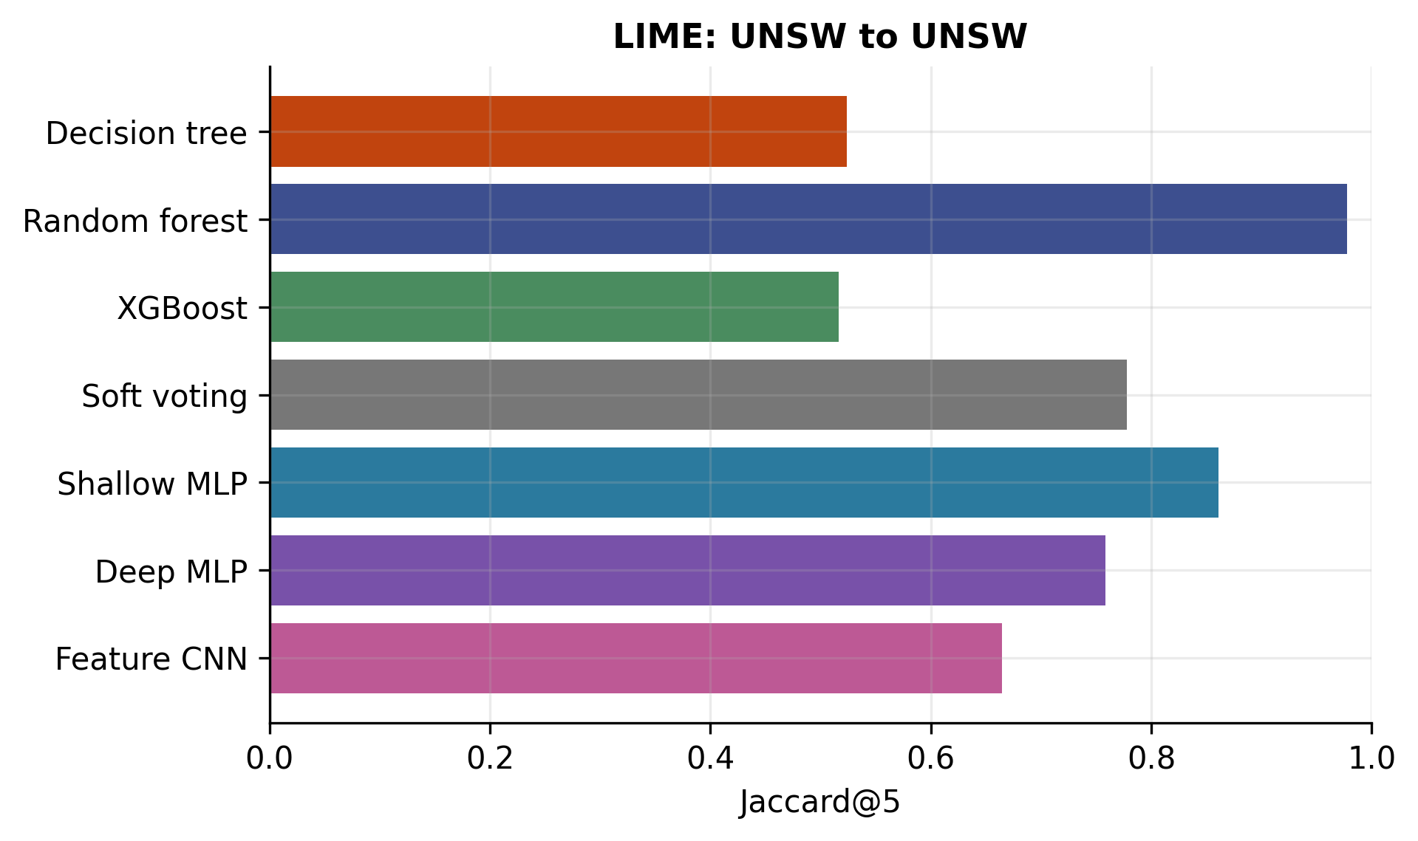
Figure 4.25: Jaccard@5 for UNSW to UNSW: seed-42 detectors, 20 balanced unique-group cases, three LIME seeds, source-median masking and absolute attribution rankings. Mean pairwise set overlap across three explanation seeds.
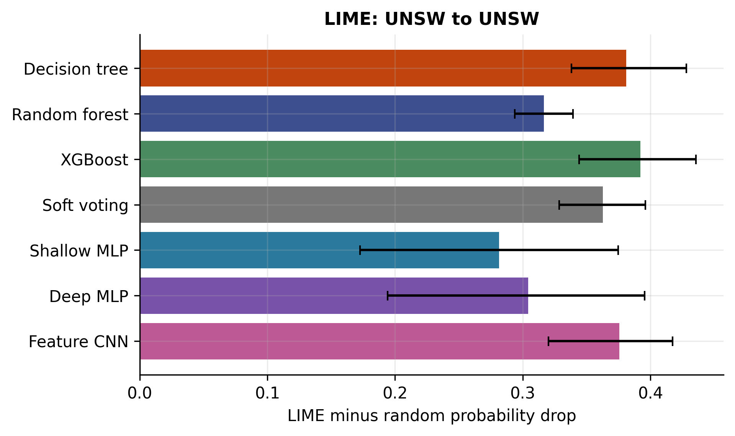
Figure 4.26: LIME minus random probability drop for UNSW to UNSW: seed-42 detectors, 20 balanced unique-group cases, three LIME seeds, source-median masking and absolute attribution rankings. Intervals are 95% stratified bootstrap intervals over 20 cases, conditional on one fitted model; they are not training-seed uncertainty.
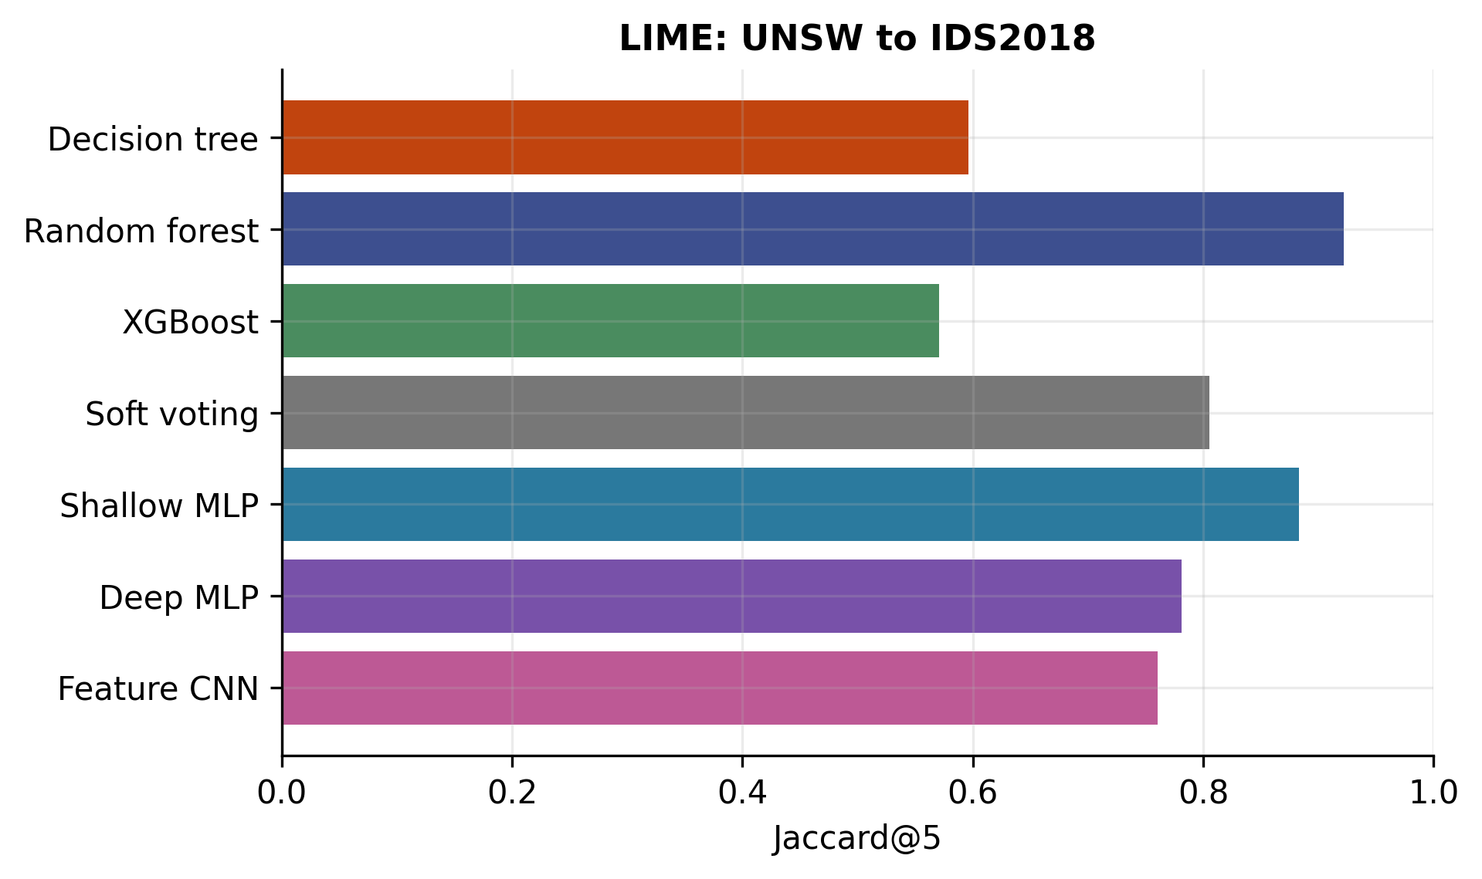
Figure 4.27: Jaccard@5 for UNSW to IDS2018: seed-42 detectors, 20 balanced unique-group cases, three LIME seeds, source-median masking and absolute attribution rankings. Mean pairwise set overlap across three explanation seeds.
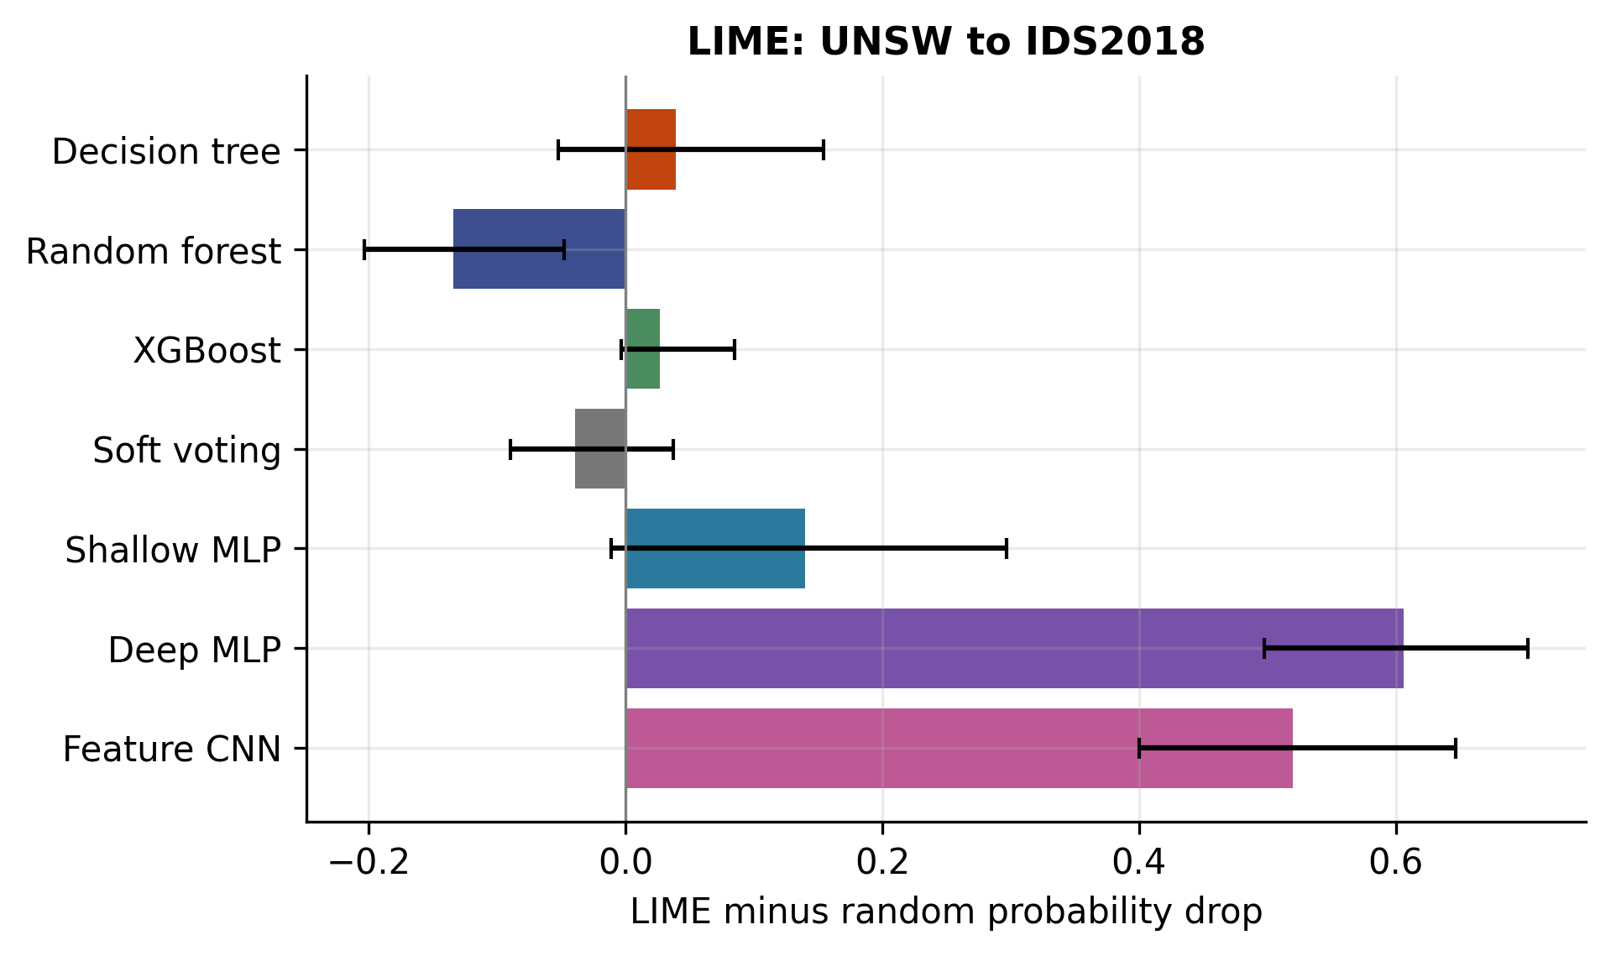
Figure 4.28: LIME minus random probability drop for UNSW to IDS2018: seed-42 detectors, 20 balanced unique-group cases, three LIME seeds, source-median masking and absolute attribution rankings. Intervals are 95% stratified bootstrap intervals over 20 cases, conditional on one fitted model; they are not training-seed uncertainty.
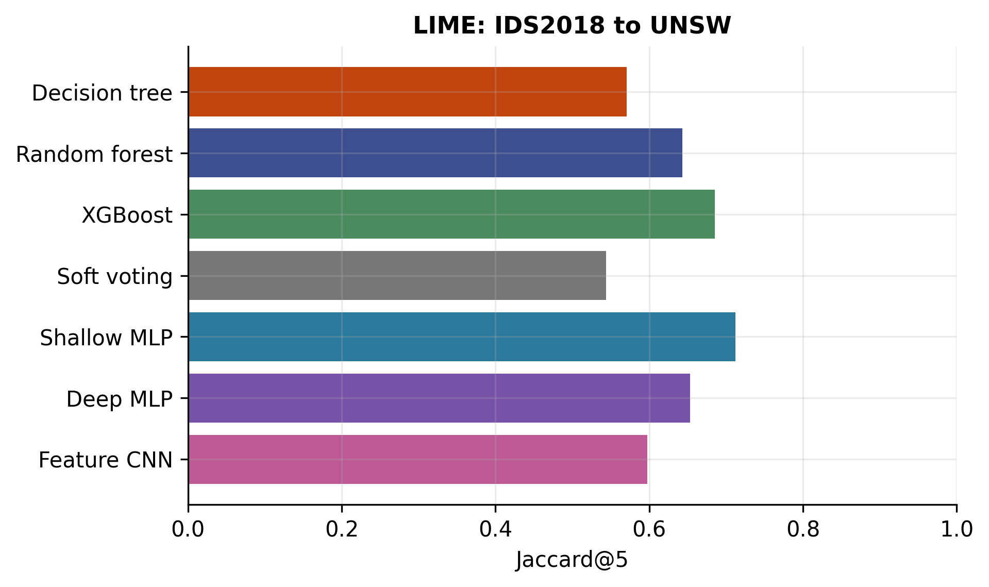
Figure 4.29: Jaccard@5 for IDS2018 to UNSW: seed-42 detectors, 20 balanced unique-group cases, three LIME seeds, source-median masking and absolute attribution rankings. Mean pairwise set overlap across three explanation seeds.
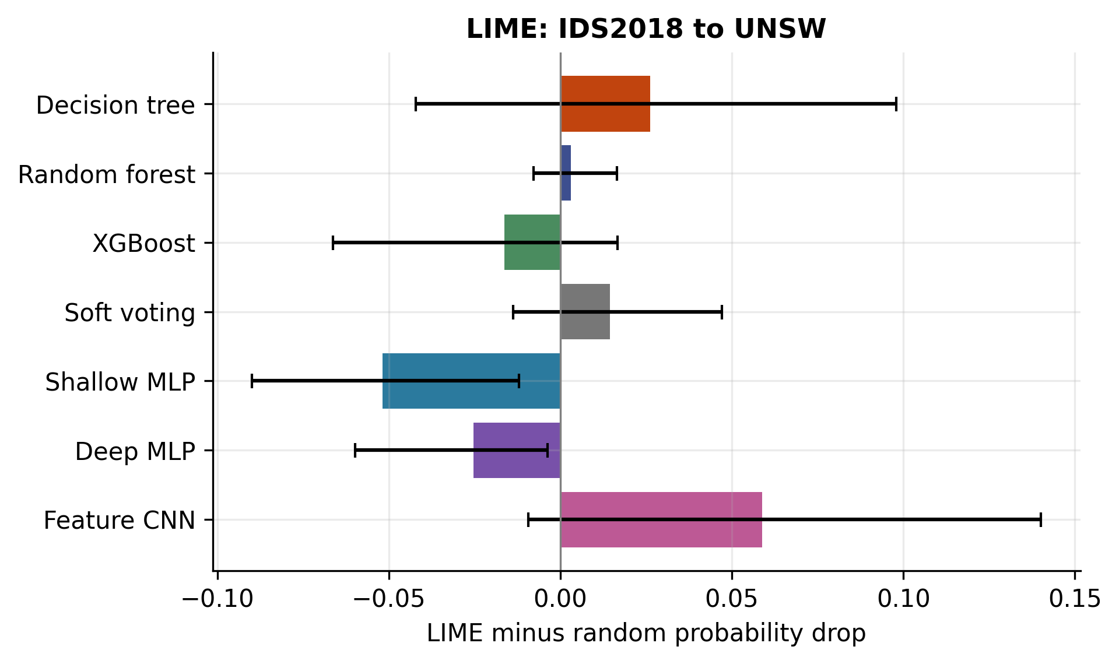
Figure 4.30: LIME minus random probability drop for IDS2018 to UNSW: seed-42 detectors, 20 balanced unique-group cases, three LIME seeds, source-median masking and absolute attribution rankings. Intervals are 95% stratified bootstrap intervals over 20 cases, conditional on one fitted model; they are not training-seed uncertainty.
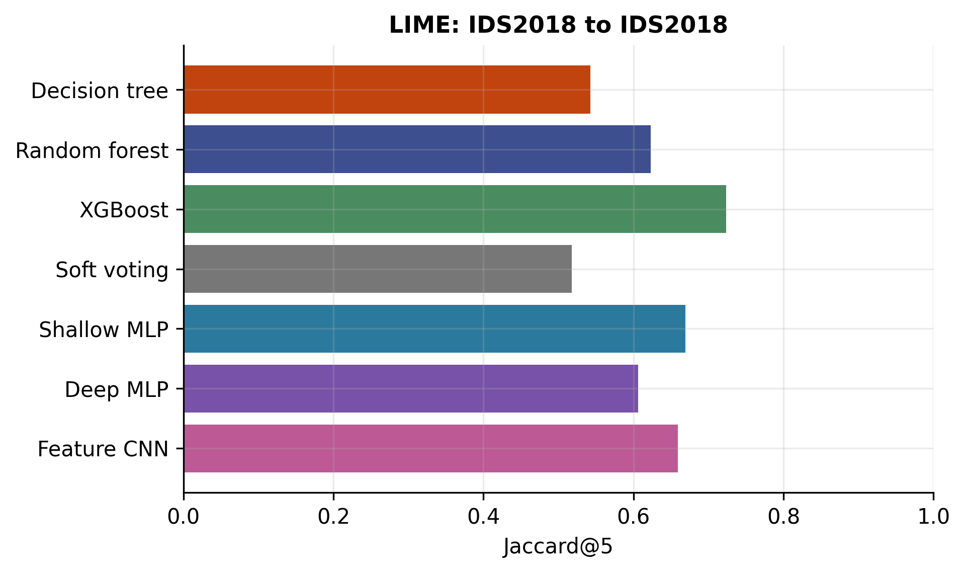
Figure 4.31: Jaccard@5 for IDS2018 to IDS2018: seed-42 detectors, 20 balanced unique-group cases, three LIME seeds, source-median masking and absolute attribution rankings. Mean pairwise set overlap across three explanation seeds.
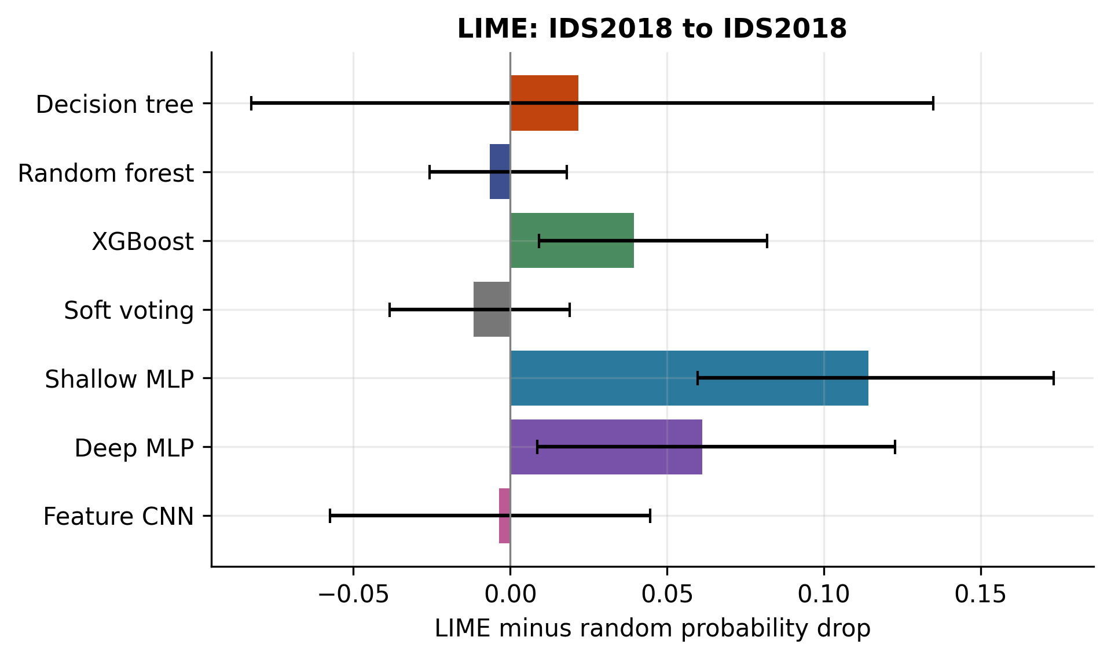
Figure 4.32: LIME minus random probability drop for IDS2018 to IDS2018: seed-42 detectors, 20 balanced unique-group cases, three LIME seeds, source-median masking and absolute attribution rankings. Intervals are 95% stratified bootstrap intervals over 20 cases, conditional on one fitted model; they are not training-seed uncertainty.

4.2.15 Sensitivity to the masking definition
The four-variant post-hoc check changes measured explanation relevance without changing the underlying classifier. For U-trained random forest evaluated on I, mean advantage is -0.1338 with median/absolute masking and -0.1247 with mean/absolute masking. Signed-descending ranking changes these values to 0.0795 and 0.2215 respectively. Removing a feature that opposes the original class can increase its probability, so absolute and signed ranking have different meanings.
This sensitivity is a reason to retain all variants and state the intervention precisely. It is not a reason to replace the primary result with whichever variant appears favorable. Mean and median baselines can both create implausible combinations of flow features. The measured quantity is conditional perturbation sensitivity; causal or semantic explanation correctness remains unmeasured.

4.2.16 Matched LLM classification extension
Table 4.18: LLM classification: identical metrics in each of four balanced 100-case direction cells.
Model | Predicted class | Macro-F1 | BA | FAR
Qwen | Benign | 0.3333 | 0.5000 | 0.0000
TinyLlama | Attack | 0.3333 | 0.5000 | 1.0000
SmolLM2 | Benign | 0.3333 | 0.5000 | 0.0000
Qwen and SmolLM2 predict Benign for every evaluated case, while TinyLlama predicts Attack for every case. Each source/target cell is balanced, so all three obtain accuracy 0.5, balanced accuracy 0.5 and macro-F1 0.3333. A zero false-alarm rate for the benign-only models is accompanied by zero attack recall; it is not successful detection. TinyLlama attains attack recall one by flagging every benign case as well.
These outcomes are negative results for the frozen small-model, four-example, rounded-input and constrained-label protocol. They do not establish that all LLM intrusion detection fails. Label verbalization, example order, serialization and prompt format remain plausible sensitivities requiring a separately specified follow-up. The completed test cohort must not become a hidden development set for improving the original headline result.
Table 4.19: Detector macro-F1 on the balanced 100-case LLM cohorts (seed 42).
Model | U to U | U to I | I to U | I to I
DecisionTree | 0.9800 | 0.5586 | 0.4172 | 0.9800
RandomForest | 0.9700 | 0.3042 | 0.3333 | 0.9800
XGBoost | 0.9800 | 0.3304 | 0.4544 | 0.9800
SoftVoting | 0.9700 | 0.2857 | 0.3967 | 0.9800
ShallowMLP | 0.9800 | 0.5262 | 0.3743 | 0.9800
DeepMLP | 0.9800 | 0.7726 | 0.3552 | 0.9800
FeatureCNN | 0.9800 | 0.7821 | 0.3658 | 0.9800
The matched detector results use exactly the balanced 100-case cohorts. They must not be substituted for full-test metrics. For example, a detector can look much stronger on a 50/50 sample than on a domain's original prevalence while making the same kinds of conditional errors. This is an evaluation-cohort distinction, not evidence that the transfer experiment changed its saved predictions.

4.2.17 LLM explanation validity and conditional masking
Table 4.20: Valid explanation coverage aggregated over all four direction cells.
Model | Own valid / total | Detector valid / total
Qwen | 26 / 80 | 58 / 80
TinyLlama | 0 / 80 | 0 / 80
SmolLM2 | 0 / 80 | 5 / 80
Across all four directions, Qwen produces 26 valid own-decision explanations out of 80 and 58 valid detector explanations out of 80. SmolLM2 produces no valid own explanations and five valid detector explanations. TinyLlama produces no valid explanations under the required schema. Failures include outputs that do not meet the required format or feature constraints; the raw responses remain available. No valid masking subset is silently expanded to represent all outputs.
Table 4.21: Conditional explanation masking: named-minus-random mean advantage on valid outputs only.
Model | Direction | Kind | Valid n | Advantage
SmolLM2 | I to U | detector | 2 | 0.4036
SmolLM2 | U to I | detector | 1 | 0.0807
SmolLM2 | U to U | detector | 2 | 0.0000
Qwen | I to I | detector | 12 | 0.1332
Qwen | I to I | own | 13 | -0.0114
Qwen | I to U | detector | 16 | 0.0538
Qwen | I to U | own | 13 | -0.0038
Qwen | U to I | detector | 17 | 0.0270
Qwen | U to U | detector | 13 | 0.2367
Qwen's valid own explanations are limited to the two I-source cells, with mean advantages -0.0114 and -0.0038. Detector-grounded conditional advantages are positive in its four cells, but are conditional on validity and refer to XGBoost rather than Qwen's collapsed classifier. SmolLM2's 0.4036 detector advantage in I-to-U is based on only two valid explanations. Such a small selected subset cannot establish overall explanation quality. A missing conditional score is not a measured zero.
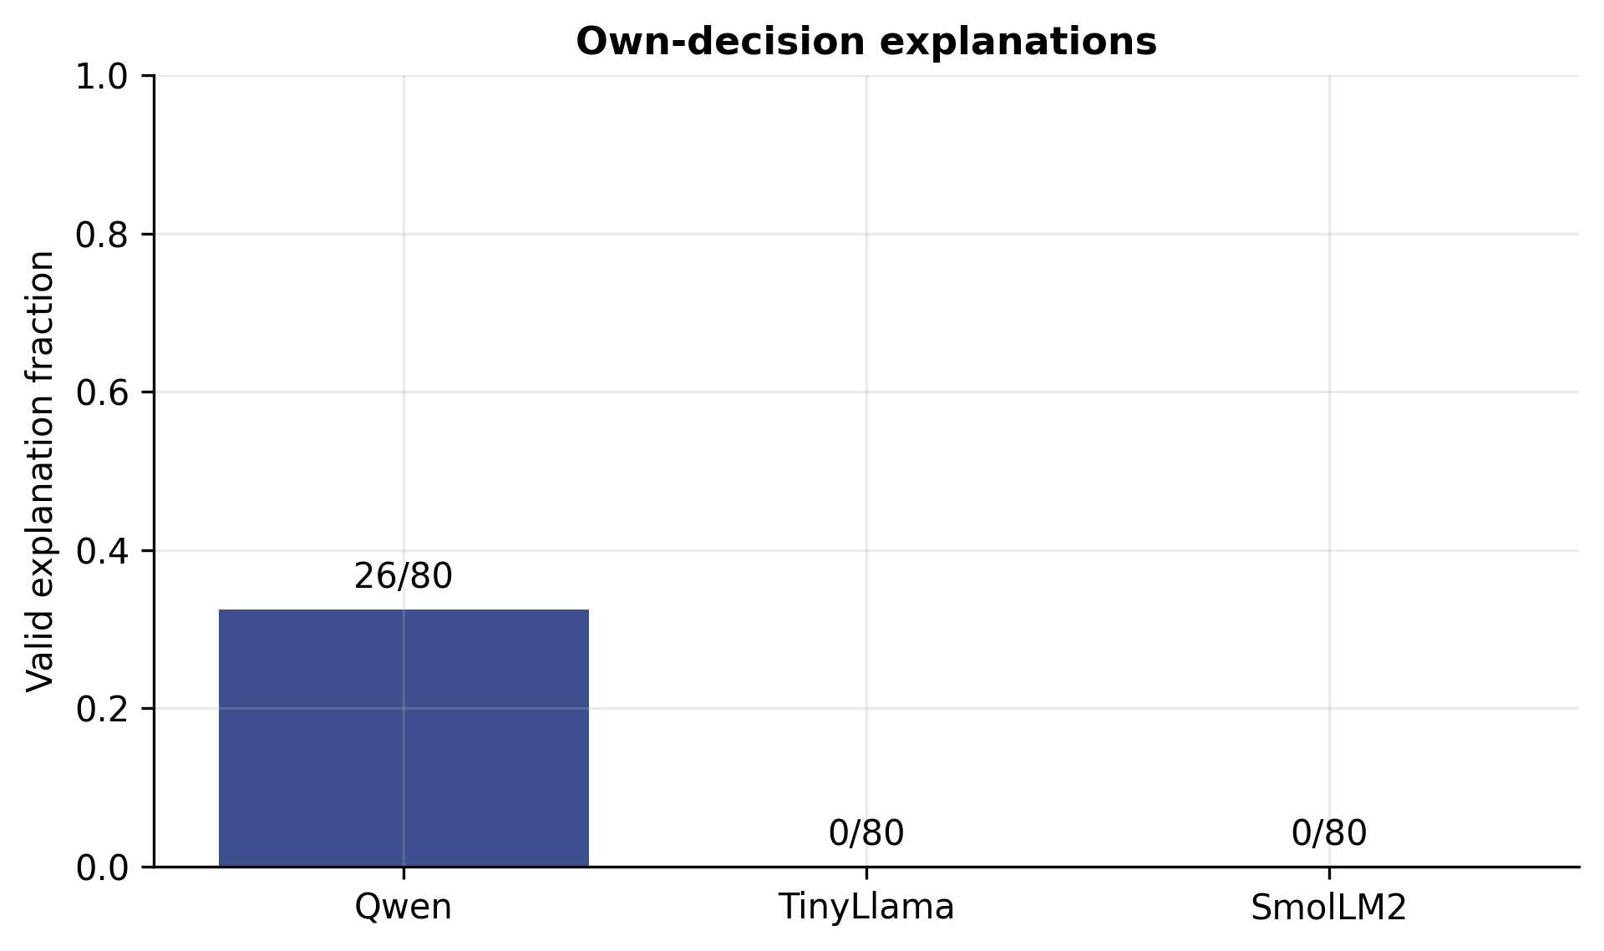
Figure 4.33: Valid own explanations out of all 80 requested outputs per model. Coverage must accompany any masking score calculated only on valid explanations.
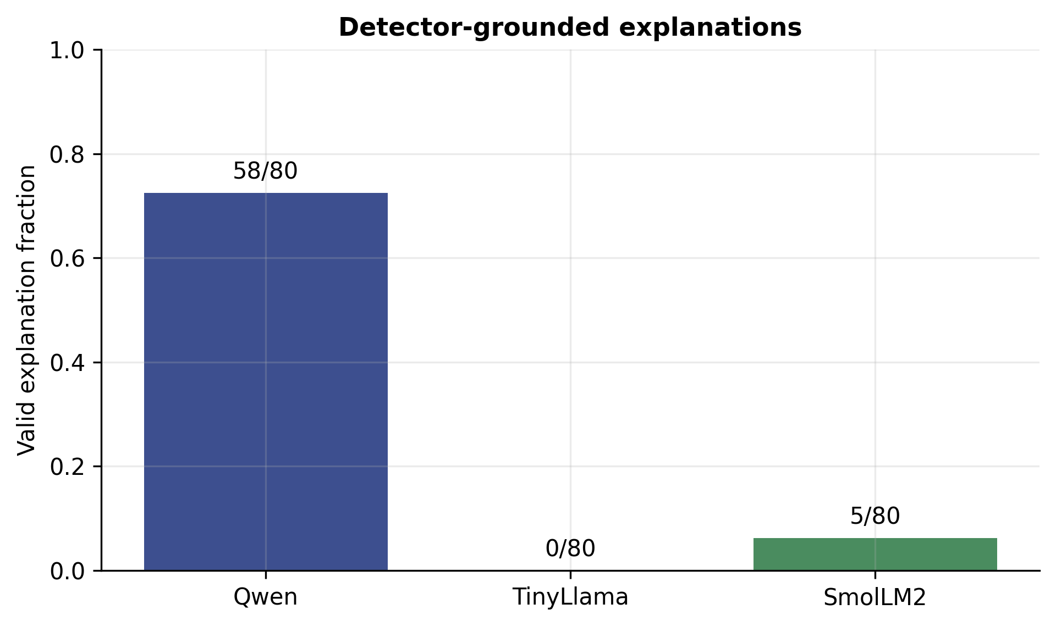
Figure 4.34: Valid detector explanations out of all 80 requested outputs per model. Coverage must accompany any masking score calculated only on valid explanations.

4.2.18 Calibration and imbalance extensions
Source-only calibration produces metric-dependent changes rather than a universal repair. For U-trained random forest on I, Brier score improves from 0.227757 to 0.209142 while ECE15 worsens from 0.324661 to 0.345976. These measures summarize different aspects of probability error. The outcome warns against selecting one calibration score after observing the target results.
For the U-trained random forest, removing class weights raises within-domain macro-F1 from 0.9645 to 0.9710, but lowers I-domain macro-F1 from 0.4373 to 0.3064 and raises FAR from 0.1412 to 0.5044. Training-only undersampling yields transfer macro-F1 0.3355 and FAR 0.5348. Improvements within a source domain therefore need not improve transfer. These are seed-42 ablations, not three-seed conclusions.

4.2.19 Threats to validity
Internal validity is strengthened by source-only preprocessing, consistent feature-group splits, saved predictions and matched controls. It is limited by the chosen representation, bounded samples and finite model configurations. Grouping prevents exact encoded-input overlap across partitions but does not remove every possible dependence or collection artifact. The cleaned releases and extreme-value handling differ from an assumption of pristine original packet captures.
Construct validity is limited because Jaccard measures repeatability and masking measures response to an artificial intervention. Neither is a direct measure of causal explanation correctness, semantic truth or analyst usefulness. Bootstrap intervals are conditional and exploratory. LLM validity checks cannot certify full prose accuracy; excluding invalid responses creates a selected subset whose composition can differ from the original balanced cohort.
External validity is limited to two datasets, three small LLMs, fixed architectures and a CPU-feasible sample budget. The feature CNN provides no temporal evidence. The neural results do not imply an exhaustive comparison of deep learning. Repeated seeds improve transparency but do not establish deployment reliability. Operational timing was affected by concurrent work and interrupted runs and is not used as a controlled speed comparison.

4.3 Discussion

4.3.1 Why Stability Cannot Be Inherited
The RQ1 result changes what a published stability figure means. If LIME's reproducibility on a Decision Tree bore some predictable relationship to its reproducibility on a Random Forest, then a single careful study would suffice for the field and everyone else could cite it. The 2.6-fold spread, combined with four failed attempts to account for it, removes that possibility.
This is worth separating from the more familiar claim that LIME is unstable. That claim is already in the literature [5], [24] and is not this thesis's contribution. The contribution is the finding that the degree of instability varies enormously and unpredictably across models, which means the property cannot be characterised once and reused. A practitioner deploying an explainer has to measure it on their own model, on their own data. The protocol in Section 3.6.1 is inexpensive — approximately fifteen minutes per model on a four-core desktop — so this is a practical recommendation rather than an aspirational one.

4.3.2 What the Dissociation Means for Practice
The stability–faithfulness dissociation has a direct consequence for how explainers are validated. Both properties are routinely described as measures of explanation quality, and it is tempting to treat them as interchangeable proxies. Section 4.2.7 shows that they are not merely distinct but inversely related across the models studied here.
A validation protocol that measured only faithfulness would have rated the Decision Tree's explanations best of the three. A protocol that measured only stability would have rated them worst. Both protocols exist in the literature; neither, applied alone, would have described this system correctly. The practical recommendation is that a deployed explainer be characterised on both axes, and that the pair be reported together rather than summarised into a single quality score.

4.3.3 The Metric Decides the Conclusion
A finding common to RQ1 and RQ4, and easy to miss because it is methodological rather than substantive, is that the choice of comparison metric determines the conclusion reported.
In RQ1, Jaccard@5 and Kendall τ order the six models differently, and order the attack classes differently within a single model. In RQ4, Spearman ρ and Jaccard@5 give different pictures of the same explainer pair: LIME and TreeSHAP correlate at ρ = 0.676 on the Random Forest, which reads as substantial agreement, while sharing only two of their top five features, which does not. Both statements describe the same pair of rankings.
Part of the explanation is technical. Permutation importance has 18 of 39 features inside its own noise floor even under f1_macro scoring, so a rank correlation computed over its full ordering is partly correlating noise against noise. Set-overlap measures restricted to the top-k avoid that, but discard ordering information entirely. Neither is wrong; they answer different questions, and a study reporting one of them reports one of two available conclusions.
The recommendation that follows is simple and applies beyond this thesis: report a set-overlap measure and a rank-correlation measure together, always.

4.3.4 An Unresolved Tension
One tension in the results is not resolved here, and is stated as an open question rather than smoothed over.
On the Decision Tree, RQ2 rates LIME as marginally more faithful than TreeSHAP (2.29× against 2.20×), while RQ4 shows LIME disagreeing with everything else on that same model — including with two independent methods that agree strongly with each other. A method that is the odd one out ought not also to be the most faithful.
A candidate reconciliation follows the mechanism sketched in Section 4.2.7. Masking a feature that happens to route this particular instance through the tree will break the prediction locally, even if the model does not depend on that feature in general. LIME, fitted locally around the instance, may be finding exactly such features: individually sufficient to change this prediction, but not part of the model's globally important set, which is what TreeSHAP and permutation importance report. That would be local faithfulness without global validity.
This is plausible and consistent with the data, but it was not tested. Resolving it would require a faithfulness protocol matched to global rankings rather than local ones, which is beyond the scope of the present work and is listed in Section 5.3.2.

4.3.5 Operational Implications for a SOC
Drawing the results together, four recommendations follow for a security team considering deploying an explainable intrusion detection system.
- Measure stability on your own model before trusting any explanation. Fifteen minutes of computation establishes whether repeated explanations agree. A Jaccard@5 in the region of 0.34 means a single explanation should not be acted on without repetition.
- Always compare against a random-feature control. An absolute comprehensiveness figure is uninterpretable. On these models, masking ten random features of thirty-nine already moved the prediction by roughly 0.32.
- Run at least two independent explainers and treat disagreement as information. Where TreeSHAP and permutation importance converge and LIME does not, the balance of evidence favours the two that agree — particularly when the outlier nominates fields with no security semantics.
- Budget explanation separately from detection. At roughly 0.1 s per explanation against microseconds per detection, explanation cannot be applied to every alert. Design the trigger policy explicitly.

4.4 Threats to Validity
There are some limitations that are important to highlight that have led to specific outcomes. These are summed up below in full in order to track all aspects of results dependent on the limits.
Construct validity. According to the protocols of mean-imputation masking, a model would get inputs that are likely to be impossible in reality (flow with mean byte count number but original TCP flags). The fact is mentioned in the faithfulness literature [26] and is unavoidable under the outlined technique; using a new masking procedure would evaluate the resistance of a model to it. In addition, TOPSIS parameters for the model have been selected by us and are not the known convention.
Internal validity. RQ2 relied on the single LIME seed while RQ1 shows that the finding of LIME is not stable so that the measured faithfulness of LIME is a random variable with a variance that was not calculated. The models do not tune their hyperparameters as they apply only max_depth=30 and min_samples_leaf=5 for considering about the memory used for two million entries. The models employ only one split seed for the detection process, so there is no estimate of variance of the reported metrics.
Statistical conclusion validity. Rare-class results rest on very small samples: the Worms class contributes 33 test flows, and a 95% interval around its 0.939 recall spans roughly 0.80 to 0.98. Permutation importance has 18 of 39 features inside its own noise floor, so Spearman correlations computed over its full ordering are partly correlating noise. Four RQ1 mechanisms were falsified and no mechanism is claimed; with six models, any further variable that fits post hoc would be curve-fitting.
External validity. NF-UNSW-NB15-v2 is synthetic traffic generated in a controlled environment, and results may not transfer to production capture. All measurements come from a single dataset; the cross-network question that would test transferability is RQ3, which is specified in Section 5.3.1 but not executed. Logistic Regression did not converge within its iteration limit, which is reported rather than corrected, but means its explanations are explanations of a non-converged model.

4.5 Summary
Six classifiers were trained on 1,986,745 NetFlow records, frozen, and explained. The soft-voting ensemble reached macro-F1 0.6743 on the ten-class task and 0.9751 on the binary task, absorbing a member with a 44.79% false alarm rate without collapse.
Against those frozen models, three properties of the explanations were measured. LIME's reproducibility varied 2.6-fold across models, from Jaccard@5 = 0.337 to 0.868, and four pre-registered mechanisms failed to account for the variation. LIME and TreeSHAP were both substantially more faithful than a random-feature control, at 1.73× to 2.29× comprehensiveness with p < 10⁻⁴⁶ throughout. And the identity of the closest-agreeing explainer pair changed with every model.
The single most consequential result is the relationship between the first two. Stability and faithfulness moved in opposite directions: the model whose explanations were least reproducible produced the most faithful ones. Neither property predicts the other, and neither alone is sufficient to validate an explainer. Cutting across all three experiments, the choice between a set-overlap measure and a rank-correlation measure changed which model, class or explainer pair appeared best — so both must be reported.
The conclusion the evidence supports is a warning rather than a mechanism: explanation reliability is a property of a specific explainer applied to a specific model on specific data, and it must be measured there. It cannot be inherited from the literature.
CHAPTER V

Conclusion and Future Works

5.1 Conclusion
This thesis began from an observation about a habit rather than about a technology. Explainable AI has been adopted enthusiastically in network intrusion detection, but the explanations it produces are treated as outputs to be displayed rather than as measurements to be validated. A published LIME plot is offered as evidence that a model has been understood, and the reader is left to supply, unaided, the assumptions that make that evidence meaningful: that the plot would reappear on a second run, that the features it names are the ones the model used, and that an independent method would agree.
We set out to check those assumptions on a working system. Six classifiers were trained on 1,986,745 NetFlow records from NF-UNSW-NB15-v2, reduced to 39 leak-free features, combined by soft voting, and then frozen. Against those frozen models, three properties of the resulting explanations were measured: stability under repetition, faithfulness against a random-feature control, and agreement between independent explainers.
The measurements did not fall where we expected. LIME's reproducibility varied 2.6-fold across models with nothing else changed — from a mean Jaccard@5 of 0.337 on the Decision Tree to 0.868 on the Random Forest. Four mechanisms proposed to account for that spread were stated in advance and all four were falsified. LIME and TreeSHAP were both substantially more faithful than chance, at 1.73 to 2.29 times a random-feature control with p < 10⁻⁴⁶ throughout, which is a genuinely reassuring result. But stability and faithfulness turned out to move in opposite directions: the model whose explanations were least reproducible produced the most faithful ones. And the identity of the closest-agreeing pair of explainers changed with every model tested.
Cutting across all three experiments was a fourth result that we did not anticipate and that has proved the most portable. Set-overlap and rank-correlation measures ranked the same models, the same attack classes and the same explainer pairs differently. The metric chosen determines the conclusion reported, which means both must be presented together.
The conclusion the evidence supports is a warning rather than a mechanism. Explanation reliability is not a property of LIME, or of SHAP, that can be established once and cited thereafter. It is a property of a particular explainer applied to a particular model on particular data, and it varies enough between those combinations that it cannot be inherited from a published evaluation of a different one. It has to be measured where it is deployed — and, at roughly fifteen minutes per model on a four-core desktop, it can be.
The wider point is about what the field asks of its instruments. Detection models are held to a rigorous evaluation standard: cross-validation, confidence intervals, controls, significance tests. Explanations, which are the part of the system a human actually acts on, are held to almost none. This thesis is an argument, backed by measurements, that the same standard should apply to both.

5.1.1 Conclusions from the expanded study
The expanded evidence qualifies the historical conclusions above. Seven detector families completed three-seed comparisons on two datasets. XGBoost reached mean binary macro-F1 0.9750 on UNSW; random forest reached 0.9852 on IDS2018. Neural models were competitive within datasets but did not eliminate the loss under frozen transfer. RQ3 is now completed for the specified binary detection and LIME protocols. The UNSW-trained random forest retained target-domain Jaccard@5 0.9222 while its LIME-minus-random masking advantage was -0.1338, demonstrating that reproducibility alone does not establish predictive relevance.
The three small local LLMs completed classification and both explanation tasks, but each collapsed to one predicted class under the frozen four-example protocol. These are negative benchmark findings, not a claim about every LLM. The historical audit found no material arithmetic reversal; descriptive within-model stability–advantage correlations were positive. The original RQ4 agreement results remain a separate contribution, and the new neural and LLM comparisons do not supply missing SHAP or TOPSIS experiments.

5.2 Contribution of this Thesis

5.2.1 Empirical Contributions
A 2.6-fold spread in LIME stability across six classifiers on identical data. To our knowledge this is the first systematic measurement of run-to-run explanation stability in network intrusion detection, and the first to establish that the magnitude of the instability is model-dependent rather than a fixed property of the explainer.
Four documented falsifications. Surface smoothness, detection accuracy, model family and probability granularity were each proposed as mechanisms and each was refuted by the data. Reporting them is a contribution in its own right: it demonstrates that the explanation offered was tested rather than asserted, and it saves the next researcher four dead ends.
The stability–faithfulness dissociation. Across the three tree models, the least stable explanations were the most faithful. The two properties are commonly treated as interchangeable proxies for explanation quality; here they move in opposite directions, which means an explainer validated on either alone has not been validated.
Model-dependent explainer agreement. A different explainer pair was closest in each of the three models tested, and the ordering reshuffled completely between them. Agreement is a property of the model being explained, not of the explainers.
Two secondary findings about the detector. Soft voting worked seamlessly with an average misidentification rate of 44.79 percent and continued to perform better than its best individual member, demonstrating that in case of member failure, it deteriorates gracefully instead of abruptly. There is the cost of explanation being four or five times greater per instance than that of detection.

5.2.2 Methodological Contributions
A frozen-model protocol for faithfulness. A difference between the two evaluation approaches is not just a cosmetic one. When retraining on a feature subset that contains only top-k features we can check if these are good enough to build a model; however, since the retrained model restores its performance with the help of correlated substitutes, we do not know if the original model has used them. In contrast, holding the model constant but “intervening” on its inputs is the only way to find out the answer to the question of interest asked by the analyst.
The random-feature control as the experiment rather than a check. we mask just ten of the available thirty-nine features from our models, we see a difference in the predicted probability of roughly 0.32. Any comprehensiveness statistic offered without reference to that number will make no sense.
Deliberate weak controls. We were able to make the RQ1 comparison across model families instead of only three tree versions because we included models, such as Gaussian Naive Bayes, Logistic Regression, and multilayer perceptron, which are not really considered state-of-the-art classifiers. Without those models, we wouldn't even be able to test any of the mainstream theories.
Dual-metric reporting. every experiment, it is good to report a set-overlap measure and a rank-correlation measurement together.

5.2.3 Artefact Contributions
The complete experimental pipeline is released publicly at https://github.com/mehedihasan722/Thesis-Defense-Project-XAI-ids under an open licence. It comprises the data loader with its identifier-removal gate, the six model definitions and the manual soft-voting implementation, the stability, faithfulness and agreement modules, the two diagnostic scripts, and every result table from which the figures in Chapter IV are generated. Seeds are fixed, dependency versions are pinned, and two independent executions reproduced the binary baseline results to four decimal places.
The full pipeline runs in approximately four hours on a four-core desktop with 16 GB of memory. This matters for the recommendation made in Section 4.3.1: measuring explanation reliability on one's own deployment is cheap enough to be routine practice.

5.3 Future Works

Completed RQ3 and remaining work
The RQ3 plan retained below describes the original pre-defence scope. Cross-network detection and LIME transfer have now been completed in both directions, as reported in the expanded results. Source-only calibration, training-only class-imbalance controls and masking-definition sensitivity are also completed extensions. Chronological evaluation, independent networks, larger or fine-tuned language models, prompt sensitivity on independent development data, and analyst usefulness remain future work. The original RQ4 agreement experiment remains preserved; no expanded SHAP or TOPSIS comparison is claimed for the neural models.

5.3.1 RQ3 — Cross-Network Drift
The fourth research question specified in Chapter I was not executed, and its design is recorded here in enough detail to be picked up directly.
Question. Do the feature rankings an explainer produces survive a change of network infrastructure? A ranking that reorders completely when the same attack class is observed on a different network would mean that any operational knowledge derived from it is site-specific.
Design. Train the frozen-model pipeline on NF-UNSW-NB15-v2 and on NF-CSE-CIC-IDS2018-v2, which share the same 43-feature NetFlow schema [15]. Generate explanations in both directions — models trained on one infrastructure, explained on flows from the other — and quantify importance drift per attack class using Spearman ρ, Kendall τ and Jaccard@10.
What differentiates it. Hernandez et al. [28] compared rankings across networks qualitatively and on merged background traffic. The per-class quantitative comparison is the step not taken, and it is the one that would establish whether drift is uniform or concentrated in particular attack families.
Why it was not executed. The second corpus is approximately three gigabytes and the experiment requires a full retraining cycle in both directions. Neither the storage nor the schedule permitted it within this thesis. Declaring the gap rather than concealing it is, we think, the more defensible position.

5.3.2 Immediate Extensions
- Multi-seed RQ2. RQ1 establishes that the LIME ranking is a random variable, but RQ2 used a single seed. Repeating the faithfulness measurement across the ten stability seeds would quantify the variance of faithfulness itself — the most direct gap in the present work.
- A second masking strategy. Mean imputation creates off-manifold inputs. Repeating RQ2 with conditional or marginal resampling would test how far the faithfulness results depend on that choice.
- A global faithfulness protocol. The unresolved tension of Section 4.3.4 — LIME rated most faithful on the Decision Tree while disagreeing with everything else on it — requires a faithfulness test matched to global rankings rather than local ones.
- Variance estimates for detection. Repeating the detection stage across several split seeds would replace the point estimates of Table 4.1 with means and standard deviations.
- A class-imbalance ablation. Comparing class_weight="balanced" against SMOTE [34], undersampling and no correction would establish how far the per-class precision collapse of Table 4.3 is a consequence of the weighting choice.

5.3.3 Longer-Term Directions
- Deterministic explainers. Whether deterministic LIME variants [24] remove the RQ1 instability without sacrificing the faithfulness advantage of Section 4.2.6 is an open and directly testable question.
- A stability-aware alerting policy. If explanation stability can be estimated cheaply per instance, an IDS could withhold or flag explanations that fall below a reliability threshold, rather than presenting all of them with equal confidence.
- Analyst studies. Every claim in this thesis concerns properties of explanations, not their effect on human decisions. Whether an unstable explanation actually degrades analyst performance — and whether analysts can detect instability unaided — requires a study with human participants.
- Extension to deep sequence models. The tree models here admit exact TreeSHAP. Recurrent and transformer detectors require sampling-based approximations, which introduces a second stochastic component and may compound the instability measured in RQ1.
- Explanations as shared intelligence. If explanations are exported between organisations as threat intelligence, their reliability and their privacy exposure both become inter-organisational concerns, of the kind analysed for cyber threat intelligence more generally [9].

5.3.4 Future work after the completed extension
The first priority is a separately preregistered LLM sensitivity study. It should vary label verbalization and order, prompt structure, feature serialization and example selection using independent development data, then evaluate a locked protocol on new held-out cases. Constant-class baselines and invalid-output coverage should remain explicit. Larger models, retrieval and fine-tuning can be studied as separate configurations with their own compute and provenance records.
The second priority is temporal and external validation. Additional releases and a verified chronological split would test robustness to time and collection changes. Domain adaptation should be separated from frozen transfer and should state exactly which target data are used. Native attack-taxonomy harmonization needs an explicit mapping and uncertainty treatment rather than assuming labels with similar names are identical.
The third priority is explanation realism and usefulness. Conditional or domain-constrained perturbations could reduce implausible flow combinations. Comparisons of signed evidence, alternative explainers and larger multi-seed cohorts should preserve all prespecified variants. An analyst study would need recruited participants, an appropriate protocol and task outcomes such as triage accuracy and time; generated prose alone cannot substitute for that evidence.
Finally, data-quality work should investigate extreme rate values and rare-category coverage. Controlled efficiency tests would need isolated hardware use, complete end-to-end timing and consistent recovery accounting. These are future experiments. The present report distinguishes them from completed calibration, imbalance and masking extensions.

5.4 Final Remarks
When this project began, the plan was to build an explainable intrusion detection system and demonstrate that its explanations were sound. Four falsified hypotheses later, what we can demonstrate is narrower and, we think, more useful: that soundness varies, that it varies in ways we could not predict, and that it is therefore something a practitioner has to measure rather than assume.
There was a real temptation, on seeing the fourth mechanism fail, to keep testing variables until one of them fitted. With six models it would not have been difficult to find something. We are glad we stopped, and we would encourage anyone extending this work to hold the same line: a mechanism that fits six points and nothing else is not a finding, and an examiner is right to probe it.
The result we would most like to see carried forward is the smallest one. Report a set-overlap measure and a rank-correlation measure together. It costs nothing, and in three separate experiments here it was the difference between two contradictory descriptions of the same data. Most of what this thesis found came from measuring things the field had agreed to assume — which suggests there is more of it to find.

References
[1] G. Apruzzese, P. Laskov, E. Montes de Oca, W. Mallouli, L. Brdalo Rapa, A. V. Grammatopoulos, and F. Di Franco, “The role of machine learning in cybersecurity,” Digital Threats: Research and Practice, vol. 4, no. 1, pp. 1–38, 2023.
[2] A. Khraisat, I. Gondal, P. Vamplew, and J. Kamruzzaman, “Survey of intrusion detection systems: techniques, datasets and challenges,” Cybersecurity, vol. 2, no. 20, pp. 1–22, 2019.
[3] M. T. Ribeiro, S. Singh, and C. Guestrin, “‘Why should I trust you?’ Explaining the predictions of any classifier,” in Proc. 22nd ACM SIGKDD Int. Conf. Knowledge Discovery and Data Mining (KDD), 2016, pp. 1135–1144.
[4] S. M. Lundberg and S.-I. Lee, “A unified approach to interpreting model predictions,” in Advances in Neural Information Processing Systems (NeurIPS), vol. 30, 2017, pp. 4765–4774.
[5] D. Alvarez-Melis and T. S. Jaakkola, “On the robustness of interpretability methods,” arXiv preprint arXiv:1806.08049, 2018.
[6] A. Ghorbani, A. Abid, and J. Zou, “Interpretation of neural networks is fragile,” in Proc. AAAI Conf. Artificial Intelligence, vol. 33, 2019, pp. 3681–3688.
[7] D. Slack, S. Hilgard, E. Jia, S. Singh, and H. Lakkaraju, “Fooling LIME and SHAP: Adversarial attacks on post hoc explanation methods,” in Proc. AAAI/ACM Conf. AI, Ethics, and Society (AIES), 2020, pp. 180–186.
[8] S. Krishna, T. Han, A. Gu, J. Pombra, S. Jabbari, S. Wu, and H. Lakkaraju, “The disagreement problem in explainable machine learning: A practitioner's perspective,” arXiv preprint arXiv:2202.01602, 2022.
[9] A. Albakri, “Managing cybersecurity and privacy risks of cyber threat intelligence,” Ph.D. thesis, School of Computing, University of Kent, Canterbury, UK, 2021.
[10] R. Sommer and V. Paxson, “Outside the closed world: On using machine learning for network intrusion detection,” in Proc. IEEE Symposium on Security and Privacy, 2010, pp. 305–316.
[11] D. Arp, E. Quiring, F. Pendlebury, A. Warnecke, F. Pierazzi, C. Wressnegger, L. Cavallaro, and K. Rieck, “Dos and don'ts of machine learning in computer security,” in Proc. 31st USENIX Security Symposium, 2022, pp. 3971–3988.
[12] L. Breiman, “Random forests,” Machine Learning, vol. 45, no. 1, pp. 5–32, 2001.
[13] T. Chen and C. Guestrin, “XGBoost: A scalable tree boosting system,” in Proc. 22nd ACM SIGKDD Int. Conf. Knowledge Discovery and Data Mining (KDD), 2016, pp. 785–794.
[14] N. Moustafa and J. Slay, “UNSW-NB15: A comprehensive data set for network intrusion detection systems,” in Proc. Military Communications and Information Systems Conf. (MilCIS), 2015, pp. 1–6.
[15] M. Sarhan, S. Layeghy, and M. Portmann, “Towards a standard feature set for network intrusion detection system datasets,” Mobile Networks and Applications, vol. 27, pp. 357–370, 2022. (arXiv:2101.11315)
[16] M. Sarhan, S. Layeghy, and M. Portmann, “Evaluating standard feature sets towards increased generalisability and explainability of ML-based network intrusion detection,” Big Data Research, vol. 30, p. 100359, 2022.
[17] S. M. Lundberg, G. Erion, H. Chen, A. DeGrave, J. M. Prutkin, B. Nair, R. Katz, J. Himmelfarb, N. Bansal, and S.-I. Lee, “From local explanations to global understanding with explainable AI for trees,” Nature Machine Intelligence, vol. 2, no. 1, pp. 56–67, 2020.
[18] C.-L. Hwang and K. Yoon, Multiple Attribute Decision Making: Methods and Applications. Berlin, Germany: Springer-Verlag, 1981.
[19] M. Behzadian, S. K. Otaghsara, M. Yazdani, and J. Ignatius, “A state-of-the-art survey of TOPSIS applications,” Expert Systems with Applications, vol. 39, no. 17, pp. 13051–13069, 2012.
[20] S. Patil, V. Varadarajan, S. M. Mazhar, A. Sahibzada, N. Ahmed, O. Sinha, S. Kumar, K. Shaw, and K. Kotecha, “Explainable artificial intelligence for intrusion detection system,” Electronics, vol. 11, no. 19, p. 3079, 2022.
[21] C. S. Kalutharage, X. Liu, C. Chrysoulas, N. Pitropakis, and P. Papadopoulos, “Explainable AI-based DDoS attack identification method for IoT networks,” Computers, vol. 12, no. 2, p. 32, 2023.
[22] A. Barredo Arrieta, N. Díaz-Rodríguez, J. Del Ser, A. Bennetot, S. Tabik, A. Barbado, S. García, S. Gil-López, D. Molina, R. Benjamins, R. Chatila, and F. Herrera, “Explainable artificial intelligence (XAI): Concepts, taxonomies, opportunities and challenges toward responsible AI,” Information Fusion, vol. 58, pp. 82–115, 2020.
[23] S. Neupane, J. Ables, W. Anderson, S. Mittal, S. Rahimi, I. Banicescu, and M. Seale, “Explainable intrusion detection systems (X-IDS): A survey of current methods, challenges, and opportunities,” IEEE Access, vol. 10, pp. 112392–112415, 2022.
[24] M. R. Zafar and N. M. Khan, “DLIME: A deterministic local interpretable model-agnostic explanations approach for computer-aided diagnosis systems,” arXiv preprint arXiv:1906.10263, 2019.
[25] J. DeYoung, S. Jain, N. F. Rajani, E. Lehman, C. Xiong, R. Socher, and B. C. Wallace, “ERASER: A benchmark to evaluate rationalized NLP models,” in Proc. 58th Annual Meeting of the Association for Computational Linguistics (ACL), 2020, pp. 4443–4458.
[26] S. Hooker, D. Erhan, P.-J. Kindermans, and B. Kim, “A benchmark for interpretability methods in deep neural networks,” in Advances in Neural Information Processing Systems (NeurIPS), vol. 32, 2019, pp. 9737–9748.
[27] A. Warnecke, D. Arp, C. Wressnegger, and K. Rieck, “Evaluating explanation methods for deep learning in security,” in Proc. IEEE European Symposium on Security and Privacy (EuroS&P), 2020, pp. 158–174.
[28] A. Hernandez et al., “SHAP-based feature analysis and cross-dataset evaluation for network intrusion detection,” 2025. (Bibliographic details to be confirmed against the published version.)
[29] F. Pedregosa, G. Varoquaux, A. Gramfort, V. Michel, B. Thirion, O. Grisel, M. Blondel, P. Prettenhofer, R. Weiss, V. Dubourg, J. Vanderplas, A. Passos, D. Cournapeau, M. Brucher, M. Perrot, and É. Duchesnay, “Scikit-learn: Machine learning in Python,” Journal of Machine Learning Research, vol. 12, pp. 2825–2830, 2011.
[30] P. Virtanen, R. Gommers, T. E. Oliphant, M. Haberland, T. Reddy, D. Cournapeau, et al., “SciPy 1.0: Fundamental algorithms for scientific computing in Python,” Nature Methods, vol. 17, pp. 261–272, 2020.
[31] F. Doshi-Velez and B. Kim, “Towards a rigorous science of interpretable machine learning,” arXiv preprint arXiv:1702.08608, 2017.
[32] A. Nadeem, D. Vos, C. Cao, L. Pajola, S. Dieck, R. Baumgartner, and S. Verwer, “SoK: Explainable machine learning for computer security applications,” in Proc. IEEE European Symposium on Security and Privacy (EuroS&P), 2023, pp. 221–240.
[33] M. G. Kendall, “A new measure of rank correlation,” Biometrika, vol. 30, no. 1–2, pp. 81–93, 1938.
[34] N. V. Chawla, K. W. Bowyer, L. O. Hall, and W. P. Kegelmeyer, “SMOTE: Synthetic minority over-sampling technique,” Journal of Artificial Intelligence Research, vol. 16, pp. 321–357, 2002.
[35] F. Wilcoxon, “Individual comparisons by ranking methods,” Biometrics Bulletin, vol. 1, no. 6, pp. 80–83, 1945.
[36] D. Hoogla, “NF-UNSW-NB15-v2 (deduplicated NetFlow intrusion detection dataset),” Kaggle, 2023. Licence CC BY-NC-SA 4.0. [Online]. Available: https://www.kaggle.com/datasets/dhoogla/nfunswnb15v2
[37] C.-K. Yeh, C.-Y. Hsieh, A. Suggala, D. I. Inouye and P. Ravikumar. On the (In)fidelity and Sensitivity of Explanations. NeurIPS, 2019. https://arxiv.org/abs/1901.09392
[38] P. R. B. Houssel, P. Singh, S. Layeghy and M. Portmann. Towards Explainable Network Intrusion Detection using Large Language Models. 2024. https://arxiv.org/abs/2408.04342
[39] P. R. B. Houssel, S. Layeghy, P. Singh and M. Portmann. eX-NIDS: A Framework for Explainable Network Intrusion Detection Leveraging Large Language Models. 2025. https://arxiv.org/abs/2507.16241
[40] Qwen. Qwen2.5-0.5B-Instruct model card. https://huggingface.co/Qwen/Qwen2.5-0.5B-Instruct
[41] TinyLlama. TinyLlama-1.1B-Chat-v1.0 model card. https://huggingface.co/TinyLlama/TinyLlama-1.1B-Chat-v1.0
[42] Hugging Face. SmolLM2-1.7B-Instruct model card. https://huggingface.co/HuggingFaceTB/SmolLM2-1.7B-Instruct
Appendix A

Reproduction Guide
Every result in this thesis is reproducible from the archived repository at https://github.com/mehedihasan722/Thesis-Defense-Project-XAI-ids. The project directory used during development was E:\Thesis\Project\thesis-xai-ids. Python 3.11 is required; later interpreters have no wheels for the pinned dependency versions.

A.1 Environment Setup
git clone https://github.com/mehedihasan722/Thesis-Defense-Project-XAI-ids.git
cd thesis-xai-ids
py -3.11 -m venv .venv
.\.venv\Scripts\Activate.ps1 # Windows PowerShell
pip install -r requirements.txt

A.2 Data Acquisition and Verification
The dataset is obtained from Kaggle [36] and must pass the schema and identifier gate before any model is trained.
kaggle datasets download -d dhoogla/nfunswnb15v2 -p data/raw/unsw --unzip
python verify.py # Stage 1 gate: schema + identifier check

A.3 Stage 2 — Detection Baselines
python run_baselines.py --task multiclass --no-svm --logreg --nb --mlp
python run_baselines.py --task binary --no-svm
Outputs results/tables/baselines_{task}_seed42.csv, the per-class recall tables, and the frozen models and split indices under results/models/.

A.4 Explanation Experiments
# RQ1 — stability, approximately 15 minutes per model
python run_rq1_stability.py --model RandomForest --n-instances 1000
python summarise_rq1.py # collects all six models onto one table

# RQ2 — faithfulness against the random control
python run_rq2_faithfulness.py --model RandomForest --n-instances 500

# RQ4 — four-way ranking agreement
python run_rq4_agreement.py --model RandomForest --n-instances 300

A.5 Diagnostics and Figures
python check_perm.py # is permutation importance signal or noise?
python check_granularity.py # does output granularity explain RQ1?
python make_diagrams.py # Figures 1.1, 2.1, 3.1-3.5
python make_figures.py # Figures 4.1-4.11 from results/tables

Total runtime for the complete pipeline across all six models is approximately four hours on an Intel Core i3-10100 with 16 GB of memory. All figures are written at 300 dpi in PNG and as vector PDF into results/figures/.
Appendix B

Supplementary Result Tables
The tables below support claims made in Chapter IV but are not required to follow the argument.

B.1 RQ1 Stability by Class on the Decision Tree
Table B.1 is the counterpart to Table 4.5 for the least stable model. Every class falls below Jaccard@5 = 0.5, and Benign is the worst at 0.2157 with Kendall τ = 0.0991 — effectively no rank agreement between runs.
Table B.1: RQ1 — stability by class on the Decision Tree, ordered by Jaccard@5.
Class | n | Jaccard@5 | Std | Jaccard@10 | Kendall τ
Benign | 100 | 0.2157 | 0.0238 | 0.2312 | 0.0991
Fuzzers | 100 | 0.2562 | 0.0523 | 0.2540 | 0.1296
Generic | 100 | 0.2782 | 0.0937 | 0.2663 | 0.1337
Exploits | 100 | 0.2839 | 0.0652 | 0.2813 | 0.1469
DoS | 100 | 0.2914 | 0.0997 | 0.2707 | 0.1383
Shellcode | 100 | 0.3657 | 0.0786 | 0.2855 | 0.1737
Analysis | 100 | 0.4058 | 0.1136 | 0.3141 | 0.1892
Backdoor | 100 | 0.4234 | 0.1232 | 0.3198 | 0.1912
Worms | 33 | 0.4689 | 0.1476 | 0.3388 | 0.2209
Reconnaissance | 100 | 0.4720 | 0.1220 | 0.3223 | 0.2035

B.2 Probability Granularity Diagnostic
Table B.2 supports the fourth falsification of Section 4.2.5. Spearman correlation between Jaccard@5 and the number of distinct top-class probabilities is ρ = 0.600 at p = 0.208. Logistic Regression emits over seven times as many distinct probability values as the Decision Tree yet ranks second-worst on stability.
Table B.2: Probability granularity against LIME stability, ordered by Jaccard@5.
Model | Jaccard@5 | Distinct top-class probabilities | Distinct probabilities (all) | Mean confidence
Decision Tree | 0.3373 | 221 | 563 | 0.9972
Gaussian Naive Bayes | 0.5443 | 277 | 586 | 0.9896
Logistic Regression | 0.5505 | 1,604 | 3,680 | 0.9432
XGBoost | 0.6381 | 657 | 1,768 | 0.9922
Multilayer Perceptron | 0.8080 | 727 | 2,065 | 0.9891
Random Forest | 0.8684 | 675 | 1,814 | 0.9911

B.3 Smoothness Axis Diagnostic
Table B.3 supports the first falsification. Ordering the six models from smoothest to least smooth probability surface produces three inversions against the stability ordering, the most striking being Logistic Regression — a globally linear model, and therefore the case where LIME's linear surrogate should fit best — placing fifth of six.
Table B.3: Probability-surface character against LIME stability across the six frozen models.
Model | Surface | n | Jaccard@5 | Jaccard@10 | Kendall τ
Gaussian Naive Bayes | smooth, simple | 933 | 0.5443 | 0.5184 | 0.5230
Logistic Regression | smooth, linear | 933 | 0.5505 | 0.5590 | 0.4320
Multilayer Perceptron | smooth, non-linear | 933 | 0.8080 | 0.6483 | 0.4978
XGBoost | averaged trees (200) | 933 | 0.6381 | 0.4676 | 0.5450
Random Forest | averaged trees (100) | 933 | 0.8684 | 0.8015 | 0.6526
Decision Tree | single tree, piecewise-constant | 933 | 0.3373 | 0.2848 | 0.1584

B.4 Repository Structure
config.py seeds, paths, identifier list, N_JOBS
verify.py Stage 1 gate — run this first
run_baselines.py Stage 2 — detection models
run_rq1_stability.py RQ1 — LIME repeatability
run_rq2_faithfulness.py RQ2 — masking vs random control
run_rq4_agreement.py RQ4 — four-way ranking agreement
check_perm.py diagnostic: permutation signal or noise?
check_granularity.py diagnostic: granularity vs RQ1
summarise_rq1.py collects RQ1 across all models
make_diagrams.py Figures 1.1, 2.1, 3.1-3.5
make_figures.py Figures 4.1-4.11
src/ data_loader.py single entry point for all data
models.py model definitions, manual soft voting
evaluation.py macro-F1, PR-AUC, false alarm rate
stability.py Jaccard@k, Kendall tau
faithfulness.py comprehensiveness, sufficiency, masking
agreement.py Spearman/Jaccard matrices, TOPSIS
explainers.py SHAP variant selection (Tree/Linear/Kernel)
results/tables/ all output CSVs — tracked in git
results/figures/ PNG (300 dpi) and vector PDF
Appendix C

Expanded Study Evidence
The original Appendices A and B are retained in full. This appendix adds the new explanation-transfer evidence. The expanded experiment inventory is results/study/completed_metrics.csv; model revisions and configurations are in study/model_revisions.json and study/config.json. Separate figures and their numerical provenance are recorded in results/study/preserved_report/.
The tables below include within-domain and cross-domain results omitted from the compact comparison in Chapter IV. Every row has 20 balanced unique groups and three LIME seeds under a fixed training-seed-42 detector. Intervals are class-stratified percentile bootstrap intervals over case means, not deployment guarantees.
Table C.1: Explanation results for U to U.
Model | Jaccard@5 | Advantage | 95% interval
DecisionTree | 0.5240 | 0.3809 | [0.3381, 0.4281]
RandomForest | 0.9778 | 0.3165 | [0.2938, 0.3395]
XGBoost | 0.5165 | 0.3922 | [0.3443, 0.4356]
SoftVoting | 0.7778 | 0.3628 | [0.3286, 0.3961]
ShallowMLP | 0.8611 | 0.2813 | [0.1724, 0.3747]
DeepMLP | 0.7587 | 0.3043 | [0.1943, 0.3956]
FeatureCNN | 0.6645 | 0.3756 | [0.3202, 0.4172]
Table C.2: Explanation results for U to I.
Model | Jaccard@5 | Advantage | 95% interval
DecisionTree | 0.5960 | 0.0394 | [-0.0525, 0.1545]
RandomForest | 0.9222 | -0.1338 | [-0.2034, -0.0476]
XGBoost | 0.5706 | 0.0268 | [-0.0032, 0.0848]
SoftVoting | 0.8056 | -0.0395 | [-0.0898, 0.0370]
ShallowMLP | 0.8833 | 0.1400 | [-0.0109, 0.2966]
DeepMLP | 0.7810 | 0.6057 | [0.4976, 0.7028]
FeatureCNN | 0.7603 | 0.5199 | [0.4002, 0.6464]
Table C.3: Explanation results for I to U.
Model | Jaccard@5 | Advantage | 95% interval
DecisionTree | 0.5710 | 0.0261 | [-0.0422, 0.0980]
RandomForest | 0.6433 | 0.0031 | [-0.0079, 0.0164]
XGBoost | 0.6853 | -0.0162 | [-0.0662, 0.0167]
SoftVoting | 0.5440 | 0.0145 | [-0.0137, 0.0471]
ShallowMLP | 0.7119 | -0.0519 | [-0.0898, -0.0121]
DeepMLP | 0.6530 | -0.0253 | [-0.0599, -0.0038]
FeatureCNN | 0.5974 | 0.0588 | [-0.0093, 0.1401]
Table C.4: Explanation results for I to I.
Model | Jaccard@5 | Advantage | 95% interval
DecisionTree | 0.5427 | 0.0218 | [-0.0826, 0.1349]
RandomForest | 0.6232 | -0.0066 | [-0.0257, 0.0181]
XGBoost | 0.7238 | 0.0394 | [0.0092, 0.0820]
SoftVoting | 0.5177 | -0.0117 | [-0.0384, 0.0189]
ShallowMLP | 0.6690 | 0.1142 | [0.0598, 0.1733]
DeepMLP | 0.6063 | 0.0612 | [0.0086, 0.1227]
FeatureCNN | 0.6595 | -0.0036 | [-0.0575, 0.0447]

