Spam Email Detection Project Report
This document summarizes the spam email detection project, including dataset details, model training code, evaluation results, and an accuracy comparison graph.

1. Project Overview
The project detects spam emails using text classification. The dataset contains email text and binary labels: 1 for spam and 0 for not spam.
The processed dataset is split into training, validation, and test sets.

2. Dataset and Preprocessing
The text data is vectorized using sklearn's CountVectorizer with English stop words removed. The vectorizer is fitted only on the training split and reused for validation and test splits.

3. Models Trained
Three classification models were trained:
- - Naive Bayes
- - Decision Tree
- - Random Forest

4. Evaluation Results
Model | Train Accuracy | Validation Accuracy | Test Accuracy
Naive Bayes | 0.9970 | 0.9930 | 0.9843
Decision Tree | 1.0000 | 0.9572 | 0.9616
Random Forest | 1.0000 | 0.9852 | 0.9773
The table above shows the accuracy of each trained model on train, validation, and test splits.

5. Accuracy Comparison Graph
The following graph compares the accuracy of all three models across train, validation, and test datasets.
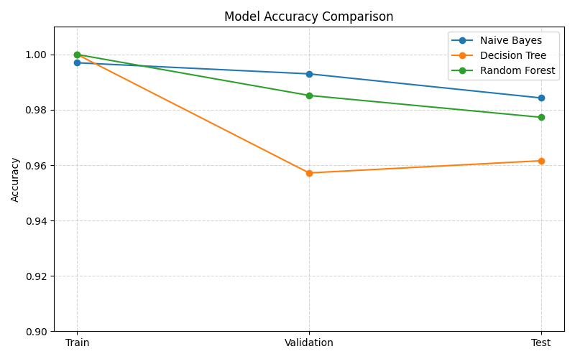

6. Saved Outputs
Model files saved in the models/ directory:
- - models/naive_bayes_model.pkl
- - models/decision_tree_model.pkl
- - models/random_forest_model.pkl
- - models/vectorizer.pkl
Report files saved in the reports/ directory:
- - reports/classification_report.txt
- - reports/decision_tree_classification_report.txt
- - reports/random_forest_classification_report.txt
- - reports/project_report.docx

7. Code Summary
The main training logic is the same for all three models: load data, vectorize text, fit the classifier, evaluate splits, save the model, and save the report.

Code: train_model.py
from pathlib import Path
import joblib
import pandas as pd
from sklearn.feature_extraction.text import CountVectorizer
from sklearn.metrics import accuracy_score, classification_report, confusion_matrix
from sklearn.naive_bayes import MultinomialNB
ROOT_DIR = Path(__file__).resolve().parents[1]
DATA_DIR = ROOT_DIR / "data" / "processed"
MODELS_DIR = ROOT_DIR / "models"
REPORTS_DIR = ROOT_DIR / "reports"
TEXT_COLUMN = "text"
LABEL_COLUMN = "spam"
LABELS = [0, 1]
TARGET_NAMES = ["Not Spam", "Spam"]
def load_split(split_name):
path = DATA_DIR / f"{split_name}.csv"
if not path.exists():
raise FileNotFoundError(f"Missing {split_name} split: {path}")
df = pd.read_csv(path)
missing_columns = {TEXT_COLUMN, LABEL_COLUMN} - set(df.columns)
if missing_columns:
raise ValueError(f"{path} is missing columns: {sorted(missing_columns)}")
return df[TEXT_COLUMN].astype(str), df[LABEL_COLUMN].astype(int)
def evaluate_split(model, vectorizer, split_name, x_values, y_values):
x_vec = vectorizer.transform(x_values)
predictions = model.predict(x_vec)
accuracy = accuracy_score(y_values, predictions)
report = classification_report(
y_values,
predictions,
labels=LABELS,
target_names=TARGET_NAMES,
digits=4,
)
matrix = confusion_matrix(y_values, predictions, labels=LABELS)
return (
f"{split_name.title()} Accuracy: {accuracy:.4f}\n"
f"{split_name.title()} Classification Report:\n{report}\n"
f"{split_name.title()} Confusion Matrix [[TN, FP], [FN, TP]]:\n{matrix}\n"
)
def main():
x_train, y_train = load_split("train")
x_validation, y_validation = load_split("validation")
x_test, y_test = load_split("test")
vectorizer = CountVectorizer(stop_words="english")
x_train_vec = vectorizer.fit_transform(x_train)
model = MultinomialNB()
model.fit(x_train_vec, y_train)
sections = [
evaluate_split(model, vectorizer, "train", x_train, y_train),
evaluate_split(model, vectorizer, "validation", x_validation, y_validation),
evaluate_split(model, vectorizer, "test", x_test, y_test),
]
report_text = "\n".join(sections)
MODELS_DIR.mkdir(parents=True, exist_ok=True)
REPORTS_DIR.mkdir(parents=True, exist_ok=True)
joblib.dump(model, MODELS_DIR / "naive_bayes_model.pkl")
joblib.dump(vectorizer, MODELS_DIR / "vectorizer.pkl")
(REPORTS_DIR / "classification_report.txt").write_text(report_text, encoding="utf-8")
print(report_text)
print(f"Saved model to: {MODELS_DIR / 'naive_bayes_model.pkl'}")
print(f"Saved vectorizer to: {MODELS_DIR / 'vectorizer.pkl'}")
print(f"Saved report to: {REPORTS_DIR / 'classification_report.txt'}")
if __name__ == "__main__":
main()

Code: train_decision_tree.py
# train_decision_tree.py
# Adapted from train_model.py for Decision Tree Classifier
from pathlib import Path
import joblib
import pandas as pd
from sklearn.feature_extraction.text import CountVectorizer
from sklearn.metrics import accuracy_score, classification_report, confusion_matrix
from sklearn.tree import DecisionTreeClassifier
ROOT_DIR = Path(__file__).resolve().parents[1]
DATA_DIR = ROOT_DIR / "data" / "processed"
MODELS_DIR = ROOT_DIR / "models"
REPORTS_DIR = ROOT_DIR / "reports"
TEXT_COLUMN = "text"
LABEL_COLUMN = "spam"
LABELS = [0, 1]
TARGET_NAMES = ["Not Spam", "Spam"]
def load_split(split_name):
path = DATA_DIR / f"{split_name}.csv"
if not path.exists():
raise FileNotFoundError(f"Missing {split_name} split: {path}")
df = pd.read_csv(path)
missing_columns = {TEXT_COLUMN, LABEL_COLUMN} - set(df.columns)
if missing_columns:
raise ValueError(f"{path} is missing columns: {sorted(missing_columns)}")
return df[TEXT_COLUMN].astype(str), df[LABEL_COLUMN].astype(int)
def evaluate_split(model, vectorizer, split_name, x_values, y_values):
x_vec = vectorizer.transform(x_values)
predictions = model.predict(x_vec)
accuracy = accuracy_score(y_values, predictions)
report = classification_report(
y_values,
predictions,
labels=LABELS,
target_names=TARGET_NAMES,
digits=4,
)
matrix = confusion_matrix(y_values, predictions, labels=LABELS)
return (
f"{split_name.title()} Accuracy: {accuracy:.4f}\n"
f"{split_name.title()} Classification Report:\n{report}\n"
f"{split_name.title()} Confusion Matrix [[TN, FP], [FN, TP]]:\n{matrix}\n"
)
def main():
x_train, y_train = load_split("train")
x_validation, y_validation = load_split("validation")
x_test, y_test = load_split("test")
vectorizer = CountVectorizer(stop_words="english")
x_train_vec = vectorizer.fit_transform(x_train)
model = DecisionTreeClassifier(random_state=42) # You can tune hyperparameters here
model.fit(x_train_vec, y_train)
sections = [
evaluate_split(model, vectorizer, "train", x_train, y_train),
evaluate_split(model, vectorizer, "validation", x_validation, y_validation),
evaluate_split(model, vectorizer, "test", x_test, y_test),
]
report_text = "\n".join(sections)
MODELS_DIR.mkdir(parents=True, exist_ok=True)
REPORTS_DIR.mkdir(parents=True, exist_ok=True)
joblib.dump(model, MODELS_DIR / "decision_tree_model.pkl")
joblib.dump(vectorizer, MODELS_DIR / "vectorizer.pkl") # Reusing the same vectorizer
(REPORTS_DIR / "decision_tree_classification_report.txt").write_text(report_text, encoding="utf-8")
print(report_text)
print(f"Saved model to: {MODELS_DIR / 'decision_tree_model.pkl'}")
print(f"Saved vectorizer to: {MODELS_DIR / 'vectorizer.pkl'}")
print(f"Saved report to: {REPORTS_DIR / 'decision_tree_classification_report.txt'}")
if __name__ == "__main__":
main()

Code: train_random_forest.py
# train_random_forest.py
# Adapted from train_model.py for Random Forest Classifier
from pathlib import Path
import joblib
import pandas as pd
from sklearn.ensemble import RandomForestClassifier
from sklearn.feature_extraction.text import CountVectorizer
from sklearn.metrics import accuracy_score, classification_report, confusion_matrix
ROOT_DIR = Path(__file__).resolve().parents[1]
DATA_DIR = ROOT_DIR / "data" / "processed"
MODELS_DIR = ROOT_DIR / "models"
REPORTS_DIR = ROOT_DIR / "reports"
TEXT_COLUMN = "text"
LABEL_COLUMN = "spam"
LABELS = [0, 1]
TARGET_NAMES = ["Not Spam", "Spam"]
def load_split(split_name):
path = DATA_DIR / f"{split_name}.csv"
if not path.exists():
raise FileNotFoundError(f"Missing {split_name} split: {path}")
df = pd.read_csv(path)
missing_columns = {TEXT_COLUMN, LABEL_COLUMN} - set(df.columns)
if missing_columns:
raise ValueError(f"{path} is missing columns: {sorted(missing_columns)}")
return df[TEXT_COLUMN].astype(str), df[LABEL_COLUMN].astype(int)
def evaluate_split(model, vectorizer, split_name, x_values, y_values):
x_vec = vectorizer.transform(x_values)
predictions = model.predict(x_vec)
accuracy = accuracy_score(y_values, predictions)
report = classification_report(
y_values,
predictions,
labels=LABELS,
target_names=TARGET_NAMES,
digits=4,
)
matrix = confusion_matrix(y_values, predictions, labels=LABELS)
return (
f"{split_name.title()} Accuracy: {accuracy:.4f}\n"
f"{split_name.title()} Classification Report:\n{report}\n"
f"{split_name.title()} Confusion Matrix [[TN, FP], [FN, TP]]:\n{matrix}\n"
)
def main():
x_train, y_train = load_split("train")
x_validation, y_validation = load_split("validation")
x_test, y_test = load_split("test")
vectorizer = CountVectorizer(stop_words="english")
x_train_vec = vectorizer.fit_transform(x_train)
model = RandomForestClassifier(n_estimators=100, random_state=42) # You can tune hyperparameters here
model.fit(x_train_vec, y_train)
sections = [
evaluate_split(model, vectorizer, "train", x_train, y_train),
evaluate_split(model, vectorizer, "validation", x_validation, y_validation),
evaluate_split(model, vectorizer, "test", x_test, y_test),
]
report_text = "\n".join(sections)
MODELS_DIR.mkdir(parents=True, exist_ok=True)
REPORTS_DIR.mkdir(parents=True, exist_ok=True)
joblib.dump(model, MODELS_DIR / "random_forest_model.pkl")
joblib.dump(vectorizer, MODELS_DIR / "vectorizer.pkl") # Reusing the same vectorizer
(REPORTS_DIR / "random_forest_classification_report.txt").write_text(report_text, encoding="utf-8")
print(report_text)
print(f"Saved model to: {MODELS_DIR / 'random_forest_model.pkl'}")
print(f"Saved vectorizer to: {MODELS_DIR / 'vectorizer.pkl'}")
print(f"Saved report to: {REPORTS_DIR / 'random_forest_classification_report.txt'}")
if __name__ == "__main__":
main()

8. Commands to Run
Use the following commands from the project root:
- python scripts/train_model.py
- python scripts/train_decision_tree.py
- python scripts/train_random_forest.py
- python scripts/predict.py

