**Problem set no 3 solve;**

**1.Take a number from use check it is Odd or Even.**

#include <iostream>  
using namespace std;  
int main() {  
 int x;  
 cout <<" Please input a Number"<< endl;  
 cin >> x;  
 if (x%2==0)

{  
 cout <<x<<" is an Even Number"<<endl;

}  
 else  
 cout <<x<<" is an Odd Number"<<endl;  
 return 0;  
}

**2. Take a number from user and check whether the number is positive, negative or neither.**

#include <iostream>  
using namespace std;  
int main() {  
 int x;  
 cout <<" Please input a Number"<< endl;  
 cin >> x;  
 if (x>0)  
 {  
 cout <<x<<" is a positive Number"<<endl;  
 }  
 else if (x<0)  
 {  
 cout <<x<< " is negative"<<endl;  
 }  
 else  
 {  
 cout <<x<<" is neither "<<endl;  
 }  
 return 0;  
}

**3.Write a program that takes a number as input and check it is an integer or floating-point number.**

#include <iostream>  
using namespace std;  
int main() {  
 float x;  
 cout <<" Please input a Number"<< endl;  
 cin >> x;  
 if (x-int(x)!=0)  
 {  
 cout<< x<<" is a float-point number"<<endl;  
 }  
 else  
 {  
 cout <<x<< " is integer number"<<endl;  
 }  
 return 0;  
}

**4.Write a program that check if a number is divisible by 7 or 5.**

#include <iostream>  
using namespace std;  
int main() {  
 int x;  
 cout <<" Please input a Number"<< endl;  
 cin >> x;  
 if (x%5==0 || x%7==0)  
 {  
 cout<< x<<" is Divisible by 7 or 5"<<endl;  
 }  
 else  
 {  
 cout <<x<<" is not Divisible by 7 or 5"<<endl;  
 }  
 return 0;  
}

**5. Write a program that check is a number is divisible by 3 or 5.**

#include <iostream>  
using namespace std;  
int main() {  
  
 int x;  
 cout <<" Please input a Number"<< endl;  
 cin >> x;  
 if (x%3==0 && x%5==0)  
 {  
 cout<< x<<" Divisible by 3 and 5"<<endl;  
 }  
 else  
 {  
 cout <<x<<" not Divisible by 3 and 5"<<endl;  
 }  
 return 0;  
}

**6. Write a program that check if a number is greater than 50 AND Less than 100 and divisible by 9 or 13.**

#include <iostream>  
using namespace std;  
int main() {  
 int x;  
 cout <<" Please input a Number"<< endl;  
 cin >> x;  
 if (x>50 && x<100)  
 {  
 if (x%9==0 || x%13==0)  
 {  
 cout << x << " is it is divisible by 9 or 13" << endl;  
 }  
 else  
 {  
 cout <<x<<" is not divisible by 9 or 13"<<endl;  
 }  
 }  
 else  
 {  
 cout <<x<<" is less than 50 or bigger than 100"<< endl;  
 }  
 return 0;  
}

**7.Write a program that check if a number is within the range [35,75) and divisible by 5 but not by 2.**

#include <iostream>  
using namespace std;  
int main() {  
  
 int x;  
 cout <<" Please input a Number"<< endl;  
 cin >> x;  
 if (x>=35 && x<75)  
 {  
 if (x % 5 == 0 && x % 2 != 0)  
 {  
 cout << x << " divisible by 5 but not by 2" << endl;  
 }  
 else  
 {  
 cout << x << " not divisible by 5 or can be divisible by 5 and 2 " << endl;  
  
 }  
 }  
 else  
 {  
 cout << x << " is less than 50 or bigger than 100" << endl;  
 }  
 return 0;  
}

**8.Write a program that check if a number is within the range (10,40) and divisible by 5 or within the range (60,90) and divisible by 9.**

#include <iostream>  
using namespace std;  
int main() {  
  
 int x;  
 cout <<" Please input a Number"<< endl;  
 cin >> x;  
 if ((x>10 && x<40 && x%5==0) || (x>60 && x<90 && x%7==0))  
 {  
 cout<<x<<" divisible by 5 within (10,40)range or divisible by 7 with in (60,90)range"<<endl;  
 }  
 else if ((x>10 && x<40 && x%5!=0) || (x>60 && x<90 && x%7!=0))  
 {  
 cout<<x<<" not divisible by 5 within (10,40)range or divisible by 7 within (60,90)range"<<endl;  
 }  
 else  
 {  
 cout << x << " is not in (10,40) or (60,90) range" << endl;  
 }  
 return 0;  
}

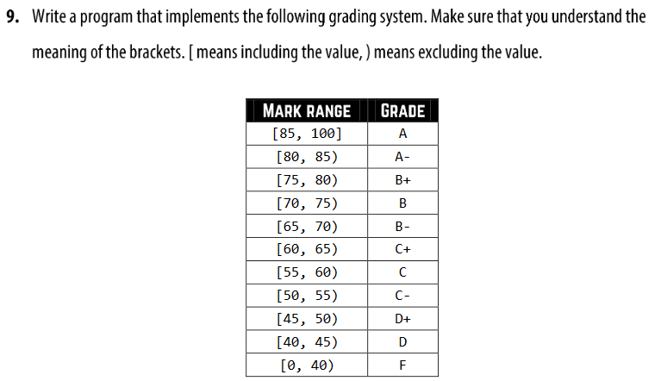

#include <iostream>  
using namespace std;  
int main() {  
  
 int x;  
 cout <<" Please input your Exam Marks"<< endl;  
 cin >> x;  
 if (x<=100 && x>=85)  
 {  
 cout<< " Congratulation you got A "<<endl;  
 }  
 else if (x>=80&&x<=85)  
 {  
 cout<< " Congratulation you got A- "<<endl;  
 }  
 else if (x>=75 && x<80)  
 {  
 cout<< " Congratulation you got B+ "<<endl;  
 }  
 else if (x>=70 && x<75)  
 {  
 cout<< " you got B "<<endl;  
 }  
 else if (x>=65 && x<70)  
 {  
 cout<< " you got B- "<<endl;  
 }  
 else if (x>=60 && x<65)  
 {  
 cout<< " you got c+ "<<endl;  
 }  
 else if (x>=55 && x<60)  
 {  
 cout<< " you got C "<<endl;  
 }  
 else if (x>=50 && x<55)  
 {  
 cout<< " you got c- "<<endl;  
 }  
 else if (x>=45 && x<50)  
 {  
 cout<< " you got D+ "<<endl;  
 }  
 else if (x>=40 && x<45)  
 {  
 cout<< " you got D "<<endl;  
 }  
 else if(x>=0 && x<40)  
 {  
 cout<<" you are failed in exam "<<endl;  
 }  
 else  
 {  
 cout << x << " you input wrong number please check again" << endl;  
 }  
 return 0;  
}

**10.Write a program that take user age as input and then find out what stage of human life they are in using the table given below.**

|  |  |
| --- | --- |
| Age range | Stage |
| Less than 3 year | Infancy |
| From 3 years to less than 12 years | Childhood |
| From 12 years to less than 20 years | Adolescence |
| From 20 years to less than 40 years | Young Adulthood |
| From 40 years to less than 65 years | Mature Adulthood |
| 65 years and above | Late Adulthood |

Code: problem 10

#include <iostream>  
using namespace std;  
int main() {  
  
 int x;  
 cout << " Please input your age" << endl;  
 cin >> x;  
 if (x<3)  
 {  
 cout << "Infancy"<<endl;  
 }  
 else if (x>=3&&x<12)  
 {  
 cout<<"Childhood"<<endl;  
 }  
 else if (x>=12&&x<20)  
 {  
 cout<<"Adolescence"<<endl;  
 }  
 else if (x>=20&&x<40)  
 {  
 cout<<"Young Adulthood"<<endl;  
 }  
 else if (x>=40&&x<65)  
 {  
 cout<<"mature Adulthood"<<endl;  
 }  
 else  
 {  
 cout<<"Late Adulthood"<<endl;  
 }  
 return 0;  
}

**11. Write a program that takes integer input 0to 10 from user and display the number in words.**

Code: problem 11

#include <iostream>  
using namespace std;  
  
int main () {  
 int x;  
 cout << " Please input an integer number from 0 to 10"<<endl;  
 cin >> x;  
 if (x==0)  
 {  
 cout <<"Zero"<<endl;  
 }  
 else if (x==1)  
 {  
 cout <<"One"<<endl;  
 }  
 else if (x==2)  
 {  
 cout <<"Two"<<endl;  
 }  
 else if (x==3)  
 {  
 cout <<"Three"<<endl;  
 }  
 else if (x==4)  
 {  
 cout <<"Four"<<endl;  
 }  
 else if (x==5)  
 {  
 cout <<"Five"<<endl;  
 }  
 else if (x==6)  
 {  
 cout <<"Six"<<endl;  
 }  
 else if (x==7)  
 {  
 cout <<"Seven"<<endl;  
 }  
 else if (x==8)  
 {  
 cout <<"Eight"<<endl;  
 }  
 else if (x==9)  
 {  
 cout <<"Nine"<<endl;  
 }  
 else if (x==10)  
 {  
 cout <<"Ten"<<endl;  
 }  
 else  
 {  
 cout <<" Your input not in 0 to 10 Range" <<endl;  
 }  
 return 0;  
}

**12.Write a program that takes three number from user and find out the largest and smallest number.**

Code: problem 12

#include <iostream>  
using namespace std;  
  
int main () {  
 float x,y,z;  
 cout << " Please input Three Number" <<endl;  
 cin >> x>>y>>z;  
 if (x>=y)  
 {  
 if (x>z && y>z && x>=y && x>=z)  
 {  
 cout<<x<<" is the largest number"<<endl;  
 cout<<z<<" is the smallest"<<endl;  
 }  
 else if (x<z && y<z)  
 {  
 cout <<z<<" is the largest number"<<endl;  
 cout<<y<<" is the smallest number"<<endl;  
 }  
 else  
 {  
 cout <<x<<" is the largest number"<<endl;  
 cout<<y<<" is the smallest number"<<endl;  
 }  
 }  
 else if (x<y)  
 {  
 if (y>z && x>z )  
 {  
 cout<<y<<" is the largest number"<<endl;  
 cout<<z<<" is the smallest"<<endl;  
 }  
 else if (x<y && y<z)  
 {  
 cout <<z<<" is the largest number"<<endl;  
 cout<<x<<" is the smallest number"<<endl;  
 }  
 else  
 {  
 cout <<y<<" is the largest number"<<endl;  
 cout<<x<<" is the smallest number"<<endl;  
 }  
 }  
  
 return 0;  
}

**13. Write a program that check if a year is a leap year or not.**

#include <iostream>  
using namespace std;  
int main() {  
 int x;  
 cout <<" Please input a year"<< endl;  
 cin >> x;  
 if (x%400==0)  
 {  
 cout <<x<<" is a Leap year"<<endl;  
 }  
  
 else if (x%100!=0 && x%4==0)  
 {  
 cout <<x<<" is a Leap year"<<endl;  
 }  
 else  
 {  
 cout<< x<< " is not a leap year"<<endl;  
 }  
  
 return 0;  
}

**14.Write a program that takes a character from user and checks if it is an uppercase later or lowercase latter, a digit, or a symbol.**

#include <iostream>  
using namespace std;  
int main() {  
 char x;  
 cout << " please input a single keyword"<< endl;  
 cin >> x;  
 if( x>=65 && x<=90)  
 {  
 cout <<x<< " is an uppercase letter"<< endl;  
 }  
 else if (x>=97 && x<=122)  
 {  
 cout <<x<< " is a Lowercase letter"<< endl;  
 }  
 else if (x>=48 && x<=57)  
 {  
 cout <<x<< " is a Digits"<< endl;  
 }  
 else if ((x>=33 && x<=47) || (x>=58 && x<=64) || (x>=91 && x<=96) || (x>=123&&x<127))  
 {  
 cout <<x<< " is a Symbol"<< endl;  
 }  
 return 0;  
}

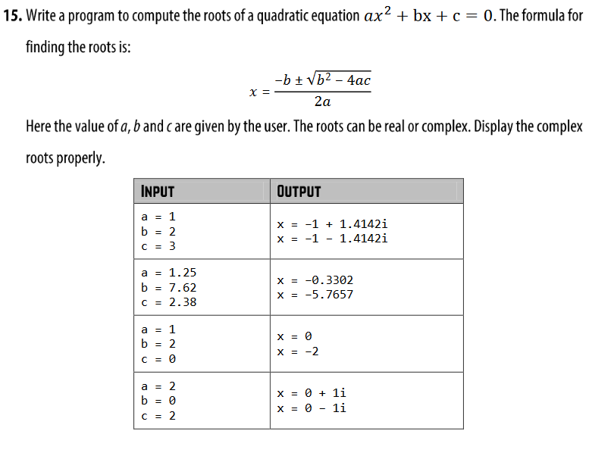

Code: Problem no 15

#include <iostream>  
#include<cmath>  
using namespace std;  
int main() {  
 float a,b,c,x;  
 cin>>a>>b>>c;  
 x=(b*b)-(4*a*c);  
 if(x<0){  
 cout<<"x = "<<-b/(2*a)<<"+"<<sqrt(-x)/(2*a)<<"i\n";  
 cout<<"x = "<<-b/(2*a)<<"-"<<sqrt(-x)/(2*a)<<"i\n";  
 }  
 else{  
 cout<<"x = "<<-b/(2*a)+sqrt(x)/(2*a)<<"\n";  
 cout<<"x = "<<-b/(2*a)-sqrt(x)/(2*a)<<"\n";  
 }  
 return 0;  
}

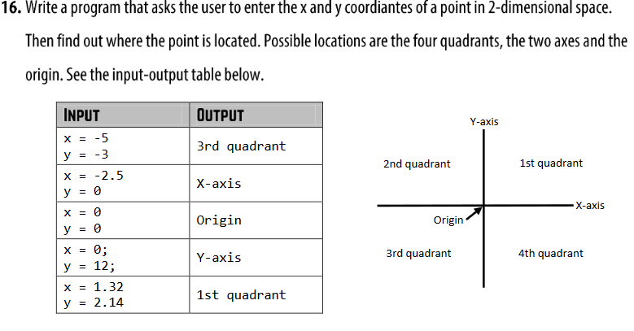

.

#include <iostream>

#include <math.h>  
using namespace std;  
int main() {  
 float x,y;  
 cout << "please Enter the value of x and y"<<endl;  
 cin >> x >> y;  
 if (x==0 & y==0)  
 {  
 cout << " the point is at origin"<<endl;  
 }  
 else if (x==0 & y>0)  
 {  
 cout << " the point is at positive Y axis"<<endl;  
 }  
 else if (x>0 & y==0)  
 {  
 cout << " the point is at positive X axis"<<endl;  
 }  
 else if (x==0 & y<0)  
 {  
 cout << " the point is at Negative Y axis"<<endl;  
 }  
 else if (x<0 & y==0)  
 {  
 cout << " the point is at X Negative axis"<<endl;  
 }  
 else if (x>0 & y>0)  
 {  
 cout << " the point is at 1st quadrant"<<endl;  
 }  
 else if (x<0 & y>0)  
 {  
 cout << " the point is at 2nd quadrant"<<endl;  
 }  
 else if (x<0 & y<0)  
 {  
 cout << " the point is at 3rd quadrant"<<endl;  
 }  
 else if (x>0 & y<0)  
 {  
 cout << " the point is at 3rd quadrant"<<endl;  
 }  
 return 0;  
}

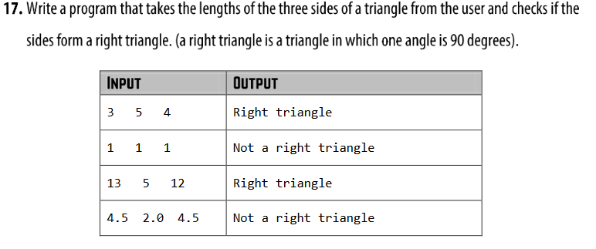

#include <iostream>  
#include <math.h>  
using namespace std;  
int main() {  
 float x,y,z;  
 cout << "please input the length of three side of your triangle"<<endl;  
 cin >> x >> y>> z;  
 if (pow(x,2)==(pow(y,2)+pow(z,2)))  
 {  
 cout << "right triangle"<<endl;  
 }  
 else if (pow(y,2)==(pow(x,2)+pow(z,2)))  
 {  
 cout << "right triangle"<<endl;  
 }  
 else if (pow(z,2)==(pow(x,2)+pow(y,2)))  
 {  
 cout << "right triangle"<<endl;  
 }  
 else  
 {  
 cout << " Not a right triangle"<<endl;  
 }  
 return 0;  
}

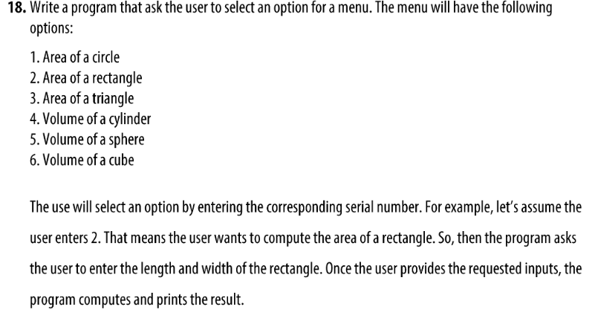

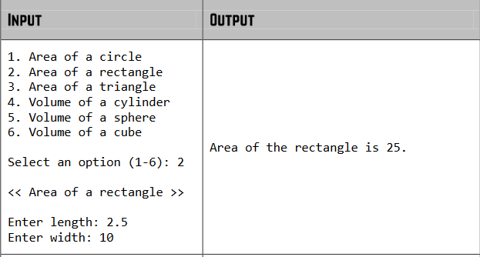

# #include <iostream>  
#include <math.h>  
using namespace std;  
int main() {  
  
  
 float x,r,circle,l,w,rectangle,b,h,triangle,ra,hi,cylinder,radius,sphere,cube,y;  
  
 cout<<"press 1 if you want to calculate the Area of a circle"<<endl;  
 cout<<"press 2 if you want to calculate the Area of a rectangle"<<endl;  
 cout<<"press 3 if you want to calculate the Area of a triangle"<<endl;  
 cout<<"press 4 if you want to calculate the Volume of a cylinder"<<endl;  
 cout<<"press 5 if you want to calculate the Volume of a sphere"<<endl;  
 cout<<"press 6 if you want to calculate the Volume of a cube"<<endl;  
 cout <<" Please select an option"<<endl;  
 cin>> x;  
 if (x==1)  
 {  
 cout << " please input the radius of your circle" << endl;  
 cin >> r;  
 circle = 3.1416 * pow(r,2);  
 cout << " The area of your circle is " << circle << endl;  
 }  
 else if (x==2)  
 {  
 cout << " please input the length & width of your rectangle" << endl;  
 cin >>l>>w;  
 rectangle = l*w;  
 cout << " The area of your rectangle is " << rectangle << endl;  
 }  
 else if (x==3)  
 {  
 cout << " please input the base & height of your triangle" << endl;  
 cin >>b>>h;  
 triangle = .5*b*h;  
 cout << " The area of your triangle is " << triangle << endl;  
 }  
 else if (x==4)  
 {  
 cout << " please input the radius & height of your cylinder" << endl;  
 cin >>ra>>hi;  
 cylinder=3.1416*pow(ra,2)*hi;  
 cout << " The volume of your cylinder is " << cylinder << endl;  
 }  
 else if (x==5)  
 {  
 cout << " please input the radius of your sphere" << endl;  
 cin >>radius;  
 sphere=1.33*pow(radius,3)*3.1416;  
 cout << " The volume of your sphere is " << sphere << endl;  
 }  
 else if (x==6)  
 {  
 cout << " please input the radius of your cube" << endl;  
 cin >>y;  
 cube=pow(y,3);  
 cout << " The area of your rectangle is " << cube << endl;  
 }  
 return 0;  
}