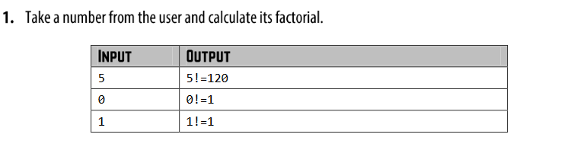
#include <iostream>
using namespace std;
int main() {
int x, fact=1;
cin>>x;
for (int i = 1;i<=x;i++) {
fact= fact*i;
}
cout <<fact;
return 0;
}
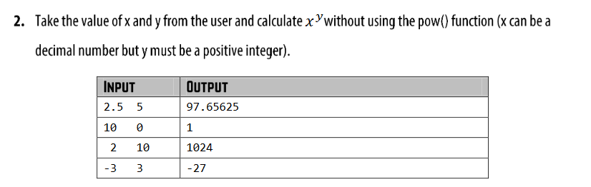
#include <iostream>
using namespace std;
int main() {
float x, m=1;
int y;
cout << "input a number then it's power"<<endl;
cin>>x;
cin>>x;
for (int i = 1;i<=y;i++) {
m= m*i;
}
cout <<m;
return 0;
}

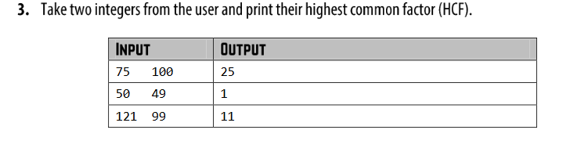
#include <iostream>
using namespace std;
int main() {
int a,b,x,y,t,hcf;
cout << "input a number then it's power"<<endl;
cin>>x>>y;
a=x;
b=y;
while (b!=0){
t=b;
b=a%b;
a=t;
}
hcf=a;
cout <<hcf;
return 0;
}

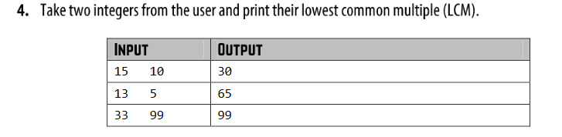
#include <iostream>
using namespace std;
int main() {
int a,b,x,y,t,hcf,lcm;
cout << "input a number then it's power"<<endl;
cin>>x>>y;
a=x;
b=y;
while (b!=0){
t=b;
b=a%b;
a=t;
}
hcf=a;
lcm=(x*y)/hcf;
cout <<lcm;
return 0;
}

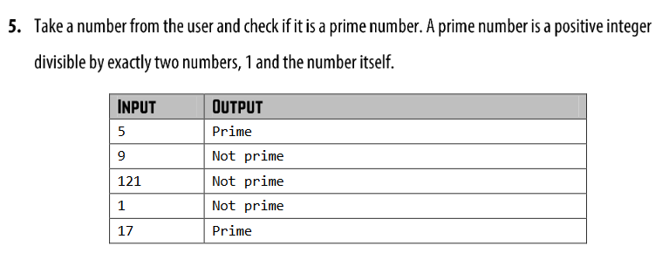
#include <iostream>
using namespace std;
int main() {
int n;
int count=0;
cout << "input a number " << endl;
cin >> n;
for (int i = 1; i <=n; i++) {
if (n%i==0){
count++;
}
}
if (count==2){
cout <<"prime"<<endl;
}
else{
cout <<"not prime"<<endl;
}
return 0;
}

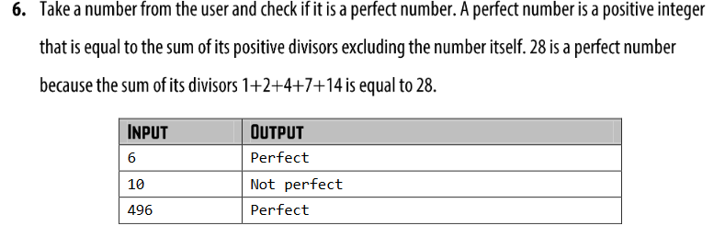
#include <iostream>
using namespace std;
int main() {
int x;
int sum=0;
cout<<"Enter a number: ";
cin>> x;
for (int i = 1; i <x ; i++) {
if (x%i==0){
sum =sum+i;
}
}
if (sum==x){
cout <<"perfect";
}
else {
cout <<"not perfect";
}
return 0;
}

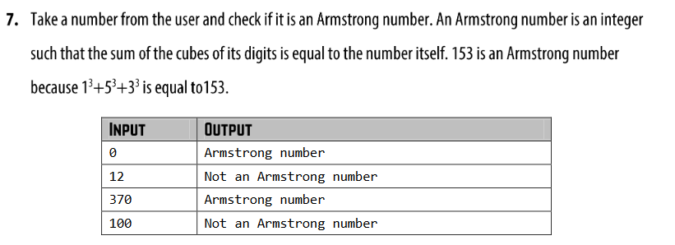
#include <iostream>
#include <cmath>
using namespace std;
int main() {
int x,rem;
int sum=0;
cout<<"Enter a number: ";
cin>> x;
int y=x;
while (x){
rem=x%10;
x=x/10;
sum=(sum+ pow(rem,3));
}
if (sum==y){
cout <<"Armstrong number";
}
else {
cout <<"not an Armstrong number";
}
return 0;
}

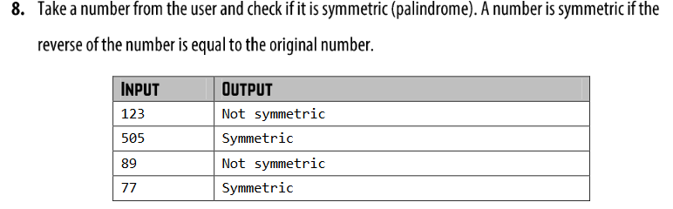
#include <iostream>
using namespace std;
int main(){
int x, reverse=0, rem;
cout<<"Enter a number: ";
cin>>x;
int y=x;
while(x!=0)
{
rem=x%10;
x=x/10;
reverse=reverse*10+rem;
}
if (reverse==y){
cout<< "symmetric\n";
}
else {
cout << "Not symmetric\n";
}
return 0;
}

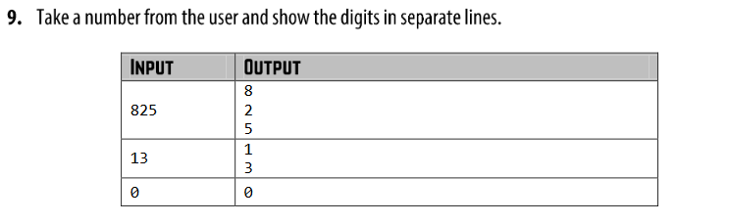
#include <iostream>
using namespace std;
int main(){
int x, reverse=0, rem;
cout<<"Enter a number: "<<endl;
cin>>x;
while(x!=0)
{
rem=x%10;
x=x/10;
reverse = reverse*10+rem;
}
while(reverse!=0)
{
rem=reverse%10;
reverse=reverse/10;
cout <<rem<<endl;
}
return 0;
}

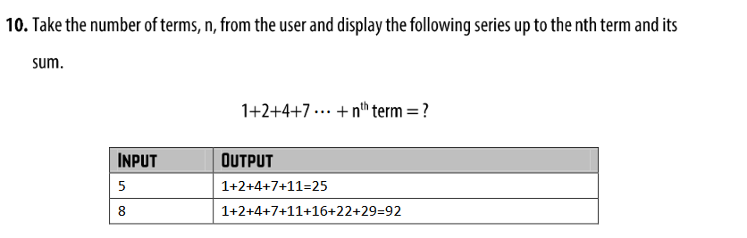
#include <iostream>
using namespace std;
int main(){
int n;
int sum =0;
int count= 1;
cout << "input the number of terms: ";
cin >> n;
for (int i = 0; i<n ; i++){
count = count+i;
cout<<count;
sum = sum + count;
if (i<n-1){
cout<<"+";
}
else{
cout<<"="<<sum;
}
}
return 0;
}

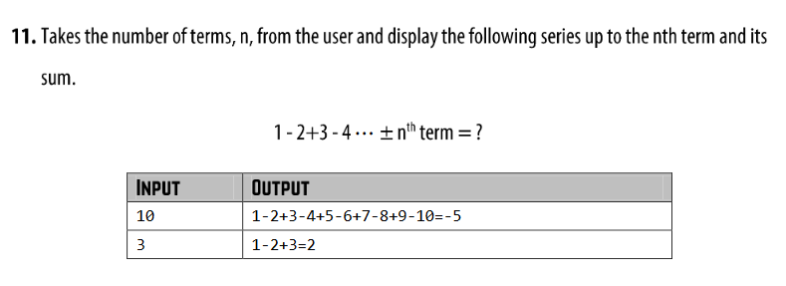
#include <iostream>
using namespace std;
int main() {
int n;
int odd_sum = 0;
int even_sum=0;
cout << "input the number of terms" << endl;
cin >> n;
for (int i = 1; i <= n; i++) {
if (i % 2 != 0) {
cout << i;
odd_sum = odd_sum + i;
if (i < n) {
cout << "-";
} else {
cout << "=";
}
} else {
cout << i;
even_sum = even_sum + i;
if (i < n) {
cout << "+";
} else {
cout << "=";
}
}
}
int sum = odd_sum -even_sum;
cout <<sum<<endl;
return 0;
}

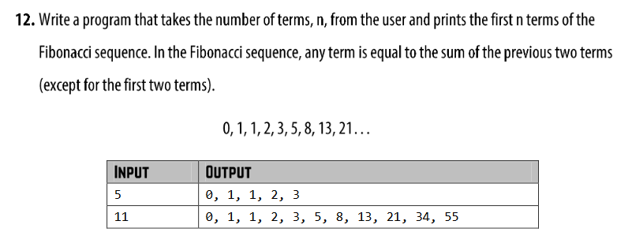
#include <iostream>
using namespace std;
int main(){
int n,a=0,b=1,sum=0;
cin>>n;
while (n>0){
cout<<a;
if (n!=1){
cout <<",";
}
sum = a+b;
b=a;
a=sum;
n--;
}
return 0;
}

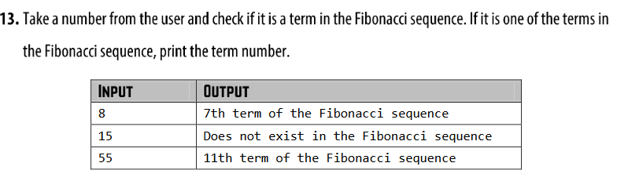
#include <iostream>
using namespace std;
int main(){
int n,a=0,b=1,sum=0,count=0;
cin >>n;
for (int i = 1; i <n ; i++) {
if (a==n){
count++;
cout <<n<<" is the"<<i<<" th term";
break;
}
sum= a+b;
b=a;
a=sum;
}
if (count==0){
cout<<"Does not exist in Fibonacci sequence";
}
return 0;
}

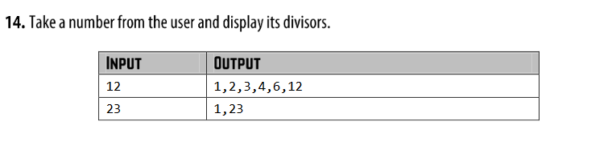
#include <iostream>
using namespace std;
int main() {
int x;
cout << "input a number " << endl;
cin >> x;
for (int i=1; i<=x; i++) {
if (x%i==0){
cout <<i;
if (i<x) {
cout <<",";
}
}
}
return 0;
}

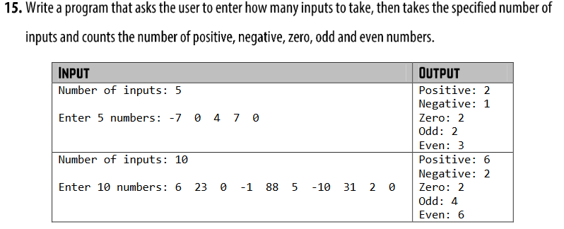
#include <iostream>
using namespace std;
int main(){
int x=0,n;
int negative=0;
int positive=0;
int zero=0;
int even=0,odd=0;
cout<<"Enter a number: "<<endl;
cin>>x;
for (int i = 0; i <x ; i++) {
cin >> n;
if (n < 0) {
negative++;
if (n % 2 == 0) {
even++;
} else {
odd++;
}
}
else if (n > 0) {
positive++;
if (n % 2 == 0) {
even++;
} else {
odd++;
}
} else {
zero++;
}
}
cout << "even: "<<even<<endl;
cout <<"odd "<< odd<<endl;
cout << "positive "<<positive<<endl;
cout <<"negative "<<negative<<endl;
cout << "zero "<<zero<<endl;
return 0;
}

